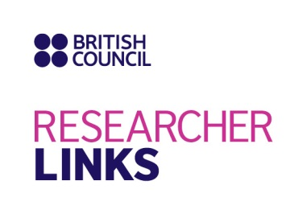

Application Form

1. Applicant
Name and title
Gender (for statistical purposes only: this will not be considered in assessment)
Position and institution
Postal address
Email
Phone number
Brief CV (academic career, publications, markers of esteem, and any other relevant information) – no more than ½ page of A4

2. Abstract - Please provide a summary of your area of research

3. Please describe your reasons for wishing to attend the workshop
4. Please describe the potential impact of the workshop on your professional development, including the ability to work at an international level
5. Please indicate how you plan to disseminate the outcomes of the workshop and the new knowledge/skills you will have acquired
6. The workshop will be conducted in English as standard. Please indicate your ability to work and communicate in English
Native speaker |  | Good
Excellent |  | Need support
7. Please use this space to give any additional information that you feel is relevant for your application

This form should be submitted by Friday 6th January 2017 as an email attachment to:
- (UK applicants): maggie.bolton@abdn.ac.uk
- (Uruguay applicants): trilateraluruguay@gmail.com
- (Brazil applicants): skakofes@gmail.com

