2026 School of Social Science PGR Writing Retreat

Anna Gaudet and Sone Erikainen

Since 2024, the School of Social Science has organised an annual writing retreat for our PhD researchers in the small town of Kingussie within the Cairngorms national park in the Scottish Highlands. This year’s edition of the Retreat brough together 10 researchers, including one member of academic staff, from Sociology, Anthropology, Politics and International Relations. We spent three nights and two and a half days at the Kingussie Railway Rooms discussing research and career development, walking, cooking, relaxing, and, of course, writing.

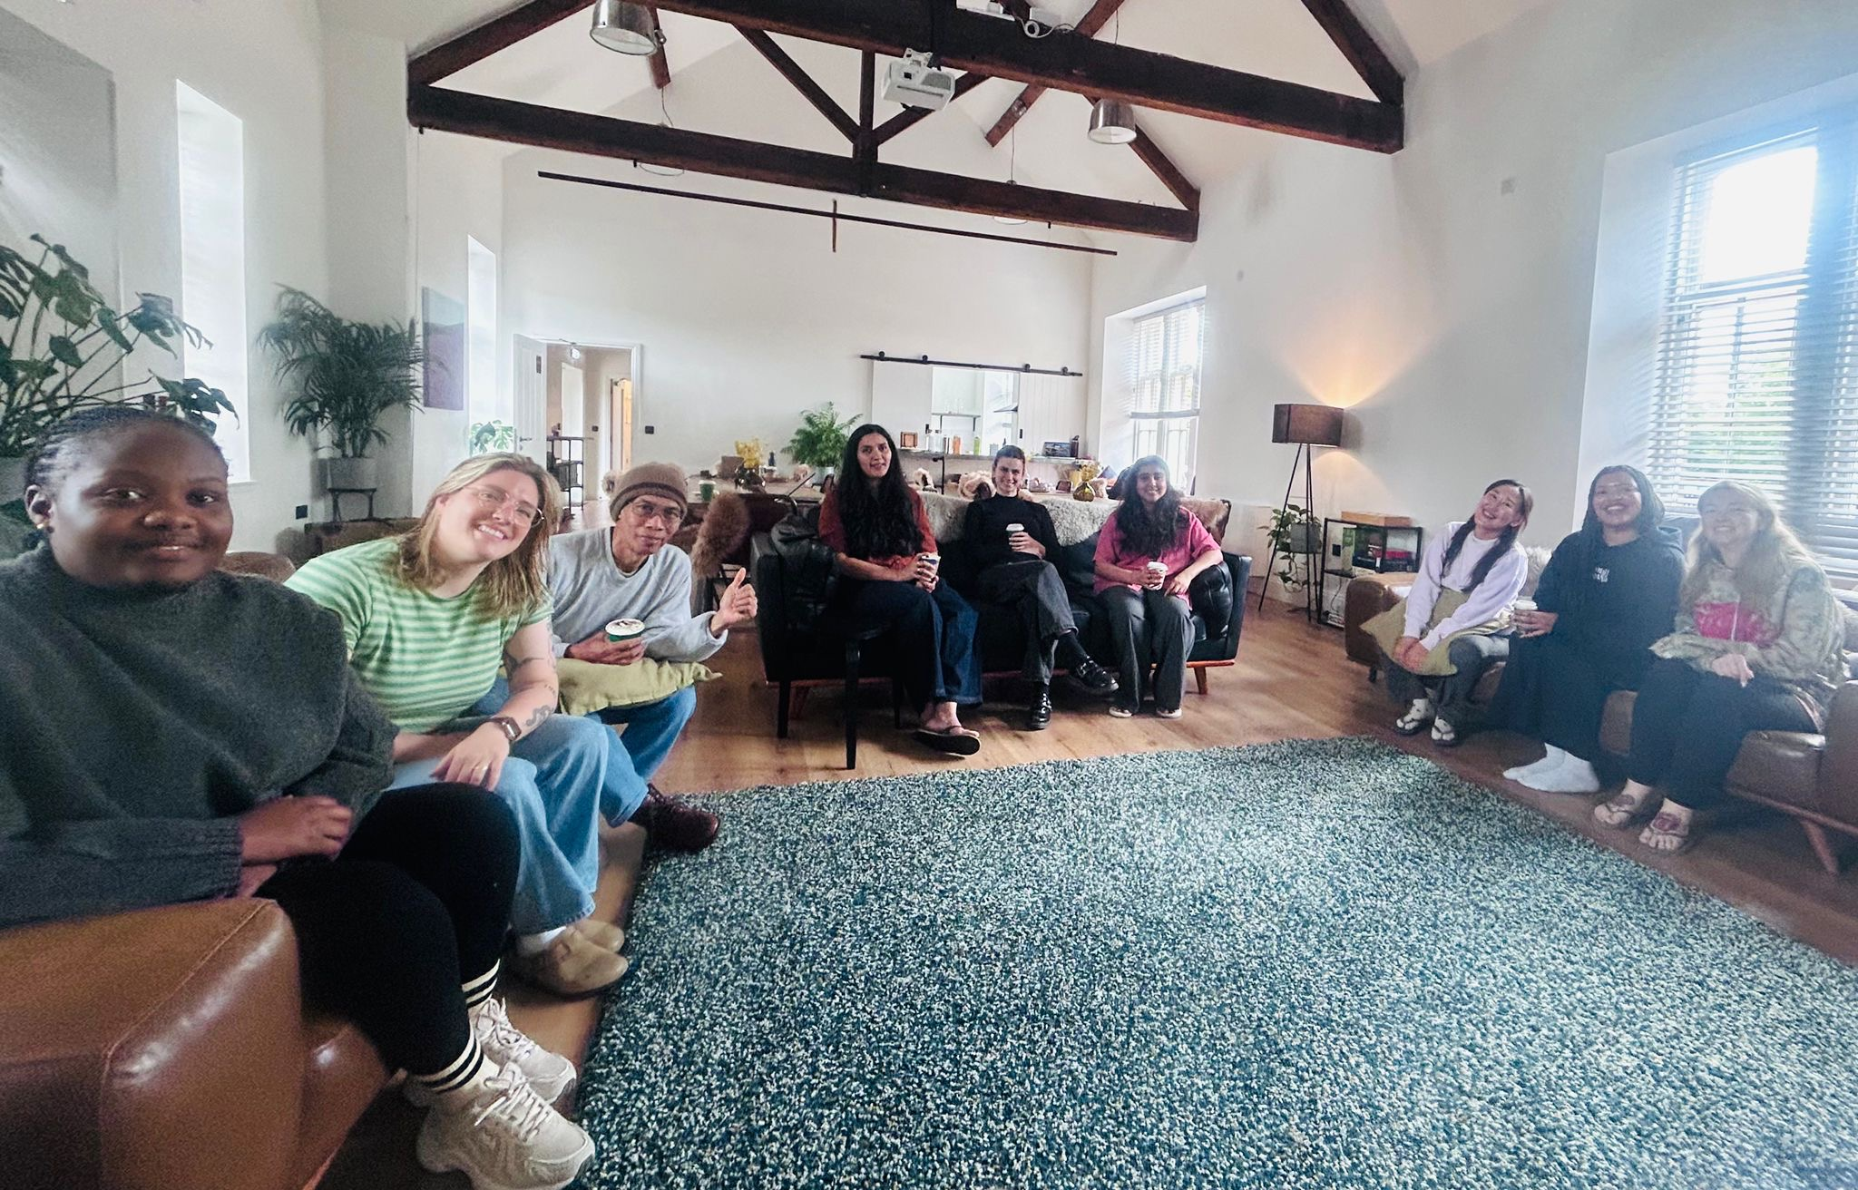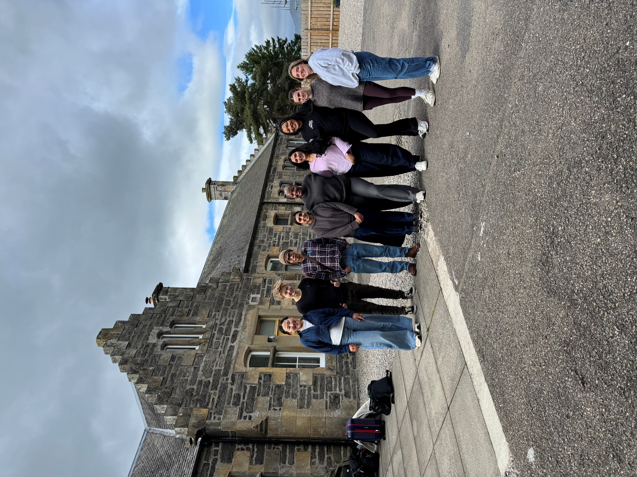

The Writing Retreat was initiated and is driven by the School EDI Committee, and its core aims are to foster community and research culture, sense of belonging, and inclusion for doctoral researchers in the School, as well as to offer dedicated joint writing time and informal workshops on topics of interest. While the event was co-organised by the PGR Engagement Committee (PGREC) this year, in the future, we aim to have the Retreat become fully student led and facilitated by the PGREC.

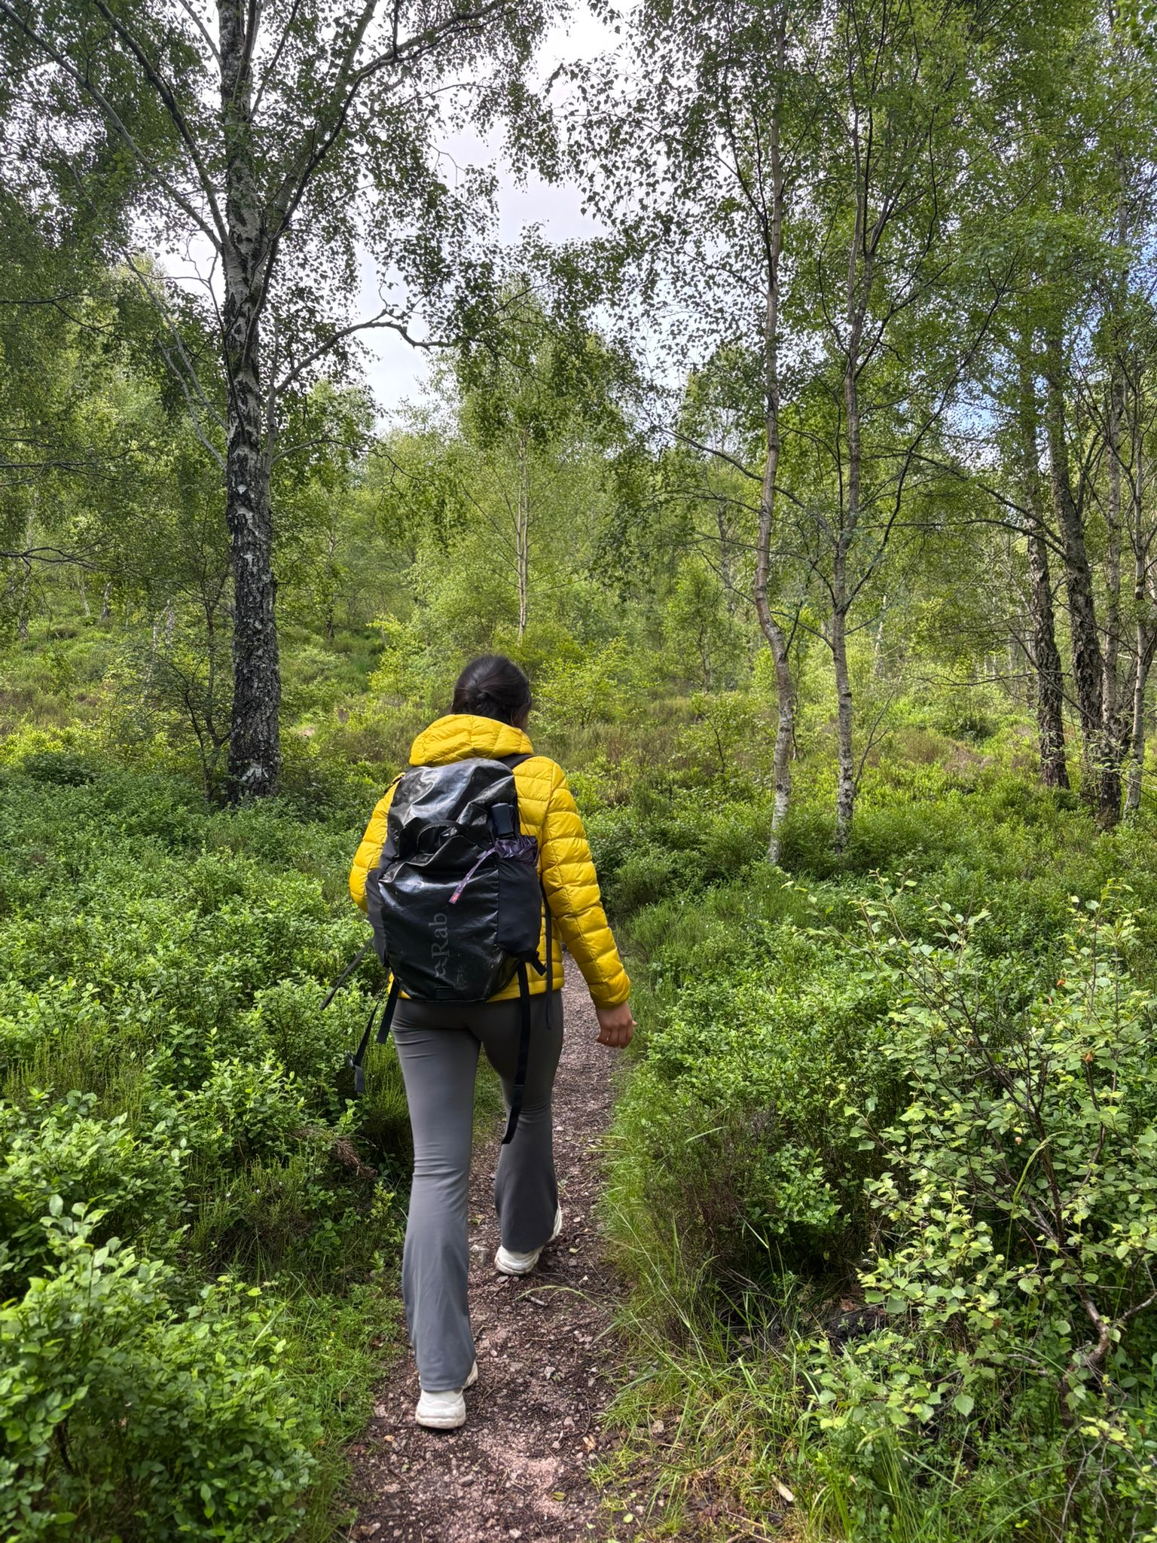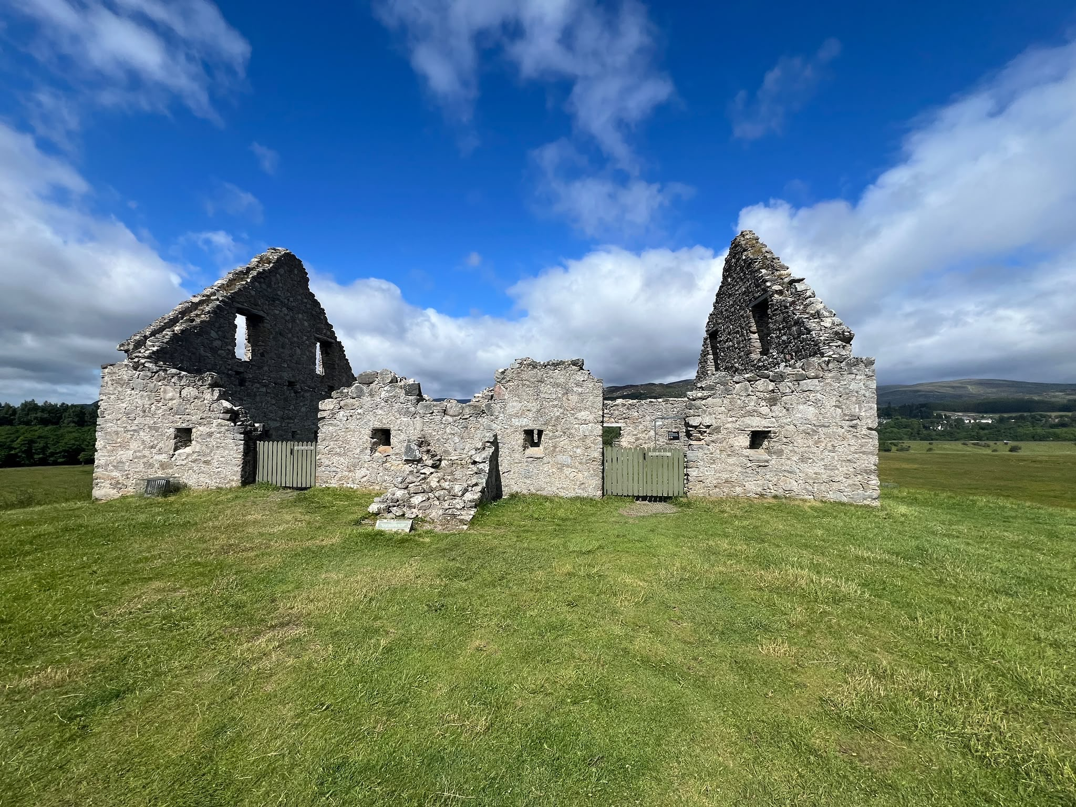

The Writing Retreat days were structured into writing blocks where everyone taking part could either work together in a shared space or in their own rooms to meet their separate writing goals for the day. Some chose to break up the writing blocks with walks in the beautiful surrounding nature or to the nearby ruins of Ruthven Barracks. We also had informal workshops on topics around academic careers led by the participating staff member, and a workshop on creative methods led by two participating doctoral researchers. The Writing Retreat was self-catered, meaning that everyone took part in planning our meals, preparing the food and tidying up. In the evenings, we cooked and ate together, creating some meaningful memories along the way. While all the food was excellent, a definite highlight was the barbecue outside on the last night.

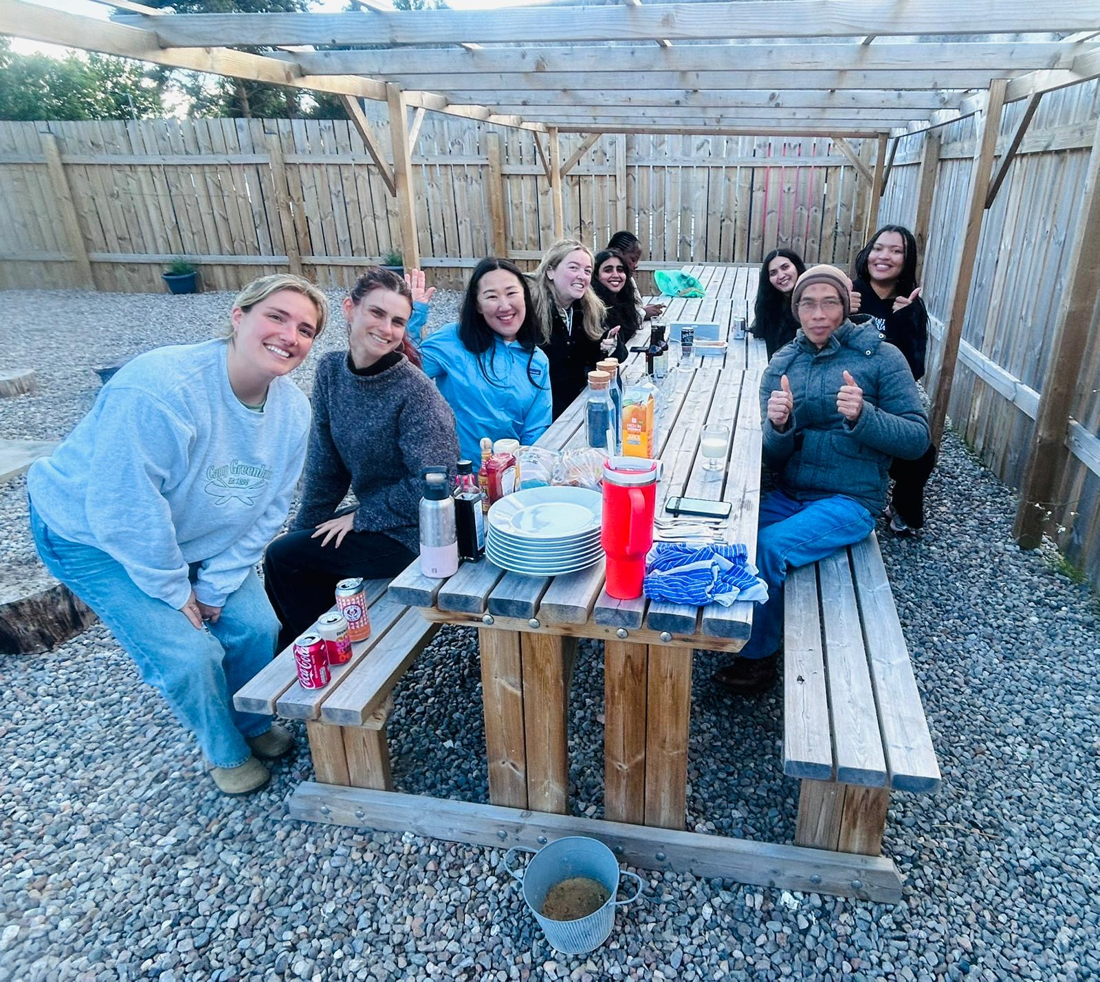
The feedback from participants collected after the Retreat was exclusively positive. One of the most commended aspects of the trip according to the attending PGRs was the opportunity to build relationships with their peers and feel a part of a community. One of the students noted, “Everyone helped to create a welcoming, supportive and safe environment in which it was easy to focus, connect, and be encouraged.” Similarly, another student underscored that “our PhD students want to be more involved in PGR and department activities, the retreat is such a great opportunity to foster a positive and engaged research culture!” Students also emphasised that they found the Retreat particularly helpful towards their productivity levels, allowed them to make progress in their writing, and facilitated knowledge transfer. It was stated that “the retreat is an amazing environment for sharing advice, best practice, and opportunities we would not hear about otherwise”. Without a doubt, the 2026 Retreat succeeded in achieving its core aims and had a positive impact on students’ wellbeing, academic development and writing skills, as well as their sense of community.

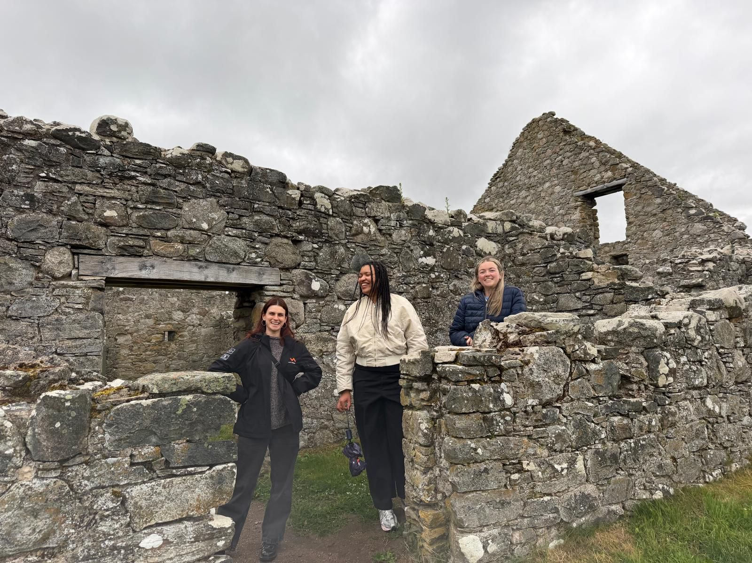

In the last three years, the Writing Retreat has become a highly valued and celebrated part of the School PGR research culture, and it exemplifies good practice in building belonging and inclusion for PhD students. The overwhelmingly positive experiences that the participants took away from it highlight the importance of the School’s continued investment in this annual event.
