BSc Geology & Mineralogy
Reunion: class of 1978-79

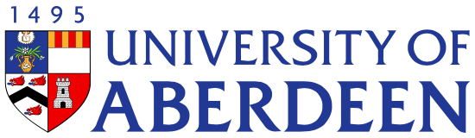

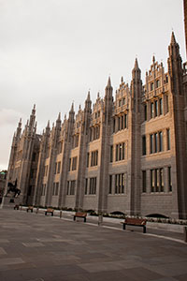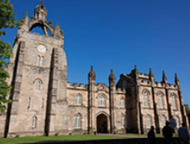

13 July 2019
The Boat Inn, Aboyne

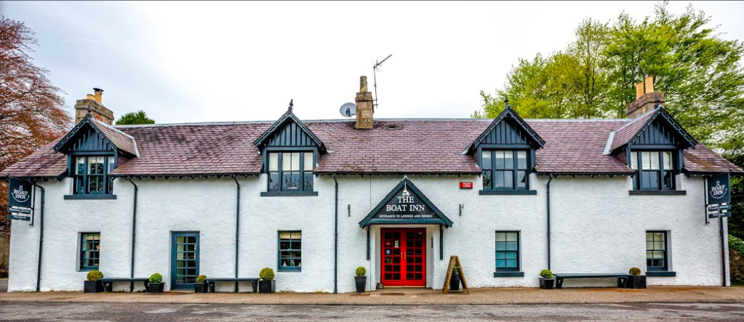


www.theboatinnaboyne.co.uk

Charleston Road, Aboyne, AB34 5EL,
Tel +44 (0) 1339 886137 E enquiries@theboatinnaboyne.co.uk

Programme

19:00 Drinks
19:45 Group photo
20:00 Supper
With Music from the 1970’s

- - -

Starters

Soup of the Day
with Granary Bread and butter
(V)(GF available)

Menzies Juniper Smoked Venison,
Apple and Celeriac Slaw (GF)

Vegan Mushroom and Roast Garlic Pate, Watercress Salad, Scottish Oatcakes

- - -
Wines
Chile Pinto De Vista, Sauvignon Blanc
Chile Punta De Vista, Merlot

- - -

Mains

Beef and Haggis Pie
with seasonal vegetables and herb mash

Breaded Fish and Chips
with either salad, mushy peas or garden peas

Boat Inn Chicken OR Vegetable Tikka Curry, Saffron and Cardamom Rice, Kachumber (GF)

Pan Fried Salmon,
Salsa Verdi and Citrus Bulgar

Lemon and Thyme Risotto,
Asparagus Spears, Preserved Lemon and Green Olive Salsa (GF, Ve available)

- - -
Deserts
Boat Inn Sticky Toffee Pudding
with Hot Fudge Sauce and Ice Cream

Vanilla Ice Cream and Hot Fudge Sauce
(GF available)

Chocolate and Bean Curd Mousse,
Pistachio and Raspberry (Ve) (GF)

After Dinner
Coffee or a dram

Heads & Tails
For the charity Prostate Cancer UK



Our thanks for this evening go to
- Lynn and the Chef’s Team at The Boat Inn

Special thanks go to
- Retired lecturers Bill Ashcroft, Clive Rice and Alan Crane
- Woody who travelled from Calgary, Canada
- David who travelled from Perth, Australia
- Neil who travelled from Nairobi, Kenya
- Gordon who travelled from Assen, The Netherlands
- Bruce and Alex who travelled from Stavanger, Norway
- Yourselves who have travelled from all parts of the UK

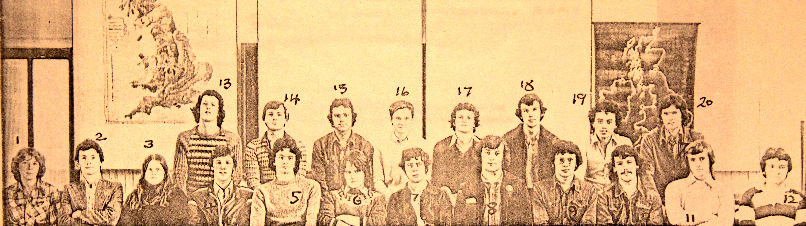
Year 3 Class photo 1977-78 ^{James Wood was absent}

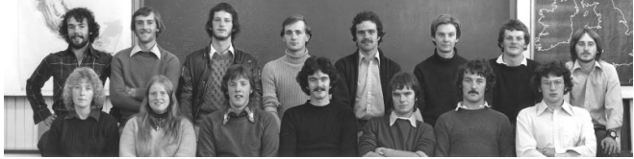
Year 4 Class photo 1978-79 Graeme Brown & John Wood were absent

