**IODP 370 T-Limits Post Cruise Meeting,**

**Field Trip, NW Highlands**

**4th to 7th June 2018**

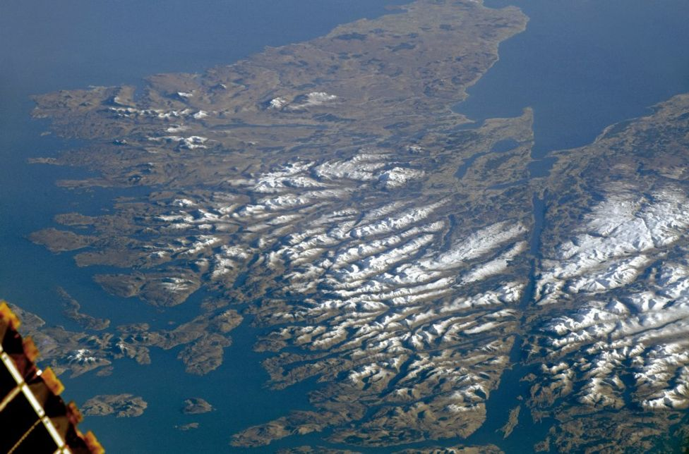

***Photo ISS-NASA***



|  |
| --- |
| Prepared and led by Stephen A. Bowden |
| Field leaders: Alison J. Wright – Highland Geological Society & Donald Stewart – Aberdeen Geological Society |
| Contributions from: Yazuru Yamamoto, Satoshi Toni, Man-Yin Tsang, Kiho Yang – core logging team during IODP 370 |
|  |



**A One Page Geology of the NW Highlands**

**Lewisian**

A long history of structure deformation, volcanic activity and metamorphism formed a crystalline basement of gneisses that date to 3.1 to 2.7 Ga. These are termed the Lewisian, after the Isle of Lewis. The gneisses vary in their extent of deformation, and evidence different periods of intrusion with basic Scourie dykes dated to about 2.3 Ga, and younger less deformed pegmatite dykes (granitic) dated to 1.7 Ga.

**Torridonian**

The Torridonian comprises three sedimentary successions with unconformities or time-gaps between each, and with marked unconformity on the Lewisian Basement beneath. The Torridonian itself Is divided into the Stoer Group, and then the Diabaig and Applecross formations. The Stoer Group itself is notably older 1.2-1.1 Ga than the rest of the Torridonian group ~0.8 Ga. The Torridonian Group is typically held to have been deposited as part of a continental succession – but geochemical evidence contrary to this emerges from time to time.

**Lower Palaeozoic**

The Lower Palaeozoic is marine in character and unconformably overlies both the Torridonian and the Lewisian. The lower-most unit is the basal quartzite (a simple white quartzite- with occasional stylolites) ~ 560 Ma in age. This passes up into the pipe rock (Cambrian in age). The pipe rock is also a quartzite, but has *Skolithus* burrows. These are vertical trace fossils 15-25 cm in length and 1.5 to 3 cm diameter. They give the pipe rock a speckled appearance. The two units are combined into the Eriboll formation.

Above the pipe rock is the fucoid beds. These are dolomitic siltstones. They have a wavy or mottled appearance, caused by the mixing of grey mud and orange dolomitic siltstones. This mottled colour is interpreted as *Cruziana* (burrows) and *Rusphycus* (resting) – trace fossils for arthropods (e.g. Trilobites). Above the fucoid beds are the *Salterella* grits. These are coarse-grained muddy sandstones, some units contain *Salterella* – a small helically coiled Gastropod.

Above the Salterella Grits is the Durness Limestone. The Durness Limestone is an informal name for lithologically varied unit that ranges from Cambrian to Ordovician. Parts of the Durness Limestone are heavily dolomitised, others contain chert-nodule horizons. The succession is part of a Laurentian carbonate sequence that spans the USA, Canada and Greenland. In these other places it ranges from Cambrian to Devonian in age. In Scotland these younger units are missing and the top of the succession is terminated by the Moine thrust.

**The Moine Thrust Zone and Moine Schists**

The Moine comprises metamorphosed Neoproterozoic sediments (psamites – metamorphosed sandstones) and covers most of the central highlands to the East of the Moine-thrust. Within the vicinity of the Moine Thrust distinct metamorphic fabrics are present. These include flaggy-cleavage or other lineations that give the impression of bedding, and also the formation of mylonites – fine grained, banded rocks with occasional porphyroclasts (clasts of Lewisian).

**Grenvillian Orogeny**: 1.2 – 0.9 Ga – Timewise, between Stoer and upper Torridonian groups.

**Caledonian Orogeny**: 490–390 Ma led to the development of the Moine Thrust and emplacement of the Moine-Schist over the younger Lower Palaeozoic.

|  |  |
| --- | --- |
|  |  |

Figure 1. Geological Map and Stratigraphic column taken from Goodenough and Krabbendam (2011)

**House Keeping and Other Information**

The trip runs from 4th to 7th June. During the trip you should be prepared for rain and wind, and wet and unstable ground. You should carry with you in a small backpack a spare jumper, a sunhat and sun cream, a windbreaker or other light water proof coat. Bring a little water and small amount of food. You will also want a small water proof bag in which to keep small electronic equipment. Your footwear needs to help you walk all day, help you walk safely on rock-outcrops and protect your feet. Most people will choose hiking boots. I would also suggest bringing with you a small flask for a hot drink,

The cost of your accommodation will be recovered using an on-line shop. When you pay we will also collect basic safety information from you. During the trip you will need cash to pay for afternoon and evening meals for 4 days.

The main part of the field trip occurs on two days. On Day 2, 5th June, we will look at Mesoproterozoic sediments and practice our logging skills. We will think about the evidence for, and habitat of the oldest known evidence of life in Northern Europe. On Day 3, 6th June we will look at field analogues for features we encountered during coring activities during IODP 370, as well as having a traverse (a mini bus equivalent of a transect) across the Moine Thrust and North West Highland Geology.

**Day 1 – Travel from Aberdeen**

**Collect from Hotel 0930**

Stone Circle – Group Photo

**1100-1130 Coffee and Light Snack**

**Mealfuarvonie – A hike with more light Snacking, views over Loch Ness**

**Tain by 1800.**

**Day 2 – Proterozoic Geobiology**

**Leave Tain Hotel at 0830**

**1000-1030 Contact between the Lewisian and Torridonian**

Aim: View contact between Lewisian and Torridonian

Locality: South of Clachtoll

At this locality we will view the contact between the Torridonian and the Lewisian. This includes the infiltration of mud into the fractured basement and the deposition of thick alluvial fans.

**1045-1200 Stromatolite Locality**

Aim: Log Stromatolite Occurrence at Clachtoll

Locality: Clachtoll

The stromatolites at Clachtoll are the oldest evidence of life currently known in Europe. At this locality we will log their occurrence and unravel aspects of their palaeoenvironment. We will also compare logs and think how uncertainty in logging manifests when logging core, rather than outcrops.

**1230-1330 Lunch in the Sun (pies collected)**

**1350-1420 Stacfadda**

Aim: View Scotland’s Impact Deposit

Locality: North of Stoer

The stromatolites at Clachtoll are the oldest evidence of life currently known in Europe. At this locality we will log their occurrence and unravel aspects of their palaeoenvironment. We will also compare logs and think how uncertainty in logging manifests when logging core, rather than outcrops.

**1440-1540 Chilled Drive to Achiltube**

**1545-1645** Badenscallie, Achiltube

Aim: View the Precambrian Lake Sediments of the Diabaig

Locality: Badenscallie

The Stac Fada formation was for a long time interpreted as a volcanic formation. However, it has recently been reinterpreted as an impact deposit.

**1700-1715 STEL-Locality**

Aim: View cataclastites

Locality: Achiltibue

Cataclastite seems in the early evening.

**1900 – Arrive Back at Tain**

**Background – Stoer Group**

|  |  |
| --- | --- |
|  |  |
| Figure 2. Stratigraphic log taken from Goodenough and Krabbendam (2011) and sketch of fan facies environments from Stewart 2002. (TAT is the Clachtoll formation, TAS the Stoer Bay formation) |

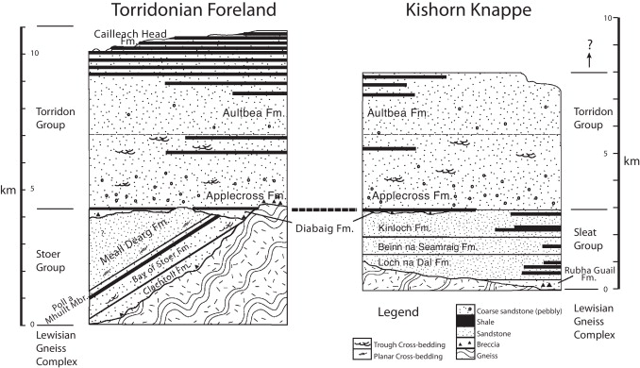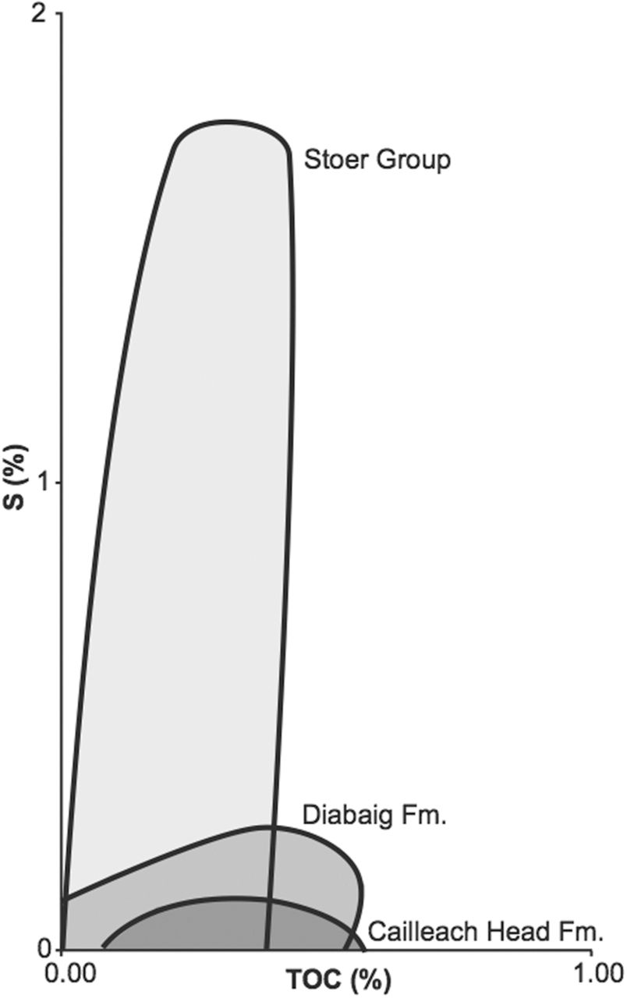

Figure 3. Taken from Wacey et al., 2015. Shown are mudstones and their organic carbon contents within the Torridonian. The diabaig is less sulphidic than the Stoer Group.

|  |  |
| --- | --- |
| Chromium Anomally | Quartz with intersecting planar deformation fabrics |
| Shatter cones – this one from Kentland Indian Photo from Ernston & Claudin | Kinked Biotites |
| Figure 4. Evidence for impact deposit Amor et al 2008. Chromium, High pressure quartz phases and planar deformation fabrics and shatter cones are normally taken as evidence of hyper velocity impact. In the case of the Stac Fada only two of the three are present. Look out for the third. | |

**Day 3 The Moine Thrust**

Day 3 (Leave Tain Hotel at 0830)

**1000-1100 Knockan Crag**

Aim: View the Moine Thrust

Locailty: Knockan Crag Geopark Visitor Centre

One of the best outcrops of the Moine Thrust can be found at the Knockan Crag Visitor Centre. The Centre also contains an exhibit and provides a walkthrough of the main stratigraphic units of the NW highlands.

**1120-1130 Duplex formation, a little intrusion, some Glaciology and core geology**

Aim: View detachment and Imbrication

Locality: Assynt

Detachment surfaces are important geological boundaries that separate different style of deformation. As with the previous days stop think about how this feature would be recognized in core. Perhaps sketch the view, then sketch only a thin part of it? What would you log to know if you had drilled through such a feature? Perhaps compare you sketches to the IODP 370 decollement zone?

**1150-1250 Assynt triple unconformity and the pipe rock and fuccoid beds**

Aim: View the Triple Unconformity and pipe rock.

Locailty: Assynt

This locality has roadside outcrops of quartzite and fuccoid bed. Compare the ichnofabrics and burrows of the two units. How do you think the depositional environments would have varied? The Pipe Rock contains *Skolithos,* the Fuccoid beds a mixture of *Cruziana* (burrows) and *Rusphycus* (resting).

Don’t spend too long at the outcrop, the main thing to see here is the triple unconformity, and away to south the Moine riding over the top of the less metamorphosed Palaeozoic units beneath.

You probably want to sketch this also.

**1320-1345 Glencoul**

Aim: View the Glencoul Thrust and site C0023 in Context

Locailty: Assynt

The Glencoul thrust can be seen. Work out or read on the sign and decide what the units involved are. If you sketch it, you could add for scale a thin pipe, and a flying boat or spaceship 5.3 km above your diagram. For scale, from top to bottom is about 900 m.

**1400-1500 Lunch Kylesku**

**1530-1550 Laxford Brae**

Aim: Unravel the Lewisian

Locailty: Laxford Brae

This road cut provides an excellent opportunity to unravel the Lewisian. Don’t read the sign, look and sketch for yourselves which units came first?

**1600-1730 Durness**

Aim: View an interesting section of the Durness and the Moine

Locailty: Balnakiel Bay

Outcrops of Stromatolite-bearing Durness Formation and other microbially-mediated sediments are present at this locality. Stratigraphically the Balnakiel formation is Ordovician in age, and young for the Durness Formation in Scotland.

On the far north of the bay is an outcrop of Moine schist with well-developed axial planar cleavage, and steeply plunging fabrics that give a strong impression of a bedding direction that isn’t there.

**1930 Arrive Back in Tain**

**Day 4 – Journey Back**

**To be confirmed**

**Inverness**

**AberdeenBackground**

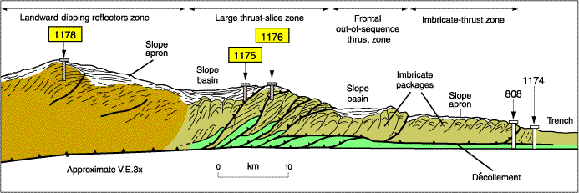

Moore et al 2001

|  |  |
| --- | --- |
| http://publications.iodp.org/proceedings/370/103/figures/370_103_F18.png  Heuer et al 2017 | File:P667674.jpg  BGS photograph P667674, © NERC |

Figure 6. Cross section of the Nankai accreationary complex. Sketch the imbrications, then choosing a representative portion think how such a structure could be identified using bedding and core alone? What Magic skills did Yuzuru and the other loggers use to find the detachment surfaces? What complicates the data used?

Log Sheets For Stoer

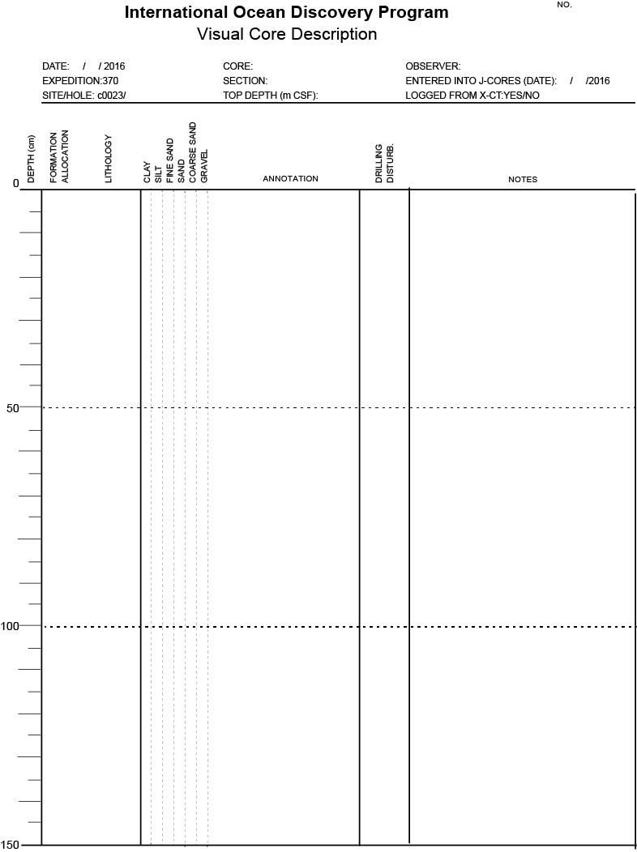



Log Sheets For Badenscallie





Knockan Crag

|  |  |
| --- | --- |
| Sketch in Section | Recognition Criteria |
|  | •  •  • |
|  | •  •  • |
|  | •  •  • |
|  | •  •  • |

Assynt-Roadside, Imbrication and Interpreting detachments in core

|  |  |
| --- | --- |
|  |  |
|  | log |
|  | dip |
|  | structure |

**Lewisian – cross cutting relationships**

Compare the cross cutting relationships at Laxford Brae and on the North Coast .

|  |  |
| --- | --- |
|  | Lewisian at Laxford Brae |
|  | Lewisian- Boudinage |

**References and Additional Reading**

Amor, K., Hesselbo, S.P., Porcelli, D. , Thacker S., Parnell J. (2008). A Precambrian proximal ejecta blanket from Scotland. Geology, 36 (4).

Goodenough K. and Krabbendam M. (2011) NMSE - Publishing Ltd (15 May 2011) A Geological Excursion Guide to the North-West Highlands of Scotland

Heuer, V.B., Inagaki, F., Morono, Y., Kubo, Y., Maeda, L., and the Expedition 370 Scientists, 2017. Temperature Limit of the Deep Biosphere off Muroto. Proceedings of the International Ocean Discovery Program, 370: College Station, TX (International Ocean Discovery Program). https://doi.org/10.14379/iodp.proc.370.2017

Moore, G.F., Taira, A., Klaus, A., et al., 2001. *Proc. ODP, Init. Repts.,* 190: College Station, TX (Ocean Drilling Program). doi:10.2973/odp.proc.ir.190.2001

Prave, A.R. 2002. Life on land in the Proterozoic: evidence from the Torridonian rocks of northwest Scotland. Geology, 40, 811-814.

Stewart, A.D., 2002, The later Proterozoic Torridonian rocks of Scotland: their sedimentology, Geochemistry and Origin. Memoir (Geological Society of London), No. 24, p. 5 –21.

Trewin, NH (ed) 2002. *The Geology of Scotland*, (4th edn) The Geological Society, London.