Giving feedback is important in 2 ways:

First, it creates a learning process, for both the giver and the receiver. For both of you (the giver and receiver of feedback) it means a more active engagement with the learning process. Your learning is no longer happening in private, but ‘out in the open’. Expressing your views out loud is a powerful check to see how well you understand something. The giver of feedback becomes more familiar with marking criteria, and they develop their powers of (self)judgement. When you are able to judge other people’s work, you will also be able to apply it to your own work. The receiver of feedback becomes encouraged to reflect on their own work. (for this encouragement to happen, it is crucial to give constructive, helpful feedback)

Second, ‘giving feedback’ is a model of how science progresses. We do not know what is the true state of the world, there is no objective benchmark against which to judge our research results (if we did, we wouldn’t have to do research) and so the only way to do research and get results that we can trust, is through scrutinizing each other’s work. When you submit an article to a scientific journal, it’s other people who scrutinize it, and (if they’re nice people!) will give you advice on how to improve it, if that needs to be done. By being critical of our own and other people’s work, we can ensure that the high standards of scientific progress are met.

There are different types of feedback:

- Diagnostic/summative (learner is explained why they were given a certain grade)
- Feedforward/formative (learner can understand what to improve next time)

In the peer feedback task this week you will be doing ‘feedforward’. This task has 2 purposes.

Help the other person learn. You can do this by:

- being kind, aiming critique at the draft, not the person
- being specific, talking in concrete terms and avoiding general statements
- being constructive, focusing on improvement, rather than pointing out the ‘bad’
- focusing on explaining why something is good or not so good
- referring to the marking criteria

The other purpose is that you yourself learn from giving feedback, so:

- Compare your work to theirs; did they interpret the marking criteria differently?
- Try to see your own work in a different light, more ‘objectively’, as if someone else wrote it
- If the other person did something better, try to achieve the same (ask them how they did it)
- Check if the other person finds it easy or hard to understand your feedback. The clearer you are, the better you will be able to judge your own work, too.

Examples of good feed-forward
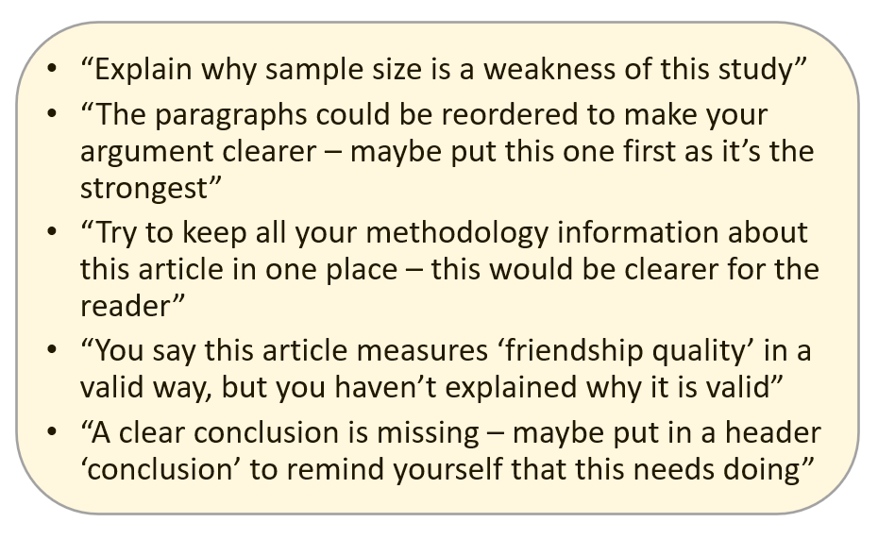

Examples of poor feed-forward

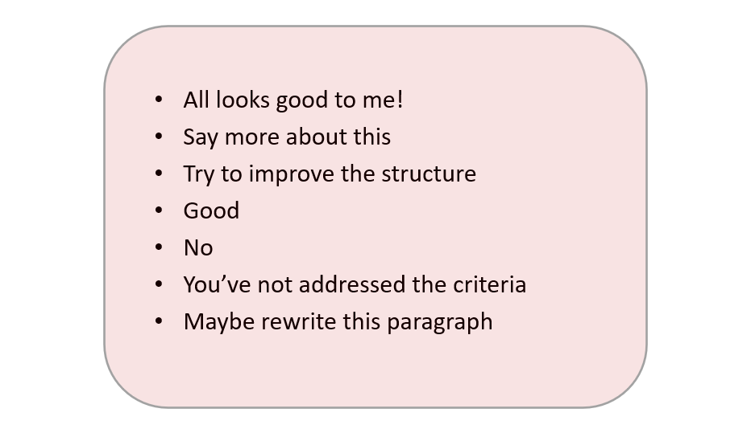

To do

Go to this week’s folder, where you will find a list with pairings – find the person you have been paired with for this task. You need to send your Critical Review draft to them, and they need to send you yours. In this week’s folder you will also find a Feedback Form. This is the one you need to complete and send to your peer after you have read their draft. Do ask if your peer has any questions about your feedback and respond to them if they do.

To do

Send the Feedback Form you receive from your peer, to your tutor. You have until the end of this week to complete this task.

