**What is a Bupa Wellbeing health expenses?**

Bupa wellbeing health expenses offers money back towards your everyday healthcare costs such as dental treatment, eye tests, private consultations and prescriptions.

**How does it work?**

You choose where you want to receive your treatment. You pay upfront and then claim the cash back to help cover the cost up to your annual benefit limits.

**What are my annual benefit limits?**

Please refer to the below table – Level 1 Benefits

|  |  |
| --- | --- |
| **Treatment** | **Annual benefit limit – *up to*** |
| Access to Bupa online health assessment tool – Positive Health | Included |
| A health assessment | £100 |
| Dental | £60 |
| Dental injury | £200 |
| Optical | £60 |
| Treatments (physiotherapy, osteopathy, chiropractic, chiropody, acupuncture) | £150 |
| Prescriptions | £25 |
| Consultation and diagnostics | £200 |
| Hospital (in-patient, day-surgery) | £20 per night for 20 days/nights |

**Are dependents included in the plan?**

This plan will cover up to 4 of your children FREE of charge up to the age of 21. Each child has their own separate annual benefit limit as shown above.

**How do I claim the cash back?**

To make a claim, you must use the claim form provided by BUPA. If you don’t have a claim form, you can call BUPA on 0845 606 6003. You will need to provide the fully competed form and original receipt(s) as soon as you have used your service/received treatment, you can email these over to Bupa. In any event, your claim will need to be submitted to BUPA within 90 days unless it was not reasonably possible to do so.

**Is there a cost associated with this scheme?**

A Company funded medical plan is a benefit in kind, so you are required to pay tax on this benefit as below:

Basic rate tax payer £10.40 per annum (approx 87p per month)

Higher rate tax payer £20.80 per annum (approx £1.73 per month)

**Are there any additional benefits of this plan?**

This plan also comes with the following benefits:

* Health line – speak directly to a qualified nurse by calling this confidential 24/7 phone service
* Employee Assistance Programme – telephone counselling covering bereavement, stress, anxiety, depression, emotional problems, legal advice etc. Six face to face counselling sessions where required.
* Access to BUPA member offers including discounts at retailers, days out, entertainment etc.

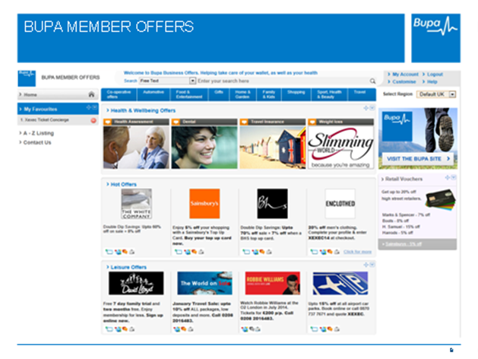

* Access to Bupa mobile apps re Fitness, Running and internet links to access Bupa’s extensive information and expertise on Health and Wellbeing