Annual Teaching Fellows' Event 2015
Work-Related Learning

Thursday 3rd December 14:00-16:30
Sir Duncan Rice Library, Craig Suite, Level VII
13:45 – 14:00 | Registration & Refreshments
14:00 – 14:10 | Welcome & Introduction  Professor Peter McGeorge, Vice-Principal (Learning & Teaching)
14:10 – 15:00 | Keynote Presentation: Work-related learning – a matter of principle (s)?  Sabine McKinnon, Senior Lecturer in Academic Development  This presentation explores how work-related learning can be defined and how it can be embedded in the taught curriculum. It presents some of the outcomes of the Real WoRLD project, a strategic initiative at Glasgow Caledonian University which has attracted considerable interest in the UK higher education sector. The presentation will focus on a set of five ‘principles of work-related learning’ which were designed to provide academic staff with a benchmark for good practice. Based on contemporary theories of learning and pedagogic research they emphasise that work-related learning does not jeopardise the quality of the teaching in an academic discipline but enhances it to help students reflect on their learning in the university and beyond.  Keynote Speaker Information:  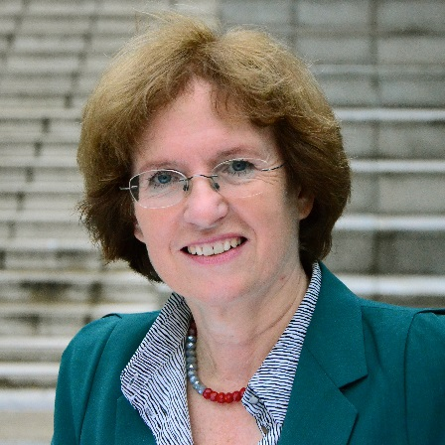  Sabine McKinnon, MA, SFHEA, Senior Lecturer in Academic Development, Centre for Learning Enhancement and Academic Development, Glasgow Caledonian University  At Glasgow Caledonian University Sabine has been responsible for major strategic change initiatives such as the Real WoRLD Project which was set up to advise academic staff on embedding work-related learning in the curriculum. Her work has been published in conference and journal papers, book chapters and reports. A graduate of the University of Hamburg Sabine’s background is in modern languages. She has taught at different universities in England and Scotland. Sabine is also a Senior Fellow of the Higher Education Academy.
15:00 – 15:30 | Poster Presentations: Tea/Coffee & Cake
15:30 – 16:30 | Swap Shop Sessions - Parallel Oral Presentations (Overleaf)
Group A (Room 224, 2nd Floor, The Library)  Facilitated by Dr Stuart Durkin, Teaching Fellow, School of Social Science | Inspiring and Measuring Professionalism in Medical Students  Professor Rona Patey, Director of Teaching & Dr Fiona Parker, Communication Skills Lead, School of Medicine, Medical Sciences and Nutrition  There is increasing attention on initiatives to support the development of professional values and assessment of professional behaviour during the undergraduate years in medicine. This is expressed both at medical school level and in high level curriculum policy documents¹. Whilst it appears to be commonly agreed that professionalism should be a core part of the medical undergraduate curriculum, how we achieve this successfully is a matter of ongoing debate and investigation². The presentation will outline some current approaches to the teaching and assessment of professionalism in medical schools in this contested area.  References  1. Medical students: professional values and fitness to practise’ GMC and Medical Schools Council 2009. Downloadable at http://www.gmc-uk.org/education/undergraduate/professional_behaviour.asp).  2. Teaching Professionalism in medical education: A best evidence in medical education (BEME) systematic review. Downloadable at http://www.bemecollaboration.org/Published+Reviews/TeachingProfessionalism/).  Entrepreneurial Education – How to be Disruptive!  Dr Ian Heywood, Senior Teaching Fellow, Business School  One of the biggest challenges I have found in teaching entrepreneurial concepts lies in encouraging learners to shift their mindset (a way they research and develop new business opportunities). All too often, learners seek to develop their ideas for new ventures around incremental changes to existing business propositions. What I needed to do was find a way to get them to think much more ‘disruptively’. In this workshop I will share with colleagues the approach I have adopted to help my learners challenge the ‘status quo’. In the session I will also share how being part of a European Project - www.coneeect.eu has helped me develop my own approach to designing learning and teaching interventions.
Group B (Meeting Room 2, 7th Floor, The Library)  Facilitated by Lindsay Tibbetts, Senior Teaching Fellow, Business School | A ‘Barista’ Approach to Developing Graduate Employability  Kenny McIntosh, Lecturer, School of Education  The Learning from Work (ED1521) course is open to Year 1 and 2 students across the University and seeks to develop University of Aberdeen Graduate Attributes while addressing the range of skills, qualities and dispositions employers require of graduates. In this presentation, definitions of ‘barista’ will be drawn from popular culture and used to outline, illustrate and critically discuss some of the aims, principles, activities and outcomes of the Learning from Work course.  Making the Implicit Explicit: Working-Related Learning in the Academic Curriculum  Dr Bruce Scharlau, Senior Teaching Fellow, School of Natural & Computing Sciences  Work-related-learning helps students understand how their studies apply to their future career. Therefore we can all include aspects of this in our teaching. WRL is not just about placements, it is also about coursework that you assign, the topics discussed in tutorials and offering authentic assessments. Come along and find out how you too can bring work-related-learning into your classroom.

