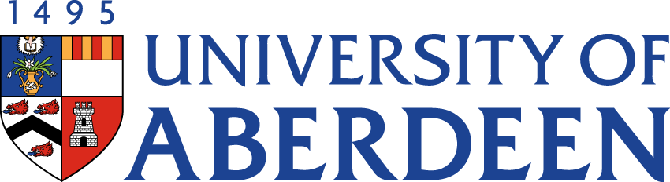

There will be a meeting of the SUSTAINABLE DEVELOPMENT COMMITTEE on TUESDAY 30 MAY MARCH 2023 at 10.35am – 12.25pm via Microsoft Teams.
Heather Crabb
Senior Vice-Principal’s Office
Tel: 01224 272404
Email: h.crabb@abdn.ac.uk
BUSINESS
DECLARATION OF INTEREST:
Any member or individual in attendance (including officers) who has a clear interest in a matter on the agenda must declare that interest at the meeting. Items for information will not normally be considered.

FOR DISCUSSION

- MINUTES
Minutes of the Sustainable Development Committee meeting held on 9 March 2022
(enclosed)
- MATTERS ARISING
  - Table of Actions SDC22:83

- SUSTAINABILITY RISK REGISTER SDC22:84

LIVING & WORKING SUSTAINABLY

- UPDATE FROM AUSA SDC22:85

- SUSTAINABLE DEVELOPMENT GOALS UPDATE

- CLIMATE & SUSTAINABILITY ASSEMBLY (Strategic discussion Topic) SDC22:86

- EAST GRAMPIAN COASTAL PARTNERSHIP: VOLUNTEERING & FUNDING SDC22:87

- CAMPUS ENERGY/HEATING UPDATE SDC22:88

NET ZERO

- NET ZERO UPDATE SDC22:89

RESEARCH

- UPDATE FROM INTERDISICPLINARY CENTRES SDC22:90

- DATE OF NEXT MEETING
The next meeting of the Sustainable Development Committee will be held on Tuesday 22 August 2023 at 10.35am via Microsoft Teams.

