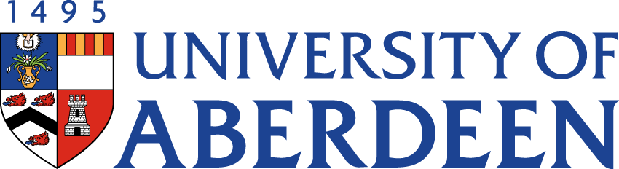

There will be a meeting of the SUSTAINABLE DEVELOPMENT COMMITTEE on WEDNESDAY 25 MAY 2022 at 10.35pm – 12.25pm via Microsoft Teams.
Heather Crabb
Senior Vice-Principal’s Office
Tel: 01224 272404
Email: h.crabb@abdn.ac.uk
BUSINESS
DECLARATION OF INTEREST:
Any member or individual in attendance (including officers) who has a clear interest in a matter on the agenda must declare that interest at the meeting. Items for information will not normally be considered.

FOR DISCUSSION

- MINUTES
Minutes of the Sustainable Development Committee meeting held on 16 February 2022
(enclosed)
- MATTERS ARISING
2.1 Table of Actions SDC22:35
2.2 Update on Sustainability Structures

- SUSTAINABILITY RISK REGISTER SDC22:36

- EMBEDDING SUSTAINABILITY RESPONSIBILITIES SDC22:37
4.1 Update from Fiona Smith, HR Manager (Partnerships)

- UPDATE FROM AUSA SDC22:38

- CENTRE FOR ENERGY TRANSITION UPDATE SDC22:39

- CENTRE FOR ENVIRONMENT & BIODIVERSITY UPDATE SDC22:40

- REPORT FROM SUSTAINABLE BUSINESS TRAVEL WORKING GROUP
  - Update from Gary Macfarlane, Working Group Chair (joining at 11.30am) SDC22:41

- SUSTAINABLE DEVELOPMENT GOALS UPDATE
  - THE Impact Rankings Update SDC22:42
  - SDG Accord Update

- CAMPUS ENERGY/HEATING UPDATE
  - Energy Usage and Existing Heating Infrastructure (Presentation from Tristan Wolfe, Energy Manager)
  - Sustainable Heating Strategy Update

- SUSTAINABILITY OPEN SESSION UPDATE
11.1 Participant Questions SDC22:43

- PUBLIC BODIES’ LEADERSHIP ON THE GLOBAL CLIMATE EMERGENCY SDC22:44

- GREEN GOWN AWARDS

FOR INFORMATION

- QUEEN’S PLATINUM JUBILEE CHALLENGE SDC22:45

- DATE OF NEXT MEETING
The next meeting of the Sustainable Development Committee will be held on Wednesday 24 August 2022 at 10.35am – 12.25pm via Microsoft Teams.

