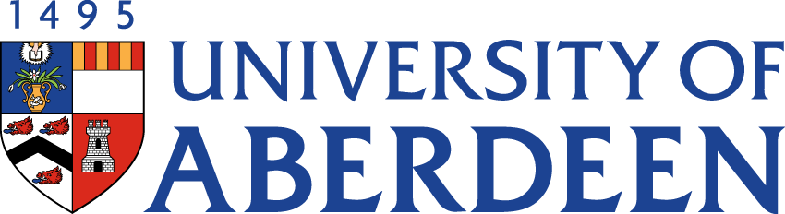

There will be a meeting of the SUSTAINABLE DEVELOPMENT COMMITTEE on WEDNESDAY 16 FEBRUARY 2022 at 1.35pm – 3.25pm via Microsoft Teams.
Heather Crabb
Senior Vice-Principal’s Office
Tel: 01224 272404
Email: h.crabb@abdn.ac.uk
BUSINESS
DECLARATION OF INTEREST:
Any member or individual in attendance (including officers) who has a clear interest in a matter on the agenda must declare that interest at the meeting. Items for information will not normally be considered.

FOR DISCUSSION

- MINUTES
Minutes of the Sustainable Development Committee meeting held on 10 November 2021
(enclosed)
- MATTERS ARISING
2.1 Table of Actions SDC22:23
2.2 Sustainability Structures & Support: Dean for Environmental Sustainability SDC22:24

- UPDATE FROM SUSTAINABLE BUSINESS TRAVEL WORKING GROUP
  - Update from Gary Macfarlane, Working Group Chair SDC22:25

- COP26 OUTCOMES SDC22:26 (Angela Michael and Ana Payo-Payo will be in attendance for this item)

- EMBEDDING SUSTAINABILITY RESPONSIBILITIES
  - Update from Tracey White, Head of HR SDC22:27

- ABERDEEN 2040 IMPLEMENTATION
  - Aberdeen 2040 Implementation Plan SDC22:28
  - Education Update from Ruth Taylor, Vice-Principal (Education) SDC22:29

- SUSTAINABILITY RISK REGISTER SDC22:30

- ACTIVE TRAVEL PLEDGE SDC22:31

- CLIMATE ASSEMBLY

- SUSTAINABLE DEVELOPMENT GOALS UPDATE

- UPDATE FROM AUSA SDC22:32

- CENTRE FOR ENERGY TRANSITION UPDATE SDC22:33

- CENTRE FOR ENVIRONMENT & BIODIVERSITY UPDATE SDC22:34

FOR INFORMATION

- DATE OF NEXT MEETING
The next meeting of the Sustainable Development Committee will be held on Wednesday 25 May 2022 at 10.35am – 12.25pm via Microsoft Teams.

