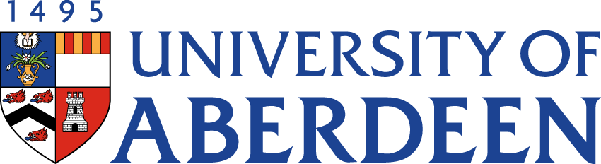

There will be a meeting of the SUSTAINABLE DEVELOPMENT COMMITTEE on TUESDAY 15 NOVEMBER 2022 at 10.35am – 12.25pm via Microsoft Teams.
Heather Crabb
Senior Vice-Principal’s Office
Tel: 01224 272404
Email: h.crabb@abdn.ac.uk
BUSINESS
DECLARATION OF INTEREST:
Any member or individual in attendance (including officers) who has a clear interest in a matter on the agenda must declare that interest at the meeting. Items for information will not normally be considered.

FOR DISCUSSION

- MINUTES
Minutes of the Sustainable Development Committee meeting held on 24 August 2022
(enclosed)
- MATTERS ARISING
  - Table of Actions SDC22:55a
  - School Level Energy Data & Carbon Footprint Reporting SDC22:55b

- REVISED TERMS OF REFERENCE SDC22:56

- SUSTAINABILITY RISK REGISTER SDC22:57

LIVING & WORKING SUSTAINABLY

- UPDATE FROM THE DEAN FOR ENVIRONMENTAL SUSTAINABILITY SDC22:58

- SUSTAINABLE DEVELOPMENT GOALS UPDATE
  - Times Higher Education Impact Rankings 2023 Oral Report
  - QS World University Rankings: Sustainability 2023 SDC22:59
  - Sustainable Development Goals Report 2022 Available on Teams Site

- ABERDEEN CITY COUNCIL BIG ISSUE BIKES SCHEME SDC22:68

EDUCATION
- UPDATE FROM AUSA SDC22:60

- UPDATE FROM VICE-PRINCIPAL (EDUCATION) Oral Report

RESEARCH

- UPDATE FROM INTERDISICPLINARY CENTRES SDC22:61

NET ZERO

- NET ZERO UPDATE
11.1 Net Zero Update SDC22:62
11.2 Indicative Net Zero Strategy SDC22:63
11.3 Initial Net Zero Projects SDC22:64
11.4 Draft Public Bodies Climate Change Duty Report 2021/22 SDC22:65

- CLIMATE ASSEMBLY UPDATE SDC22:66
FOR INFORMATION

- CAMPUS ENERGY/HEATING UPDATE
  - Update from Sustainable Heating Programme Board SDC22:67

- DATE OF NEXT MEETING
The next meeting of the Sustainable Development Committee will be held on Tuesday 21 February 2023 at 10.35am via Microsoft Teams.

