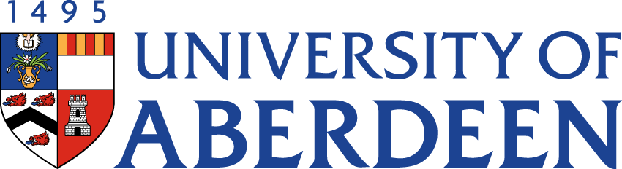

There will be a meeting of the SUSTAINABLE DEVELOPMENT COMMITTEE on MONDAY 13 NOVEMBER 2023 at 1.30pm – 2.55pm via Microsoft Teams.
Heather Crabb
Senior Vice-Principal’s Office
Tel: 01224 272404
Email: h.crabb@abdn.ac.uk
BUSINESS
DECLARATION OF INTEREST:
Any member or individual in attendance (including officers) who has a clear interest in a matter on the agenda must declare that interest at the meeting. Items for information will not normally be considered.

FOR DISCUSSION

- MINUTES
Minutes of the Sustainable Development Committee meeting held on 30 August 2023
(enclosed)
- MATTERS ARISING
  - Table of Actions SDC20231113.2

- SCHEDULE OF BUSINESS SESSION 2023/24
  - Identifying Future Strategic Discussion Topics SDC20231113.3

- SUSTAINABILITY RISK REGISTER SDC20231113.4

LIVING & WORKING SUSTAINABLY

- REVIEW OF GUIDING PRINCIPLES OF SUSTAINABLE BUSINESS TRAVEL SDC20231113.5

- UPDATE FROM DEAN FOR ENVIRONMENTAL SUSTAINABILITY
  - Update on Activities (Oral update)

- SUSTAINABLE DEVELOPMENT GOALS UPDATE
  - THE Impact Rankings 2024 Submission (Oral update)
  - Annual Sustainable Development Goals Report SDC20231113.7.2

- HESPA REPORT INTEGRATING CLIMATE INTO STRATEGY & PLANNING SDC20231113.8

NET ZERO

- NET ZERO UPDATE SDC20231113.9

- PUBLIC BODIES CLIMATE CHANGE DUTIES SUBMISSION 2022/23 SDC20231113.10

EDUCATION

- ORAL UPDATE FROM DEAN (EDUCATION)

- UPDATE FROM AUSA SDC20231113.12

RESEARCH

- UPDATE FROM INTERDISICPLINARY CENTRES SDC20231113.13

STRATEGIC DISCUSSION TOPIC

- RE-IMAGINING OUR CAMPUSES PROJECT (Pete Edwards Presentation)

- DATE OF NEXT MEETING
The next meeting of the Sustainable Development Committee will be held on Tuesday 20 February 2024 at 10.05am via Microsoft Teams.

