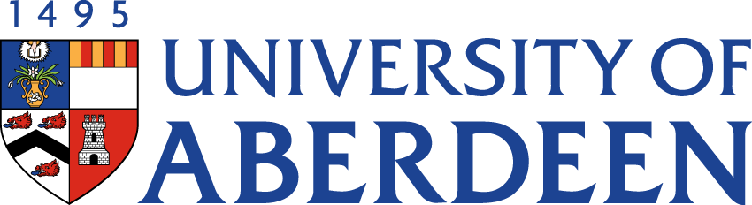

There will be a meeting of the SUSTAINABLE DEVELOPMENT COMMITTEE on WEDNESDAY 10 NOVEMBER 2021 at 1.35pm – 3.25pm via Microsoft Teams.
Heather Crabb
Senior Vice-Principal’s Office
Tel: 01224 272404
Email: h.crabb@abdn.ac.uk
BUSINESS
DECLARATION OF INTEREST:
Any member or individual in attendance (including officers) who has a clear interest in a matter on the agenda must declare that interest at the meeting. Items for information will not normally be considered.

FOR DISCUSSION

- MINUTES
Minutes of the Sustainability Steering Group meeting held on 25 August 2021
(enclosed)
- MATTERS ARISING
2.1 Table of Actions SDC22:12

- SUSTAINABLE BUSINESS TRAVEL WORKING GROUP UDPATE
To Note: Gary Macfarlane in attendance for this item SDC22:13

- SUSTAINABILITY RISK REGISTER SDC22:14

- ABERDEEN 2040 IMPLEMENTATION PLAN
5.1 Update on Sustainability Commitments

- UPDATE FROM AUSA

- SUSTAINABLE DEVELOPMENT GOALS AND THE IMPACT RANKING UPDATE SDC22:15

- CLIMATE UPDATE
  - Draft Public Bodies Climate Change Duty Submission 2021 SDC22:16
  - UUK Publication: Confronting the Climate Emergency SDC22:17

- SUSTAINABILITY STRUCTURES AND SUPPORT SDC22:18

- SUSTAINABILITY INVESTMENT IDEAS SDC22:19

- SUSTAINABLE HEATING STRATEGY
11.1 Project Board Terms of Reference SDC22:20

- UN GLOBAL COMPACT SDC22:21

- CENTRE FOR ENVIRONMENT & BIODIVERSITY UPDATE SDC22:22

FOR INFORMATION

- DATE OF NEXT MEETING
The next meeting of the Sustainability Steering Group will be held on Wednesday 16 February 2022 at 10.35am – 12.25pm via Microsoft Teams.

