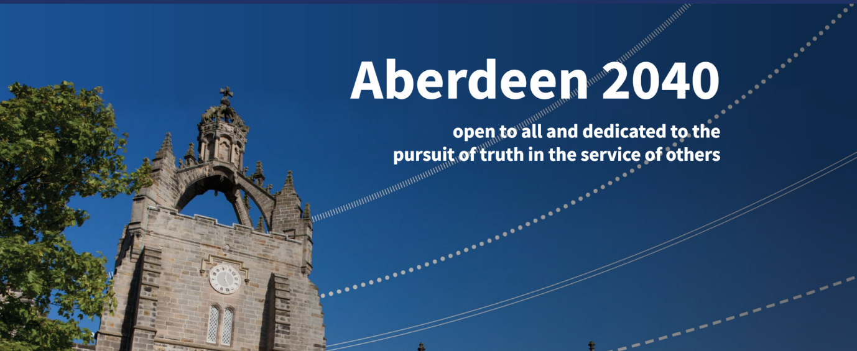
Race Equality Charter
Staff and Student Surveys 2022

Results of the 2022 Race Equality Charter staff and student surveys carried out by the University of Aberdeen to explore whether racial inequalities exist in its policies and procedures

Contents
- Acknowledgements....................................................................................... 3
- Foreword by Principal and Vice-Chancellor.................................................4
- Support............................................................................................................ 5
- Introduction.................................................................................................... 6
- Presentation of Results and Terminology.....................................................9
- Executive Summary......................................................................................10
- Demographics of respondents.....................................................................14
- Race Equality Charter Survey: Staff Responses.........................................21
- Race Equality Charter Survey: Student Responses...................................69
- Conclusion.................................................................................................. 119
- Appendix 1...................................................................................................120
- Appendix 2...................................................................................................122

Acknowledgements
The Race Equality Charter staff and student surveys were carried out by the University of Aberdeen with the aim of assessing the culture of the Institution and to explore whether racial inequalities exist in our policies and procedures.
The University is grateful to all staff and students who completed the surveys and provided insights and suggestions, and to our intern student who contributed to the analysis of the open comments.
The University is also grateful to Advance HE for providing the templates used in these surveys, independent specialists Peachy Mondays for their administrative support and the University Race Equality Strategy Group, co-chaired by Ruth Taylor (Vice-Principal Education) and Siladitya Bhattacharya (Head of the School of Medicine, Medical Sciences and Nutrition) for their support and input while we continue with our antiracism journey.

Information about our antiracism work, race equality groups, and resources can be found on our Race Equality webpages.

Queries about this report can be e-mailed to:
recsurvey@abdn.ac.uk

Foreword by Principal and Vice-Principal

We are pleased to share with you the results of the University’s Race Equality Charter staff and student surveys 2022.

We would like to thank all staff and students who responded to the survey and provided feedback. We recognise that the results of the surveys indicate that racism is experienced by our staff and students and we are determined that we take the appropriate steps to recognise, address and eradicate it.

The surveys are critical to enhancing our understanding of racism - we recognise that racism exists on our campuses and in society. The tragic killing of George Floyd in Minneapolis in 2020 and the Black Lives Matter movement have further highlighted the endemic racism in society and motivated us to accelerate our work on race equality by listening to, and learning from, our valued diverse community.

We encourage conversations on race and racism and these surveys offered a further opportunity for staff and students to share their experiences and ideas. This will support the University as we continue to understand and address the barriers faced by our staff and students from racialised groups and work collaboratively with our community to develop strategies which will result in action against racism.

As a University we are taking action to be open, diverse and inclusive, to create a culture where all our staff and students feel welcome and safe irrespective of their race or ethnic group. Over the last two years we have been building on our antiracism work. Examples of action taken include:
- Firmly embedding Inclusion as a core strategic theme through Aberdeen 2040
- Launched a bold Antiracism Strategy which is informed by our institutional data and feedback from staff and students and external partners
- Established a Race Equality Strategy Group to oversee and drive change
- Delivered race literacy training for staff, senior management and Court members, and launched online training materials
- Appointed Race Equality Champions in Schools and Directorates
- Signed up to the Advance HE Race Equality Charter
- Signed up to the Joint Commitment between the Scottish Government and public sector leaders which commits us to taking forward the recommendations of the Scottish Parliament’s Equalities and Human Right Committee
- Adopted the Jerusalem Declaration on Antisemitism (JDA)
- Signed up to the Advance HE Declaration on Race

We know that there is still much to be done and this includes ensuring our curriculum is fully inclusive and contributing to tackling the national awarding gap linked to race and ethnicity.

The Race Equality Charter staff and student surveys have been invaluable in providing further insights which will support our work in this area.

Racism has no place in our University and we will continue to take action to prevent and tackle it.

Professor George Boyne Professor Ruth Taylor
Principal and Vice-Chancellor Vice-Principal, Education

Support

We understand that the results of the surveys reported in this report may be triggering or upsetting. We are here to listen and to support you.

You can seek support from the following:
- Human Resources Team hr@abdn.ac.uk
- University Counselling Service counselling@abdn.ac.uk
- University’s Race Equality Network for staff and Postgraduate Researchers racenetwork@abdn.ac.uk
- Employee Assistance Programme-Care First (detail can be found here)
- AUSA Advice team ausaadvice@abdn.ac.uk
- AUSA Black and Minority Ethnic Students Forum either at ausapresident@abdn.ac.uk or bme-forum@abdn.ac.uk

Further information can be found on our Race Equality – Support website here.

If you have any points you wish to raise or suggestions, please email:

recsurvey@abdn.ac.uk

4. Introduction

4.1 Background
The University of Aberdeen is committed to addressing racial inequalities, and creating environments where individuals and communities thrive, irrespective of race or ethnicity. Our vision, aligned with our Strategic Plan Aberdeen 2040 is to become an antiracist University.

In February 2022, we launched our first University Race Equality Charter staff and student surveys to assess the culture of our institution and explore whether racial inequalities exist in our policies and processes.

The results of the staff and student surveys, set out in this report, have been invaluable in supporting the identification of areas of good practice as well as those where action is required. In particular, the results split by ethnicity have highlighted some stark disparities between responses from White and Racialised Groups respondents which warrant further investigation.

Section 4.2 below provides a summary of the antiracism work undertaken by the University in advance of the surveys being launched and explains the University’s commitment to the Race Equality Charter. Alongside this work, the Race Equality Strategy Group developed a bold Antiracism Strategy, which provides a framework for action and enables the University to build on progress and actions taken. The Strategy was informed by our institutional data and feedback from staff, students and external partners and was designed to galvanise, empower and drive change.

We recognise that this is the start of an ongoing commitment to tackling racism. The issues that have been identified through the analysis of the surveys will be addressed in our Antiracism Strategy Action Plan 2022 - 2025.

4.2: Antiracism work undertaken prior to the 2022 Race Equality Charter surveys
Sector reports highlighted prevalence of racism in Higher Education
Race equality work had been integrated into wider inclusion work in the University. In 2019, however, when the Tackling Racial Harassment: Universities Challenged report was published by the Equality and Human Rights Commission (EHRC) we recognised the need to review the report in the context of our own University, given the report’s shocking findings about racism in UK universities. We established the Tackling Racial Harassment Working Group to review and seek to address the recommendations in the report. The Group developed an Action Plan which was approved by the University Equality, Diversity and Inclusion Committee (EDIC) and taken forward.
The EHRC report was followed by the publication, in November 2020, of the Universities UK (UUK) Tackling Racial Harassment in Higher Education report which provided specific and practical recommendations for tackling racism. By this point the University had initiated listening sessions on race to understand the challenges and barriers experienced by staff and students from racialised groups, as well as developed a training plan and established the Race Equality Strategy Group. The UUK report provided additional support to the University in its antiracism work.
The above reports indicated the prevalence and scale of racism in Higher Education. They provided a helpful framework on which to accelerate our antiracism work and we have been able to assess our progress in part by using the recommendations as key leverages for change and to track areas of development.

Race Equality Charter
To progress our work on antiracism, in 2019 we signed up to the Advance HE Race Equality Charter, which provides a framework through which institutions work to identify and self-reflect on institutional and cultural barriers faced by racialised groups. The University has adopted the principles of the Charter and will apply for a Bronze accreditation within the next two years.

In September 2020, we established the Race Equality Strategy Group (RESG) to drive forward change on race equality and to act as the self-assessment team for the Institutional Race Equality Charter Bronze application. This means that the Group is responsible for collecting and analysing appropriate quantitative and qualitative data which can be used to identify where racial under-representation exists in the University, where barriers exist for staff and students from racialised groups and how and when racism, including systemic racism manifests.

RESG launched a series of listening activities (e.g., interviews, focus groups and online submission forms) with the aim of empowering staff and students from racialised groups to engage and share their experiences of racism and ideas for combatting it. The Race Equality Network (open to all) was established to provide a safe space for our staff and students to share their experiences and seek support.

The listening activities along with the analysis of student and staff data have provided insights that prompted us to act. The key themes from the listening activities and other actions taken are summarised below.

Education on race and racism
Educating ourselves and increasing our understanding of racism in Higher Education, without overburdening racialised groups in the University, has been our priority. We have been networking across the sector and beyond, sharing and analysing data, and keeping our community up to date with new thinking and approaches through, for example, our race webpages.

Race literacy training, initially for front-line staff and subsequently offered to all staff and postgraduate researchers, was delivered and backed up with e-training opportunities. The Senior Management Team and Court members have engaged with tailored training supporting their leadership of an antiracist University.

The Race Definitions Task and Finish Group has been supporting knowledge creation on race-related terminology and Black History Month events (co-created with staff and students) and other events organised by our Networks have provided our community with further opportunities to listen, learn and reflect while showcasing the talent and achievements of role models from racialised groups.

Reporting racial discrimination
This area continues to be a key priority for us. We have launched an Online Reporting Tool and appointed Race Equality Champions to enhance supportive reporting options for staff and students. We recognise the importance of regularly communicating the options for reporting racism and ensuring the safety of staff and students who report incidents to us. Front-line staff will receive tailored training on how to handle a disclosure of racism in 2022/23.

Diversity of the Institution
The University recently revised its Recruitment and Selection Policy placing positive action at its heart. This Policy provides a key tool for addressing the under-representation of racialised groups across the University, including within the senior leadership. RESG will have a role in monitoring the effectiveness of the Policy.

Regional and national engagement
Throughout our work on antiracism, while urgently seeking to understand and address the issues internal to the University, we have also liaised across the Higher Education sector to share learning and to hear about initiatives which have been successful elsewhere and to link into networks which could enhance our knowledge and impact. At a national level we have sponsored UK charities which support Black students and graduates to realise their potential.

More recently we have sought to engage local partners in Aberdeen, recognising that our staff and students are part of a local community and their experience of living and working in Aberdeen can be shaped by their interactions and experiences outwith the University. We invited local partners to support the establishment of an Antiracism Roundtable to provide an opportunity for regional partnership working. The Roundtable, comprising local public sector partners, is in its early stages, however, it will develop to provide a platform for collaborating to address racism in the northeast of Scotland.

Decolonising the curriculum and closing the ethnicity awarding gap
To improve the student experience in our Institution we established the Decolonising the Curriculum Steering Group which is committed to tackling embedded racial stereotypes and providing wider perspectives within the curriculum.

Moreover, in line with the work undertaken by other Institutions, we have been carrying out analysis of our degree classifications as this has provided useful information as to whether we may need to intervene to provide more support to groups of students who are not awarded to the same level as other students. Our analysis showed that, in line with the Russell Group of Universities and the UK as a whole, an awarding gap exists between UK-domiciled qualifiers who identify as from being from White backgrounds and those from Racialised Groups backgrounds. Although this awarding gap has decreased over the last five years (from 10.3% (in favour of White) in 2016/17 to 7.8% in 2020/21) the awarding gap is not acceptable, and a number of actions have been put in place which aim to address it.

The above examples of the work undertaken provide a backdrop to this report and are provided for context and information. The results of the surveys will help to shape and prioritise our antiracism work as we move forward. It will be critical for us to continue to engage staff and students and identify where progress is positively changing outcomes for racialised groups in the University and where further activity is required.

Presentation of Results and Terminology
5.1 Presentation of results
The staff and student surveys were undertaken online (except for staff who do not regularly access their e-mail accounts being provided with paper copies) by independent specialists Peachy Mondays between 21 February 2022 and 28 March 2022. The University used the Advance HE survey templates. The surveys included questions with seven answer options (Strongly Agree, Agree, Slightly Agree, Neither Agree nor Disagree, Slightly Disagree, Disagree, Strongly Disagree) and free text space was provided to give staff and students an opportunity to be as specific as possible with their suggestions and ideas. Quantitative data are presented in three categories, and these are used for the analysis in this report:
Category 1: ‘strongly agree/slightly agree/agree’ (a combination of these responses is presented),
Category 2: ‘neutral’ (shown in the survey as neither agree nor disagree)
Category 3: ‘strongly disagree/slightly disagree/disagree’ (a combination of these responses is presented).
This approach of combining the responses for the three ‘agree’ options and the three ‘disagree’ options provides more meaningful analysis, although the data for each individual answer option is available and are shown in Appendix 1 (staff) and Appendix 2 (students).
To support an assessment of whether racial inequalities exist within the University, respondents to the surveys were invited to disclose their ethnic background. This has enabled the survey data to be split by respondents who identified as White (W) or from a Racialised Group (RG) background, which is important for identifying where the perspectives and experiences of Racialised Groups differ from White respondents. Responses from those who chose not to disclose their ethnicity (ND) are also reported (underneath the pie charts) for completeness.
The low number of respondents within specific Racialised Groups did not allow us to further split the data by ethnic group as this may have compromised the anonymity of the respondents. However, we appreciate that the experience and perception of racial inequalities within our Institution may differ between Racialised Groups. A more granular data analysis will therefore be carried out as a part of the Race Equality Strategy Group’s self-assessment process with the purpose of developing targeted actions.
Quantitative results are shown in pie charts along with a short explanation in bold. At the end of each section of the surveys (each section contained between 1 and 6 questions), respondents had the opportunity to provide open comments, either to expand on answers provided to questions in that specific section or to suggest ways in which the University could address issues raised by the respondent. The open comments (which were split by those from White respondents and from Racialised Groups) were analysed using an inductive analysis approach. Specifically, raw data were broken down into primary codes and then grouped to form secondary codes. The secondary codes were then grouped to identify the main themes.
The analysis of the open comments was not intended, in these surveys, to identify the most prevalent themes but to understand further the views of our respondents in relation to the quantitative data. All the views expressed through the surveys are important to us, and where comments identify issues of concern we will review them carefully, including what action we can take, irrespective of the number of respondents who identified a particular issue. The narrative on the analysis of the open comments does not include numerical measures for these reasons. Some representative quotes are reported in areas where issues were highlighted.

5.2 Terminology
Results in this report are presented using the following terminology and abbreviations:
- Racialised Groups (RG): Respondents who identified themselves as from a racialised group - Arab, Asian, Black, Chinese, Gypsy/traveller, Mixed, Other Ethnicities
- White (W): Respondents who identified themselves as White Scottish or Other White backgrounds
- Not disclosed (ND): Respondents who did not disclose their ethnicity

Executive Summary

6.1 Background
The University of Aberdeen, aligned with its Strategic Plan Aberdeen 2040, is committed to becoming an antiracist Institution by creating environments where individuals and communities thrive, irrespective of race or ethnicities. In February 2022, we launched our first University Race Equality Charter staff and student surveys to assess the culture of our Institution and explore whether racial inequalities exist in our policies and processes. The results of the surveys, shown in this report, have been invaluable in supporting the identification of areas of good practice as well as those where action is required. In particular, the results split by ethnicity have highlighted some stark disparities between responses from White (W) and Racialised Groups (RG) which warrant further investigation.

6.2 Structure of the staff and student surveys
The staff survey included 29 single-select multiple-choice questions and 11 open-text boxes. Questions covered the following topics:

- Diversity of the Institution
- Diversity of the local population
- Reporting racial discrimination
- Recommending the Institution
- Recruitment and Selection
- Career development and progression
- Annual Review
- Flexible working
- Pay

A total of 1,318 surveys were completed and returned (632 Academic staff and 686 Professional Services staff), giving an overall response rate of 40%.
1,055 respondents identified themselves as being from a White (W) background and 110 identified as being from a Racialised Group (RG) background. 153 respondents did not disclose their ethnicity or race (ND). The full results of the staff survey are reported in section 8.

The student survey included 30 single-select multiple-choice questions and 13 open-text boxes. Questions covered the following topics:

- Diversity of the Institution
- Diversity of the local population
- Reporting racial discrimination
- Recommending the Institution
- Course progression
- Further study
- Employment
- Course content
- Course format
- Assessment and support
- Students’ union

605 surveys were completed and returned (376 Undergraduates, 210 Postgraduates, 5 Other and 14 not disclosed) giving an overall response rate of 4%. 353 respondents identified themselves as from a White (W) background and 222 identified as being from a Racialised Group (RG) background. 30 respondents did not disclose their ethnicity or race (ND). The full results of the student survey are reported in section 9.

  - Main findings of the staff survey
The analysis of the results of the staff survey indicates that between 75% and 90% of staff from both White (W) and Racialised Group (RG) backgrounds:
- would recommend the Institution to a prospective staff member
- undertake Annual Reviews with their line manager
- agree that the University undertakes recruitment fairly and transparently
- are aware of the flexible working/hybrid working options available to them, agreed that they can take advantage of flexible working, are confident that requests of flexible working would be granted where possible and considered their manager to be supportive of flexible working.
The areas in the survey where staff raised concerns are summarised below.

6.3.1 Ethnic/racial diversity of the Institution
Lack of ethnic/racial diversity in our Institution was reported to affect staff’s sense of belonging in the University with staff from RG feeling more impacted than people from a W background (72% of RG and 44% of W). Both cohorts (57% of RG and 51% of W) reported that lack of ethnic/racial diversity also affected their desire to stay at the University.

6.3.2 Treatment received by colleagues and students
Although 71% of RG and 81% of W staff respondents agreed that they are treated equally by their colleagues irrespective of their race/ethnicity, we are concerned that 21% of RG and 6% of W staff respondents did not feel that way.
Similarly, 73% of RG and 74% of W staff respondents agreed that they are treated equally by students irrespective of their race/ethnicity; however, 11% of RG and 7% of W disagreed they are treated equally.

6.3.3 Reporting racial discrimination
67% of RG and 80% of W staff respondents have not witnessed/have been victim of racial discrimination on campus. However, we are concerned to see that 25% of RG and 10% of W have witnessed/experienced racial discrimination in our Institution, and a slightly higher proportion (34% of RG and 20% of W) in the local area.
More than half of the staff respondents (58% of RG and 66% of W) reported that they knew how to report a race-related incident to our Institution; however, 31% of RG and 26% of W disagreed that they know how to do this. Lack of trust in our reporting process is another area of concern, with only 57% of RG and 68% of W agreeing that appropriate action would be taken if they reported a race-related incident to the University (17% of RG and 7% of W disagreed).

6.3.4 Career development and progression
Responses regarding career development, promotion and regrading indicated that our staff from both cohorts (RG staff slightly more so than W staff) had encountered barriers related to career development and progression. Specifically:
25% of RG and 21% of W respondents from both Professional Services and academic roles indicated that they did not believe that development opportunities are allocated fairly and transparently (53% of RG and 50% of W agreed); 50% of RG and 38% of W respondents in Professional Services roles reported that they had not been encouraged to apply for more senior roles in the University and 53% of RG and 45% of W had not been encouraged to apply for regrading (note: regrading takes place in exceptional circumstances in Professional Services when the business need for the role has evolved and extended over time); 34% of RG and 23% of W respondents in academic roles reported that they had not been encouraged to apply for promotion.

6.3.5 Recruitment
15% of RG and 13% of W disagreed that the University’s recruitment and selection policies lead to the best candidate being recruited.

6.3.6 Pay
19% of RG and 22% of W disagreed they were paid on a parity with colleagues in the same role (65% of RG and 59% of W agreed) and 25% of RG and 26% of W respondents did not believe that pay awards are allocated fairly and transparently (50% of RG and 46% of W agreed).

  - Main findings of the student survey
The analysis of the results of the student survey highlighted that between 70% and 89% of students from both White (W) and Racialised Groups (RG) backgrounds:
- would recommend the Institution to a prospective student
- are progressing well in their course
- agreed that their course content matches their expectations and includes the opinions of a variety of people
- enjoy the way their course is taught and are happy with the assessment processes
- are comfortable contributing to academic discussion, approaching their course tutor/lecturer, and know where to get additional academic support.

Areas where students highlighted issues relate to the following:

6.4.1 Ethnic/racial diversity of the Institution
RG students were proportionately more than twice as likely as W students (55% of RG and 22% of W) to consider the diversity of the University before applying to study here. Moreover, a higher proportion of RG students reported that the diversity (or lack of diversity) of the Institution impacted on their sense of belonging (65% of RG and 34% of W) as well as on their desire to stay at the University (64% of RG and 40% of W).

6.4.2 Reporting racial discrimination
Although 65% of RG and 91% of W respondents disagreed that they had witnessed or been the victim of racial discrimination on campus, we are concerned to see that 23% of RG and 5% of W have witnessed/experienced it in our Institution. A slightly higher proportion of respondents (34% of RG and 14% of W) reported that they have witnessed/experienced racial discrimination in the local area.
Both cohorts (39% of RG and 42% of W) reported that they did not know how to report a race-related incident (51% of RG and 48% of W knew how to do this) and 15% of RG and 6% of W respondents did not trust that appropriate action would be taken if they reported an incident (51% of RG and 60% of W agreed that appropriate action would be taken).

6.4.3 Employment

23% of RG and 28% of W reported that they did not understand the graduate-level employment opportunities open to them (60% of RG and 61% of W had a good understanding) and 11% of RG and 20% of W disagreed that the University had helped them to develop the skills required for a graduate-level job (67% of RG and 58% of W agreed that the University did help them).

6.4.4 Course content

22% of RG and 10% of W reported that issues of race are not included in academic discussions (51% of RG and 65% of W agreed issues of race are included) and 15% of RG and 9% of W reported that course tutors and lecturers are not confident and competent in facilitating these discussions (53% of RG and 62% of W agreed they are confident/competent).

6.4.5 Students’ union
22% of RG and 12% of W reported that they regularly attend events led by AUSA.

6.5 Next steps

The Race Equality Charter surveys offered staff and students the opportunity to share their thoughts and concerns about the existence of racial inequalities within our policies and procedures. The results of both surveys clearly indicate that these inequalities exist in our Institution and further work needs to be done to achieve our aspiration to become an antiracist University.

It will be important to follow-up the issues identified in both surveys through additional consultation with staff and students (e.g., focus groups, interviews) as well as with relevant internal and external groups/networks/societies which will help the Institution to identify what barriers staff and students face while they work and study with us, and to establish solutions and actions.

An Antiracism Strategy Action Plan is being developed to support the implementation of the Antiracism Strategy and address the issues identified in the surveys. The Race Equality Strategy Group, in its role of Race Equality Charter Self-Assessment Team, will be responsible for driving forward and monitoring the implementation of the Antiracism Strategy and related Action Plan.

An annual report of progress and challenges met will be submitted to Senior Management Team (SMT) and Court, and will be released to staff and students for transparency.

The Race Equality Charter surveys will be repeated every two years to continue to explore views on racial inequalities and monitor the success of our actions and identify where a change in approach is required.

Demographics of respondents

7.1 Response rate

7.1.1 Staff survey
A total of 1,318 surveys were completed and returned by staff (632 Academic staff and 686 Professional Services staff), giving an overall response rate of 40%. The response rates across the Schools and Directorates are shown in Figure 1. Alumni Relations (80%); Development Trust (19%); Academic Services & Online Education (34%; Digital & Information Services (42%); Estates & Facilities (29%); External Relations (43%); Finance (46%); People (52%); Planning (67%); Research & Innovation (49%); Principal’s Office (75%); Senior Vice-Principal’s Office (71%); University Secretary’s Office (100%); Business (29%); Biological Sciences (48%); Divinity, History, Philosophy and Art History (42%); Education (29%); Engineering (34%); Geosciences (44%); Language, Literature, Music & Visual Culture (39%); Law (21%); Medicine, Medical Sciences & Nutrition (42%); Natural & Computing Sciences (46%); Psychology (67%); Social Science (57%).
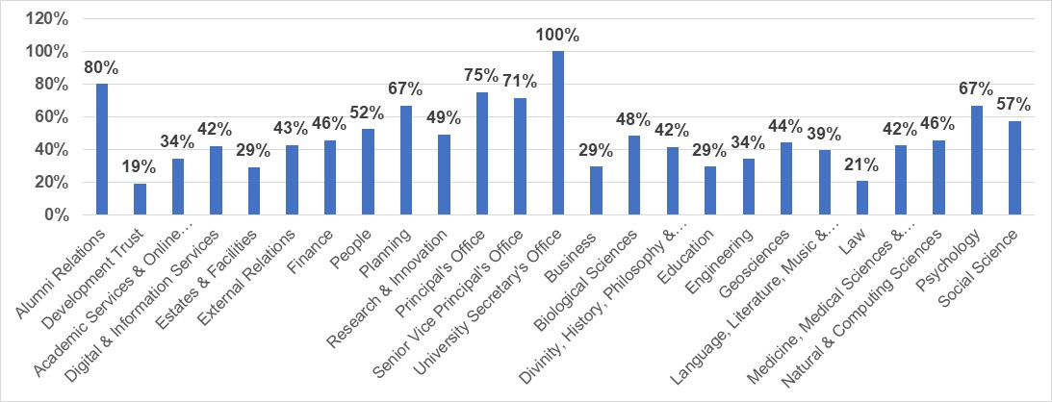
Figure 1: Race Equality Charter staff survey response rate by School/Professional Services Directorates.

7.1.2 Student survey
A total of 605 surveys were completed and returned by students (376 Undergraduates, 210 Postgraduates, 5 Other and 14 not disclosed) giving an overall response rate of 4%. The response rates by School are shown in Figure 2. Biological Sciences (7%); Business (3%); Divinity, History, Philosophy & Art History (7%); Education (1%); Engineering (5%); Geosciences (8%); Language, Literature, Music & Visual Culture (5%); Law (3%); Medicine, Medical Sciences & Nutrition (4%); Natural & Computing Sciences (4%); Psychology (5%); Social Science (6%).
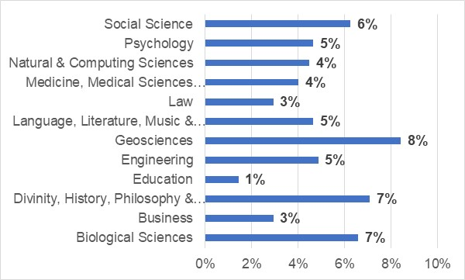
Figure 2: Race Equality Charter student survey response rate by School.

7.2 Demographics of respondents by ethnicity

7.2.1 Staff survey
Overall, 1,055 respondents identified themselves as being from a White background and 110 identified as being from a Racialised Group. 153 respondents did not disclose their ethnicity or race (Figure 3).
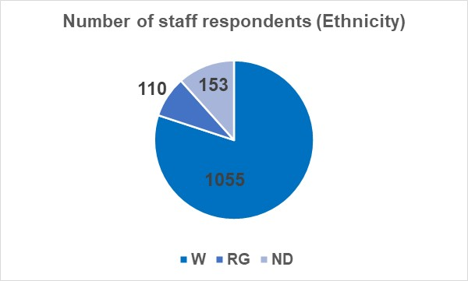
Figure 3: Number of staff respondents by ethnicity (White, W; Racialised Groups, RG; Ethnicity not disclosed, ND). White (W)= Scottish and Other White backgrounds; Racialised Groups (RG)= Arab, Asian, Black, Chinese, Gypsy/Traveller, Mixed and Other ethnicities.

7.2.2 Student survey
Overall, 605 surveys were completed and returned giving an overall response rate of 4%.
353 respondents identified themselves as from a White (W) background and 222 identified as being from a Racialised Group (RG) background. 30 respondents did not disclose their ethnicity or race (ND) (Figure 4).
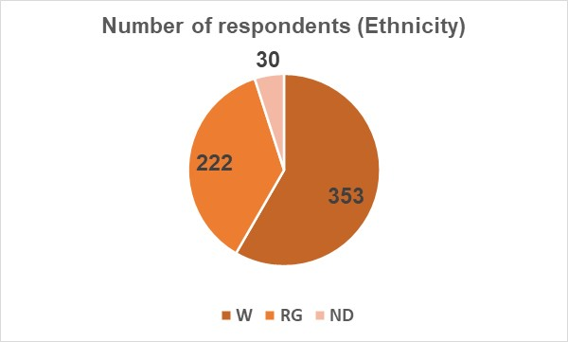
Figure 4: Number of student respondents by ethnicity (White, W; Racialised Groups, RG; Ethnicity not disclosed, ND). White (W)= Scottish and Other White backgrounds; Racialised Groups (RG)= Arab, Asian, Black, Chinese, Gypsy/Traveller, Mixed and Other ethnicities.

  - Demographics of respondents by ethnic group

7.3.1 Staff survey
Within the staff respondents who chose to disclose their ethnic group, 606 were White-Scottish, 449 from Other White backgrounds, 37 were Arab or Asian, 11 Black, 11 Mixed backgrounds and 51 from Other Ethnicities. 153 respondents chose not to disclose their ethnic group (Figure 5).
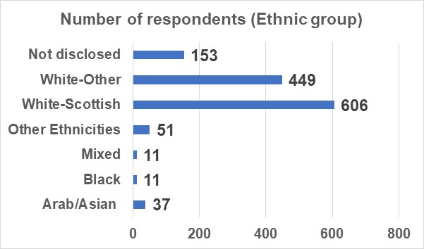
Figure 5: Number of staff respondents by ethnic group. Arab/Asian= Arab, Indian, Pakistani, Bangladeshi, Chinese; Black= African, Caribbean; Mixed= White and Asian, White and Black-African; White and Black-Caribbean, Other (Asian, Black, Ethnicities, Mixed).

7.3.2 Student survey
Within the student respondents who chose to disclose their ethnic group, 151 were White-Scottish, 202 from other White backgrounds, 91 were Arab or Asian, 68 Black, 21 Mixed backgrounds and 42 from Other Ethnicities. 30 respondents chose not to disclose their ethnic group (Figure 6).
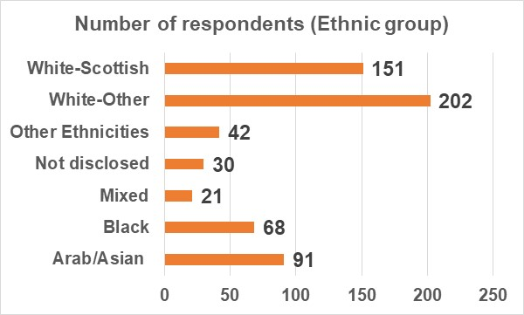
Figure 6: Number of student respondents by ethnic group. Arab/Asian= Arab, Indian, Pakistani, Bangladeshi, Chinese; Black= African, Caribbean; Mixed= White and Asian, White and Black-African; White and Black-Caribbean, Other (Asian, Black, Ethnicities, Mixed).

  - Demographics of respondents by nationality

7.4.1 Staff survey

A breakdown by nationality shows that the majority of staff respondents (n=915) identified themselves as UK/British, 144 from within Europe, and 103 from outside Europe. A total of 156 chose not to disclose their nationality (Figure 7).
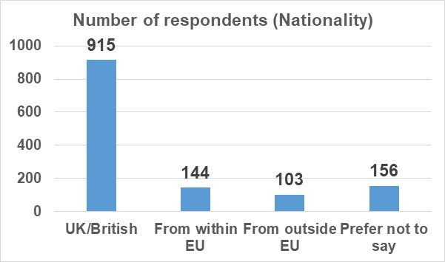
Figure 7: Number of staff respondents by nationality

7.4.2 Student survey
A breakdown by Nationality shows that the majority of student respondents (n=309) identified themselves as UK/British, 159 from outside Europe, and 118 from within Europe. A total of 19 students chose not to disclose their nationality (Figure 8).
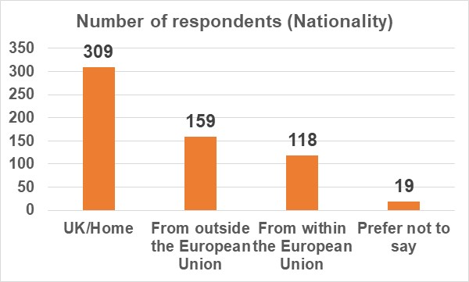
Figure 8: Number of student respondents by nationality

  - Demographics of respondents by religion

A breakdown by religion/beliefs shows that the majority of staff and student respondents identified with no religion/beliefs (n=624 staff and n=221 students) or Christianity (n=359 staff and n=170) or Atheism (n=86 staff and n=75 students). Numbers of respondents within the other religions/beliefs were too small and they are not reported to maintain anonymity. 190 staff and 45 student respondents chose not to disclose their religion/beliefs.

Other questions were included in the section ‘About you’ of the staff and student surveys. However, we have chosen to not report those results as the intersection of the information may breach anonymity.

Race Equality Charter Survey: Staff Responses

Staff were invited to provide their views on their experience of working at the University of Aberdeen and answer questions which would support the identification of racial inequalities within our policies and processes. The University used the survey template provided by Advance HE.

Areas covered in the survey were the following:
- Diversity of the Institution (section 8.1)
- Diversity of the local population (section 8.2)
- Reporting racial discrimination (section 8.3)
- Recommending the Institution (section 8.4)
- Recruitment and Selection (section 8.5)
- Career development and progression (section 8.6)
- Annual Review (section 8.7)
- Flexible working (section 8.8)
- Pay (section 8.9)

Information about Presentation of results and Terminology can be found in section 5.

8.1 Diversity of the Institution
This section of the survey explored whether staff considered the ethnic racial diversity of the University before applying to work here, whether the ethnic/racial diversity impacted on their sense of belonging and desire to stay, and whether they felt they were treated equally by staff and/or students irrespective of their racial/ethnic group.

8.1 A: Quantitative analysis
Q1-1: I considered the ethnic/racial diversity of the University of Aberdeen before applying here
8.1A.1: 15% of White and 29% of Racialised Groups respondents did consider the racial/ethnic diversity of the University when they applied to work here; 47% of White and 45% of Racialised Groups respondents did not.
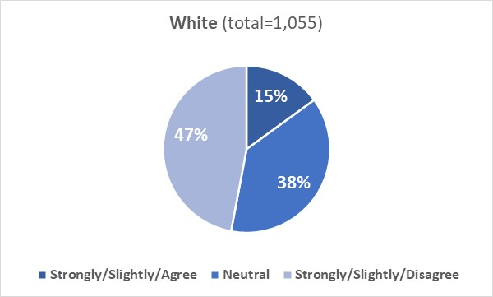
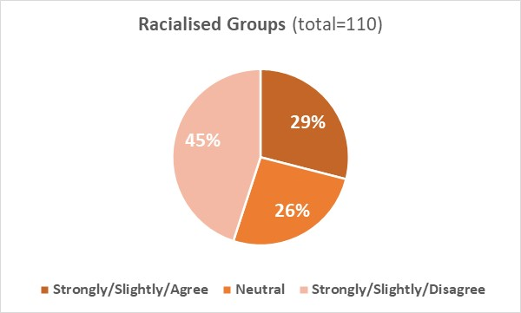
Ethnicity not disclosed (ND) (combined ‘Agree’ 20% (n=30), Neutral 33% (n=51), combined ‘Disagree’ 47% (n=72)).
Q1-2: The ethnic/racial diversity of the University of Aberdeen impacts on my sense of belonging
8.1A.2: The diversity (or lack of diversity) of the University impacted on sense of belonging to the University for 44% of White and 72% of Racialised Groups respondents; 19% of White and 12% of Racialised Groups respondents disagreed that diversity impacted them (a disparity is observed between the two cohorts).
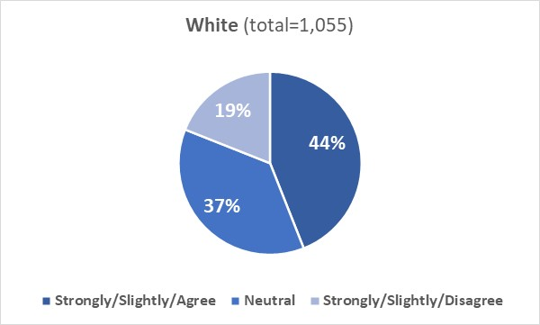
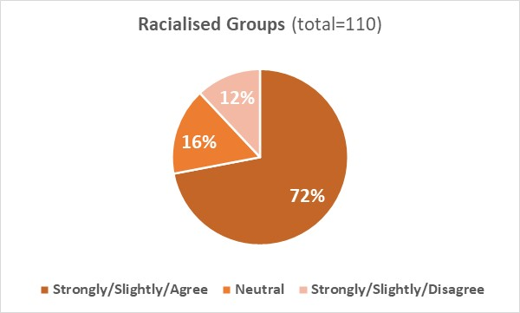
Ethnicity not disclosed (ND) (combined ‘Agree’ 45% (n=70), Neutral 31% (n=47), combined ‘Disagree’ 24% (n=36)).

Q1-3: The ethnic/racial diversity of the University of Aberdeen impacts on my desire to stay
8.1A.3: The diversity (or lack of diversity) of the University impacted on the desire to stay of 51% of White and 57% of Racialised Groups respondents; 17% of White and 19% of Racialised Groups respondents disagreed that diversity impacted them.
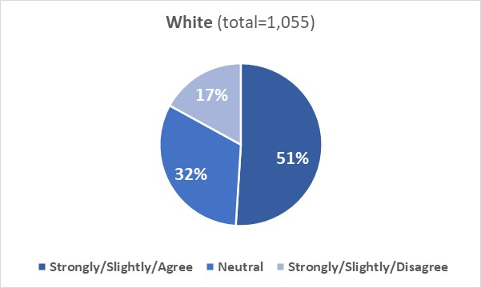
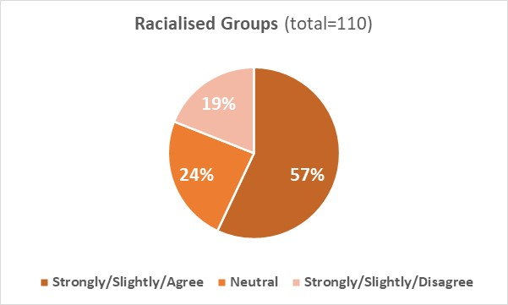
Ethnicity not disclosed (ND) (combined ‘Agree’ 45% (69), Neutral 31% (48), combined ‘Disagree’ 24% (36)).

Q1-4: I believe I am treated equally by colleagues, irrespective of my ethnicity or race
8.1A.4: 81% of White and 71% of Racialised Groups respondents reported that they were treated equally by colleagues irrespective of their race/ethnic group, 6% of White and 21% of Racialised Groups respondents disagreed that they were treated equally (a disparity is observed between the two cohorts).
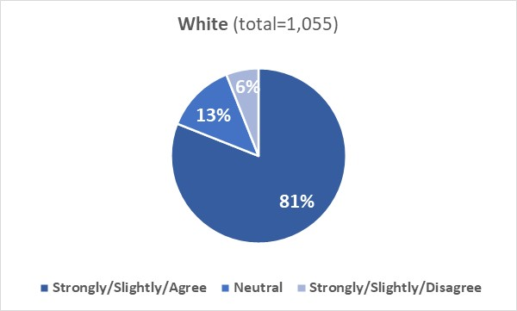
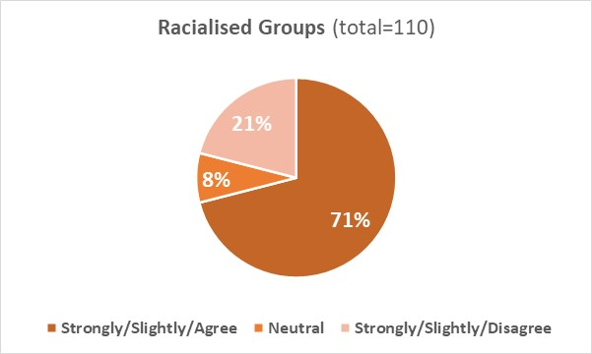
Ethnicity not disclosed (ND) (combined ‘Agree’ 58% (n=89), Neutral 23% (n=35), combined ‘Disagree 19% (n=29)).

Q1-5: I believe I am treated equally by students, irrespective of my ethnicity or race
8.1A.5: 74% of White and 73% of Racialised Groups respondents agreed that they received equal treatment from students; 7% of White and 11% of Racialised Groups respondents disagreed that they were treated equally.
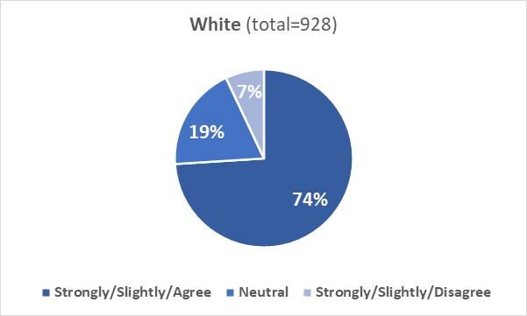
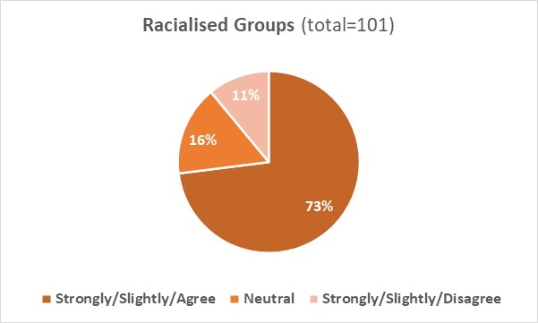
Ethnicity not disclosed (ND) (combined ‘Agree’ 60% (n=87), Neutral 22% (n=32), combined ‘Disagree’ 17% (n=25)).

8.1 B: Qualitative analysis

Open comments from White (W) staff in relation to the five questions in section ‘Diversity of the Institution’ were grouped into five broad themes and sub-themes (Table 1).

Table 1: Inductive content analysis of question responses from White staff regarding the staff survey section “Diversity of the Institution”.
Theme number | Theme | Sub-theme
Theme 1 | Influence of University’s diversity | - 1.1 Diversity was not a personal consideration when joining  - 1.2 Diversity was not an institutional priority upon joining  - 1.3 Diversity does not influence current work experience
Theme 2 | University’s racial/ethnic climate | - 2.1 Positives of diversity in University  - 2.2 Negatives of diversity in University  - 2.3 University lacks diversity  - 2.4 University is diverse
Theme 3 | Never experienced differential (unequal) treatment due to race or ethnicity | (none)
Theme 4 | No differential treatment | - 4.1 Based on personal beliefs  - 4.2 Based on observations of the University
Theme 5 | Race/ethnicity influences experience at the University | - 5.1 Benefits from racial privilege  - 5.2 Experience differ from minority staff

Influence and climate of ethnic/racial diversity in University
Respondents (W) reported that they did not consider the ethnic/racial diversity of the University when they applied to work here either because it was not important to them (sub-theme 1.1) or because diversity was not an institutional priority when they joined the University a long time ago (sub-theme 1.2). They also reported that diversity did not affect their desire to stay or work here (sub-theme 1.3).

Positives and negatives of having a diverse University were mentioned by the respondents (W). On a positive side, diversity was reported to enhance working experience, improve sense of belonging and desire to stay (sub-theme 2.1). On a negative side, it was reported that bias and unequal treatment may occur against people from racialised groups (sub-theme 2.2).

Consideration of whether the University is diverse differs within the respondents (W), with comments highlighting either lack of diversity within the University (or own department) (sub-theme 2.3) or a recent increasing diversity within the Institution (sub-theme 2.4)

Treatment received by colleagues/students
Respondents (W) reported that they have never experienced or witnessed unequal treatment at the University due to race or never felt discriminated or favoured due to their [white] background, or that they were equally treated by staff and students (Theme 3).

There was the belief/hope that everyone is treated equally regardless of ethnicity (sub-theme 4.1) and the consideration that the University is an equality and diversity-minded employer with no problems with race equality (sub-theme 4.2).

Experience at the University is influenced by race/ethnicity
There were comments where respondents (W) recognised the benefits of being from a white background (preferential treatment, white privilege) (sub-theme 5.1) and reported occurrence (or perception) of unequal treatment against people from Racialised Groups (sub-theme 5.2).

Comments from Racialised Groups (RG) staff to the five questions in section ‘Diversity of the Institution’ were grouped into three broad themes and sub-themes (Table 2).

Table 2: Inductive content analysis of question responses from Racialised Group staff regarding the staff survey section “Diversity of the Institution”.
Theme number | Theme | Sub-theme
Theme 6 | Problems concerning diversity and equality of University | - 6.1 Presence of bias or discrimination in University  - 6.2 Lack of inclusivity and diversity in University staff  - 6.3 Limitations in University’s addressal of racial incidents
Table 7 | Positive experience in University | (none)
Table 8 | Lack of concrete perception of diversity and equality in University | (none)

Problems concerning diversity/equality of University
Respondents (RG) reported that they have faced discriminatory behaviour on the grounds of ethnicity and gender, or they have been stereotyped due to their background or they have experienced racial microaggressions/verbal xenophobia from colleagues (sub-theme 6.1). Lack of diversity in several areas of the University or lack of inclusivity by members of staff was also reported (sub-theme 6.2).

There were comments where respondents (RG) reported that they did not feel satisfied about either the way the University addresses race-related incidents and the lack of consideration of intersectionality within equality policies (sub-theme 6.3)

Positive experience in University
Within theme 7, comments were about positive experience of the respondents (RG) (happy with the University’s values, grateful to work here, perception of fairness and equal treatment among colleagues).

There were respondents (RG) who reported that they did not give to this topic much attention to form an opinion (Theme 8).

Examples of quotes by respondents from both cohorts (W and RG) are reported below.

“I have been at the University for 20+ years so the diversity wasn't something I considered when joining. It would be something I would consider if joining now”- W staff

“Ethnicity and race did not play any role in my choice to join the UoA. [...] Heterogeneity in all levels, and in the senior management could help mitigate the bias”. RG staff

“I am responding from a very strong position of privilege and am acutely aware of that. For me personally, these are honest answers. I am very conscious that others will have good reason to answer very differently “-W staff

“I am mixed race and personally I've felt I have been privileged to have always been treated well [...]. That said, there have been times when I've joined a new team or met a new Department and I've been aware that the ethnic/racial diversity usually seems limited”- RG staff

“While I haven't been impacted directly, I know of some cases where a lecturer's background affected the way the students treated them”- W staff
8.2 Diversity of the local population
This section of the survey explored whether the ethnic/racial diversity of the local population impacted on day-to-day life of our staff and whether staff were aware of ethnic/racial tensions in the local area.

8.2 A: Quantitative analysis
Q2-1: The ethnic/racial diversity of the local population impacts on my day-to-day life
8.2A.1: Diversity (or lack of diversity) of the local population impacted on day-to-day life for 27% of White and 55% of Racialised Groups respondents; 36% of White and 18% of Racialised Groups respondents disagreed to feel impacted by diversity (a disparity is observed between the two cohorts).
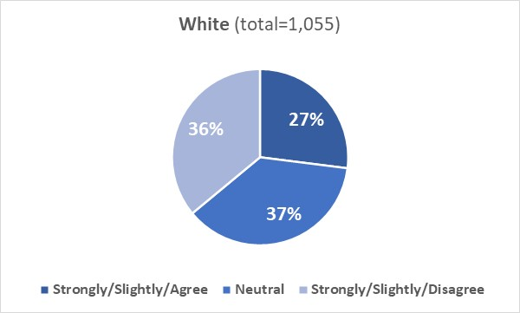
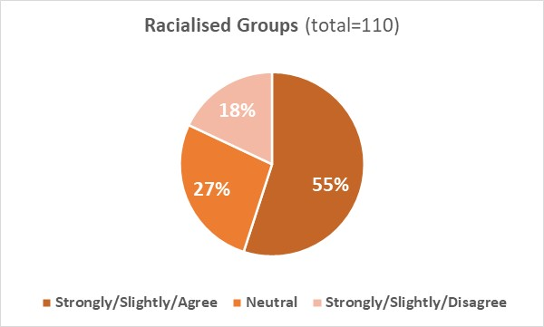
Ethnicity not disclosed (ND) (combined ‘Agree’ 36% (n=55), Neutral 33% (n=51), combined ‘Disagree’ 31% (n=47)).
Q2-2: I am aware of ethnic/racial tensions within the local community
8.2A.2: 35% of White and 39% of Racialised Groups respondents were not aware of ethnic/racial tensions within the local community, with 42% of White and 36% of Racialised Groups respondents being aware of them.
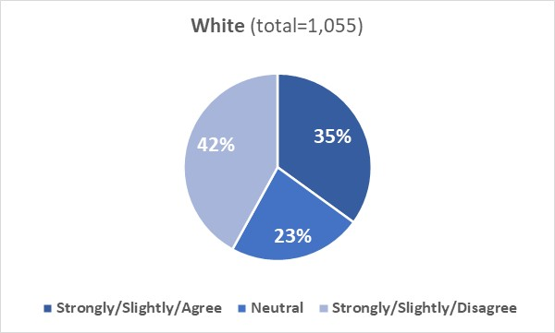
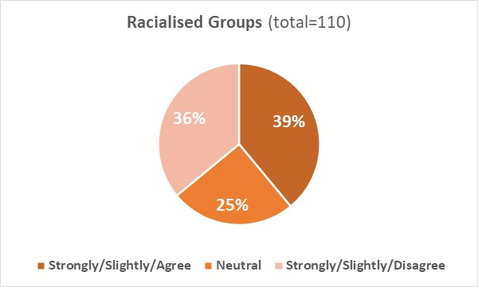
Ethnicity not disclosed (ND) (combined ‘Agree’ 38% (n=59), Neutral 29% (n=45), combined ‘Disagree’ 33% (n=49)).

8.2 B: Qualitative analysis

Open comments from White (W) staff in relation to the two questions in section ‘Diversity of the local population’ were grouped into four broad themes and sub-themes (Table 3).

Table 3: Inductive content analysis of question responses from White staff regarding the staff survey section “Diversity of the local population”.
Theme number | Theme | Sub-theme
Theme 1 | Local community is not diverse | (none)
Theme 2 | Differences in perception of community’s diversity as an influence | - 2.1 Diversity in community has a positive impact  - 2.2 Indifferent to diversity of community
Theme 3 | Tensions exist within community | (none)
Theme 4 | Factors affecting awareness of community tensions | - 4.1 Location  - 4.2 Personal observations or perceptions  - 4.3 Level of involvement in community

Ethnic/racial diversity of the local population
Respondents (W) reported that Aberdeen is not a diverse city in comparison to other UK cities, that being from a white background reinforces sense of privilege in areas with minimal diversity and reduces sense of belonging in minority groups (Theme 1).

Diversity within the community was reported to have a positive impact because it enhances day-to-day life and creates a rich and stimulating environment; lack of diversity instead was reported to strengthen the existence of racial bias (sub-theme 2.1).

There were comments where respondents (W) reported to be indifferent and not feeling impacted by the diversity in the community (sub-theme 2.2).

(Un)awareness of ethnic/racial tensions within the local community
Comments within theme 3 reported awareness or occurrence (respondents (W) were either victims or witnesses) of ethnic/racial tensions which have involved either people from a White background (e.g., tensions between Scots and English, discrimination against Polish) or those from Racialised Groups. For example, from the comments it emerged that the pandemic exacerbated hate against people from an Asian background. Refugees and immigrants were reported not to be welcomed in the local community.

Respondents (W) who reported unawareness of occurrence of ethnic/racial tensions within the local community said that they did not live in the local community (sub-theme 4.1) or that they never observed/were made aware/suspected that ethnic/racial tensions in the local community may exist (lack of perception of ethnic/racial tensions was attributed by some respondents to their [white] ethnicity) (sub-theme 4.2), or they reported to not be active members/know little about the local community (sub-theme 4.3).

Comments from Racialised Groups (RG) staff to the two questions in section ‘Diversity of the local population’ were grouped into one broad theme and sub-themes (Table 4).

Table 4: Inductive content analysis of question responses from Racialised Group staff regarding the staff survey section “Diversity of the local population”.
Theme number | Theme | Sub-theme
Theme 5 | Local community is not diverse | - 5.1 Aware of these issues in local community  - 5.2 Unaware of these issues in local community

There were comments where respondents (RG) reported that they were aware or have been victim/witness of racism and discrimination in the local community (sub-theme 5.1); in other comments respondents (RG) reported lack of awareness/experience with ethnic/racial tensions in the local community (sub-theme 5.2).
Examples of quotes by respondents from both cohorts (W and RG) are reported below.

“Although I am aware of ethnic/racial tensions within the local community, other staff/students may not be aware of - so as a university perhaps we need to cascade that information to them”- W staff

“In the north east of Scotland community - I am aware of racism in the community both anecdotally through the experience of others and also by coming across it through inappropriate language and perspectives which I have tried to tackle”- RG staff

“Community-wide racism and lack of understanding about diversity and the positivity it brings to our environment. Aberdonians are predominantly white and I am concerned about the impact that has on the sense of belonging for our students - everyone should feel that they belong where they live”- W staff

“I am aware of hate crime in and around Old Aberdeen. Staff and students need to be reminded to be safe especially walking in the dark”- RG staff

“I live outside Aberdeen so am not aware of tensions in the local community”- W staff

“If there are any racial tensions in the community I am not aware of them”- RG staff

8.3 Reporting racial discrimination
This section of the survey explored whether staff have witnessed/have been victim of racial discrimination on campus or in the local area, knew how to report a race-related incident to the Institution and believed an appropriate action would be taken if an incident is reported.

8.3 A: Quantitative analysis
Q3-1: I have witnessed or been the victim of racial discrimination on campus
8.3A.1: 80% of White and 67% of Racialised Groups disagreed they have witnessed or been the victim of racial discrimination on campus; 10% of White and 25% of Racialised Groups respondents agreed that they had witnessed or experienced it on campus (a disparity is observed between the two cohorts).
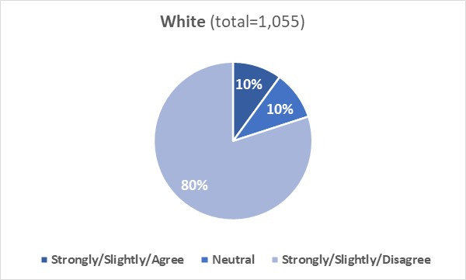
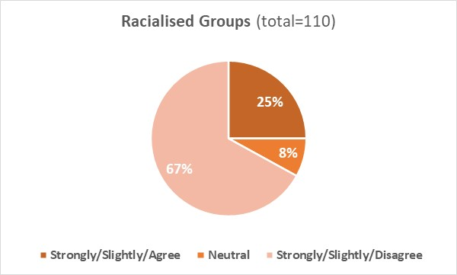
Ethnicity not disclosed (ND) (combined ‘Agree’ 25% (n=38), Neutral 20% (n=30), combined ‘Disagree’ 55% (n=85)).
Q 3-2: I have witnessed or been the victim of racial discrimination in the local area
8.3A.2: 71% of White and 51% of Racialised Groups respondents disagreed that they have witnessed or been the victim of racial discrimination in the local area; 20% of White and 34% of Racialised Groups agreed they had witnessed or experienced it in the local area (a disparity is observed between the two cohorts)
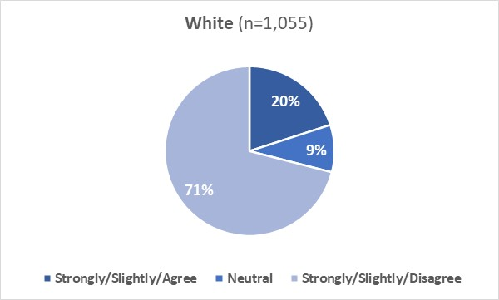
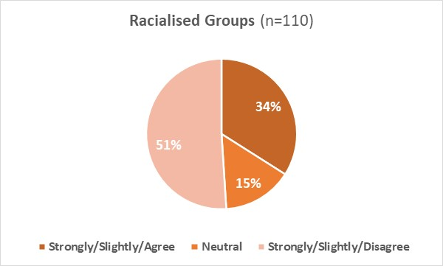
Ethnicity not disclosed (ND) (combined ‘Agree’ 31% (n=47), Neutral 19% (n=29), combined ‘Disagree’ 50% (n=77)).

Q3-3: I know how to report a race-related incident in my Institution
8.3A.3: 66% of White and 58% of Racialised Groups respondents knew how to report a race-related incident to the University, with 26% of White and 31% of Racialised Groups respondents stating they did not know it.
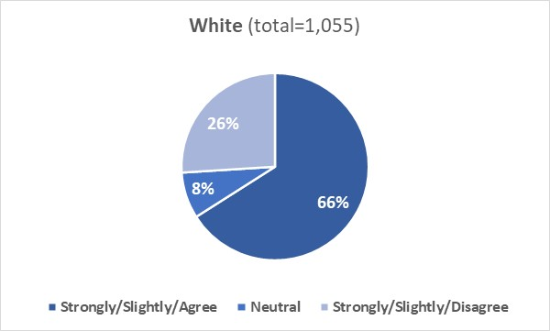
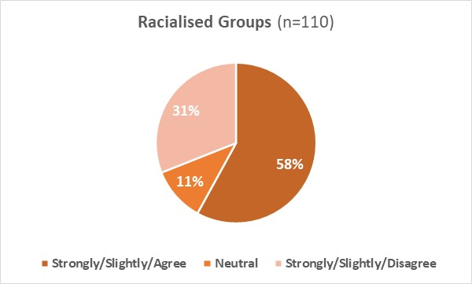
Ethnicity not disclosed (ND) (combined ‘Agree’ 59% (n=89), Neutral 16% (n=25), combined ‘Disagree’ 25% (n=39)).

Q3-4: If I reported a race-related incident to my Institution, appropriate action would be taken
8.3A.4: 68% of White and 57% of Racialised Groups respondents agreed that an appropriate action would be taken in case of a disclosure of a race-related incident; 7% of White and 17% of Racialised Groups respondents disagreed that this would be the case (a disparity is observed between the two cohorts).
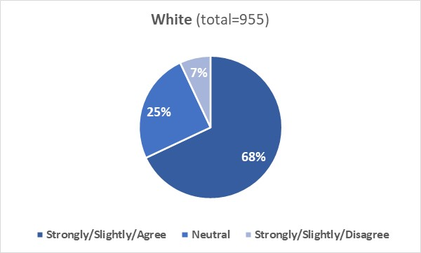
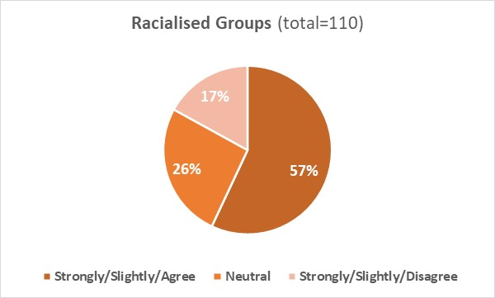
Ethnicity not disclosed (ND) (combined ‘Agree’ 44% (n=67), Neutral 31% (n=48), combined ‘Disagree’ 25% (n=38)).

8.3 B: Qualitative analysis
Comments from White (W) staff to the four questions in section ‘Reporting racial discrimination’ were grouped into five broad themes and sub-themes (Table 5).

Table 5: Inductive content analysis of question responses from White staff regarding the staff survey section “Reporting racial discrimination”.
Theme number | Theme | Sub-theme
Theme 1 | Not witnessed or experienced discrimination | (none)
Theme 2 | Discrimination occurs in the University and local community | (none)
Theme 3 | Positive perception of reporting process | - 3.1 Optimistic/confident in reporting outcomes  - 3.2 Aware of method of reporting
Theme 4 | Barriers hindering confidence in reporting process | - 4.1 Structural barriers  - 4.2 Perceived limitations
Theme 5 | Knowledge/experiences with reporting very limited | (none)

Occurrence of ethnic/racial discrimination on campus and/or in the local area
There were comments where respondents (W) reported that they have never witnessed or have been victim of racial discrimination on campus and/or in the local community (Theme 1) and comments where respondents reported to have witnessed/have been victim of discrimination/racism on campus and/or in the local area (e.g., use of insensitive language, microaggressions, racism in jokes, discriminatory remarks, and discrimination against people from Racialised Groups and/or White people (e.g., Scots vs English) (Theme 2).

Positive perception of the reporting process
Comments within theme 3 were from respondents (W) who reported to be confident about the University reporting system, assumed that the University would address reported race-related incidents, believed that measures were already in place to take appropriate actions, were confident that issues would be dealt with fairly, and appreciated the University’s commitment to tackling racial discrimination (sub-theme 3.1).
There were comments where respondents (W) reported that they were aware on how to report a race-related issue or felt confident that information/guidelines could be found easily on the website (sub-theme 3.2).

Barriers hindering confidence in the reporting process
Comments within theme 4 referred to possible barriers (perceived by White respondents) that may hinder confidence in the reporting process. These were:
- structural barriers: limitations in the structure of the reporting process and in the way the University addresses incidents; never heard of an outcome of incidents that have been reported; still awaiting the report of an incident which was reported a long time ago; no significant outcomes after the incident was reported; incidents not handled well (sub-theme 4.1).
- perceived limitations: unsure or not confident that an incident would be taken seriously and/or an appropriate action would be taken; staff may feel risk to job if complaints were made; staff may not fully trust the University’s ability to handle incidents; addressing potential discrimination in an environment which encourages free speech may be difficult (sub-theme 4.2).
Within theme 5, comments were from respondents (W) who reported that they have never reported an incident or have limited/lack of knowledge about how to report a race-related incident to the Institution or did not know how the incident would be handled (Theme 5).
Comments from Racialised Groups (RG) staff to the four questions in section ‘Reporting racial discrimination’ were grouped into two broad themes and sub-themes (Table 6).

Table 6: Inductive content analysis of question responses from Racialised Group staff regarding the staff survey section “Reporting racial discrimination”.
Theme number | Theme | Sub-theme
Theme 6 | Racial/ethnic discrimination | (none)
Theme 7 | Awareness of reporting process or outcome | - 7.1 Lack of knowledge of reporting process/outcomes  - 7.2 Aware of reporting procedures

Occurrence of ethnic/racial discrimination on campus and/or in the local area
There were comments where respondents (RG) reported incidents of discrimination involving them or their close friends/relatives (Theme 6).

(Un)awareness/confidence in the reporting process
Respondents (RG) reported they were not aware of how to report a race-related incident or did not know whether appropriate actions would be taken in case of a disclosure (sub-theme 7.1). There were comments where respondents (RG) reported that they were aware of how/where to report an incident (sub-theme 7.2).

Examples of quotes by respondents from both cohorts (W and RG) are reported below.

“Witnessed racial discrimination and abuse within the city but not directly within the university. I wouldn't know off hand how to report incidences within the university but presume i could find out through the website”- W staff
“I am not aware of any specific internal policy re dealing with discrimination in all levels, ie from/to students to/from senior management”- RG staff

“I have never been a victim of an ethnicity-based incident. I don't think I've witnessed an ethnicity-based incident on campus (though I'm not on campus much these days). I haven't witnessed such an incident where I live either. Of course, as a White Brit, I might not recognise an ethnicity-based incident for what it is. Small acts of ethnic-based aggression might be missed by those of us in the majority population, that's why talking about diversity, racism and hearing directly from people who have experienced ethnically-motivated attacks or incidents is important”- W staff

“I know where to report racial discrimination/harassment. I am aware that the Medical School have taken steps to address racial discrimination in response to an open letter from students in 2020 so I trust that the university acts on these incidents”- RG staff

“We have had a race related incident in my Department that has taken over a year to address and we are still awaiting a full report or full response since it was escalated to HR. This doesn't give me confidence that appropriate action would be taken if it happened again”- W staff

“I have raised some issues in the past but no action was taken. Caucasian staff get away with being rude all the time and that is the lifestyle that we should accept. Equity, diversity, and inclusion is symbolic but no action is taken to confront racist or intersectionality issues”- RG staff

8.4 Recommending the Institution

This section of the survey explored whether staff would recommend the Institution to a prospective staff member.

8.4 A: Quantitative analysis
Q4-1: I would recommend my Institution to a prospective staff member
8.4A.1: 90% of White and 83% of Racialised Groups respondents reported that they would recommend the Institution to a prospective staff member with 4% of White and 7% of Racialised Groups respondents disagreeing that they would.
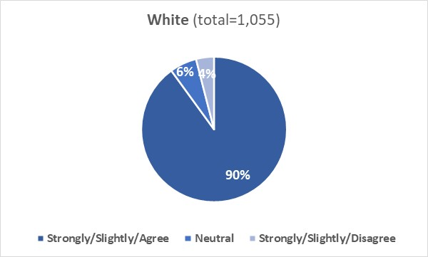
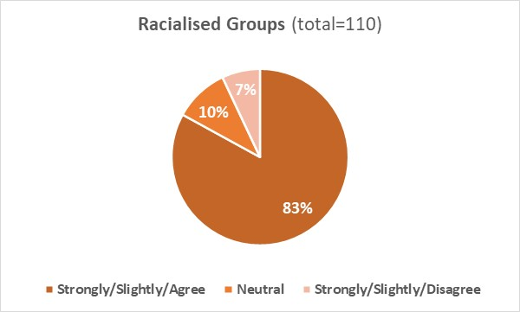
Ethnicity not disclosed (ND) (combined ‘Agree’ 72% (n=111), Neutral 12% (n=19), combined ‘Disagree’ 15% (n=23)).

8.4 B: Qualitative analysis

Comments from White (W) staff to the question in section ‘Recommending the Institution’ were grouped into three broad themes and sub-themes (Table 7).

Table 7: Inductive content analysis of question responses from White staff regarding the staff survey section “Recommending the Institution”.
Theme number | Theme | Sub-theme
Theme 1 | Positive perception of the University | - 1.1 Would recommend the University  - 1.2 Enjoys working at the University  - 1.3 Progressive and caring Institution
Theme 2 | Issues concerning negative perception of the University | - 2.1 Staff-related limitations  - 2.2 Issues with diversity and equality
Theme 3 | Recommending the Institution would be context-relevant | (none)

Positive perception of the University
Respondents (W) reported that they would recommend the University (or their own department) to a prospective staff member (sub-theme 1.1), enjoy working at the University because is multicultural, safe, welcoming, a great place to work at where staff are well-informed, supported and satisfied with their jobs (sub-theme 1.2).

There were comments where respondents (W) considered the University as caring and supportive, with a progressive Senior Management Team (sub-theme 1.3).

Issues concerning negative perception of the University
Comments within theme 2 were from respondents (W) who would not recommend the University to a prospective staff member for various reasons:
- not race-related: workload; lack of opportunities for career progression (sub-theme 2.1)
- lack of ethnic/racial diversity/treatment received: lack of ethnic/racial diversity within the Institution, including within the Senior Management Team; occurrence (e.g., being witness) of unsatisfactory behaviour by senior white staff; unfavourable outcomes in relation to cases brought forward to the University (sub-theme 2.2).
There were comments where respondents (W) reported that recommending the University would depend on applicant’s work area and expectations, and various other (not specified) factors (Theme 3).

Comments from Racialised Groups (RG) staff to the question in section ‘Recommending the Institution’ were grouped into three broad themes and sub-themes (Table 8).

Table 8: Inductive content analysis of question responses from Racialised Group staff regarding the staff survey section “Recommending the Institution”.
Theme number | Theme | Sub-theme
Theme 4 | Positive perception of the University | (none)
Theme 5 | Factors inhibiting likelihood of recommending the University | - 5.1 Negative experience  - 5.2 Presence of racial bias
Theme 6 | Likelihood of recommending the Institution influenced by various factors | (none)

Positive perception of the University
Respondents (RG) reported to have a positive perception of the University, appreciated the good working environment, were satisfied with their University’s role, and recognised that things have improved recently (including the commitment towards race equality) (Theme 4).

Reasons for not recommending the University
Comments within theme 5 were from respondents (RG) who had a negative perception of the University. They reported that the system is managerial, and that there is a work’s culture which hinders creativity and productivity (sub-theme 5.1).
Respondents (RG) reported that there is a work’s culture which enables exclusion of certain groups, with minority individuals feeling that they must perform to a level of whiteness to fit in the University, and that they would recommend the Institution only to white staff (sub-theme 5.2)

Comments within theme 6 were from respondents (RG) who reported that recommending the Institution would depend on the candidate’s circumstances and department they would apply for.

8.5 Recruitment and Selection

This section of the survey explored whether staff considered our recruitment and selection processes fair and transparent and leading to the recruitment of the best candidates.

8.5 A: Quantitative analysis
Q5-1: From what I have seen, the University of Aberdeen undertakes recruitment and selection fairly and transparently
8.5A.1: 83% of White and 75% of Racialised Groups respondents agreed that the University undertakes recruitment and selection fairly and transparently, with 7% of White and 12% of Racialised Groups respondents disagreeing with this statement.
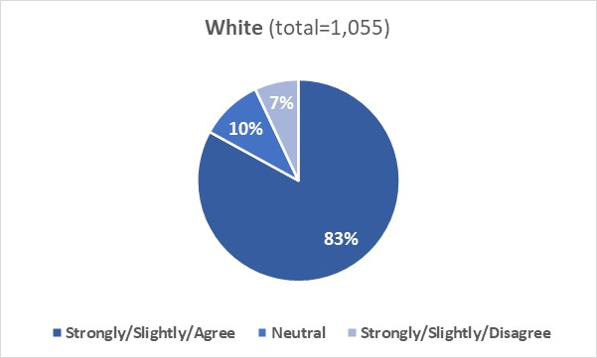
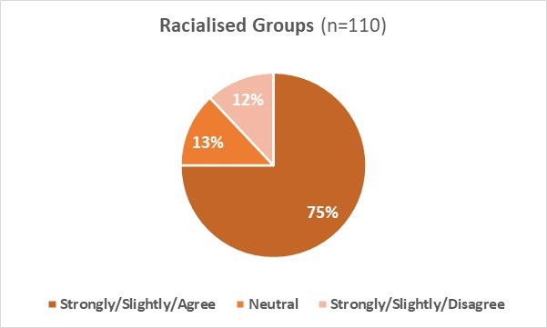
Ethnicity not disclosed (ND) (combined ‘Agree’ 67% (n=102), Neutral 14% (n=21), combined ‘Disagree’ 19% (n=30)).
Q5-2: The University’s recruitment and selection policies lead to the best candidate being recruited
8.5A.2: 70% of White and 66% of Racialised Groups respondents agreed that the University’s recruitment and selection policies lead to the best candidates being recruited, with 13% of White and 15% of Racialised Groups disagreeing with this statement.
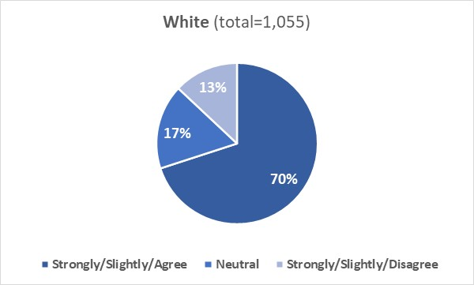
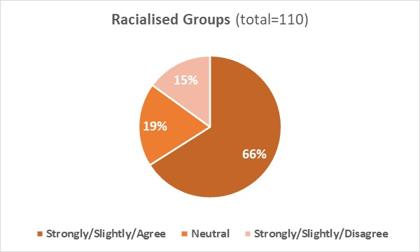
Ethnicity not disclosed (ND) (combined ‘Agree’ 49% (n=75), Neutral 26% (n=40), combined ‘Disagree’ 25% (n=38)).

8.5 B: Qualitative analysis

Comments from White (W) staff to the two questions in section ‘Recruitment and Selection’ were grouped into five broad themes and sub-themes (Table 9).

Table 9: Inductive content analysis of question responses from White staff regarding the staff survey section “Recruitment and Selection”.
Theme number | Theme | Sub-theme
Theme 1 | Positive experience with the recruitment process | (none)
Theme 2 | Does not know enough about the recruitment and selection process | (none)
Theme 3 | Factors hindering diversity of staff recruited | - 3.1 Structural-specific barriers  - 3.2 External barriers
Theme 4 | Negative side of actions taken to diversify staff | (none)
Theme 5 | Factors hindering selection of best candidate | - 5.1 Bias in candidate selection  - 5.2 Structural barriers  - 5.3 Perception of best candidate is subjective

Positive or no experience with the recruitment process
Respondents (W) reported that the University recruitment and selection processes are fair and transparent, guidelines are clear, HR takes recruitment seriously, processes have improved recently (after the change of the management team), and that good selections are made from pool of candidates available (Theme 1).
Respondents (W) who have had not enough experience with the recruitment and selection processes said that they were unable to add any further thoughts (Theme 2)

Factors hindering diversity of staff recruited
A few factors (perceived by White respondents) were reported to hinder the diversity of staff recruited. These were:
- Structural-specific barriers: bias; favouritism; lack of inclusive language used in job adverts; no consideration for applicant’s disability/needs; insufficient actions put in place by the Institution to attract a diverse array of applicants (sub-theme 3.1).
- External factors: cost of living and location of Aberdeen; Covid-19 pandemic (sub-theme 3.2).

There were comments where respondents (W) reported that candidates should be chosen irrespective of their ethnicity/background and that over-emphasis on diversifying staff may lead to bias (Theme 4).

Factors hindering selection of best candidate
The ability to recruit the best candidate can be hindered by a few factors (perceived by White respondents):
- Bias in candidate selection: nepotism; candidates with connections being selected/hired over others (sub-theme 5.1)
- Structural barriers: lack of an anonymous application form; occurrence of bias during shortlisting/offer; advertising of posts not carried out widely and long enough; hiring candidates based on experience not future potential (sub-theme 5.2).
- Subjective perception of best candidate (sub-theme 5.3).

Comments from Racialised Groups (RG) staff to the two questions in section ‘Recruitment and Selection’ were grouped into two broad themes and sub-themes (Table 10).

Table 10: Inductive content analysis of question responses from Racialised Group staff regarding the staff survey section “Recruitment and Selection”.
Theme number | Theme | Sub-theme
Theme 6 | Positive experience with the recruitment process | (none)
Theme 7 | Limitations of recruitment process | - 7.1 Process is biased and lacks transparency  - 7.2 Process is discouraging  - 7.3 Process is performative

Positive experience with the recruitment process
Respondents (RG) who had a positive experience with the recruitment process reported that they believed that the recruitment is fair and rigorous, and that they were recruited because of their skills irrespective of their ethnicity (Theme 6).

Limitations in the recruitment process
There were comments where respondents (RG) reported that the recruitment process is biased/lacks transparency (sub-theme 7.1), discouraging (sub-theme 7.2) and performative (sub-theme 7.3).

Examples of quotes by respondents from both cohorts (W and RG) are reported below

“Generally, the University follows a good process for selection. There have been cases when some staff seem to appear in posts despite no apparent advert or selection process. This is sometimes for an interim post but the same transparent process should be used at all times”- W staff

“I have been involved in a number of hiring panels, in my own School and in another. These processes were conducted rigorously and fairly in my judgement [...]”- RG staff

“In my team we are all white, Scottish, male, straight and not disabled - it seems incredible that such a situation could occur without there being some institutional/recruitment biases which are preventing a greater diversity”- W staff

“The University of Aberdeen has in the past and continues to be far more likely to make "minority" hires rather for a perceived vision of race equality in both employment and subjects studied than for the reality of needs. It also does not consider ethnic or racial differences amongst candidates who are perceived as white, which includes Jews, Roma, etc. but rather lumps us all together in white v. any variety of non-white. That is racial and ethnic discrimination”- RG staff

“I have no complaints at all about my (fairly recent) interview for my current post. I think the interview was conducted robustly, and fairly”- W staff

“I am an Indian [...]. I believe my job was offered considering my skills/qualifications irrespective of my ethnicity”- RG staff

8.6 Career development and progression

This section of the survey explored whether staff believed that there are opportunities to develop and discuss career development and progression, the allocation of work-related opportunities for development is fair and transparent, and whether they have been encouraged to progress in their career through application to senior roles or regrading (for Professional Services staff) or promotion (for academic staff).

8.6 A: Quantitative analysis
Q6-1: There are opportunities for me to develop within my role
8.6A.1: 71% of White and 65% of Racialised Groups respondents agreed that there are opportunities to develop within their role; 21% of White and 26% of Racialised Groups respondents disagreed with this statement.
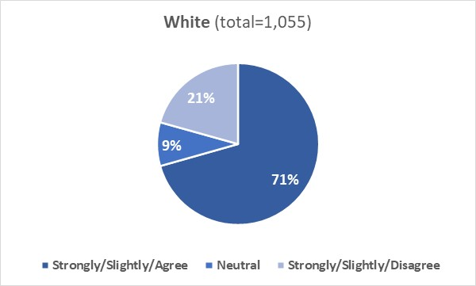
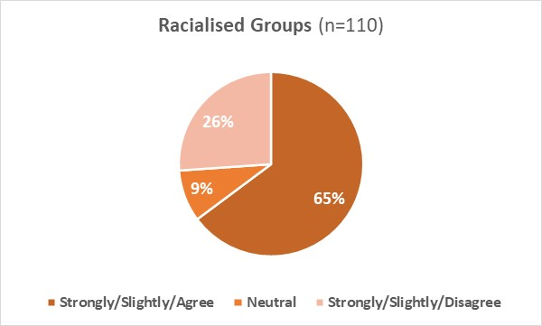
Ethnicity not disclosed (ND) (combined ‘Agree’ 51% (n=78), Neutral 11% (n=17), combined ‘Disagree’ 38% (n=58)).
Q6-2: My line manager makes time to discuss my personal development and progression
8.6A.2: 74% of White and 70% of Racialised Groups respondents agreed that they can discuss personal development and progression with their line manage; 17% of White and 22% of Racialised Groups respondents disagreed they had this opportunity.
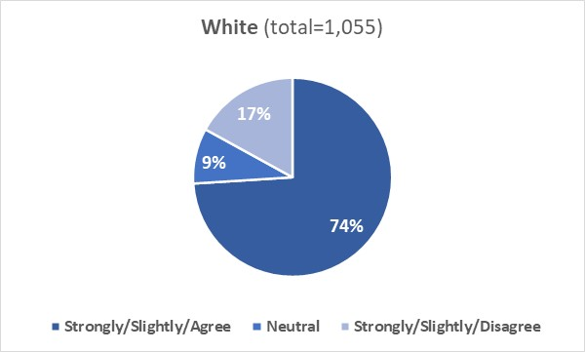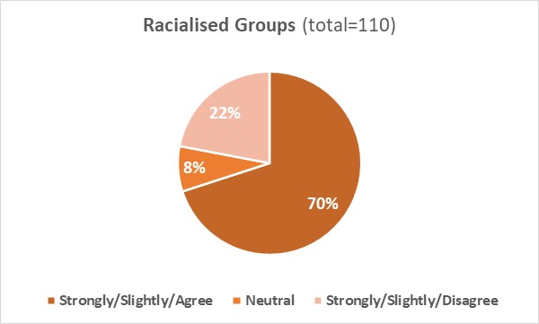
Ethnicity not disclosed (ND) (combined ‘Agree’ 53% (n=81), Neutral 15% (n=23), combined ‘Disagree’ 32% (n=49)).

Q6-3: Work-related opportunities for development, such as acting-up roles or profile-raising opportunities, are allocated fairly and transparently
8.6A.3: 50% of White and 53% of Racialised Groups respondents agreed that work-related opportunities are allocated fairly and transparently; 21% of White and 25% of Racialised Groups respondents disagreed that the allocation is fair and transparent.
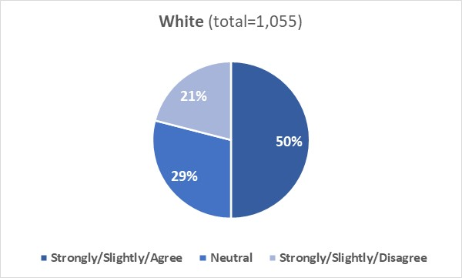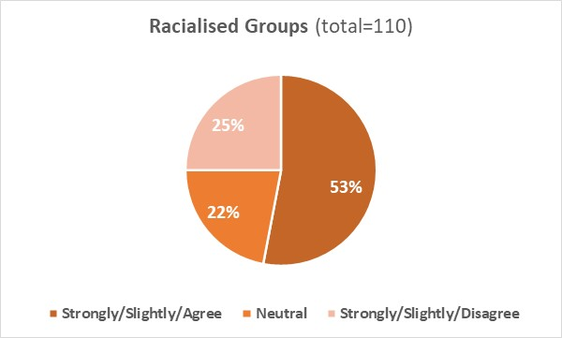
Ethnicity not disclosed (ND) (combined ‘Agree’ 40% (n=61), Neutral 25% (n=38), combined ‘Disagree’ 35% (n=54)).

Q6-4: I have been encouraged to apply for jobs at a higher grade (Professional Services roles)
8.6A.4: 35% of White and 27% of Racialised Groups respondents in Professional Services roles agreed that they had been encouraged to apply for jobs at a higher grade in the University; 38% of White and 50% of Racialised Groups respondents disagreed that this has occurred (there is a disparity between the two cohorts).
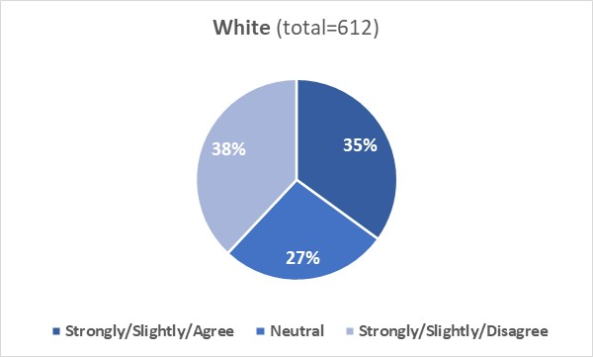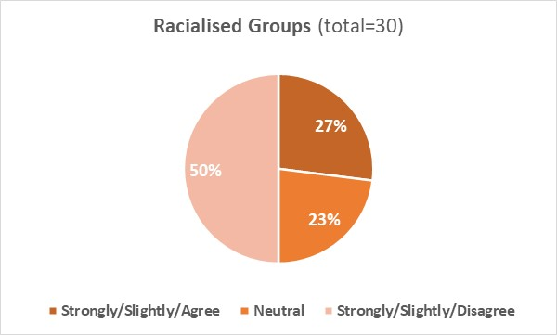
Ethnicity not disclosed (ND) (combined ‘Agree’ 22% (n=13), Neutral 21% (n=12), combined ‘Disagree’57% (n=33)).

Q6-5: I have been encouraged to have my role regraded (Professional Services roles)
8.6A.5: 27% of White and 20% of Racialised Groups respondents in Professional Services roles agreed that they had been encouraged to apply to have their role regraded; 45% of White and 53% of Racialised Groups respondents disagreed that this has occurred (note: regrading takes place in exceptional circumstances in Professional Services when the business need for the role has evolved and extended over time).
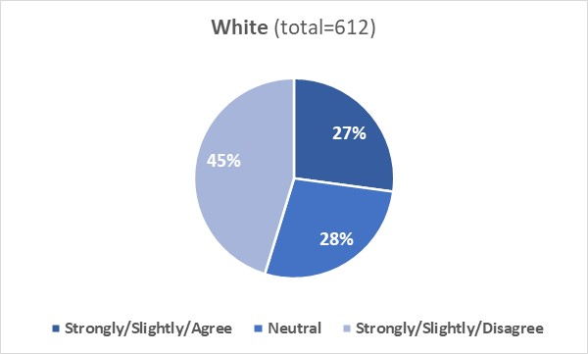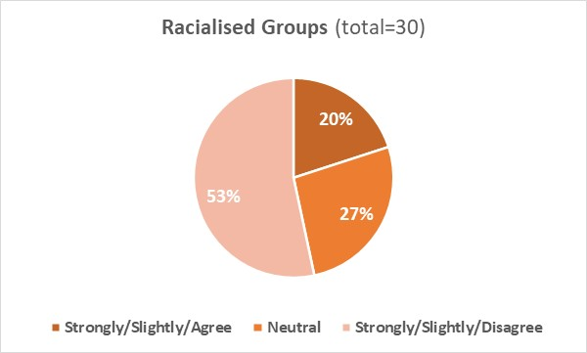
Ethnicity not disclosed (ND) (combined ‘Agree’ 9% (n=5), Neutral 26% (n=15), combined ‘Disagree’ 65% (n=38)).

Q6-6: I have been encouraged to apply for promotion (academic roles)
8.6A.6: 49% of White and 36% of Racialised Groups respondents in academic roles agreed that they have been encouraged to apply for promotion; 23% of White and 34% of Racialised Groups respondents disagreed this has occurred (there is a disparity between the two cohorts).
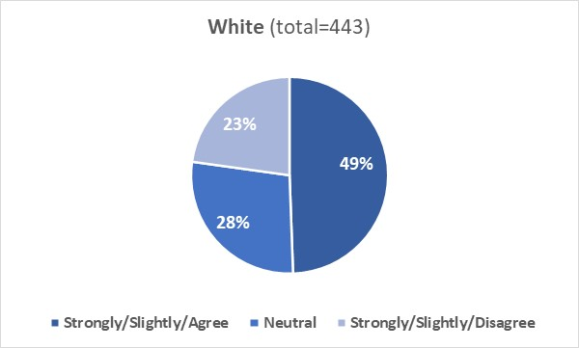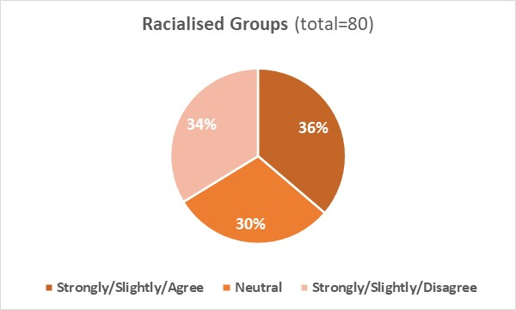
Ethnicity not disclosed (ND) (combined ‘Agree’ 49% (n=46), Neutral 19% (n=18), combined ‘Disagree’ 32% (n=31)).

8.6 B: Qualitative analysis

Comments from White (W) staff to the six questions in section ‘Career development and progression’ were grouped into two broad themes and sub-themes (Table 11).

Table 11: Inductive content analysis of question responses from White staff regarding the staff survey section “Career development and progression”.
Theme number | Theme | Sub-theme
Theme 1 | Positive experience/perception of the promotion process | (none)
Theme 2 | Barriers hindering career progression | - 2.1 Barriers specific to staff role and employment duration  - 2.2 Barriers concerning promotion and regrading structure  - 2.3 Barriers concerning lack of support provided to staff to seek progression  - 2.4 Lack of transparency and fairness in allocation process  - 2.5 Barriers concerning discrimination and bias against certain characteristics  - 2.6 Staff development is not recognised  - 2.7 External barriers

Positive experience/perception of the promotion process
Respondents (W) reported that they had a positive experience/perception of the promotion/regrading process, have had opportunity to discuss career progression with their line manager, felt encouraged/supported to apply by their manager/Head of School, and believed that there is now more transparency in the career progression paths (Theme 1).

Barriers hindering career progression
There are barriers (identified by White respondents) that may hinder career progression. These include:
- Barriers due to role/employment duration: believe they cannot be promoted or regraded because of the nature of their role or the type of their contract (e.g., fixed term, or externally funded or part-time); high workload (leaving no sufficient time for the writing of applications) (sub-theme 2.1)
- Promotion/regrading structure: regrading/promotion processes are stressful or unclear; applications require a significant amount of time; feel discouraged to apply because of the negative experience of others (sub-theme 2.2).
- Lack of support to staff seeking to progress: not feeling encouraged or supported by their line manager to apply for promotion/regrading (process relies heavily on staff putting themselves forward); not enough has been done to support minority staff in their career progression (sub-theme 2.3).
- Lack of transparency/fairness: promotion and regrading lack transparency and fairness with outcomes often affected by nepotism and favouritism; progression opportunities (e.g., acting up roles) are not advertised or are not allocated fairly/transparently (sub-theme 2.4).
- Bias and discrimination against people with some protected characteristics: factors such as age, race, or gender can play a crucial role in being supported/encouraged to apply for or in the outcome of promotion/regrading applications and/or in the allocation of progression opportunities (sub-theme 2.5)
- Staff development is not recognised: lower grades are not valued (sub-theme 2.6)
- External barriers: do not apply for promotion/regrading either because respondents are happy with their current role/grade, or because they are at the top of their career, or because they are about to retire/leave the University or because they believe that the pandemic has hindered their ability to apply (sub-theme 2.7).

Comments from Racialised Group (RG) staff to the six questions in section ‘Career development and progression’ were grouped into two broad themes and sub-themes (Table 12).

Table 12: Inductive content analysis of question responses from Racialised Group staff regarding the staff survey section “Career development and progression”.
Theme number | Theme | Sub-theme
Theme 3 | Positive experience/perception of the promotion process | (none)
Theme 4 | Factors hindering effectiveness of progression process | - 4.1 Lack of fairness/transparency  - 4.2 Lack of supervisorial support  - 4.3 Limited opportunities for progression

Positive experience with the promotion process
Respondents (RG) reported a positive experience/perception of the promotion process. They believed that promotion is transparent and fair, and training and career development courses are helpful (Theme 3).

Factors hindering effectiveness of progression process
There are factors (identified by Racialised Groups respondents) that may hinder progression:
- Lack of fairness/transparency: career progression opportunities (e.g., acting up roles) are not allocated fairly or transparently (e.g., bias/discrimination against race and gender), favouritism occurs in promotion/regrading outcomes (sub-theme 4.1).
- Lack of supervisorial support: some line managers are barely present, are not supportive or not available to discuss career progression/development (sub-theme 4.2).
- Limited opportunities for career progression (sub-theme 4.3).

Examples of quotes by respondents from both cohorts (W and RG) are reported below

“Acting up roles do not seem to be advertised in a fair and transparent way. A few occasions where you see "Interim Role" or "Acting such and such role". I don't know how they are advertised or decided. The advantage this gives the member of staff when the role does come up for advert (which in some cases i don't know if it does) makes the process unfair to the wider staffing body. In some cases, you see someone acting up for months and months, and then suddenly the role is no longer 'acting' and they are in the position”- W staff

“Line manager makes time to discuss, however, how useful and effective these discussion are is another matter. I've not been encouraged to apply for promotion but kept asking about what was required, and based on the fuzzy answer I decided I should just try”- RG staff

“[...] while I haven't been encouraged to take on profile raising or promotion opportunities, I haven't been actively discouraged either. I am a proactive member of staff and I go after opportunities that I think work for my own development and agree these with my line manager”- W staff
“My line manager does not discuss about career development or progression. Process for Career development and progression should be made more accessible to Ethnic minority. Far too often opportunities are given only based on conformity and not based on ability. The University should open up more opportunities for secondment, taking a career break and interim Leadership positions for under-represented Groups”- RG staff

8.7 Annual Review

This section of the survey explored whether staff believed that they have opportunity to undertake annual reviews with their line manager and whether they considered annual review as transparent and useful.

8.7 A: Quantitative analysis
Q7-1: I have annual reviews with my manager
8.7A.1: 84% of White and 85% of Racialised Groups respondents reported that they undertake annual reviews with their manager; 11% of White and 10% of Racialised Groups respondents disagreed they had this opportunity.
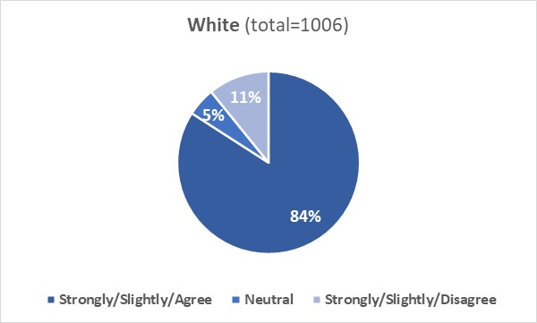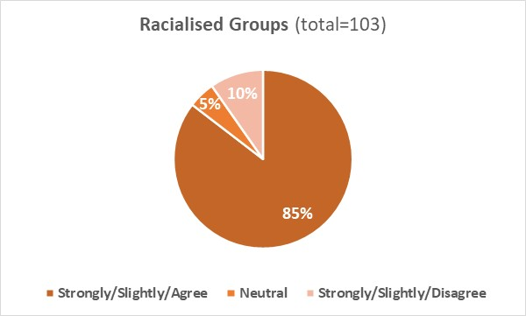
Ethnicity not disclosed (ND) (combined ‘Agree’ 80% (n=122), Neutral 7% (n=10), combined ‘Disagree’ 13% (n=20)).

Q7-2: My manager ensures my annual review is evidence-based and transparent
8.7A.2: 78% of White and 75% of Racialised Groups respondents agreed that their line manager ensures annual reviews are evidence-based and transparent; 9% of White and 12% of Racialised Groups respondents disagreed that this was the case.
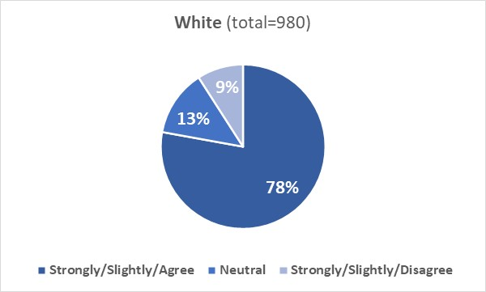
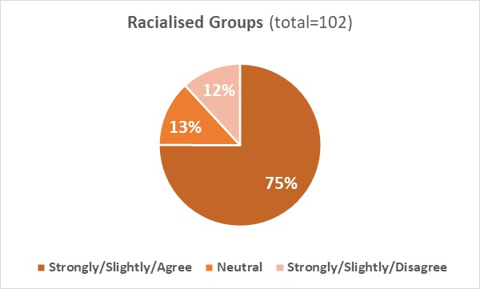
Ethnicity not disclosed (ND) (combined ‘Agree’ 70% (n=105), Neutral 13% (n=20), combined ‘Disagree’ 17% (n=25)).

Q7-3: I find the annual review process useful
8.7A.3:58% of White and 60% of Racialised Groups respondents agreed that annual review process is useful; 27% of White and 26% of Racialised Groups disagreed it is useful.
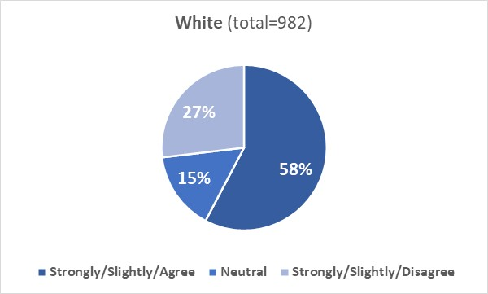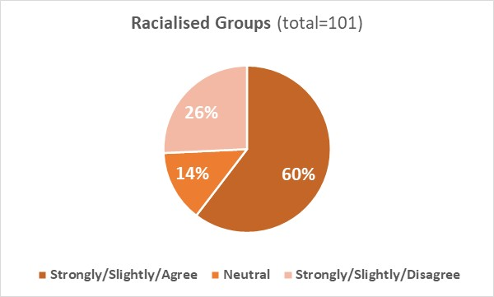
Ethnicity not disclosed (ND) (combined ‘Agree’ 42% (n=64), Neutral 16% (n=24), combined ‘Disagree’ 42% (n=63)).

8.7 B: Qualitative analysis

Comments from White (W) staff to the three questions in section ‘Annual Review’ were grouped into four broad themes and sub-themes (Table 13):

Table 13: Inductive content analysis of question responses from White staff regarding the staff survey section “Annual Review”.
Theme number | Theme | Sub-theme
Theme 1 | New employee of University | (none)
Theme 2 | Positives of Annual Review process | (none)
Theme 3 | Line manager is a key features of appraisal process | (none)
Theme 4 | Factors affecting effectiveness of appraisal process | - 4.1 Oversight limitations  - 4.2 Structural limitations  - 4.3 Role-specific barriers  - 4.4 External barriers

Some respondents (W) reported that they have had no annual review yet as they have not been in the Institution long enough (Theme 1).

Positives of Annual Review process
Respondents (W) who had positive comments about the Annual Review (AR) process reported that AR is useful for discussion with line manager and to get feedback and perspectives on potential areas of growth. AR was also defined as an opportunity to discuss concerns and future aspirations with their line manager (Theme 2).

There were comments where respondents (W) reported that the effectiveness and usefulness of the AR depends strongly on the line manager (Theme 3).

Factors affecting effectiveness of appraisal process
A few factors (identified by White respondents) may affect the effectiveness of the appraisal process:
- Oversight limitations: negative experience with AR; inconsistencies in the way annual reviews are conducted. There were comments where respondents reported that they have never had an AR either because their line manger forgot to conduct the AR or because the system in place does not allow monitoring of completion of the AR (sub-theme 4.1).
- Structural limitations: current AR structure is not effective/necessary, is repetitive, a box ticking exercise, with too much emphasis on future goals; does not help with career progression (e.g., promotion/regrading); can be frustrating and stressful; very rarely the issues raised during AR are addressed (sub-theme 4.2).
- Role-specific barriers: high workload and role-related issues hinder the ability to undertake AR (sub-theme 4.3).
- External barriers: covid-19 pandemic caused delays in the annual review schedule (sub-theme 4.4).

Comments from Racialised Groups (RG) staff to the three questions in section ‘Annual Review’ were grouped into one broad theme (Table 14):

Table 14: Inductive content analysis of question responses from Racialised group staff regarding the staff survey section “Career development and progression’.
Theme number | Theme | Sub-theme
Theme 5 | Annual Review lacks effectiveness and consistency | (none)

Respondents (RG) reported that AR is not useful, lacks effectiveness and consistency, issues raised are never addressed, forms are not useful for academics, and meetings are never followed up (Theme 5).
There were respondents (RG) who were unable to comment further as they were new to the University and have had no AR.

8.8 Flexible working

This section of the survey explored whether staff were aware of the formal flexible working policies and arrangements available, believed that requests of flexible working arrangements would be granted where possible, can take advantage of flexible working options available, and considered their line manager being supportive of flexible working patterns. Both cohorts responded similarly to the questions in this section.

8.8 A: Quantitative analysis
Q8-1: I am aware of the formal flexible and home working policies and arrangements at the Institution, for example, part-time working or condensed hours
8.8A.1: 92% of White and 91% of Racialised Groups respondents agreed that they were aware of the formal flexible and home working policies/arrangements available; 4% of White and 2% of Racialised Groups respondents disagreed they were aware.
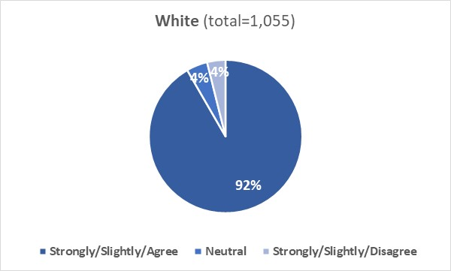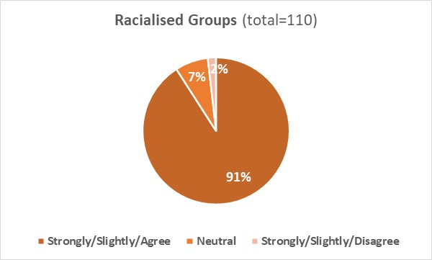
Ethnicity not disclosed (ND) (combined ‘Agree’ 86% (n=131), Neutral 9% (n=14), combined ‘Disagree’ 5% (n=8)).
Q8-2: If I formally requested flexible working arrangements, I am confident that the request would be granted if at all possible
8.8A.2: 80% of White and 78% of Racialised Groups respondents agreed that requests of flexible working would be granted where possible; 11% of White and 10% of Racialised Groups disagreed that would be the case.
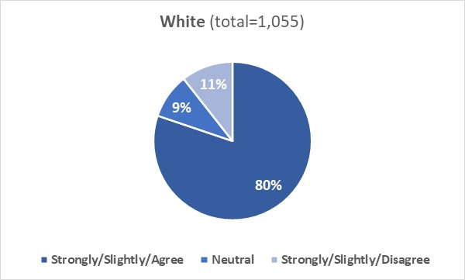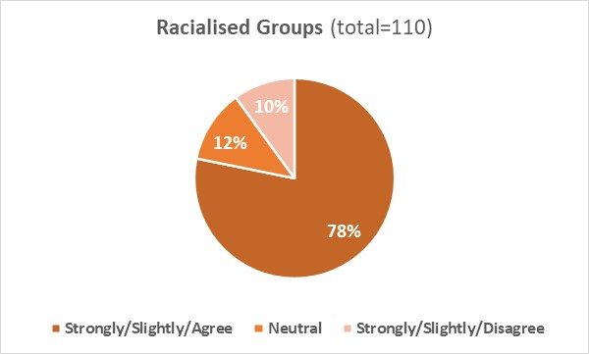
Ethnicity not disclosed (ND) (combined ‘Agree’ 56% (n=86), Neutral 25% (n=38), combined ‘Disagree’ 19% (n=29)).

Q8-3: I can take advantage of flexible/hybrid working for example, irregular/regular working from home or coming in later
8.8A.3: 82% of White and 84% of Racialised Groups respondents agreed that they can take advantage of flexible/hybrid working options available; 11% of White and 5% of Racialised Groups respondents disagreed that this was the case.
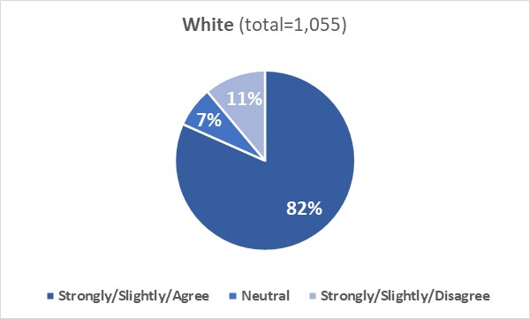
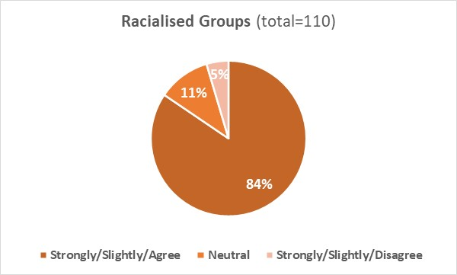
Ethnicity not disclosed (ND) (combined ‘Agree’ 73% (n=111), Neutral 14% (n=22), combined ‘Disagree’ 13% (n=20)).

Q8-4: My manager is supportive of flexible working
8.8A.4: 83% of White and 84% of Racialised Groups respondents agreed that their line manager is supportive of flexible working; 6% of both cohorts disagreed that this was the case.
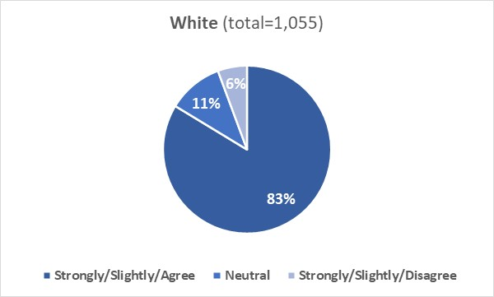
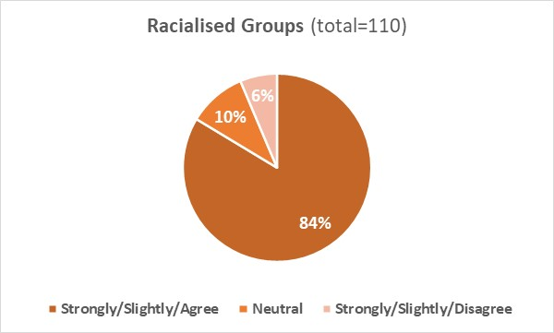
Ethnicity not disclosed (ND) (combined ‘Agree’ 75% (n=114), Neutral 15% (n=23), combined ‘Disagree’ 10% (n=16)).

8.8 B: Qualitative analysis

Comments from White (W) staff to the four questions in section ‘Flexible working’ were grouped into three broad themes and sub-themes (Table 15).

Table 15: Inductive content analysis of question responses from White staff regarding the staff survey section “Flexible working”.
Theme number | Theme | Sub-theme
Theme 1 | Experience with flexible working | - 1.1 Positives of flexibility/flexible working  - 1.2 Negatives of flexible working
Theme 2 | Barriers facing working flexibility | - 2.1 Role-specific barriers  - 2.2 Organisational barriers to home-working  - 2.3 Perception/understanding of working from home
Theme 3 | Manager oversight/relationship with manager/manager flexibility | (none)

Experience with flexible working
Respondents (W) reported that they had a positive experience with flexible working, were taking advantage of the options available, and believed that flexible working options improve wellbeing and life/work balance, ease parenthood, and increase passion and dedication to the job (some respondents reported that they have chosen their current role because it offered flexibility) (sub-theme 1.1).
There were comments where respondents (W) reported to have a negative consideration of flexible working and reported that working from home can be divisive of teams, makes difficult to manage/monitor people working from home and that the University should not allow people to work remotely full-time (sub-theme 1.2)

Barriers facing working flexibility
A few barriers (identified by White respondents) hinder working flexibility:
- Role-specific barriers: flexible working options are either challenging in certain types of roles or not available (e.g., support staff, cleaning staff) (sub-theme 2.1).
- Organisational barriers to home working: not all line managers support flexible working arrangements; perception that there is now expectation from seniors (Heads of School, Heads of department) to end hybrid working pattern; requests of flexible working are rejected without reasonable explanation; condensed hours are not supported by the University, and there are differences between areas of the University about flexible working (sub-theme 2.2).
- Perception/understanding of working from home: feeling guilty not to be present on campus, or under pressure to return on campus (sub-theme 2.3).
There were comments where respondents (W) reported that their line manager is supportive or would be supportive of flexible working if role allowed (Theme 3).

Comments from Racialised Groups (RG) staff to the four questions in section ‘Flexible working’ were grouped into three broad themes (Table 16)

Table 16: Inductive content analysis of question responses from Racialised Group staff regarding the staff survey section “Flexible working”.
Theme number | Theme | Sub-theme
Theme 4 | Positive experience with flexible working | (none)
Theme 5 | Flexible working arrangements not always suitable | (none)
Theme 6 | University is not very flexible | (none)

Positive experience with flexible working
Respondents (RG) reported that their line manager and HR are supportive of flexible working, they were informed about flexible working options available, and that the University is doing very well in terms of flexibility (Theme 4).

Issues/inconsistency with flexible working
There were comments where respondents (RG) reported that they prefer to work on campus or believed that flexible working options are not suitable for specific roles (Theme 5).

Issues reported include inconsistency in the way flexible working is granted, with some being able to work from home and others not allowed (e.g., teaching staff were asked to return on campus despite this would pose risks to their health) (Theme 6).

8.9 Pay

This section of the survey explored whether staff thought to be paid the same as their colleagues who do the same job and whether they thought that pay awards and increases are allocated fairly and transparently.

8.9 A: Quantitative analysis
Q9-1: I think I am paid the same as my colleagues who do the same job
8.9A.1: 59% of White and 65% of Racialised Groups respondents agreed that they are paid on a parity with colleagues in the same role; 22% of White and 19% of Racialised Groups respondents disagreed that this occurs.
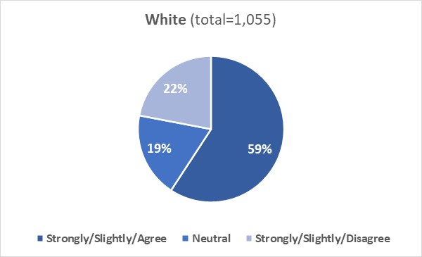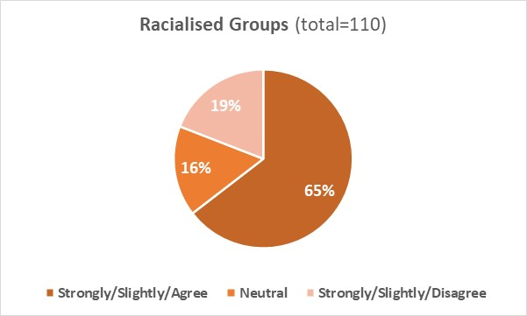
Ethnicity not disclosed (ND) (combined ‘Agree’ 44% (n=67), Neutral 21% (n=32), combined ‘Disagree’ 35% (n=54)).

Q9-2: Pay awards and increases are allocated fairly and transparently
8.9A.2: 46% of White and 50% of Racialised Groups respondents agreed that pay awards/increases are allocated fairly and transparently; 26% of White and 25% of Racialised Groups respondents disagreed that this is fair and transparent.
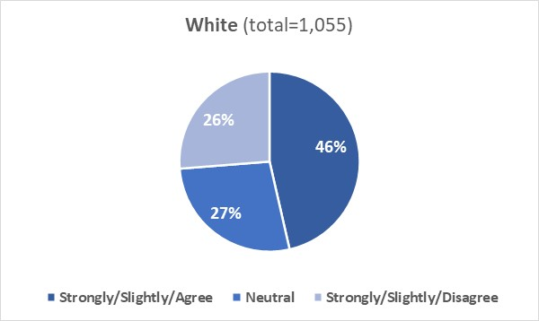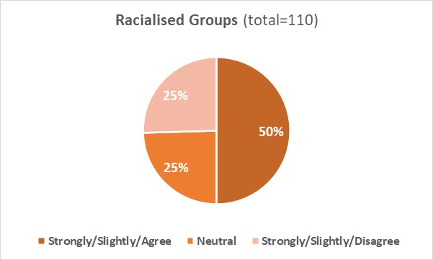
Ethnicity not disclosed (ND) (combined ‘Agree’ 25% (n=38), Neutral 28% (n=43), combined ‘Disagree’ 47% (n=72)).

8.9 B: Quantitative analysis

Comments from White (W) staff to the two questions in section ‘Pay’ were grouped into five broad themes and sub-themes (Table 17).

Table 17: Inductive content analysis of question responses from White staff regarding the staff survey section “Pay”.
Theme number | Theme | Sub-theme
Theme 1 | Positives of salary allocation process | (none)
Theme 2 | Positives of pay-award process | (none)
Theme 3 | No experience with pay award/increase | (none)
Theme 4 | Limitations of pay-award allocation process | - 4.1 Lack of awareness/transparency concerning process  - 4.2 Grade/role-specific limitations  - 4.3 Allocation of pay awards is not fair  - 4.4 Application process is discouraging
Theme 5 | Hinderances in salary allocation | - 5.1 Process lacks fairness/transparency  - 5.2 Presence of gender discrimination

Positives of salary allocation/pay-award process
Respondents (W) reported that they believed the University is improving staff pay, the grade scale is transparent and fair, their current salary and spinal point are good, and there are attempts by the University to close the gender pay gap (Theme 1). Respondents also reported that the University recognises the value of its staff, and pay increases/awards are allocated fairly and transparently (based on grades) (Theme 2).
Some respondents (W) could not comment further as they have had no experience with pay rise and awards (Theme 3).

Limitations of pay-award allocation process
Respondents (W) identified limitations in the pay-award allocation process:
- Lack of awareness/transparency of the process: both the criteria and the process for allocating pay awards are not transparent, fair, and consistent. Lack of awareness about how the allocation works was also reported (sub-theme 4.1)
- Grade/role-specific limitations: pay rises stop when the top spinal point of the grade is reached; it is difficult to get further pay rises at grade 9 or in technical positions (sub-theme 4.2).
- Allocation of pay awards is not fair: the University does not recognise increases in responsibilities and the hard work; the way pay rises are allocated seems to be subjective and not transparent/fair (sub-theme 4.3).
- Application process is discouraging: the application process for pay increases are quite discouraging; promotion and regrading processes are demotivating (sub-theme 4.4).

Hinderances in salary allocation
Hinderances (identified by White respondents) in salary allocation include:
- Lack of fairness/transparency of the process: lack of transparency in the pay rises allocation to senior staff (including members of senior management team); lack of consistency in the way staff in similar roles are paid within the same department or between departments; lack of consistency about how externally hired staff and internally promoted staff are paid (sub-theme 5.1).
- Presence of gender discrimination: existence of gender pay discrimination particularly at professorial level with female professors being paid less than male professors (sub-theme 5.2).

Comments from Racialised Groups (RG) staff to the questions in section ‘Pay’ were grouped into two broad themes and sub-themes (Table 18).

Table 18: Inductive content analysis of question responses from Racialised Groups staff regarding the staff survey section “Pay”.
Theme number | Theme | Sub-theme
Theme 6 | Factors of transparency in allocation of salary | (none)
Theme 7 | Factors hindering effectiveness of pay rise/award process | - 7.1 Presence of bias/discrimination in allocation process  - 7.2 Pay rises are not enough

Lack of transparency in allocation of salary
There were comments where respondents (RG) reported that they were not aware about the allocation of salary and did not know how much their colleagues earned (Theme 6)

Factors hindering effectiveness of pay rise/award process
Respondents (RG) reported the occurrence of gender and/or race inequality in the allocation of pay increases (sub-theme 7.1).
There were comments where respondents (RG) reported that pay rises are not significant and don’t keep up with cost of living (sub-theme 7.2).

Examples of quotes by respondents from both cohorts (W and RG) are reported below.

“It’s hard to get a pay rise even with high levels of performance - I have not received a merit based pay rise for 8+ years despite an increase in performance”- W staff

“I have no idea what the pay grades of my peers are and 1% a year for inflation is not exactly generous, in addition you do not get a pay advance or promotion if you deserve it. The promotion is not initiated by the employer - you have to spend at least a week filling in forms to beg for a promotion or more responsibility”- RG staff

“The promotions and regrading exercises are cumbersome and not reflective of a person’s contribution - once you reach the ceiling of your pay grade it is difficult to go anywhere or achieve any reward for performance”- W staff

“Race pay gap exists and the University needs to be focused to tackling this gap”- RG staff

“In some ways pay is transparent. However, there was a point in my career here where I was paid significantly less than two people hired for similar roles around the same time as me, one of whom had far less experience”- W staff

“Opportunities should be provided fairly to build capacity. When there is output, it is fine but some people hold on to the roles for ever, with no progress made. This hinders efficient people progressing. We don't nurture our own to promote them to have some stability. Some efficient people leave because there is no opportunity for progression within, which is a shame”- RG staff

Race Equality Charter Survey: Student Responses

Students were invited to provide their views on their experience of studying at the University of Aberdeen and answer questions which would support the identification of racial inequalities within our policies and processes. The University used the survey template provided by Advance HE.

Areas covered in the survey were the following:
- Diversity of the Institution (section 9.1)
- Diversity of the local population (section 9.2)
- Reporting racial discrimination (section 9.3)
- Recommending the Institution (section 9.4)
- Course progression (section 9.5)
- Further study (section 9.6)
- Employment (section 9.7)
- Course content (section 9.8)
- Course format (section 9.9)
- Assessment & Support (section 9.10)
- Students’ union (section 9.11)

Information about Presentation of results & Terminology can be found in section 5.

9.1: Diversity of the Institution
This section of the survey explored whether students considered the ethnic racial diversity of the University before applying to study here, and whether the ethnic/racial diversity impacted on their sense of belonging and desire to stay.

9.1A: Quantitative analysis
Q1-1: I considered the ethnic/racial diversity of the University of Aberdeen before applying to study here
9.1A.1: 22% of White and 55% of Racialised Groups respondents did consider the racial/ethnic diversity of the University when they applied to study here; 57% of White and 28% of Racialised Groups did not (a disparity is observed between the two cohorts).
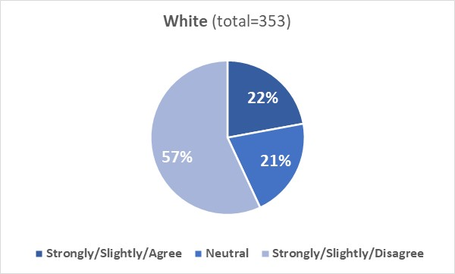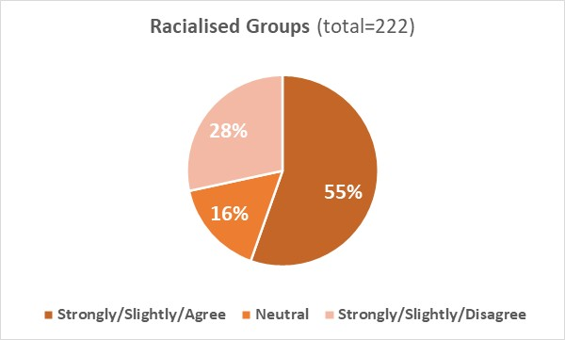
Ethnicity not disclosed (ND) (combined ‘Agree’ 33% (n=10), Neutral 7% (n=2), combined ‘Disagree’ 60% (n=18)).

Q1-2. The ethnic/racial diversity of the University of Aberdeen impacts on my sense of belonging
9.1A.2: The diversity (or lack of diversity) of the University impacted on sense of belonging to the University for 34% of White and 65% of Racialised Groups respondents; 33% of White and 18% of Racialised Groups disagreed that diversity impacted them (a disparity is observed between the two cohorts).
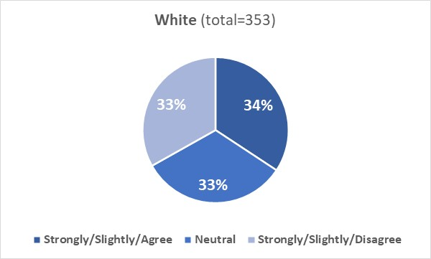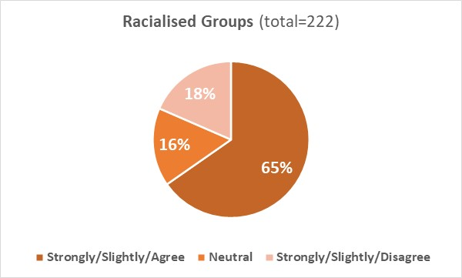
Ethnicity not disclosed (ND) (combined ‘Agree’ 33% (n=10), Neutral 10% (n=3), combined ‘Disagree’ 57% (n=17)).

Q1-3. The ethnic/racial diversity of the University of Aberdeen impacts on my desire to stay
9.1A.3: The diversity (or lack of diversity) of the University impacted on the desire to stay of 40% of White and 64% of Racialised Groups respondents; 34% of White and 21% of Racialised Groups respondents disagreed that diversity impacted them (a disparity is observed between the two cohorts).
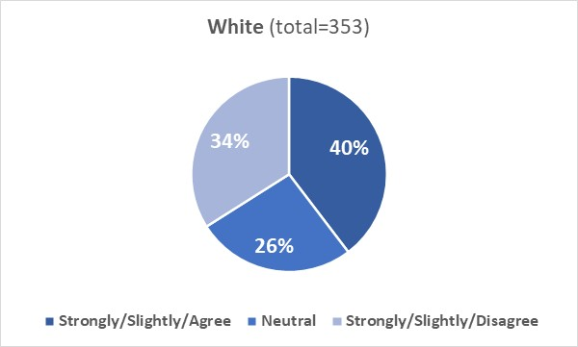
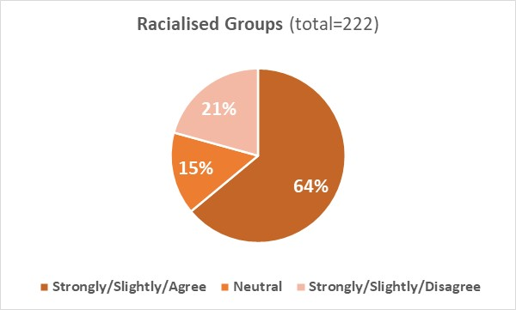
Ethnicity not disclosed (ND) (combined ‘Agree’ 33% (n=10), Neutral 13% (n=4), combined ‘Disagree’ 53% (n=16)).

9.1B: Qualitative analysis

Comments from White (W) students to the three questions in section ‘Diversity of the Institution’ were grouped into two broad themes and sub-themes (Table 19)

Table 19: Inductive content analysis of question responses from White students regarding the student survey section “Diversity of the Institution”.
Theme number | Theme | Sub-theme
Theme 1 | Perception of University’s current diversity/inclusivity | - 1.1 Positive  - 1.2 Negative
Theme 2 | Influence of University’s ethnic/racial diversity | - 2.1 Limited influence on University experience  - 2.2 Significant/positive influence on University experience

Perception of the University’s current diversity/inclusivity
Students (W) had either a positive or a negative perception of the diversity/inclusivity of the University. Those who had a positive perception reported that the University is welcoming and inclusive, treats everyone well, is diverse, and works against discrimination (sub-theme 1.1). Those who had a negative perception reported that the University is not racially diverse and would prefer an Institution with more diversity (sub-theme 1.2).

Influence of University’s ethnic/racial diversity
Students (W) reported that they did not consider the ethnic/racial diversity when they applied to study here, never felt they did not belong in the University (as a part of the majority background), have had no issues to interact with people from different ethnic/racial backgrounds, and that they applied to study here only because of the course being taught (sub-theme 2.1).
There were comments where students (W) reported that they appreciate the diversity of the Institution, that the diversity of the Institution improves desire to stay and impacts on sense of belonging, and that they considered the ethnic/racial diversity of the Institution before applying to study here (sub-theme 2.2).

Comments from Racialised Groups (RG) students to the three questions in section ‘Diversity of the Institution’ were grouped into a broad theme and sub-themes (Table 20).

Table 20: Inductive content analysis of question responses from Racialised Groups students regarding the student survey section “Diversity of the Institution”.
Theme number | Theme | Sub-theme
Theme 3 | Influence of University’s diversity/equality/inclusivity | - 3.1 Negative  - 3.2 Positive  - 3.3 No influence

Students (RG) who had a negative perception of the ethnic/racial diversity of the Institution reported that racism is widespread on campus, that they are treated unequally by their lecturers, find difficult to network with people from minority ethnicities and that the lack of diversity affects their desire to stay here (sub-theme 3.1).
Students (RG) who had a positive experience at the University reported that the Institution is diverse and welcoming, feel accepted irrespective of their ethnic/racial background, appreciate the University’s effort to tackle racism, and recognised that diversity improves experience at the University, increases sense of belonging and desire to stay (sub-theme 3.2).
There were comments from students (RG) who reported that they did not consider the ethnic/racial diversity of the Institution when they applied to study here, that diversity is not important to them, and lack of diversity does not affect their sense of belonging and their desire to stay (sub-theme 3.3).

Examples of quotes by respondents from both cohorts (W and RG) are reported below.
“My main reason for choosing Aberdeen was the availability of a course I wanted to study and its location. Outside of that I didn't consider anything really. But having now attended for 3 years I love that it is a School that prides itself on equality and diversity”- W student

“Diversity is not an important consideration for me in choosing where I want to do my studies but clearly affects my sense of belonging within the University”- RG student

“I acknowledge that because of my background and skin colour I didn't have to consider if I would feel included or safe before applying, and still will feel included way easier because of these reasons”- W student

“The University of Aberdeen has a diverse range of students, lecturers and tutors from all backgrounds, races and sexualities which makes the experience more inclusive for everyone in attendance and also depicts the value of everyone regardless of their race or origin”- RG student

“For me, the diversity of the students and staff at this university is a benefit to the university experience as a whole - allowing us the experiences of working with people from many different backgrounds”- W student

“The staff and professor racial diversity in University of Aberdeen is poor. It impacts negatively my desire to stay and my sense of belonging in the academic community”- RG staff

9.2: Diversity of the local population
This section of the survey explored whether the ethnic/racial diversity of the local population impacted on our students’ day-to-day life and whether they were aware of ethnic/racial tensions within the local community.

9.2A: Quantitative analysis
Q2-1. The ethnic/racial diversity of the local population impacts on my day-to-day life
9.2A.1: The diversity (or lack of diversity) of the local population impacted on the day-to-day life of 19% of White and 59% of Racialised Groups respondents; 49% of White and 21% of Racialised Groups respondents disagreed that diversity impacted them (a disparity is observed between the two cohorts).
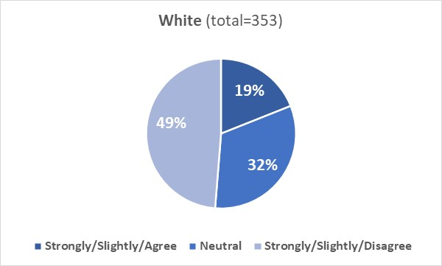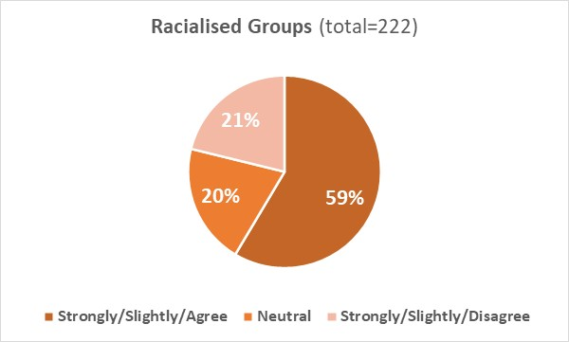
Ethnicity not disclosed (ND) (combined ‘Agree’ 53% (n=16), Neutral 23% (n=7), combined ‘Disagree’ 23% (n=7)).
Q2-2. I am aware of ethnic/racial tensions within the local community
9.2A.2: 30% of White and 50% of Racialised Groups respondents agreed they were aware of ethnic/racial tensions within the local community; 54% of White and 29% of Racialised Groups respondents were not aware (a disparity is observed between the two cohorts).
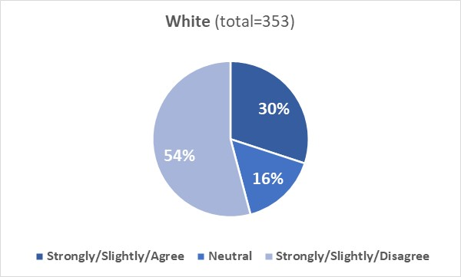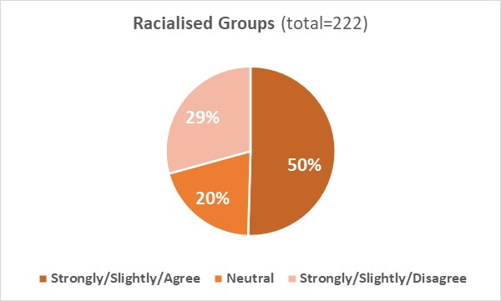
Ethnicity not disclosed (ND) (combined ‘Agree’ 50% (n=15), Neutral 17% (n=5), combined ‘Disagree’ 33% (n=10)).

9.2B: Qualitative analysis

Comments from White (W) students to the two questions in section ‘Diversity of the local population’ were grouped into two broad themes and sub-themes (Table 21).

Table 21: Inductive content analysis of question responses from White students regarding the student survey section “Diversity of the local population”.
Theme number | Theme | Sub-theme
Theme 1 | Diversity/inclusivity of the local community | - 1.1 Positive influence/perception  - 1.2 Negative influence/experience  - 1.3 No significant influence
Theme 2 | Racial/ethnic tensions in the local community | - 2.1 Present in local community  - 2.2 Not aware of them in local community

Diversity/inclusivity of the local community
Students (W) who felt positively affected by the ethnic/racial diversity of the local population reported that Aberdeen is a diverse city, appreciate networking with people from different ethnic backgrounds, and recognise the benefits of living in a multicultural city (sub-theme 1.1). Students (W) who had a negative experience reported both differential treatment and racism (as witness) in the local population (sub-theme 1.2).
There were comments where students (W) reported that the ethnic/racial diversity had no significant influence on them (sub-theme 1.3).

Racial/Ethnic tensions in the local community
Students (W) reported occurrence of racial/ethnic tensions in the local community affecting not only people from Racialised Groups but also those from a White background (Scots vs English; discrimination against Polish) (sub-theme 2.1).
There were comments where students (W) reported not to be aware/victim/witness of ethnic/racial tensions in the local community (sub-theme 2.2).

Comments from Racialised Groups (RG) students to the two questions in section ‘Diversity of the local population’ were grouped into one broad theme and sub-themes (Table 22).

Table 22: Inductive content analysis of question responses from Racialised Groups students regarding the student survey section “Diversity of the local population”.
Theme number | Theme | Sub-theme
Theme 3 | Perception of diversity/equality within local population | - 3.1 Positive  - 3.2 Negative

Comments from students (RG) reported either a positive or a negative perception of the diversity/equality within the local population.
Those who had a positive perception reported that Aberdeen is diverse, have been treated well irrespective of their ethnic background, considered the ethnic/racial diversity important to improve living experience, were not aware or have never witnessed/been victim of ethnic/racial tensions in the local population (sub-theme 3.1).
Students (RG) who had a negative perception reported that Aberdeen is not diverse, racism is widespread in the local community, and have witnessed/been victim of racism in the local population (sub-theme 3.2).

Examples of quotes by respondents from both cohorts (W and RG) are reported below.

“The ethnic and racial diversity makes a positive impact on my daily life”- W student

“There is a tonne of microaggressions which impact the daily experiences of racialised people here in Aberdeen. Then there are structural issues within the university which impede racial equality, for example within staffing as well as around handling of racism complaints”- RG student

“I am aware of racism and inequality around me, and always know that it exists wherever you go, but I have never experienced it myself or seen someone experience it”- W student

“I am aware that many people in Aberdeen are not as accepting or friendly to most people of colour and I feel that the university could help by organising specific events targeted toward protected characteristics”- RG student

“Friends of mine have mentioned their experiences of racial tension within the community, although I have not personally experienced it”- W student

“I have not felt any racial tensions or problems in my day-to-day life due to race within the university or in an university setting of any kind. However, I have experienced some tensions in the local community and in general public spaces”- RG student

“Scottish people are racist toward English people all the time; is this on your agenda to address or do you only care about racism when it's done by white people on black people?”- W student

9.3: Reporting racial discrimination
This section of the survey explored whether students have witnessed/been victim of racial discrimination on campus or in the local area, whether they knew how to report a race-related incident to the Institution and whether they believed an appropriate action would be taken in case a race-related incident is reported.

9.3A: Quantitative analysis
Q3-1. I have witnessed or been the victim of racial discrimination on campus
9.3A.1: 91% of White and 65% of Racialised Groups disagreed they have witnessed or been the victim of racial discrimination on campus; 5% of White and 23% of Racialised Groups respondents reported that they had witnessed or experienced it on campus (a disparity is observed between the two cohorts).
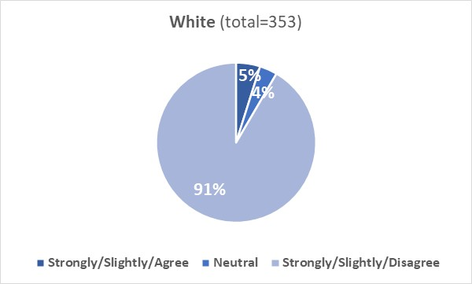
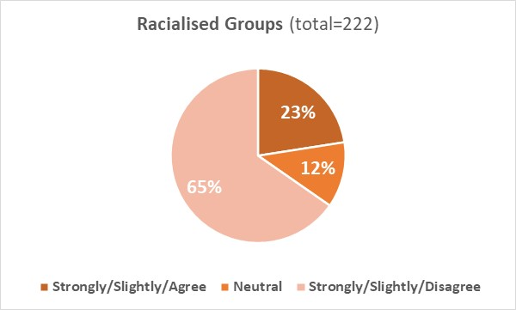
Ethnicity not disclosed (ND) (combined ‘Agree’ 73% (n=22), Neutral 3% (n=1), combined ‘Disagree’ 23% (n=7)).
Q3-2. I have witnessed or been the victim of racial discrimination in the local area
9.3A.2: 83% of White and 55% of Racialised Groups respondents disagreed that they have witnessed or been the victim of racial discrimination in the local area; 14% of White and 34% of Racialised Groups agreed they had witnessed or experienced it in the local area (a disparity is observed between the two cohorts).
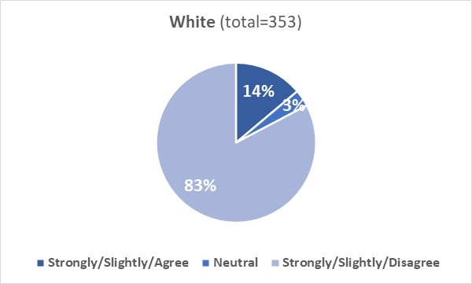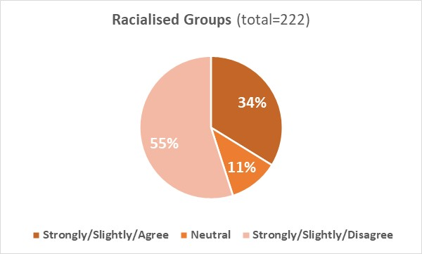
Ethnicity not disclosed (ND) (combined ‘Agree’ 67% (n=20), Neutral 10% (n=3), combined ‘Disagree’ 23% (n=7)).

Q3-3. I know how to report a race-related incident in my institution
9.3A.3: 48% of White and 51% of Racialised Groups respondents knew how to report a race-related incident to the University, with 42% of White and 39% of Racialised Groups respondents stating they did not know it.
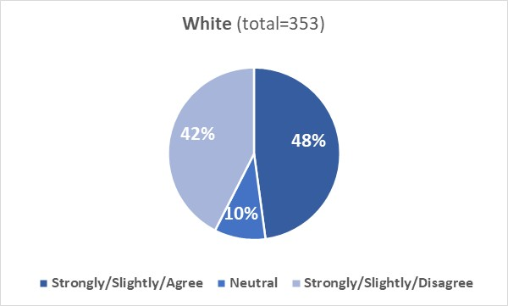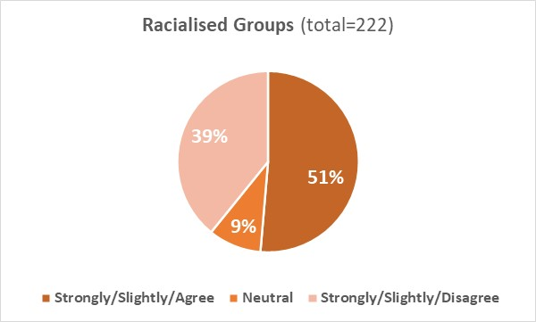
Ethnicity not disclosed (ND) (combined ‘Agree’ 53% (n=16), Neutral 10% (n=3), combined ‘Disagree’ 37% (n=11)).

3-4. If I reported a race-related incident to my institution, appropriate action would be taken
9.3A.4: 60% of White and 51% of Racialised Groups respondents agreed that an appropriate action would be taken in case of a disclosure of a race-related incident; 6% of White and 15% of Racialised Groups disagreed that this would be the case (a disparity is observed between the two cohorts).
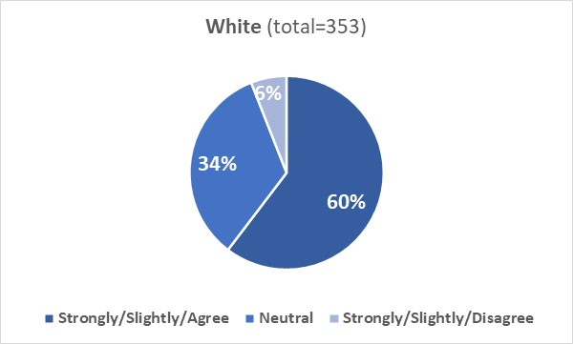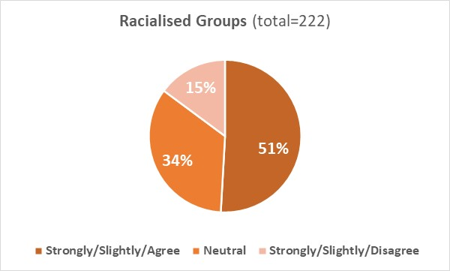
Ethnicity not disclosed (ND) (combined ‘Agree’ 43% (n=13), Neutral 40% (n=12), combined ‘Disagree’ 17% (n=5)).

9.3B: Qualitative analysis

Comments from White (W) students to the four questions in section ‘Reporting racial discrimination’ were grouped into three themes and sub-themes (Table 23)

Table 23: Inductive content analysis of question responses from White students regarding the student survey section “Reporting racial discrimination”.
Theme number | Theme | Sub-theme
Theme 1 | Experienced/witnessed racial discrimination | (none)
Theme 2 | Awareness/positive perception of reporting process | (none)
Theme 3 | Factors hindering reporting of racial/ethnic discrimination | - 3.1Limited awareness/knowledge on reporting process/outcomes  - 3.2 Not experienced/witnessed discrimination  - 3.3 Perceived/known limitations of reporting process  - 3.4 Environmental barriers  - 3.5 Personal barriers

Experience of racial discrimination
Comments within theme 1 were from students (W) who reported that they have been victim/have witnessed racial discrimination (verbal assault from member of staff, racist comments observed in the classroom, racism due to English or non-UK backgrounds)

Awareness/positive perception of reporting process
There were comments were students (W) reported a positive perception of the reporting process, believed/experienced that the University takes racial discrimination seriously and appropriate action would be/was taken to resolve a race-related incident (Theme 2).

Factors hindering reporting ethnic/racial discrimination
Factors (identified by White students) that may hinder reporting of discrimination include:
- Limited awareness/knowledge on reporting process/outcomes: unaware of the reporting process; unsure whether an action would be taken if a race-related incident would be reported; unaware of outcomes of reported incidents (sub-theme 3.1).
- Not experienced/witnessed discrimination (sub-theme 3.2).
- Perceived/known limitations of reporting process: racial incidents reported by/against white people would not be taken seriously; witnessed incidents that were not handled well; students are not trained to recognise aggressive behaviour (sub-theme 3.3).
- Environmental barriers: some areas discourage reporting of incidents (sub-theme 3.4).
- Personal barriers: would report incident only if they were sure about the outcome; microaggressions are too subjective to report (sub-theme 3.5).

Comments from Racialised Groups (RG) students to the four questions in section ‘Reporting racial discrimination’ were grouped into two broad themes and sub-themes (Table 24)

Table 24: Inductive content analysis of question responses from Racialised Groups students regarding the student survey section “Reporting racial discrimination”.
Theme number | Theme | Sub-theme
Theme 4 | Racial discrimination in University/community | - 4.1 Has witnessed/experienced racial discrimination  - 4.2 Has never witnessed/experienced racial discrimination
Theme 5 | Experience/perception of reporting process | - 5.1 Positive  - 5.2 Negative  - 5.3 Limited

Racial discrimination in University/community
Students (RG) reported different experience of racial discrimination, with some reporting to have witnessed/have been victim of racial discrimination on campus (in the University halls, in classrooms) and/or in the local area (sub-theme 4.1), while other respondents (RG) reporting that they have never experienced/witnessed racial discrimination (sub-theme 4.2).

Experience/perception of reporting process
Students (RG) who had a positive perception of the reporting process reported that the University is committed to address racial discrimination and structures are in place to report race-related incidents (sub-theme 5.1). Students (RG) who had a negative perception reported that the University does not handle race-related incidents well, do not expect that appropriate action would be taken in case a race-related incident is reported and considered the support for those reporting an incident not sufficient/good (sub-theme 5.2).
There were students (RG) who reported limited knowledge/awareness of the reporting process available at the University, never reported an incident, and were unsure whether an appropriate action would be taken in case of a disclosure (sub-theme 5.3).

Examples of quotes by respondents from both cohorts (W and RG) are reported below.

“I haven't witnessed any racial discrimination (obviously that doesn't mean it doesn't happen though). However, if I did see one, I have no idea how to report the incident to the university, and I also would have no idea whether appropriate action would be taken”- W student

“No action has ever been taken of my knowledge when racism was reported “- RG student

“I don't feel that a racially based attack on someone of a majority race would be taken seriously”- W student

“The university does not have specific support for students and staff experiencing racial discrimination and harassment. From personal experience, I am aware that correct action will not be taken”- RG student

“I would only report a racial incident if it came from a university staff member and a clear racist view or statement. “Micro aggressions” are too subjective to report”- W students

“Some mechanisms to complain are in place but without support and counselling for victims the process as it is now makes it harder and tiring for victims than for accused people. This means having supporting staff that is trained but also that has lived experience, otherwise it just won't work. Without appropriate support people won't feel safe to raise their voices and things won't change”- RG student

9.4 Recommending the Institution
This section of the survey explored whether students would recommend the Institution to a prospective student.

9.4A: Quantitative analysis
Q4-1. I would recommend my institution to a prospective student
9.4A.1: 89% of White and 83% of Racialised Groups respondents reported that they would recommend the Institution to a prospective student with 4% of White and 5% of Racialised Groups respondents disagreeing that they would.
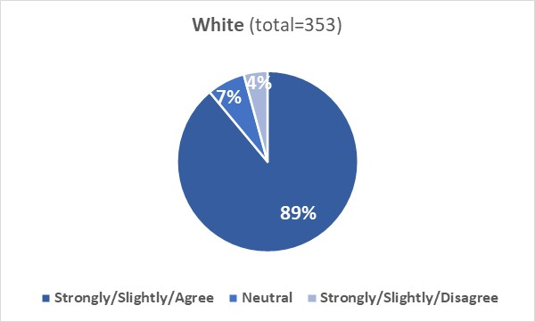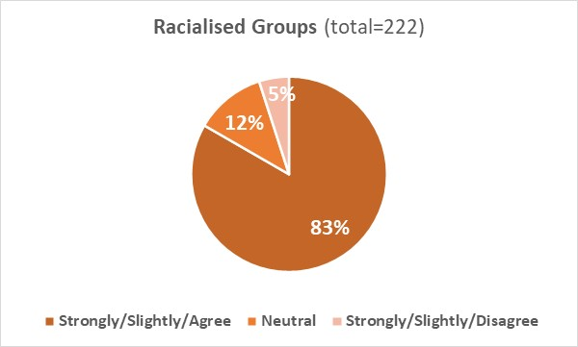
Ethnicity not disclosed (ND) (combined ‘Agree’ 67% (n=20), Neutral 23% (n=7), combined ‘Disagree’ 10% (n=3)).

9.4B: Qualitative analysis

Comments from White (W) students to the question in section ‘Recommending the Institution’ were grouped into one broad theme and sub-themes (Table 25).

Table 25: Inductive content analysis of question responses from White students regarding the student survey section “Recommending the Institution”.
Theme number | Theme | Sub-theme
Theme 1 | Perception/experience at the University | - 1.1 Positive  - 1.2 Negative  - 1.3 Neutral

Students (W) who had a positive perception or experience at the University reported that the University is safe, welcoming and supportive with great, friendly and approachable staff. They would recommend the Institution (or own department) also for reasons not related to race (e.g., high quality of teaching) (sub-theme 1.1).
Students (W) who had a negative perception or experience reported that they would not recommend the University for various reasons (lack of support for postgraduate students during the pandemic, not satisfied with learning during the pandemic, (lack of) facilities for students) (sub-theme 1.2). There were comments where students (W) reported that recommending the Institution would depend on type of student or their political views (sub-theme 1.3).

Comments from Racialised Groups (RG) students to the question in section ‘Recommending the Institution’ were grouped into one broad theme and sub-themes (Table 26).

Table 26: Inductive content analysis of question responses from Racialised Groups students regarding the student survey section “Recommending the Institution”.
Theme number | Theme | Sub-theme
Theme 2 | Perception/experience at the University | - 2.1 Positive  - 2.2 Negative  - 2.3 Neutral

Students (RG) reported either a positive or a negative experience in our Institution. Those who had a positive experience reported that they would recommend the Institution (or own department) to a prospective student, feel treated equally by teachers and appreciate the work the University is doing to tackle racism (sub-theme 2.1).
Those who had a negative perception/experience reported that they would not recommend the Institution for various reasons (unfair treatment by staff, lack of communication and transparency, Institution is not welcoming) (sub-theme 2.2).
There were comments where students (RG) said that recommending the Institution would depend on type of student and degree of interest (sub-theme 2.3).

9.5: Course progression
This section of the survey explored whether students felt they were progressing well in their course and were asked to anticipate the grade they will probably graduate with.

9.5A: Quantitative analysis
Q5-1. I am progressing well in my course
9.5A.1: 90% of White and 89% of Racialised Groups respondents agreed they were progressing well in their course, with 5% of both cohorts disagreeing with this.
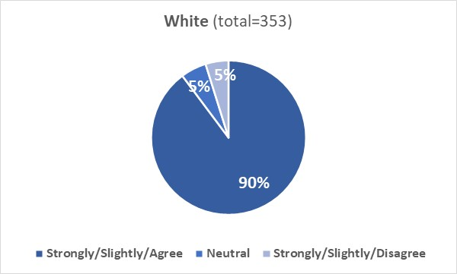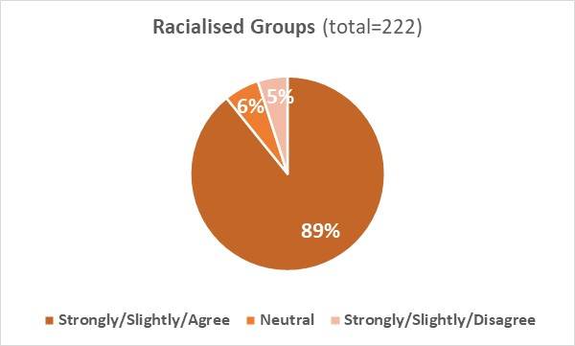
Ethnicity not disclosed (ND) (combined ‘Agree’ 83% (n=25), Neutral 13% (n=4), combined ‘Disagree’ 3% (n=1)).

Q5-2. I anticipate that I will graduate with 1st degree class, 2:1 degree, 2:2 degree, Third/pass or none of the options listed.
9.5A.2: 31% of White and 36% of Racialised Groups anticipated they will graduate with 1st class degree, 52% of White and 44% of Racialised Groups with 2:1 degree, 10% of White and 11% of Racialised Groups with 2:2 degree, 2% of both cohorts with Third/pass, and 5% of White and 8% of Racialised Groups with none of the options listed.
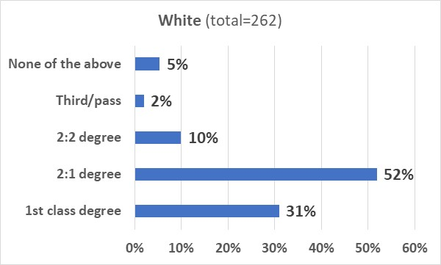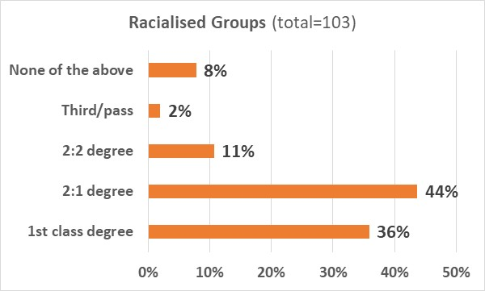
Ethnicity not disclosed (ND) (1st class degree= 43% (9), 2:1= 43% (9), 2:2= 5% (1), none of the above= 10% (3))

9.5B: Qualitative analysis

Comments from White (W) students to the two questions in section ‘Course progression’ were grouped into two broad themes and sub-themes (Table 27).

Table 27: Inductive content analysis of question responses from White students regarding the student survey section “Course progression”.
Theme number | Theme | Sub-theme
Theme 1 | Positive experience with academic support/courses | (none)
Theme 2 | Barriers hindering academic performance | - 2.1 School-specific barriers  - 2.2 Individual-specific barriers  - 2.3 Covid-specific barriers

Comments within theme 1 were from students (W) who had a positive experience and reported that the University is supportive, great lecturers and online materials, never felt overwhelmed by coursework, and feel supported to achieve best grade.

Barriers hindering academic performance
A few barriers (identified by White students) may hinder academic performance:
- School-specific barriers: no good supervision for PhD students, course content not relevant for future career, issues with online teaching (sub-theme 2.1).
- Individual-specific barriers: experiencing stress, mental health issues, feeling under pressure due to other commitments (e.g. full-time job) (sub-theme 2.2).
- Covid-specific barriers: progression/PhD affected by the pandemic (sub-theme 2.3).

Comments from Racialised Groups (RG) students to the two questions in section ‘Course progression’ were grouped into two broad themes and sub-themes (Table 28).

Table 28: Inductive content analysis of question responses from Racialised Groups students regarding the student survey section “Course progression”.
Theme number | Theme | Sub-theme
Theme 3 | Positive experience with course | (none)
Theme 4 | Barriers hindering academic performance and/or progression | - 4.1 Course/structural barriers  - 4.2 Language specific barriers  - 4.3 Personal barriers

Comments within theme 3 were from students (RG) who had a positive experience and reported that they are progressing well, enjoy their course, feel well supported and have not experienced/witnessed racism in classrooms.

Barriers hindering academic performance/progression
Barriers (identified by Racialised Groups students) may hinder academic performance and progression:
- Course/structural barriers: gap between university’s promotion of wellbeing and its actual effectiveness, high grades are given easily, issues with remote studying (sub-theme 4.1).
- Language-specific barriers: difficult to understand teachers’ language or accents (sub-theme 4.2).
- Personal barriers: experiencing mental health issues, study progress was affected by the pandemic (sub-theme 4.3).

9.6: Further study
This section of the survey explored whether students would consider, where relevant, a postgraduate course, or a PhD (after completion of the masters’ degree) or a career in academia.

9.6A: Quantitative analysis
Q6-1. Where relevant, I would consider a postgraduate course
9.6A.1: 78% of White and 79% of Racialised Groups respondents agreed that they would consider a postgraduate course; 13% of White and 9% of Racialised Groups respondents disagreed that they would consider it.
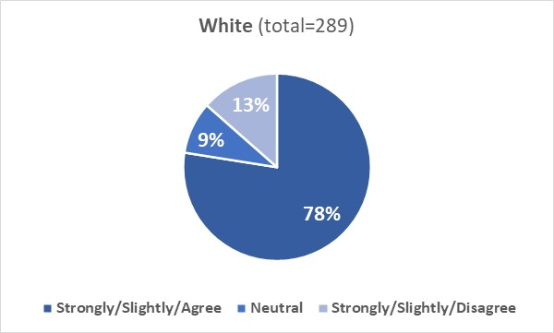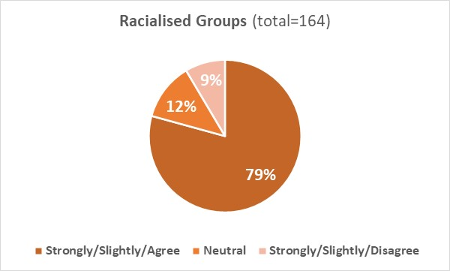
Ethnicity not disclosed (ND) (combined ‘Agree’ 61% (n=14), Neutral 22% (n=5), combined ‘Disagree’ 17% (n=4)).

Q6-2. Where relevant, I would consider a PhD once I have completed my masters' degree
9.6A.2: 61% of White and 66% of Racialised Groups respondents agreed that they would consider a PhD once they have completed their masters’ degree; 25% of White and 15% of Racialised Groups respondents disagreed they would consider it.
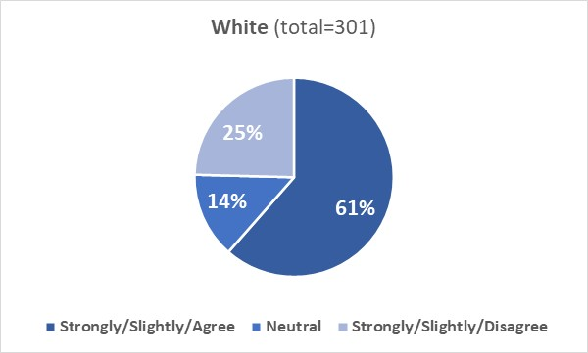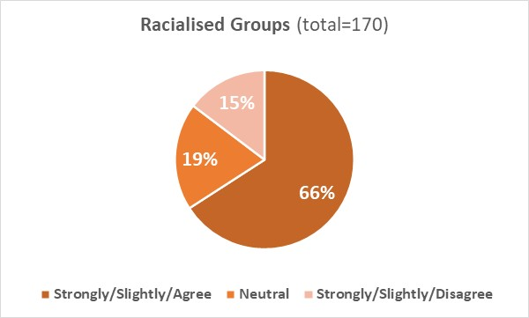
Ethnicity not disclosed (ND) (combined ‘Agree’ 67% (n=20), Neutral 23% (n=7), combined ‘Disagree’ 10% (n=3)).

Q6-3. I would consider a career in academia
9.6A.3: 50% of White and 53% of Racialised Groups respondents agreed that they would consider a career in academia; 32% of White and 26% of Racialised Groups disagreed that they would consider it.
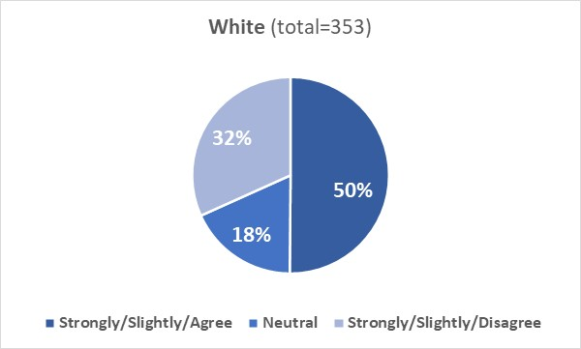
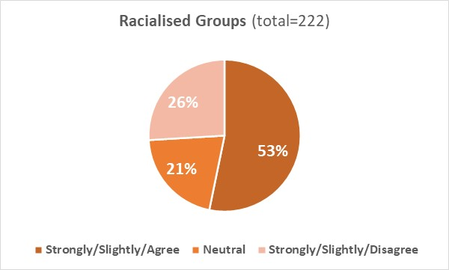
Ethnicity not disclosed (ND) (combined ‘Agree’ 54% (n=16), Neutral 20% (n=6), combined ‘Disagree’ 27% (n=8)).

9.7: Employment
This section of the survey explored whether students felt that they have a good understanding of the graduate-level employment opportunities available, and whether they thought that the University has helped them develop the skills required for graduate-level jobs.

9.7A: Quantitative analysis
Q7-1. I have a good understanding of the graduate-level employment opportunities available to me
9.7A.1: 61% of White and 60% of Racialised Groups respondents agreed that they had a good understanding of the graduate-level employment opportunities available; 28% of White and 23% of Racialised Groups disagreed with this.
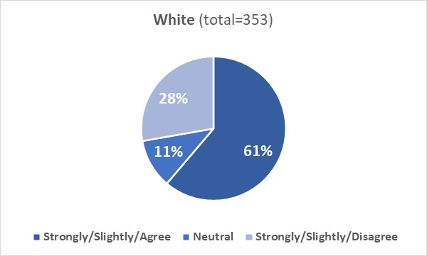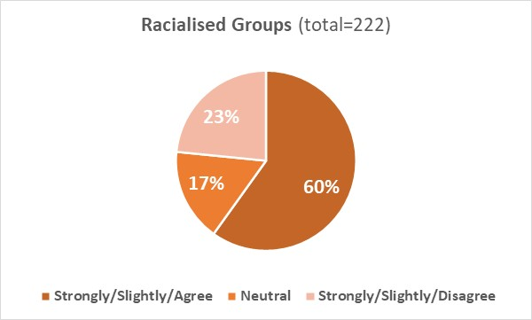
Ethnicity not disclosed (ND) (combined ‘Agree’ 67% (n=20), Neutral 10% (n=3), combined ‘Disagree’ 23% (n=7)).

Q7-2. The University of Aberdeen has helped me develop the skills I need to apply for graduate-level jobs
9.7A.2: 58% of White and 67% of Racialised Groups respondents agreed that the University has helped them develop the skills needed to apply for graduate-level jobs; 20% of White and 11% of Racialised Groups disagreed with this statement (a disparity is observed between the two cohorts).
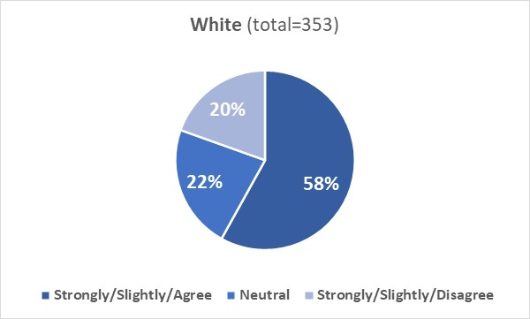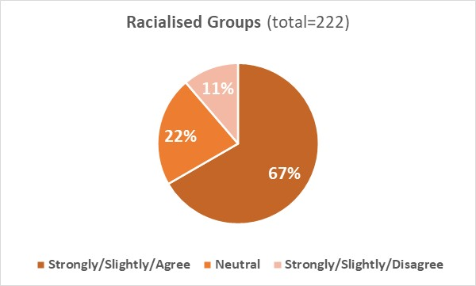
Ethnicity not disclosed (ND) (combined ‘Agree’ 60% (n=18), Neutral 23% (n=7), combined ‘Disagree’ 17% (n=5)).

9.7B: Qualitative analysis

Comments from White (W) students to the two questions in section ‘Employment’ were grouped into two broad themes and sub-themes (Table 29).

Table 29: Inductive content analysis of question responses from White students regarding the student survey section “Employment”.
Theme number | Theme | Sub-theme
Theme 1 | Positive experience/perception of University’s career and employability services | (none)
Theme 2 | Factors hindering ability to obtain a job/career | - 2.1 Limited/negative experience with career and employability services  - 2.2 Personal barriers  - 2.3 Course-specific barriers

Comments within theme 1 were from students (W) who had a positive experience or perception of the University’s career and employability services. Respondents reported that the University provides many opportunities to develop skills, is very focussed on employability and provides information sessions and skill-tutoring sessions.

Factors hindering ability to obtain a job/career
A few factors (identified by White respondents) may hinder the ability to obtain a job/career:
- Limited/negative experience with career/employability services: skills acquired not sufficient for a job; had to pursue external experience to be employable; difficult to follow career-related events due to course; information sessions on career opportunities often clash with other courses (sub-theme 2.1).
- Personal barriers: first year student not yet looking at graduate-level jobs; not considering having a career; not engaging with services provided by the University (sub-theme 2.2).
- Course-specific barriers: course does not lead to a specific job field; degree does not provide practical skills; some courses have more graduate job options than others (sub-theme 2.3).

Comments from Racialised Groups (RG) students to the two questions in section ‘Employment’ were grouped into two broad themes (Table 30)

Table 30: Inductive content analysis of question responses from Racialised Groups students regarding the student survey section “Employment”.
Theme number | Theme | Sub-theme
Theme 3 | Positive experience/perception of University employability services | (none)
Theme 4 | University employability services lack effectiveness | (none)

Comments within theme 3 were from students (RG) who reported a positive experience with the employability services provided by the University. They reported that they have had opportunity to attend career workshops, have been greatly assisted by the career service, and have learnt and developed several skills.
Those who had negative experience/perception with the employability services provided by the University reported that career service contact is inconsistent and late; services are pandered more to undergraduate; felt they have not developed any relevant skills from classes/workshops (Theme 4).

Examples of quotes by respondents from both cohorts (W and RG) are reported below.
“UoA is very focused on employability, and I love that. Makes me feel really comfortable about my future prospects”- W student

“I haven't yet had a detailed look into graduate level employment but I am sure the uni would help”- RG student

“I don't think they are teaching us enough skills that employers look for in the real-world setting. There is not enough connection being made between what we are learning and how it applies outside the lecture sometimes”- W student

“I have learnt many things and have developed many skills and that's really helping to shape my skills and knowledge”- RG student

“I am being only advised what sector I can apply. However, in my previous university many of my friends found a job with University assistance. University contacted with possible employers and they were hired. It was a bit of disappointment that it’s not happening in University of Aberdeen”- W student

“I have not developed any of the skills required to apply for graduate level jobs from any of my classes or additional workshops”- RG student

“The university has helped me develop skills in one certain area for my degree, just not the rest of them. Maybe make sure the classes focused on graduate-level jobs include more than just one type of job”- W student

9.8: Course content
This section of the survey explored whether students felt that the content of their course matches their expectations, their course reflects the opinions of a wide variety of people, whether issues of ethnicity/race are included in academic discussions and whether course tutors/lectures are confident/competent in facilitating discussions around race and ethnicity.

9.8A: Quantitative analysis
Q8-1. The content of my course matches my expectations and includes what I thought it would include
9.8A.1: 79% of White and 82% of Racialised Groups respondents agreed that their course matches their expectations and includes what they thought would include; 13% of White and 10% of Racialised Groups disagreed with this statement.
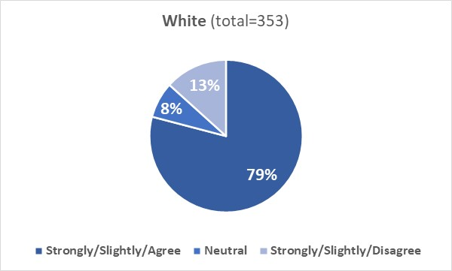
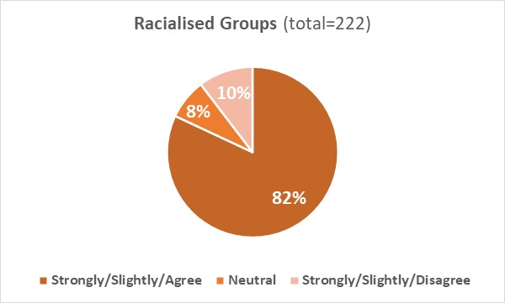
Ethnicity not disclosed (ND) (combined ‘Agree’ 73% (n=22), Neutral 13% (n=4), combined ‘Disagree’ 13% (n=4)).
Q8-2. The content of my course reflects the opinions of a wide variety of people
9.8A.2: 70% of White and 71% of Racialised Groups respondents agreed that their course reflects the opinion of a wide variety of people; 14% of White and 10% of Racialised Groups respondents disagreed with this statement.
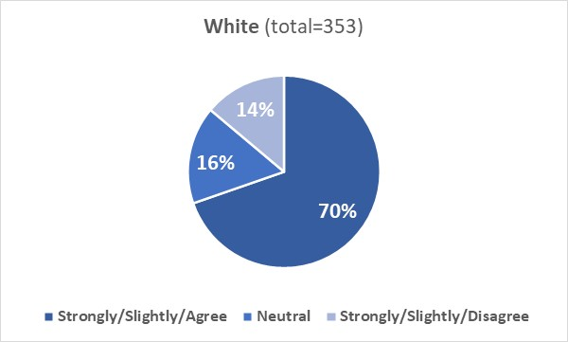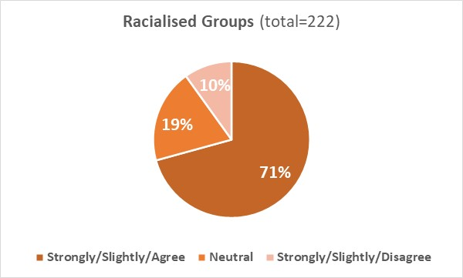
Ethnicity not disclosed (ND) (combined ‘Agree’ 57% (n=17), Neutral 26% (n=8), combined ‘Disagree’ 17% (n=5)).

Q8-3. When relevant, issues of ethnicity and race are included in academic discussions
9.8A.3: 65% of White and 51% of Racialised Groups respondents agreed that when relevant issues of ethnicity and race are included in academic discussions; 10% of White and 22% of Racialised Groups respondents disagreed that this was the case (a disparity is observed between the two cohorts).
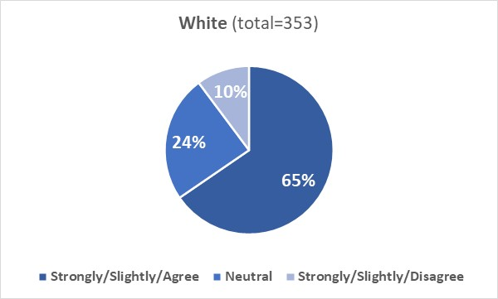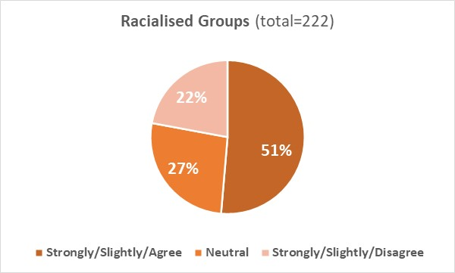
Ethnicity not disclosed (ND) (combined ‘Agree’ 40% (n=12), Neutral 43% (n=13), combined ‘Disagree’ 17% (n=5)).

Q8-4. When relevant, my course tutors and lecturers are confident and competent in facilitating discussions around ethnicity and race
9.8A.4: 62% of White and 53% of Racialised Groups agreed that when relevant course tutors and lecturers are confident and competent in facilitating discussions around ethnicity and race; 9% of White and 15% of Racialised Groups respondents disagreed that this was the case (a disparity is observed between the two cohorts).
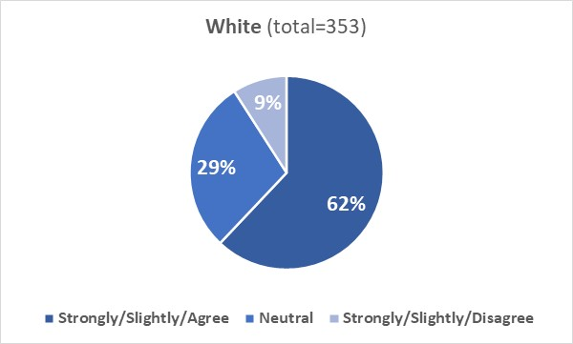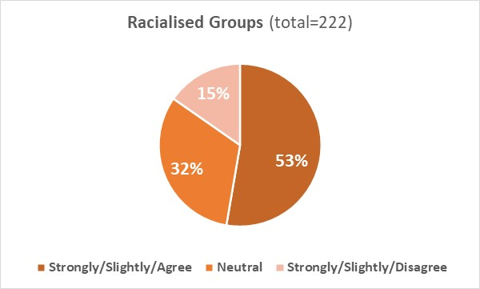
Ethnicity not disclosed (ND) (combined ‘Agree’ 53% (n=16), Neutral 33% (n=10), combined ‘Disagree’ 13% (n=4)).

9.8B: Qualitative analysis

Comments from White (W) students to the four questions in section ‘Course content’ were grouped into two broad themes and sub-themes (Table 31).

Table 31: Inductive content analysis of question responses from White students regarding the student survey section “Course content”.
Theme number | Theme | Sub-theme
Theme 1 | Discussion of ethnicity/race within course | - 1.1 Positive experience of discussions  - 1.2 Can still be improved  - 1.3 Should be avoided
Theme 2 | Issues hindering discussions of ethnicity/race within course | - 2.1 Course-specific barriers  - 2.2 Teaching-specific barriers  - 2.3 Course-material related barriers  - 2.4 Personal barriers

Discussions of ethnicity/race within course
Students (W) reported different opinions about the inclusion of topics such as race and ethnicity within their courses.
Those who had a positive experience reported that these topics were handled well in their courses, tutors/ lecturers were open and comfortable to discuss these topics and some lecturers are involved in the decolonising the curriculum work (sub-theme 1.1).
There were comments where students (W) reported that courses could include a more diverse range of resources, and discussions about race and ethnicity should be improved (sub-theme 1.2). However, for some respondents (W) decolonising the curriculum is wrong as well as politicising certain courses (sub-theme 1.3).

Issues hindering discussions of ethnicity/race within courses
Some issues (identified by White students) may hinder discussions of race/ethnicity within courses:
- Course-specific barriers: race and ethnicity topics are not relevant in their disciplines (science, engineering, math, psychology) (sub-theme 2.1).
- Teaching-specific barriers: discussions concerning black/brown people are not done to the same extent as on Europeans; lecturers avoid discussions on race and ethnicity (sub-theme 2.2).
- Course-material related barriers: course material focus on White people; not enough time to discuss race and ethnicity (sub-theme 2.3).
- Personal barriers: some respondents do not pay attention to these topics (sub-theme 2.4).

Comments from Racialised Groups (RG) students to the four questions in section ‘Course content’ were grouped into two broad themes and sub-themes (Table 32).

Table 32: Inductive content analysis of question responses from Racialised Groups students regarding the student survey section “Course content”.
Theme number | Theme | Sub-theme
Theme 3 | Positive experience of discussions | (above)
Theme 4 | Issues hindering discussions of ethnicity/race within course | - 4.1 Structural barriers  - 4.2 Course-specific barriers

Within theme 3 there were comments from students (RG) who reported that discussions concerning race/ethnicity are handled well.

Issues hindering discussions of ethnicity/race within courses
Issues (identified by Racialised Groups students) that may hinder discussions of ethnicity/race within courses include:
- Structural barriers: race and ethnicity not discussed although they are relevant within some courses; discussions of race brought up despite lack of relevance (sub-theme 4.1).
- Course-specific barriers: race and ethnicity not relevant to the course or never discussed within some courses (sub-theme 4.2).

Examples of quotes by respondents from both cohorts (W and RG) are reported below.

“The course materials are heavily white-washed and no specific information has been brought to attention to include diverse representation of the subject”- W student

“My degree doesn't really require discussions on race and ethnicity but where it was handled so far it was met with seriousness, maturity and equity”- RG student

“There are very few relevant instances of any need to discuss race in my department, the materials used are varied and represent the cutting edge of research without reference to race or ethnicity. If a question did arise from students I feel the faculty would be able to respond and discuss the situation well”- W student

“Issues of ethnicity and race are in almost all cases irrelevant. Unless the topic of the academic discussion is about race itself”- RG student

“Ethnicity and race are not relevant discussion points for my course (science), so this has never been discussed. Similarly, course content reflecting opinions of a wide variety of people is not relevant”- W student

“As well as these [race and ethnicity] I also believe that there is not enough discussion about anti-Semitism when it comes to discourse around ethnicity and race. Many people assume that anti-Semitism is just a religious intolerance. This does not sufficiently account for those people who identify as ethnically Jewish but who do not practice the religion. Nor does this take into account that much of the discrimination that Jews have experienced in the past has been carried out on both religious and ethnic lines”- RG student

“Lecturers tend to be uncomfortable with discussing ethnicity and race, which is understandable”- W student

9.9: Course format
This section of the survey explored whether students enjoyed the way their course is taught, and whether they felt comfortable to contribute to group discussions and approach course tutors with any questions or queries.

9.9A: Quantitative analysis
Q9-1. I enjoy the way my course is taught
9.9A.1: 76% of White and 74% of Racialised Groups respondents agreed that they enjoy the way their course is taught; 15% of White and 13% of Racialised Groups respondents disagreed they enjoy it.
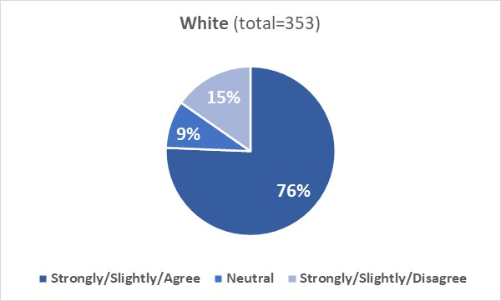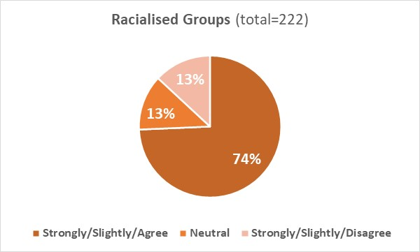
Ethnicity not disclosed (ND) (combined ‘Agree’ 57% (n=17), Neutral 27% (n=8), combined ‘Disagree’ 16% (n=5)).

Q9-2. I am comfortable contributing to group discussions
9.9A.2: 82% of White and 88% of Racialised Groups respondents agreed that they are confident contributing to group discussions; 12% of White and 9% of Racialised Groups respondents disagreed they are confident.
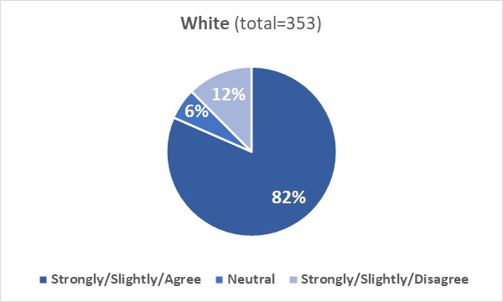
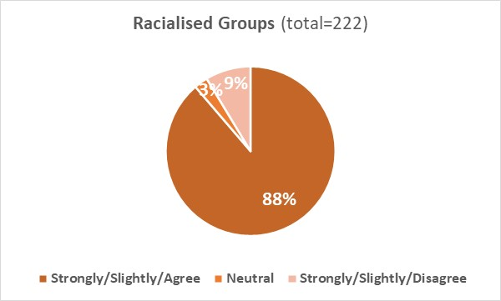
Ethnicity not disclosed (ND) (combined ‘Agree’ 80% (n=24), Neutral 13% (n=4), combined ‘Disagree’ 7% (n=2)).

Q9-3. I am comfortable approaching course tutors with any questions or queries
9.9A.3: 86% of White and 84% of Racialised Groups respondents agreed that they are comfortable approaching course tutors with any questions or queries; 7% of White and 9% of Racialised Groups respondents disagreed they are comfortable.
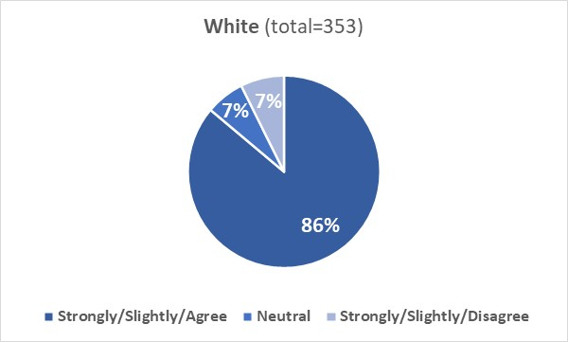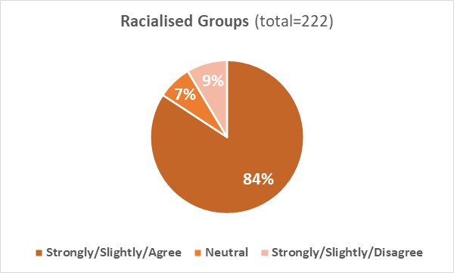
Ethnicity not disclosed (ND) (combined ‘Agree’ 83% (n=25), Neutral 10% (n=3), combined ‘Disagree’ 7% (n=2)).

9.9B: Qualitative analysis

Comments from White (W) students to the three questions in section ‘Course format’ were grouped into two broad themes and sub-themes (Table 33)

Table 33: Inductive content analysis of question responses from White students regarding the student survey section “Course format”.
Theme number | Theme | Sub-theme
Theme 1 | Comfortable approaching tutors/engaging in classes | (none)
Theme 2 | Factors hindering approachability of tutors/contribution to class | - 2.1 Negative/limited experience or perception of tutors  - 2.2 Class-specific barriers  - 2.3 Personal/external barriers

Comments within theme 1 were from students (W) who reported to feel comfortable to contribute to group discussions and considered their tutors/lecturers as approachable and friendly.

Factors hindering approachability of tutors/contribution to class
A few factors (identified by White students) may hinder approachability or ability to contribute to group discussions:
- Negative or limited experience/perception of tutors: Professors/course coordinators lack approachability/openness; no response received from tutors to queries submitted either by email or via MyAberdeen; been given incorrect information from tutors (sub-theme 2.1).
- Class-specific barriers: lecture format hinders interaction between students and tutors; not much discussion occurs due to small number of students present (sub-theme 2.2).
- Personal/external barriers: uncomfortable to ask questions; too shy to speak up during discussions; covid has affected confidence talking during seminars (sub-theme 2.3).

Comments from Racialised Groups (RG) students to the three questions in section ‘Course format’ were grouped into two broad themes and sub-themes (Table 34).

Table 34: Inductive content analysis of question responses from Racialised Groups students regarding the student survey section “Course format”.
Theme number | Theme | Sub-theme
Theme 3 | Comfortable approaching tutors/engaging in classes | (none)
Theme 4 | Factors hindering approachability of tutors/contribution to class | - 4.1 Staff-specific limitations  - 4.2 Personal limitations  - 4.3 Topic-specific limitations

There were comments where students (RG) reported to feel comfortable to ask questions and contribute to group discussions and considered their tutors inclusive, open and approachable (Theme 3).

Factors hindering approachability of tutors/contribution to class
A few factors (identified by Racialised Groups students) may hinder approachability or ability to contribute to group discussions:
- Staff-specific limitations: staff are not approachable or discourage asking questions or do not reply to queries (sub-theme 4.1).
- Personal limitations: respondents reported to be shy or to feel uncomfortable to speak out in class (sub-theme 4.2).
- Topic-specific limitations: respondents reported to feel uncomfortable to contribute to discussions about race, diversity or colonialism (sub-theme 4.3).

9.10: Assessment and support
This section of the survey explored whether students were happy with the way their course is assessed and whether they knew where to get additional academic support.

9.10A: Quantitative analysis
Q10-1. I am happy with the way my course is assessed
9.10A.1: 83% of White and 81% of Racialised Groups respondents agreed that they are happy with the way their course is assessed; 8% of White and 11% of Racialised Groups disagreed that they are happy.
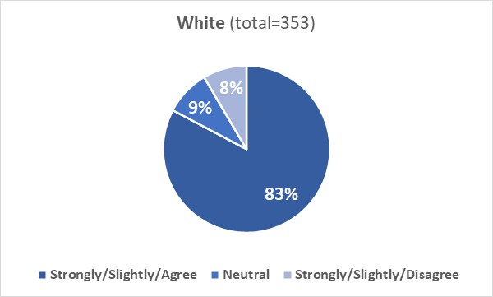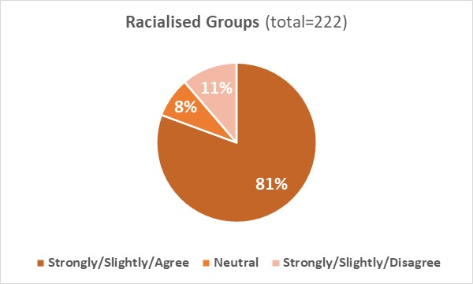
Ethnicity not disclosed (ND) (combined ‘Agree’ 87% (n=26), Neutral 10% (n=3), combined ‘Disagree’ 3% (n=1)).

Q10-2. I know where to go to get additional academic support if and when I need it
9.10A.2: 82% of respondents from both cohorts agreed that they know where to get additional academic support; 12% of White and 10% of Racialised Groups respondents disagreed that they know it.
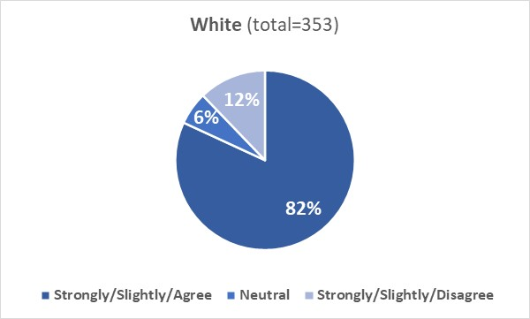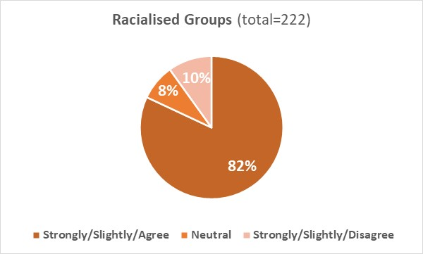
Ethnicity not disclosed (ND) (combined ‘Agree’ 73% (n=22), Neutral 13% (n=4), combined ‘Disagree’ 13% (n=4)).

9.10B: Qualitative analysis

Comments from White (W) students to the two questions in section ‘Assessment and Support’ were grouped into four broad themes and sub-themes (Table 35).

Table 35: Inductive content analysis of question responses from White students regarding the student survey section “Assessment & Support”.
Theme number | Theme | Sub-theme
Theme 1 | Positive experience with assessment/academic support | (none)
Theme 2 | Factors hindering effectiveness of assessment | - 2.1 Organisational/structural barriers  - 2.2 Personal barriers
Theme 3 | Limited/lack of experience with academic support | (none)
Theme 4 | Limited awareness about academic support | (none)

Positive experience with assessment/academic support
Students (W) reported to be happy with the way their course is assessed, appreciated communications from the University about the support available to students and reported to have had a positive experience with the academic support received (Theme 1).

Factors hindering effectiveness of assessment
Students (W) identified a few factors that may hinder the effectiveness of assessment:
- Organisational/structural barriers: too many participation grades; online open book assessments are not ideal; assessments are too theoretical, or subjective and vary across courses (sub-theme 2.1)
- Personal barriers: Some forms of disability or neurodiversity (e.g., dyslexia) hinder performance (sub-theme 2.2)

Limited/lack of experience/knowledge about academic support
There were comments where students (W) reported limited or lack of experience with academic support (Theme 3) or limited awareness about the type of academic support available (lack of clarity in the information provided or support is not well advertised) (Theme 4).

Comments from Racialised Groups (RG) students to the two questions in section ‘Assessment and Support’ were grouped into two broad themes and sub-themes (Table 36).

Table 36: Inductive content analysis of question responses from Racialised Groups students regarding the student survey section “Assessment and Support”.
Theme number | Theme | Sub-theme
Theme 5 | Experience with assessment | - 5.1 Positive  - 5.2 Negative
Theme 6 | Experience with academic support | - 6.1 Positive  - 6.2 Negative

Students (RG) reported either a positive or negative experience with both assessment and academic support.

Experience with assessment
Students (RG) who had a positive experience with the assessment, reported they were satisfied with the way the assessments are carried out (sub-theme 5.1); however, there were comments where respondents reported that course mark allocation is not fairly distributed, and high grades are given too freely (sub-theme 5.2).
Experience with academic support
Students (RG) who had a positive experience with the academic support reported that guidance on the support available is clear, teachers are caring, and the University has a good structure (sub-theme 6.1). However, there were comments where respondents reported that course coordinators are not supportive, accessing student support is difficult and they have not been guided in their own department (sub-theme 6.2).

9.11: Students’ union
This section of the survey explored whether students regularly attend students’ union events, whether they were members/thinking to become members of students’ societies, whether they thought that students from all racial and ethnic backgrounds are included equally at all students’ union events and societies, and whether racially offensive/inappropriate behaviours are not tolerated at events and activities organised by the students’ union.

9.11A: Quantitative analysis
Q11-1. I regularly attend students' union events
9.11A.1: 12% of White and 22% of Racialised Groups respondents agreed that they regularly attend students’ union events; 78% of White and 61% of Racialised Groups disagreed with this statement (a disparity is observed between the two cohorts).
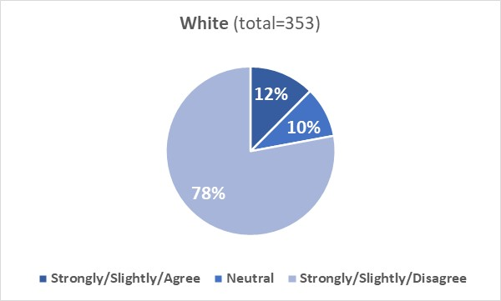
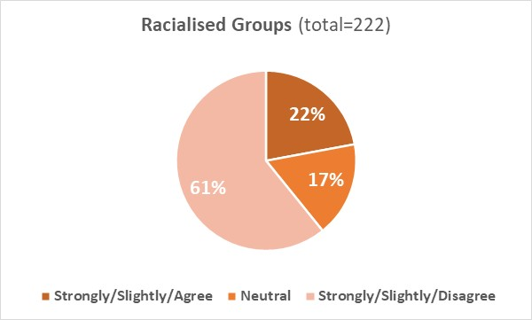
Ethnicity not disclosed (ND) (combined ‘Agree’ 13% (n=4), Neutral 13% (n=4), combined ‘Disagree’ 74% (n=22).
Q11-2. I am a member, or am thinking of becoming a member, of one or more student societies
9.11A.2: 56% of White and 58% of Racialised Groups respondents agreed that they are members or are thinking to become members of one or more student societies; 36% of White and 23% of Racialised Groups respondents disagreed with this statement (a disparity is observed between the two cohorts disagreeing with the statement of Q11-2).
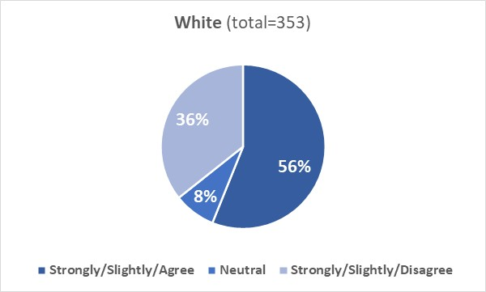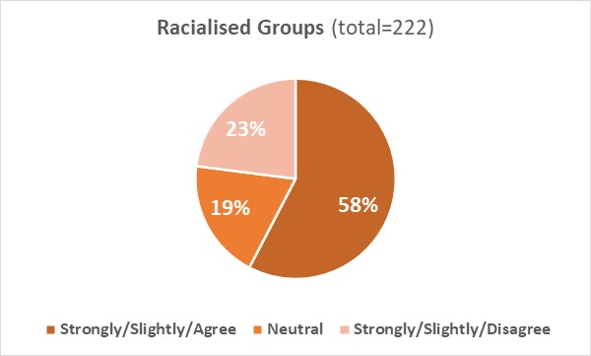
Ethnicity not disclosed (ND) (combined ‘Agree’ 50% (n=15), Neutral 17% (n=5), combined ‘Disagree’ 33% (n=10)).

Q11-3. In my experience students from all racial and ethnic backgrounds are included equally at all students' union events and societies
9.11A.3: 54% of White and 57% of Racialised Groups respondents agreed that students from all racial and ethnic backgrounds are included equally at all students' union events and societies; 5% of White and 14% of Racialised Groups respondents disagreed that this was the case (a disparity is observed between the two cohorts disagreeing with the statement of Q11-3).
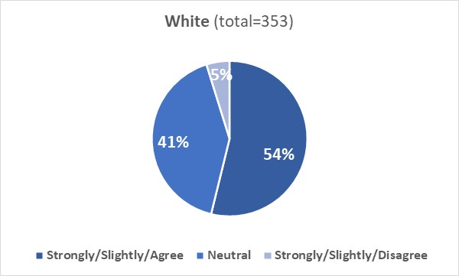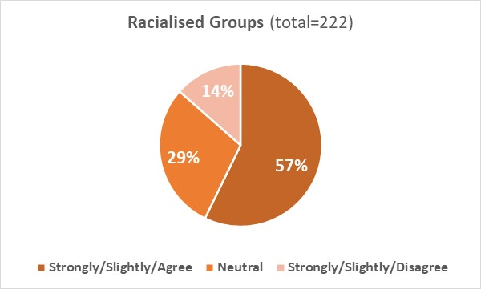
Ethnicity not disclosed (ND) (combined ‘Agree’ 67% (n=20), Neutral 23% (n=7), combined ‘Disagree’ 10% (n=3)).

Q11-4. Racially offensive or inappropriate behaviours are not tolerated at events and activities organised by the students' union
9.11A.4: 70% of White and 64% of Racialised Groups respondents agreed that racially offensive or inappropriate behaviours are not tolerated at events/activities organised by the students’ union; 1% of White and 7% of Racialised Groups respondents disagreed that this was the case.
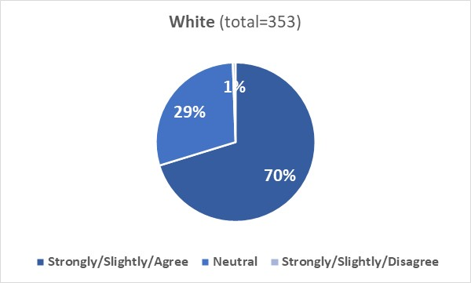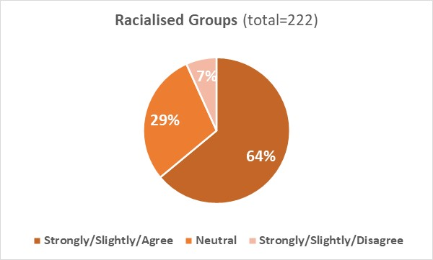
Ethnicity not disclosed (ND) (combined ‘Agree’ 53% (n=16), Neutral 33% (n=10), combined ‘Disagree’ 14% (n=4)).

9.11B: Qualitative analysis

Comments from White (W) students to the four questions in section ‘Students’ union’ were grouped into two broad themes and sub-themes (Table 37).

Table 37: Inductive content analysis of question responses from White students regarding the student survey section “Students’ union”.
Theme number | Theme | Sub-theme
Theme 1 | No experience with students’ union/societies | (none)
Theme 2 | Perception/experience with students’ union/societies | - 2.1 Positive  - 2.2 Negative

No experience with student societies
Students (W) reported that they did not have experience with students’ societies, either because they were not interested in those societies or because they had no time to join them (e.g., work commitment), or because they were on campus intermittently (Theme 1).

Perception/experience with students’ union/societies
Positive and negative experiences were reported by respondents. Students (W) who had a positive experience reported that students’ societies are open to all, welcoming and inclusive, where racism/discrimination is not tolerated (sub-theme 2.1). Students (W) who had a negative experience reported that white students may struggle to be included in some students’ societies, events organised by students’ societies are not inclusive, not well advertised and they do not facilitate networking (sub-theme 2.2).

Comments from Racialised Groups (RG) students to the four questions in section ‘Students’ union’ were grouped into a broad theme and sub-themes (Table 38)

Table 38: Inductive content analysis of question responses from Racialised Groups students regarding the student survey section “Students’ union”.
Theme number | Theme | Sub-theme
Theme 3 | Racial inequality/exclusivity in students’ societies/events | - 3.1 Absent  - 3.2 Present

Students (RG) reported a different perception of occurrence of racial inequality in students’ societies/events. Those who had a positive experience reported that they never experienced discrimination at students’ union events, felt that students’ union meetings and events are inclusive, and that discrimination is not tolerated (sub-theme 3.1). Those who had a negative experience reported occurrence of racism, discrimination, and antisemitism in some students’ societies/events (sub-theme 3.2)

Examples of quotes by respondents from both cohorts (W and RG) are reported below.

“The students’ societies are open to all, and while the diversity can vary I feel this reflects cultural bias and/or personal preference based on the particular society”- W student

“AUSA suffers from the same lack of diversity than the university and it has the same problems. Good intentions but an inability to make actual change. We need support from trained people and from people with lived experience. If racialised people are not at the centre at their own liberation it's only performative”- RG student

“Have had hardly any time to attend society events (not always well advertised anyway), but on the few occasions I have been to one, the level of diversity ethnically has been poor, but has been wide by gender”- W student

“As a muslim, I feel like most events are based around drinking alcohol, and this doesn't appeal to me in the slightest”- RG student

“I'm afraid I have not attended any events at the student union or student societies; however, I am sure they have a zero tolerance for racial and other forms of discrimination, and are inclusive to everyone”- W student

“I am thinking of becoming a member, of one or more student societies”- RG student

“I haven't joined any societies as I'm not entirely sure how to”- W student

Conclusion

The results of the 2022 Race Equality Charter surveys, alongside other listening activities, have been crucial in gathering and understanding our staff and student views on the culture of our Institution and to identifying areas where actions are required.

The results from both surveys show that we are at the beginning of our journey to tackle racism within our Institution and surrounding area.

The surveys show that, for staff and students racism occurs on our campus and in our local community. It will be important for us moving forward to put policies and initiatives in place which seek to ensure that:

- Staff and students have safe and sensitive mechanisms for reporting racism and that they feel confident that reports will be handled appropriately and timeously
- Staff and students have access to engaging and appropriate training to support the development of a culture where antiracism is understood and where individuals are empowered to contribute to the development of an antiracist university
- Senior leaders have regular opportunities to evaluate their performance in relation to leading an antiracist university and to be actively informed of good practice in this area
- The University’s policies and procedure do not perpetuate systemic racism and that high-quality control mechanisms are in place to highlight where this may occur
- The University is at the forefront of sector developments in antiracism and is alive to the evolving research and good practice within the sector and beyond
- The University community is kept up to date with race initiatives, achievements of staff and students from racialised groups are showcased and channels of communication are visible and accessible.

The results of the surveys will form an integral part of our Race Equality Charter Bronze award submission and will support ongoing robust reflection and monitoring of our progress by the Race Equality Strategy Group which includes representatives from the staff and student bodies as well as from a range of backgrounds. The Group is developing an Antiracism Strategy Action Plan which will be aligned to the Antiracism Strategy but will also adopt a flexible format so that issues identified through further surveys and engagement activities (e.g., focus groups and interviews) can be addressed through its implementation.

The results are being shared with all staff and students and will also be discussed throughout the University, contributing to a culture where confident conversations on race are supported and encouraged.

Thank you for engaging with this report and if you would like to provide feedback or comments please e-mail recsurvey@abdn.ac.uk

Appendix 1: Staff survey
Ethnicity | Strongly Agree | Agree | Slightly Agree | Neither Agree nor Disagree | Slightly Disagree | Disagree | Strongly Disagree
I considered the ethnic/racial diversity of the University of Aberdeen before applying to work here.
White (W) | 2% | 7% | 7% | 38% | 6% | 26% | 15%
Racialised Groups (RG) | 10% | 12% | 7% | 25% | 6% | 24% | 15%
The ethnic/racial diversity of the University of Aberdeen impacts on my sense of belonging.
White (W) | 7% | 21% | 16% | 37% | 4% | 10% | 5%
Racialised Groups (RG) | 23% | 32% | 17% | 16% | 2% | 3% | 7%
The ethnic/racial diversity of the University of Aberdeen impacts on my desire to stay.
White (W) | 9% | 25% | 17% | 31% | 2% | 10% | 5%
Racialised Groups (RG) | 21% | 25% | 11% | 24% | 5% | 7% | 7%
I believe I am treated equally by colleagues, irrespective of my ethnicity or race.
White (W) | 31% | 46% | 4% | 13% | 4% | 2% | 1%
Racialised Groups (RG) | 29% | 31% | 11% | 8% | 12% | 5% | 5%
I believe I am treated equally by students, irrespective of my ethnicity or race.
White (W) | 25% | 44% | 5% | 19% | 5% | 2% | 0%
Racialised Groups (RG) | 22% | 37% | 15% | 16% | 7% | 2% | 2%
The ethnic/racial diversity of the local population impacts on my day-to-day life.
White (W) | 3% | 12% | 11% | 37% | 5% | 21% | 10%
Racialised Groups (RG) | 11% | 25% | 18% | 27% | 3% | 10% | 5%
I am aware of ethnic/racial tensions within the local community.
White (W) | 2% | 13% | 20% | 23% | 10% | 25% | 7%
Racialised Groups (RG) | 5% | 15% | 19% | 25% | 9% | 18% | 9%
I have witnessed or been the victim of racial discrimination on campus.
White (W) | 1% | 3% | 6% | 10% | 4% | 37% | 40%
Racialised Groups (RG) | 5% | 10% | 10% | 8% | 5% | 27% | 35%
Ethnicity | Strongly Agree | Agree | Slightly Agree | Neither Agree nor Disagree | Slightly Disagree | Disagree | Strongly Disagree
I have witnessed or been the victim of racial discrimination in the local area.
White (W) | 2% | 10% | 8% | 9% | 4% | 33% | 34%
Racialised Groups (RG) | 6% | 17% | 11% | 15% | 4% | 18% | 29%
I know how to report a race-related incident in my institution.
White (W) | 12% | 37% | 17% | 8% | 10% | 13% | 3%
Racialised Groups (RG) | 12% | 35% | 11% | 11% | 8% | 17% | 6%
If I reported a race-related incident to my institution, appropriate action would be taken.
White (W) | 16% | 42% | 10% | 25% | 3% | 2% | 1%
Racialised Groups (RG) | 15% | 34% | 8% | 26% | 6% | 4% | 7%
I would recommend my institution to a prospective staff member.
White (W) | 33% | 49% | 8% | 6% | 2% | 1% | 0%
Racialised Groups (RG) | 31% | 42% | 10% | 10% | 3% | 2% | 3%
From what I have seen, the University of Aberdeen undertakes recruitment and selection fairly and transparently.
White (W) | 26% | 48% | 10% | 10% | 4% | 3% | 1%
Racialised Groups (RG) | 22% | 43% | 10% | 14% | 3% | 5% | 5%
The University’s recruitment and selection policies lead to the best candidates being recruited.
White (W) | 18% | 39% | 13% | 17% | 7% | 5% | 1%
Racialised Groups (RG) | 16% | 35% | 15% | 19% | 5% | 5% | 5%
There are opportunities for me to develop within my role.
White (W) | 16% | 38% | 17% | 9% | 9% | 8% | 5%
Racialised Groups (RG) | 16% | 38% | 11% | 8% | 6% | 10% | 10%
My line manager makes time to discuss my personal development and progression.
White (W) | 25% | 35% | 14% | 9% | 6% | 7% | 4%
Racialised Groups (RG) | 27% | 30% | 13% | 8% | 6% | 9% | 6%

Ethnicity | Strongly Agree | Agree | Slightly Agree | Neither Agree nor Disagree | Slightly Disagree | Disagree | Strongly Disagree
Work-related opportunities for development, such as acting-up roles or profile-raising opportunities, are allocated fairly and transparently.
White (W) | 10% | 28% | 12% | 29% | 9% | 8% | 4%
Racialised Groups (RG) | 14% | 27% | 12% | 22% | 8% | 9% | 8%
I have been encouraged to apply for jobs at a higher grade.
White (W) | 7% | 18% | 10% | 27% | 7% | 21% | 10%
Racialised Groups (RG) | 10% | 10% | 7% | 23% | 7% | 27% | 17%
I have been encouraged to have my role regraded.
White (W) | 7% | 12% | 8% | 28% | 7% | 25% | 13%
Racialised Groups (RG) | 7% | 7% | 7% | 27% | 7% | 23% | 23%
I have been encouraged to apply for promotion.
White (W) | 12% | 26% | 12% | 28% | 3% | 13% | 7%
Racialised Groups (RG) | 11% | 18% | 8% | 30% | 11% | 14% | 9%
I have annual reviews with my manager.
White (W) | 40% | 38% | 5% | 5% | 2% | 5% | 4%
Racialised Groups (RG) | 45% | 38% | 3% | 5% | 2% | 5% | 3%
My manager ensures my annual review is evidence-based and transparent.
White (W) | 31% | 38% | 8% | 13% | 3% | 4% | 3%
Racialised Groups (RG) | 34% | 31% | 9% | 14% | 4% | 5% | 3%
I find the annual review process useful.
White (W) | 14% | 29% | 15% | 15% | 9% | 11% | 7%
Racialised Groups (RG) | 18% | 28% | 15% | 14% | 6% | 12% | 8%
I am aware of the formal flexible and home working polices and arrangements at the institution, for example, part time working or condensed hours.
White (W) | 37% | 46% | 8% | 4% | 2% | 2% | 0%
Racialised Groups (RG) | 38% | 42% | 11% | 7% | 0% | 1% | 1%

Ethnicity | Strongly Agree | Agree | Slightly Agree | Neither Agree nor Disagree | Slightly Disagree | Disagree | Strongly Disagree
If I formally requested flexible working arrangements I am confident that the request would be granted if at all possible.
White (W) | 27% | 42% | 11% | 9% | 4% | 4% | 3%
Racialised Groups (RG) | 30% | 40% | 8% | 12% | 4% | 5% | 2%
I can take advantage of flexible/hybrid working for example, irregular/regular working from home or coming in later.
White (W) | 36% | 37% | 9% | 6% | 3% | 5% | 4%
Racialised Groups (RG) | 32% | 40% | 12% | 12% | 2% | 1% | 2%
My manager is supportive of flexible working.
White (W) | 36% | 39% | 8% | 12% | 2% | 2% | 2%
Racialised Groups (RG) | 38% | 39% | 6% | 10% | 3% | 2% | 2%
I think I am paid the same as my colleagues who do the same job.
White (W) | 13% | 37% | 10% | 19% | 9% | 7% | 6%
Racialised Groups (RG) | 17% | 40% | 7% | 16% | 6% | 7% | 5%
Pay awards and increases are allocated fairly and transparently.
White (W) | 8% | 25% | 14% | 27% | 10% | 11% | 5%
Racialised Groups (RG) | 9% | 31% | 10% | 25% | 6% | 11% | 8%

Appendix 2: Student survey
Ethnicity | Strongly Agree | Agree | Slightly Agree | Neither Agree nor Disagree | Slightly Disagree | Disagree | Strongly Disagree
I considered the ethnic/racial diversity of the University of Aberdeen before applying to study here.
White (W) | 3% | 8% | 10% | 21% | 8% | 26% | 23%
Racialised Groups (RG) | 19% | 24% | 12% | 16% | 5% | 10% | 13%
The ethnic/racial diversity of the University of Aberdeen impacts on my sense of belonging.
White (W) | 4% | 13% | 17% | 33% | 5% | 16% | 13%
Racialised Groups (RG) | 22% | 31% | 12% | 16% | 3% | 7% | 9%
The ethnic/racial diversity of the University of Aberdeen impacts on my desire to stay.
White (W) | 6% | 20% | 14% | 26% | 5% | 14% | 14%
Racialised Groups (RG) | 24% | 29% | 10% | 15% | 5% | 7% | 9%
The ethnic/racial diversity of the local population impacts on my day-to-day life.
White (W) | 2% | 7% | 10% | 32% | 7% | 23% | 19%
Racialised Groups (RG) | 14% | 27% | 18% | 20% | 4% | 10% | 7%
I am aware of ethnic/racial tensions within the local community.
White (W) | 3% | 8% | 20% | 16% | 15% | 27% | 12%
Racialised Groups (RG) | 13% | 16% | 22% | 20% | 7% | 13% | 9%
I have witnessed or been the victim of racial discrimination on campus.
White (W) | 1% | 2% | 3% | 5% | 3% | 32% | 56%
Racialised Groups (RG) | 7% | 9% | 7% | 12% | 3% | 25% | 37%
I have witnessed or been the victim of racial discrimination in the local area.
White (W) | 1% | 5% | 8% | 3% | 4% | 33% | 46%
Racialised Groups (RG) | 8% | 16% | 9% | 11% | 5% | 22% | 28%
I know how to report a race-related incident in my institution.
White (W) | 8% | 21% | 18% | 10% | 14% | 22% | 7%
Racialised Groups (RG) | 14% | 22% | 15% | 9% | 11% | 16% | 12%

Ethnicity | Strongly Agree | Agree | Slightly Agree | Neither Agree nor Disagree | Slightly Disagree | Disagree | Strongly Disagree
If I reported a race-related incident to my institution, appropriate action would be taken.
White (W) | 14% | 30% | 16% | 34% | 1% | 3% | 2%
Racialised Groups (RG) | 13% | 29% | 9% | 34% | 5% | 4% | 5%
I would recommend my institution to a prospective student.
White (W) | 39% | 40% | 10% | 7% | 2% | 1% | 1%
Racialised Groups (RG) | 35% | 36% | 12% | 12% | 2% | 2% | 1%
I am progressing well in my course.
White (W) | 20% | 57% | 14% | 5% | 3% | 1% | 1%
Racialised Groups (RG) | 26% | 46% | 17% | 6% | 3% | 1% | 1%
Where relevant, I would consider a postgraduate course.
White (W) | 29% | 34% | 15% | 9% | 4% | 8% | 1%
Racialised Groups (RG) | 37% | 31% | 12% | 12% | 3% | 5% | 1%
Where relevant, I would consider a PhD once I have completed my masters’ degree.
White (W) | 20% | 24% | 17% | 14% | 7% | 12% | 6%
Racialised Groups (RG) | 26% | 26% | 13% | 19% | 2% | 8% | 5%
I would consider a career in academia.
White (W) | 14% | 19% | 17% | 18% | 10% | 13% | 8%
Racialised Groups (RG) | 21% | 14% | 17% | 22% | 4% | 14% | 8%
I have a good understanding of the graduate-level employment opportunities available to me.
White (W) | 11% | 23% | 27% | 11% | 13% | 12% | 2%
Racialised Groups (RG) | 14% | 25% | 20% | 17% | 10% | 8% | 5%

Ethnicity | Strongly Agree | Agree | Slightly Agree | Neither Agree nor Disagree | Slightly Disagree | Disagree | Strongly Disagree
The University of Aberdeen has helped me develop the skills I need to apply for graduate-level jobs.
White (W) | 6% | 27% | 25% | 22% | 10% | 7% | 3%
Racialised Groups (RG) | 12% | 29% | 26% | 22% | 3% | 7% | 1%
The content of my course matches my expectations and includes what I thought it would include.
White (W) | 13% | 48% | 18% | 7% | 9% | 3% | 1%
Racialised Groups (RG) | 25% | 37% | 19% | 8% | 5% | 2% | 3%
The content of my course reflects the opinions of a wide variety of people.
White (W) | 15% | 36% | 19% | 16% | 9% | 3% | 1%
Racialised Groups (RG) | 17% | 37% | 17% | 19% | 5% | 3% | 2%
When relevant, issues of ethnicity and race are included in academic discussions.
White (W) | 17% | 33% | 16% | 24% | 4% | 4% | 2%
Racialised Groups (RG) | 11% | 27% | 13% | 27% | 7% | 9% | 6%
When relevant, my course tutors and lecturers are confident and competent in facilitating discussions around ethnicity and race.
White (W) | 16% | 33% | 13% | 29% | 4% | 3% | 2%
Racialised Groups (RG) | 14% | 24% | 15% | 32% | 5% | 6% | 4%
I enjoy the way my course is taught.
White (W) | 18% | 38% | 20% | 9% | 7% | 5% | 3%
Racialised Groups (RG) | 21% | 34% | 19% | 13% | 8% | 2% | 3%
I am comfortable contributing to group discussions.
White (W) | 22% | 43% | 17% | 6% | 8% | 3% | 1%
Racialised Groups (RG) | 27% | 41% | 20% | 4% | 6% | 2% | 0%
I am comfortable approaching course tutors with any questions or queries.
White (W) | 26% | 43% | 17% | 7% | 5% | 2% | 1%
Racialised Groups (RG) | 29% | 38% | 18% | 7% | 4% | 5% | 0%

Ethnicity | Strongly Agree | Agree | Slightly Agree | Neither Agree nor Disagree | Slightly Disagree | Disagree | Strongly Disagree
I am happy with the way my course is assessed.
White (W) | 14% | 48% | 20% | 9% | 7% | 1% | 1%
Racialised Groups (RG) | 20% | 42% | 18% | 8% | 6% | 5% | 1%
I know where to go to get additional academic support if and when I need it.
White (W) | 15% | 44% | 23% | 6% | 7% | 4% | 1%
Racialised Groups (RG) | 21% | 41% | 20% | 8% | 4% | 4% | 2%
I regularly attend students' union events.
White (W) | 2% | 3% | 7% | 9% | 16% | 33% | 30%
Racialised Groups (RG) | 4% | 5% | 13% | 17% | 12% | 26% | 23%
I am a member, or am thinking of becoming a member, of one or more student societies.
White (W) | 22% | 24% | 10% | 8% | 7% | 13% | 16%
Racialised Groups (RG) | 17% | 21% | 20% | 19% | 5% | 11% | 8%
In my experience students from all racial and ethnic backgrounds are included equally at all students’ union events and societies.
White (W) | 16% | 29% | 8% | 41% | 3% | 2% | 0%
Racialised Groups (RG) | 20% | 26% | 11% | 29% | 7% | 4% | 3%
Racially offensive or inappropriate behaviours are not tolerated at events and activities organised by the students’ union.
White (W) | 31% | 31% | 8% | 29% | 1% | 0% | 0%
Racialised Groups (RG) | 29% | 28% | 7% | 29% | 2% | 2% | 3%

