DfN Project Search 2022

November Issue



Let’s meet the interns again and see what their first internship has been like

Hello, my name is Jason, my first internship is in the Grounds Department. Where have been picking up litter, pitch lining the university pitch fields, clearing and tidying the leaves, planting daffodil bulbs, emptying, and cleaning the bins. I enjoy getting my jobs done successfully well as on time too!





Hi, I am Natalie and for my first internship I am working for the charity values into action Scotland. During this internship I am going to be helping plan an event called young Scotland got talent. So far in my internship I have been doing jobs such as emailing, using excel to keep spreadsheets, phoning people, making leaflets, and advertising, and using teams to have video calls I am really enjoying my internship so far as I am expanding my admin skills

My 1st Internship is at Hill Head student accommodation with the portering and cleaning team. I have mostly been with the portering team some of my tasks include taking out bins, routine fire checks, taking in a fire drill and dealing with student complaints. I have experienced some of what the cleaning team does and for example Hoovering corridors, cleaning student Showers, bathrooms and kitchens.

Sionead



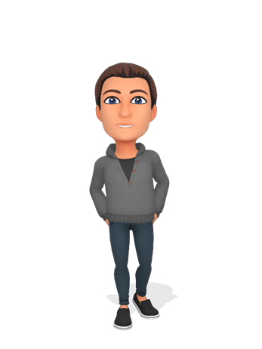

My first internship is in the music department in the university.

Will be sanitising equipment, photo copying, cataloguing, and dismantling a piano.

Ciaran

My name is Andrew and for my first internship I have been working as a shop assistant at the Bear Essentials shop in the University Hub. My main task has been to replenish the shelves with drinks after people have bought some, but my other tasks include putting bar code stickers on other types of stock like hospital scrubs and University Merchandise and restocking snacks and ID card holders as well as cleaning the dust off shelves.

Hi, I am Greg, during my time at Project Search, I have covered several different topics and have completed several different tasks. For example:

Making a data base. Doing research. Making advertising material, (posters). Making a formal video which involved writing a script, learning the script, practicing, and filming the video.

Greg



I’ve been working as a music admin assistant in the department of music within the University of Aberdeen. I work on checking and sanitising the practise rooms, digital and physical cataloguing of music sheets, taking apart broken pianos.

Ryan



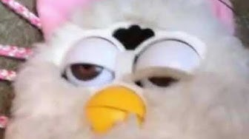

My first internship is in the BCD department at NESCol.

I have been helping set up new office, Mail collection, e-mailing students and creating labels.

Carlisle

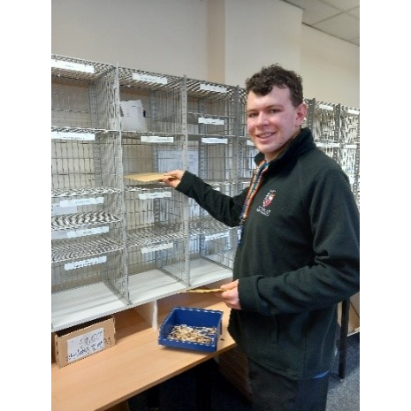

Hi, I am Niall and for my first internship I am working for the Zoology Building for Portering. During this internship I am helping Bill set up tables and chairs for exams, deliver mail and parcels to the Zoology, Cruickshank, and 23 St Machar Drive. I take out the rubbish to the bins I am really enjoying my internship so far as I am expanding my skills.

Hello, I am Cameron and for My first internship I am working with the Audio-Visual team at University of Aberdeen. During this internship, I am going to be developing a video interview on other Project Search colleges about their internship. So far in my Internship I have been shadowing the team seeing what they do as they fix issues around the University, as well as help them carry items to said places, I also have helped, check the prices and hours of projector lightbulbs to see if they need replaced. I am really enjoying my internship learning all about how Audio-Visual teams work, what they do as well as gaining confidence talking to those who I don’t know

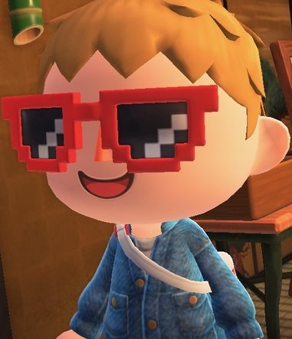

Now let’s meet the Project search Staff



My name is Andrew, and I am the Project SEARCH Lecturer for the University of Aberdeen Project SEARCH programme.  I work for Northeast Scotland College and support interns to complete a City and Guilds Employability Qualification while they are on Project SEARCH.  When interns aren’t at their designated internship, they spend time in the classroom with me at the start and end of each day completing coursework, reflecting on their experiences, and planning for key events during the year such as Employment Planning Meetings and Workshop Weeks.  We build on skills regularly using a mix of IT, group work, presentations and often host guest speakers to make the curriculum accessible to all.

Hi, my name is Jim I am employed by Values into Action Scotland. I am the Senior Job Coach at Project SEARCH, supporting the interns throughout their internships to help them learn their roles and develop skills. I also support the Interns taking steps towards finding a suitable job.



Hi, my name is Ann and work for NESCol, and currently I teach IT and City & Guilds at Project SEARCH.  When the Interns are not at their internships at the beginning and end of each day, they work in the classroom.   To enhance their IT skills, we do various qualifications using Microsoft Office, this helps the Interns to create things like their CVs, application letters and a one-page profile.  We also use software that they might end up using in an internship or eventually when they get a job.  I teach the interns as a class, but do lots of work with them individually, so I can tailor their learning to suit them.  For the City & Guilds qualification, I teach Employability Skills, alongside Andrew.



Movie Quiz

Below are some pictures from a scene of a movie can you name the movie

111

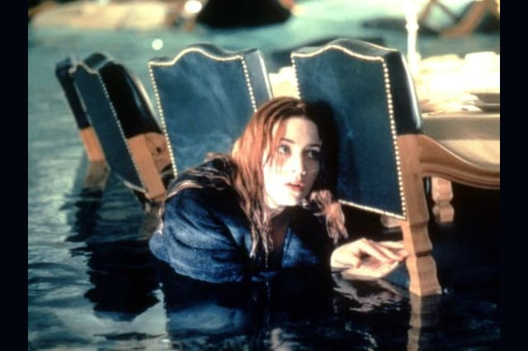

Romeo & Juliet

Titanic

Hamlet

2



Men in black

Enemy of state

Bad boys

3



The Lion king

The rescuers down under

4

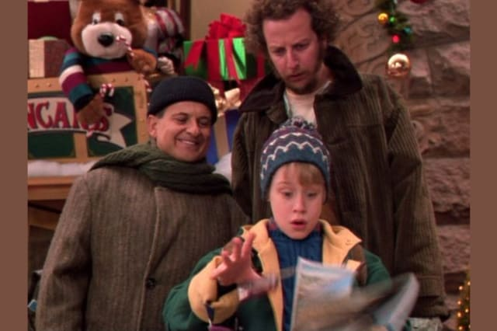

Polar express

Home alone

Home alone 2 lost in New York

5

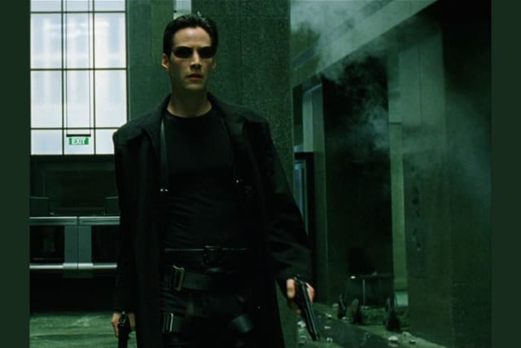

Sixth sense

Goodfellas

The matrix

Jack Frost

6



The Santa Claus

I will be home for Christmas

Answers to movie quiz

1 – Titanic

2 – Men in Black

3- The Lion King

4- Home Alone 2 lost in New York

5- The matrix

6- The Santa Claus

Thank you for reading, we are now well through our internships, stay tuned for our Christmas edition