Making an expense claim for prescription glasses for computer use

The Display Screen Regulations 1992 require employers to provide employees with glasses if they are needed for computer use. Under the expenses policy all staff are entitled to £50 towards the cost of glasses if they are required for computer use (general use glasses are not covered by this concession). This money is claimed via expenses once you have purchased your glasses.

Registering for Access
If you have not used the finance system before, you may need to register to get access to it. This can be done on the Finance page on StaffNet.
The Finance System can be found using this URL: https://www.abdn.ac.uk/staffnet/working-here/finance-system-7271.php

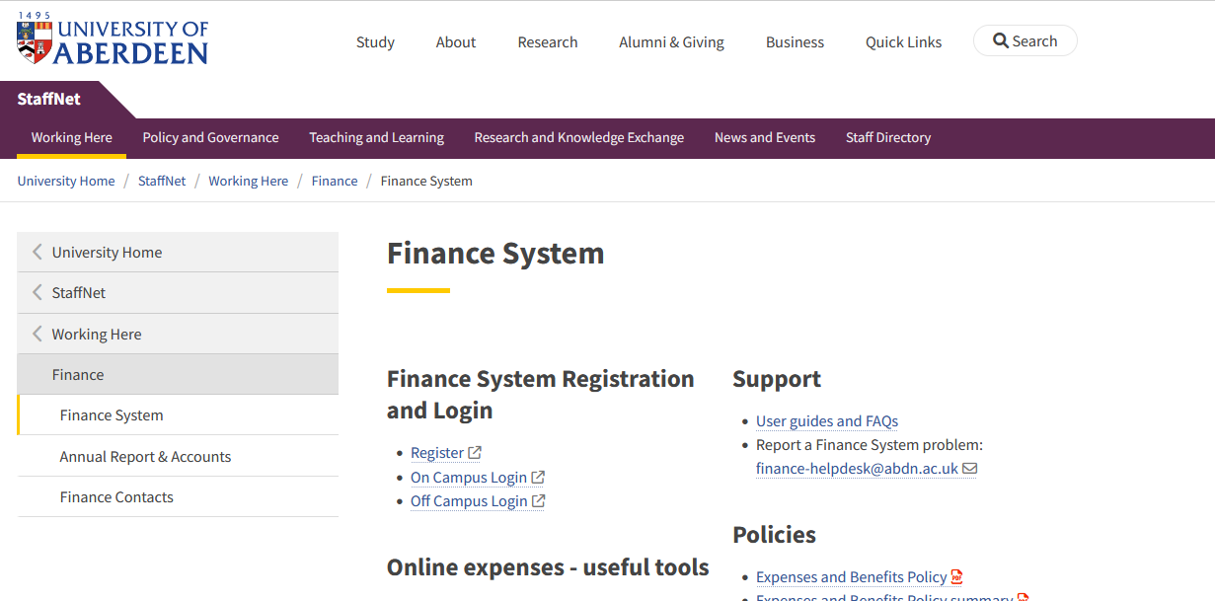
By clicking “Register” a form will open up for you to complete. It will take a few days for finance to process your application.

Making your expenses request
- You can then use the Finance Page (as above) to either use the “On Campus Login” or “Off Campus Login” to access the system.

- On the home page, under the “Your employment” tab, you will see “Expenses”
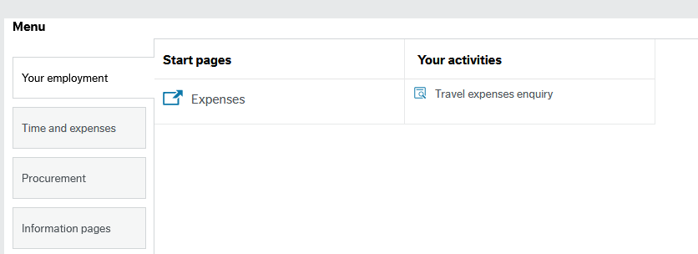

- Press “expenses” to open up the Expenses page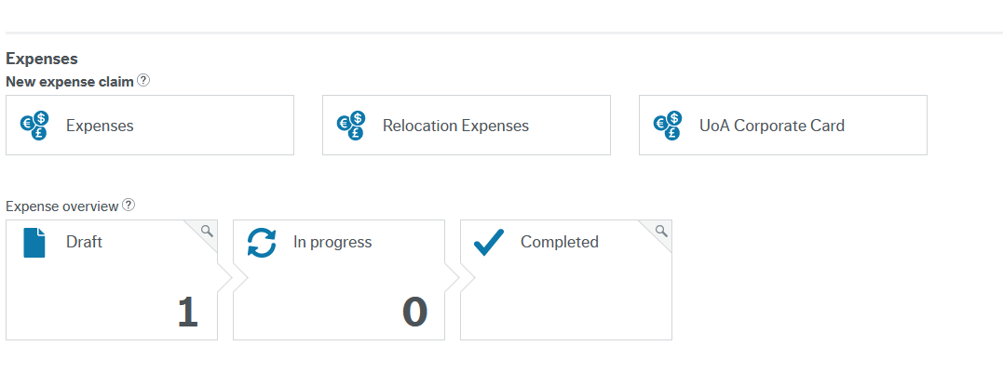

- Under the “New Expense Claim” section, press the “Expenses” box. This will open a new expense request page.

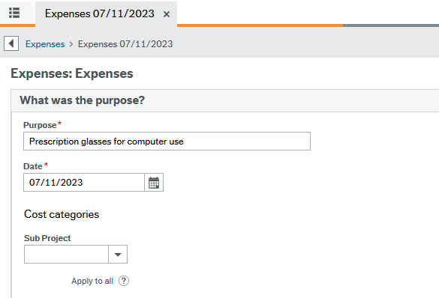

- On this page you need to enter details into:
Purpose: Prescription glasses for computer use
Date: Today’s date
Sub Project: Enter the budget number for your department (check with the budget holder or line manager before making a claim)

- Scroll to the bottom of the page and click the “Add expense” button

- On this page you need to enter details into:
Category: Select “Spectacles” from the drop down menu
Date: Enter the date
Description: Prescription glasses for computer use
Quantity: 1
Amount: Will auto-fill to £50

Adding a receipt & copy of your prescription

- On the right hand side of the screen there is a “Receipts” section. Press the blue text saying “Upload receipts”. You will need to upload a copy of your receipt from your glasses supplier and a copy of your prescription showing the glasses are for computer use.
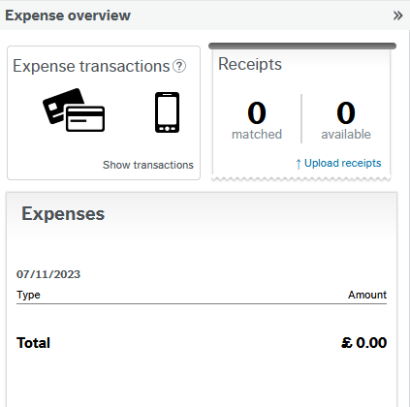

- Once you have completed these steps you can press the blue “Send for approval” button at the bottom of your page. You can also save it as a draft if you need to come back to it later.

Checking the status of your request

- You can check the status of your expense claim by going back to the expenses page and see if the claim is in progress or completed.
