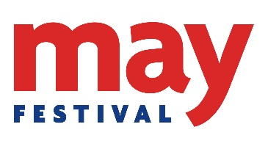
25 – 27 May 2018
Want to get involved in the May Festival? Interested in hosting an event? Please complete the form below and email festival@abdn.ac.uk by 5pm on Thursday 30th November.
Name: School/Section/Dept:

Email address: Phone number:

- What type of event are you interested in suggesting or offering? (tick all that apply)
□ Public Programme (Friday 25 – Sunday 27 May)
□ Schools’ Programme (Tuesday 22 – Thursday 24 May, activities for school class groups)
□ Children’s Programme (Saturday 26 & Sunday 27 May, activities for families)
□ Exhibition
□ Outreach event
□ Other*

*If other, please specify:

- Please provide us with a summary about your idea / event in 50 words.

- What type of audience is your event aimed at? e.g. primary school, secondary school, adults, families

- What is the main topic/theme aligned with your event? e.g. music, science, environment, literature, sport, food and drink, history, heritage & archaeology.

- Suggested venue and time of your event. Consider capacity and room set-up e.g. lecture for 100 people or workshop style for 20.

- Do you have funding available □ Yes □ No

Please indicate how you intend to fund your event

- What do you hope to gain by being part of the Festival (tick all that apply)?

□ Skills development
□ Personal enjoyment
□ Encourage use of research findings
□ Disseminate research findings
□ Develop links or test an idea with a non-academic audience
□ Enhance research impact
□ Other*

If other, please specify:

Thank you for completing the form.
Please return to festival@abdn.ac.uk by 5pm on Thursday 30th November.

