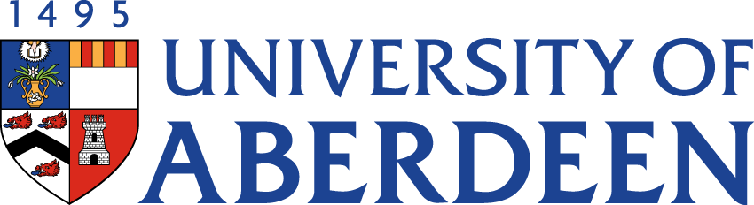

There will be a meeting of the **SUSTAINABLE DEVELOPMENT COMMITTEE** on **WEDNESDAY 24 AUGUST 2022** at **10.35pm – 12.25pm** via Microsoft Teams.

Heather Crabb

Senior Vice-Principal’s Office

Tel: 01224 272404

Email: [h.crabb@abdn.ac.uk](mailto:h.crabb@abdn.ac.uk)

BUSINESS

*DECLARATION OF INTEREST:*

*Any member or individual in attendance (including officers) who has a clear interest in a matter on the agenda must declare that interest at the meeting. Items for information will not normally be considered.*

**FOR DISCUSSION**

1. MINUTES

Minutes of the Sustainable Development Committee meeting held on 25 May 2022

(enclosed)

1. MATTERS ARISING

2.1 Table of Actions SDC22:46

2.2 Update on Sustainability Structures Oral Report

1. ANNUAL REVIEW OF TERMS OF REFERENCE SDC22:47
2. SUSTAINABILITY RISK REGISTER SDC22:48
3. SUSTAINABLE DEVELOPMENT GOALS UPDATE
   1. THE Impact Rankings Strategy Oral Report

1. CLIMATE CHANGE

6.1 Public Bodies Climate Change Duty Reporting 2022/23 SDC22:49

6.2 Climate Assembly Update Oral Report

1. NET ZERO

7.1 Queen’s Jubilee Sustainability Challenge SDC22:50

*To Note: Appendix (Draft EAUC Carbon Emissions Standardised Framework) is not for wider circulation*

7.2 Net Zero Update Oral Report

1. ABERDEEN 2040 ACTION PLAN UPDATE
   1. Sustainability Commitments 16, 17 and 19 SDC22:51
2. UPDATE FROM AUSA SDC22:52
3. UPDATE FROM INTERDISICPLINARY CENTRES

10.1 Update on Centres’ Activities Oral Report

10.2 Report on Grant Income SDC22:53

**FOR INFORMATION**

1. CAMPUS ENERGY/HEATING UPDATE
   1. Update from Sustainable Heating Programme Board SDC22:54
2. DATE OF NEXT MEETING

The next meeting of the Sustainable Development Committee will be held on Tuesday 15 November 2022 at 10.35am via Microsoft Teams.