Accessibility and Inclusion Reflection Document
This document aims to assist staff in exploring and reflecting on the opportunities and challenges of implementing inclusivity and accessibility in their courses, and to provide a base from which any changes can begin.
It will also enable regular reviewing of steps being taken across the University and identification of areas where further change, resources and support may be needed, with a focus on enhancement and collaborative development.
Under each heading below, please note down any possible issues, considering self/others/students. Reflect on the challenges and provide thoughts on short term action and longer-term action to be taken and your plans. You may find useful the information set out in “Aims, Obligations and Using the Framework”, “Tools and Resources” (particularly the checklists), “Good Practice” and the “Events” parts of the Framework.
Finally, note what support is required from others, now and in the longer term. Note the steps you are taking now to obtain this support (e.g. contacting CAD, issue being discussed within School). If you think that more formal change is needed to address this, or if you would like to share this issue with colleagues more widely, such as through a Framework event or through some suggested “good practice” on this website, please do share this on the feedback button.
If you would like some guidance, you can download an Example Accessibility and Inclusion Reflection Document. Please note the issues will vary according to the activity and this is only an example.
Once you have completed it, if you have any feedback or suggestions for the Reflection document or the Inclusivity and Accessibility Framework as a whole, please use our feedback form.

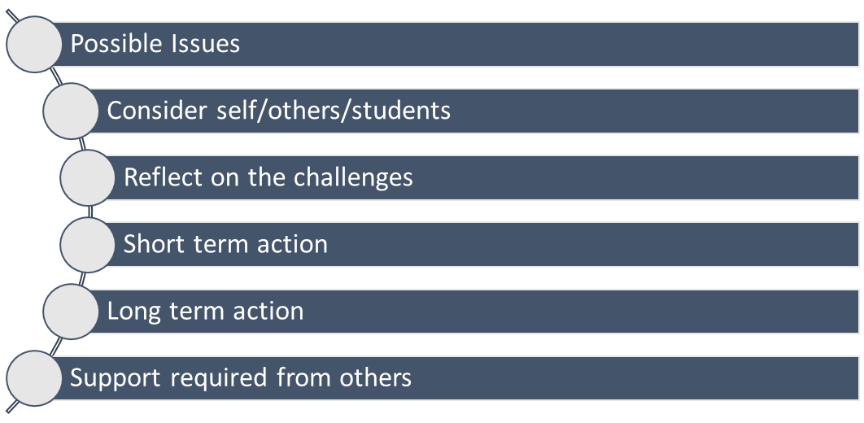
6
5
4
3
2
1

Course/activity:
- Brief detail of possible issues:
- Considered (Self/others/students):
- Reflection/challenges – met and unable to be met yet:
- Short term thoughts:
- Longer term thoughts:
- Support sought/action needed from others (eg regulator, resources, more help or reduction in other work):

Date /period of review:
- Brief detail of possible issues:
- Considered (Self/others/students):
- Reflection/challenges – met and unable to be met yet:
- Short term thoughts:
- Longer term thoughts:
- Support sought/action needed from others (eg regulator, resources, more help or reduction in other work):

Learning Outcomes:
- Brief detail of possible issues:
- Considered (Self/others/students):
- Reflection/challenges – met and unable to be met yet:
- Short term thoughts:
- Longer term thoughts:
- Support sought/action needed from others (eg regulator, resources, more help or reduction in other work):

Form and Timing Assessment and Feedback:
- Brief detail of possible issues:
- Considered (Self/others/students):
- Reflection/challenges – met and unable to be met yet:
- Short term thoughts:
- Longer term thoughts:
- Support sought/action needed from others (eg regulator, resources, more help or reduction in other work):

Delivery (physical, digital and communications):
- Brief detail of possible issues:
- Considered (Self/others/students):
- Reflection/challenges – met and unable to be met yet:
- Short term thoughts:
- Longer term thoughts:
- Support sought/action needed from others (eg regulator, resources, more help or reduction in other work):

Balancing Acts:
- Brief detail of possible issues:
- Considered (Self/others/students):
- Reflection/challenges – met and unable to be met yet:
- Short term thoughts:
- Longer term thoughts:
- Support sought/action needed from others (eg regulator, resources, more help or reduction in other work):

Reasonable Adjustment:
- Brief detail of possible issues:
- Considered (Self/others/students):
- Reflection/challenges – met and unable to be met yet:
- Short term thoughts:
- Longer term thoughts:
- Support sought/action needed from others (eg regulator, resources, more help or reduction in other work):

