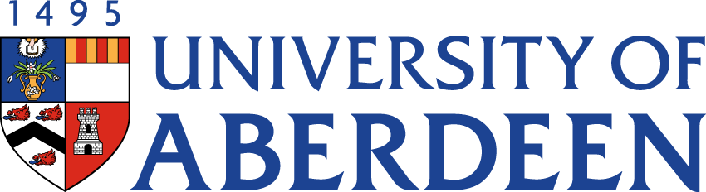

There will be a meeting of the SUSTAINABLE DEVELOPMENT COMMITTEE on THURSDAY 9 MARCH 2023 at 2.05pm – 3.55pm via Microsoft Teams.
Heather Crabb
Senior Vice-Principal’s Office
Tel: 01224 272404
Email: h.crabb@abdn.ac.uk
BUSINESS
DECLARATION OF INTEREST:
Any member or individual in attendance (including officers) who has a clear interest in a matter on the agenda must declare that interest at the meeting. Items for information will not normally be considered.

FOR DISCUSSION

- MINUTES
Minutes of the Sustainable Development Committee meeting held on 15 November 2022
(enclosed)
- MATTERS ARISING
  - Table of Actions SDC22:68

- DRAFT SCHEDULE OF BUSINESS SDC22:69

- SUSTAINABILITY RISK REGISTER SDC22:70

- ABERDEEN 2040 IMPLEMENTATION PLAN SDC22:71

EDUCATION
- GRADUATE ATTRIBUTES & SKILLS
6.1 Graduate Attributes & Skills: An Academic View SDC22:72
6.2 Graduate Attributes & Skills Presentation SDC22:73
- UPDATE FROM AUSA SDC22:74

LIVING & WORKING SUSTAINABLY

- UPDATE FROM DEAN FOR ENVIRONMENTAL SUSTAINABILITY SDC22:75

- STAFF SUSTAINABILITY TRAINING: BASELINE E-LEARNING MODULE SDC22:76

- BIODIVERSITY UPDATE SDC22:77

- CAMPUS ENERGY/HEATING UPDATE
  - Oral Update from Chair of Sustainable Heating Programme Board

NET ZERO

- NET ZERO UPDATE SDC22:78
RESEARCH

- UPDATE FROM INTERDISICPLINARY CENTRES SDC22:79

STRATEGIC DISCUSSION TOPIC
- STUDENT TRAVEL
14.1 Student Travel to Study Emissions SDC22:80
14.2 Student Travel Presentation SDC22:81
(Estrid Jonsson, Sustainability Team Intern)

FOR INFORMATION

- ROYAL ANNIVERSARY TRUST SDC22:82
  - Royal Anniversary Trust Report - ‘Accelerating Towards Net Zero’
  - Standardised Carbon Emissions Framework for Further & Higher Education (SCEF)
(both documents are available on Teams and via the hyperlinks above)

- DATE OF NEXT MEETING
The next meeting of the Sustainable Development Committee will be held on Tuesday 30 May 2023 at 10.35am via Microsoft Teams.

