Testimonials

Chris Dobbs
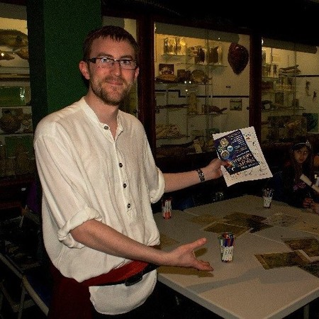
Chris was a student in 2013-2014 and continued to volunteer at the University Museums after graduating and now works at the British Museum as Assistant Collections Manager: Storage and Moves.

This course helped give me the confidence to interact with leading institutions, and an appreciation of all the tasks involved in day to day museum operations. The practical elements and placement were instrumental in giving me the experience necessary to gain employment within the museum sector.

Abbie Mitchell
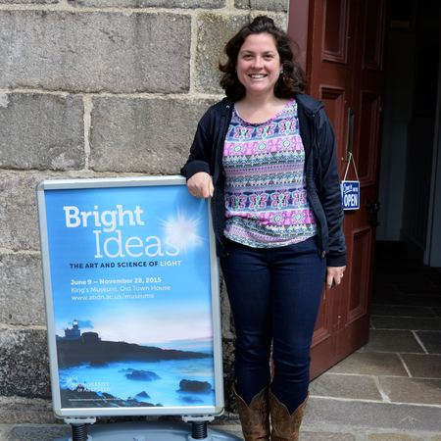
The programme provided me with unparalleled experience and insight into the museum and heritage sector. The historical and theoretical evolution of museums is explored through a variety of lecturers from different disciplines and also covers current ethical and legal frameworks to which museums must adhere. Most importantly, however, this course has given me a breadth of experience in the museum sector through hands on projects, exhibition and a work placement – it truly is the full package!

Abbie completed the MLitt Museum Studies in 2014-2015 and found work locally at Haddo House before moving to London to take their museums by storm.

Christina Mackenzie
Christina was part of the 2014-2015 Museum Studies class. She worked first as the Communications Assistant at the University Museums and continues to work for the University Museums as the Curatorial Assistant (Exhibitions).”

Maaike Van Houwelingen
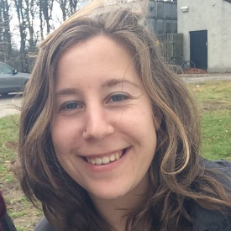
The programme is designed to train you for a real job in a Museum. Particularly during the second semester when you have the chance to create an exhibition and/or aid in the planning of a huge public event; Night at the Museums. As part of the Curating an Exhibition course I was assigned the role of ‘Object selection and research,’ which provided me with the chance to work with the collection assistants at the museum. I had a great time exploring the Museum’s stores and selecting the team’s favourite objects to use in our exhibition! While the course provided me with a theoretical base, which proved useful during the progression of the course, it also allowed me the chance to meet museum professionals from Scotland and work with the museum staff of the University of Aberdeen Museums. The Museum staff were really supportive and they are a great team that I began to feel part of by the end of the year. I loved every bit of it!

After completing her M.Litt in Museum Studies, Maaike studied for her M.Res in Social Anthropology, also at Aberdeen.”

Rebecca Guetter
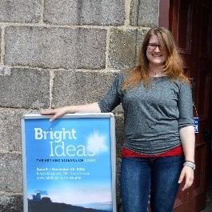
Rebecca discovered a love for Museum Education and Outreach during her time on the course and since moving back to the USA has secured a job in a historic property assisting in delivering special event programs.

I chose this course because it offered the best opportunities for practical experience. Nowadays, even some entry-level positions require previous work experience, and this programme provided me with that and much more. I loved that the course provided us with multiple opportunities for practical museum experiences from being a gallery assistant at King’s Museum to completing a 20-day placement at a museum or heritage site. Throughout this course I gained a deeper understanding of the role museums play within society, and the current struggles they are facing. Most importantly, it solidified my belief that museums are important to the communities they serve. The course was everything I wanted it to be; I met such an amazing group of people. Even being across an ocean I can still count on support from the friends I made during the programme. As clichéd as it sounds, it was the best year of my life.

Ruth Duncan
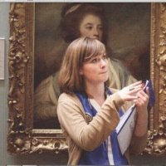
Ruth now works as a curator at the Gordon Highlanders Museum in Aberdeen and is enjoying the challenges of her post!

I took this course as I was looking for a master’s programme and a career that allowed me to develop the knowledge I had attained during my undergraduate. Competition for paid museums jobs is fierce, so chose the course in the hope that it would help me to stand out from the crowd. I gained practical experience in museum curation, which was vital for building up my CV and also for getting a sense of what it would actually be like to work in a museum and curate a museum. Dealing with issues like budget, display environment and group work was invaluable experience and prepared me well for life beyond graduation. I would encourage anyone thinking about a career in museums or galleries to choose this course and to throw themselves into it wholeheartedly. Make the most of every volunteering opportunity that comes your way too as you develop an understanding of the sector, and hopefully find your way to the career that you are passionate about.

Ruth now works as a curator at the Gordon Highlanders Museum and enjoying the challenges of this new post!

