

SR3023- Academic Skills for Sports Science Professionals
Course Handbook 2023-2024

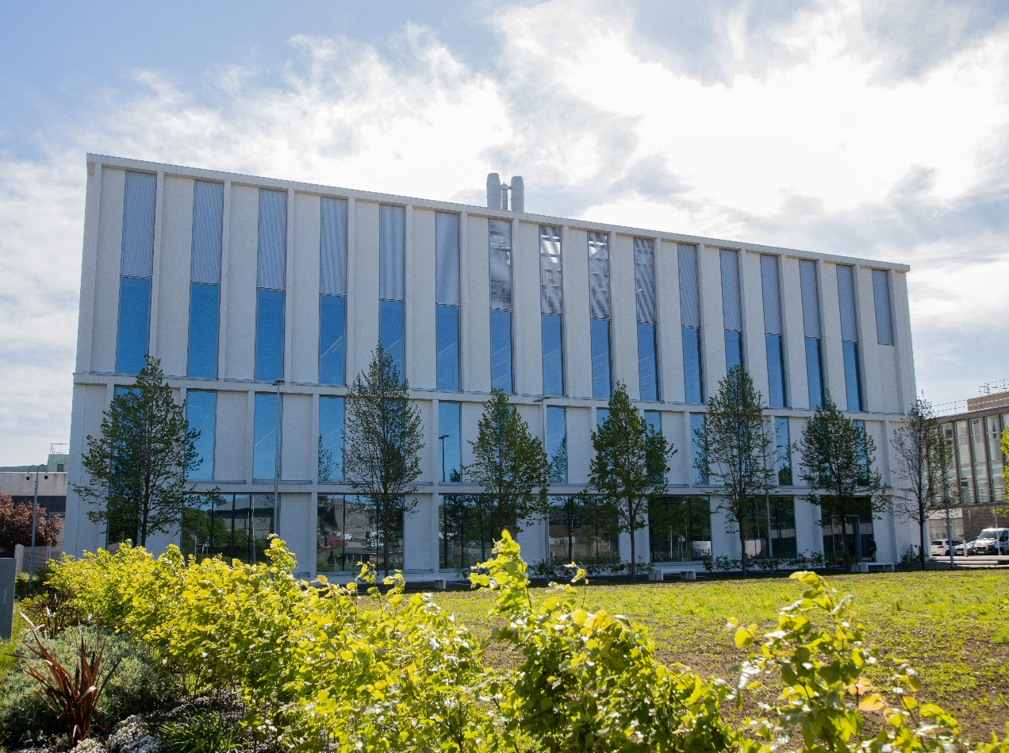
Undergraduate Medical Sciences
School of Medicine, Medical Sciences & Nutrition
Contents

- Course Summary (3)
- Course Aims & Learning Outcomes
- Course Teaching Staff (4)
- Assessments & Examinations
- Class Representatives
- Problems with Coursework (5)
- Course Reading List (6)
- Lecture Synopsis
- Practical/Lab/Tutorial Work (7)
- University Policies
- Academic Language & Skills support (8)
- Medical Sciences Common Grading Scale (10)
- Course Timetable SR3023: 2023-2024 (11)
- Campus and Floor Maps

Course Summary

This course focuses on developing core academic skills for sport science professionals and will be required for articulating Sport &Exercises Science-, Applied Sport Science and Exercise and Health Students in the School of Medicine, Medical Sciences & Nutrition.

The course consists of 5 workshops on Wednesdays 9-12pm in weeks 8,10,12,14,16. The introduction lecture will be streamed live from STH but a Sport Science staff member will be present. After the introduction student can work on the workshop question in pairs or small groups. An additional workshop on Fridays 2-3pm will give the opportunity for questions and more detailed discussion of the topic if required.

Communications and instructions will be relayed during the semester, so the information here is correct at time of writing but may change as the semester progresses. Expected low student numbers on this course might also allow some flexibility in course arrangements. Students should keep an eye on the course MyAberdeen announcements as well as University emails in general in case changes to arrangements are necessary. There will be opportunities for any students requiring extra help to receive it at the end of each Workshop or by arrangement with the course co-ordinator, hopefully including one-to-one or small group tuition if guidelines permit. Once the Workshops are finished, computer-based homework questions will be made available via MyAberdeen to be practised through self-study each week.
On Wednesdays in weeks 9, 11, 13, 15 and 17, students will be required to undertake an individual assignment under timed conditions based on the practice questions. Students will be instructed on arrangements as the course progresses.
Material in the Workshops, Practice questions and Assignments have been contextualised to the major disciplines in the Medical Sciences.

Course Aims & Learning Outcomes
- To increase confidence and competence in numerical manipulations.
- To practice numerical and practical skills.
- To understand and interpret different ways of presenting scientific data.
- To understand simple statistical analysis and how to use it.
- To understand the basis of scientific investigation and the importance of hypothesis driven enquiry.
- To understand the importance of using correct scientific English.
- To design and carry out a practical project.
- To develop transferable skills related to teamwork, time management, communication and information technology skills.

Course Teaching Staff
Course Co-ordinator:
Dr Michael Scholz (m.e.scholz@abdn.ac.uk), Dr Derek Ball (d.ball@abdn.ac.uk)

Other Staff:
School of Medicine, Medical Sciences & Nutrition Academic Contacts:
Dr Arimantas Lionikas (a.lionikas@abdn.ac.uk)
Dr Jenny Gregory (j.gregory@abdn.ac.uk)
Dr Derryck Shewan (d.shewan@abdn.ac.uk)

Assessments & Examinations
Students are required to attend all lectures and workshops, practice the homework questions each week and complete all in-course assessments by stated deadlines.
Assessment is derived from individual assignments (70%) and exercises undertaken during the workshops (30%).
The overall performance of the student is expressed as a grade awarded on the common grading scale.
You must pass all assessments in order to pass the course and so you will be given the opportunity to repeat any that you have missed or failed. If you miss a workshop or assessment due to illness or other reasons, you must contact your course co-ordinator (Dr Michael Scholz, m.e.scholz@abdn.ac.uk) or course administrator (Mr Nigel Graham, n.graham@abdn.ac.uk) immediately. It is your responsibility to be proactive in arranging to re-take missed or failed workshops or assessments. Any repeat assessment due to a failed first attempt will only be awarded a pass grade (D3 on the Common Grade Scheme), although you will be given feedback on the mark that you would have obtained, had it been your first attempt. If you cannot attend a workshop or assessment on the day, you must arrange to take it as soon as possible afterwards, so absences don’t pile up. All work is expected to be complete by the end of the course. Thereafter, unless there are medical issues or other reasons of good cause, unfinished work will be regarded as a resit issue and you will need to apply, and pay, to finish the work and complete the course. As this is a compulsory course you cannot get your degree without passing it, nor can you substitute it with another 15 credit course. So please make sure you catch up with any absences as soon as you can and that you complete all work by December.

Class Representatives

We value students’ opinions in regard to enhancing the quality of teaching and its delivery; therefore, in conjunction with the Students’ Association we support the Class Representative system.

In the School of Medicine, Medical Sciences & Nutrition we operate a system of course representatives, who are elected from within each course. Any student registered within a course that wishes to represent a given group of students can stand for election as a class representative. You will be informed when the elections for class representative will take place.
What will it involve?
It will involve speaking to your fellow students about the course you represent. This can include any comments that they may have. You will attend a Staff-Student Liaison Committee and you should represent the views and concerns of the students within this meeting. As a representative, you will also be able to contribute to the agenda. You will then feedback to the students after this meeting with any actions that are being taken.

Training
Training for class representatives will be run by the Students Association. Training will take place within each half-session. For more information about the Class representative system visit www.ausa.org.uk or email the VP Education & Employability vped@abdn.ac.uk . Class representatives are also eligible to undertake the STAR (Students Taking Active Roles) Award with further information about this co-curricular award being available at: www.abdn.ac.uk/careers.

Problems with Coursework

If students have difficulties with any part of the course that they cannot cope with, alone they should notify the course coordinator immediately. If the problem relates to the subject matter general, advice would be to contact the member of staff who is teaching that part of the course. Students with registered disabilities should contact the medical sciences office, (medsci@abdn.ac.uk) (based in the Polwarth Building, Foresterhill) to ensure that the appropriate facilities have been made available. Otherwise, you are strongly encouraged to contact any of the following as you see appropriate:

- Course student representatives
- Course co-ordinator
- Convenor of the Medical Sciences Staff/Student Liaison Committee (Professor Gordon McEwan)
- Personal Tutor
- Medical Sciences Disabilities Co-ordinator (Dr Derryck Shewan)

All staff are based at Foresterhill and we strongly encourage the use of email or telephone the Medical Sciences Office. You may have a wasted journey travelling to Foresterhill only to find staff unavailable.

If a course has been completed and students are no longer on campus (i.e. work from second half session during the summer vacation), coursework will be kept until the end of Fresher’s Week, during the new academic year. After that point, unclaimed student work will be securely destroyed.

Course Reading List
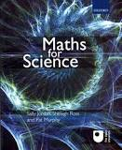
There is no official course reading list, but Maths for Science complements some of the course content and is useful for further information and practice, and is held by the University Library in Old Aberdeen and the Medical School Library on the Foresterhill site. Further, contextual tuition is available through the “Interactive Support Materials” on the MyAberdeen SM2001 course site.

Maths for Science by Sally Jordan, Shelagh Ross and Pat Murphy.

Lecture Synopsis
Ombea and Workshop Synopses
Each workshop is preceded by an introductory lecture to set the scene. Staff will be on hand to help if you get stuck or confused. You will work through a set of related questions and complete an answer sheet, which will be collected for marking. Marks will subsequently be shown in your personal MyAberdeen account.

Workshop 1: Introduction and Numerical Skills (University Week 8, Course Week 1)
The first workshop covers the use of numerical analysis to solve relevant problems in the wide range of disciplines that embrace the medical sciences. It focuses on the importance of units and their conversion, understanding volumes, concentrations and spatial measurements with an appreciation of scientific notation.

Workshop 2: Data Interpretation (Week 10, Course Week 3)
Workshop 2 demonstrates the range of graphs that can be used to display data, specifically scatter plots, bar charts, histograms, line charts, pie charts, box plots etc. It illustrates how trends can be identified within data by describing correlation and the use of correlation coefficients. The workshop highlights the utility of logged axes when data contain outliers or is curvilinear. The concept of variation within datasets is introduced and how this can be illustrated in graphs using error bars.

Workshop 3: Data Collection and Statistical Analysis (Week 12, Course Week 5)
This workshop provides an introductory guide to statistics and how to analyse scientific data. In this module, analysis of scientific data will be explained using introductory-level statistics. Building on an explanation of sampling and populations, the module will cover concepts such as how to express the centre point of a spread of data (measures of location: mean, median), how to express the spread of your data (standard deviation), how to calculate the confidence limits of a population, and how to carry out Student t-tests to compare two means from independent samples. The workshop will provide you with the ability to implement five useful statistical calculations and tests that you can employ to analyse a range of different biological data types, with the ability to interpret numerical and graphical statistical data.

Workshop 4: Experimental Design (Week 14, Course Week 7)
This workshop will consider the design of experimental protocols to test scientific hypotheses. It will also address the necessity of appropriate control samples in experimental design to allow for confounding and nuisance variables and of appropriate replicates in experimental design, as well as an appreciation of correct sampling effort. This workshop will cover experimental bias and how to reduce this by randomisation of treatments and pairing/matching subjects, and examine the relationship between experimental design and correct statistical analysis.

Workshop 5: Reporting Scientific Data and Problem Solving (Week 16, Course Week 9)
At the heart of science is problem solving. This workshop will involve interpreting complex data sets and working out what conclusions may be drawn from the information as it is presented. You will also be asked to write different types of reports appropriate to different situations.
Practical/Lab/Tutorial Work
This year, as you know, most work will be done online. Live classes will be held where possible. The course co-ordinator normally makes arrangements to meet students who are having problems with workshop or practice question concepts/questions in order to talk things through and provide clarification. This can hopefully still occur by appointment and could take place within the Zoology building for those on campus or online if preferable. Students will be updated on this as the course progresses. Repeat workshops/assessments must be arranged as soon as possible the course co-ordinator, Dr Michael Scholz (m.e.scholz@abdn.ac.uk).

University Policies
Students are asked to make themselves familiar with the information on key education policies, available here. These policies are relevant to all students and will be useful to you throughout your studies. They contain important information and address issues such as what to do if you are absent, how to raise an appeal or a complaint and how the University will calculate your degree outcome.

These University wide education policies should be read in conjunction with this programme and/or course handbook, in which School specific policies are detailed. These policies are effective immediately, for the 2023/24 academic year. Further information can be found on the University’s Infohub webpage or by visiting the Infohub.

The information included in the institutional area for 2023-24 includes the following:

- Absence
- Appeals & Complaints
- Assessment
- Avoiding Plagiarism
- Communication
- Graduate Attributes
- MyAberdeen
- Student Learning Service (SLS)
- Student Monitoring/Class Certificates
- Student Discipline
- The Co-curriculum

Where to Find the Following Information:

C6/C7- University of Aberdeen Homepage > Students > Academic Life > Monitoring and Progress > Student Monitoriung (C6 & C7)
https://www.abdn.ac.uk/students/academic-life/student-monitoring.php#panel5179

Absences- To report absences you should use the absence reporting system tool on Student Hub. Once you have successfully completed and sent the absence form you will get an email that your absence request has been accepted. The link below can be used to log onto the Student Hub Website and from there you can record any absences you may have.

Log In - Student Hub (ahttps://www.abdn.ac.uk/studenthub/loginbdn.ac.uk)

Submitting an Appeal- University of Aberdeen Homepage > Students > Academic Life > Appeals and Complaints

https://www.abdn.ac.uk/students/academic-life/appeals-complaints-3380.php#panel2109

Academic Language & Skills support
For students whose first language is not English, the Language Centre offers support with Academic Writing and Communication Skills.

Academic Writing
- Responding to a writing task: Focusing on the question
- Organising your writing: within & between paragraphs
- Using sources to support your writing (including writing in your own words, and
citing & referencing conventions)
- Using academic language
- Critical Thinking
- Proofreading & Editing

Academic Communication Skills
- Developing skills for effective communication in an academic context
- Promoting critical thinking and evaluation
- Giving opportunities to develop confidence in communicating in English
- Developing interactive competence: contributing and responding to seminar discussions
- Useful vocabulary and expressions for taking part in discussions

More information and how to book a place can be found here

Medical Sciences Common Grading Scale

Grade | Grade Point | % Mark | Category | Honours Class | Description
A1 | 22 | 90-100 | Excellent | First | • Outstanding ability and critical thought  • Evidence of extensive reading  • Superior understanding  •The best performance that can be expected from a student at this level
A2 | 21 | 85-89 | Excellent | First
A3 | 20 | 80-84 | Excellent | First
A4 | 19 | 75-79 | Excellent | First
A5 | 18 | 70-74 | Excellent | First
B1 | 17 | 67-69 | Very Good | Upper Second | • Able to argue logically and organise answers well  • Shows a thorough grasp of concepts  • Good use of examples to illustrate points and justify arguments  • Evidence of reading and wide appreciation of subject
B2 | 16 | 64-66 | Very Good | Upper Second
B3 | 15 | 60-63 | Very Good | Upper Second
C1 | 14 | 57-59 | Good | Lower Second | • Repetition of lecture notes without evidence of further appreciation of subject  • Lacking illustrative examples and originality  • Basic level of understanding
C2 | 13 | 54-56 | Good | Lower Second
C3 | 12 | 50-53 | Good | Lower Second
D1 | 11 | 47-49 | Pass | Third | • Limited ability to argue logically and organise answers  • Failure to develop or illustrate points  • The minimum level of performance required for a student to be awarded a pass
D2 | 10 | 44-46 | Pass | Third
D3 | 9 | 40-43 | Pass | Third
E1 | 8 | 37-39 | Fail | Fail | • Weak presentation  • Tendency to irrelevance  • Some attempt at an answer but seriously lacking in content and/or ability to organise thoughts
E2 | 7 | 34-36 | Fail | Fail
E3 | 6 | 30-33 | Fail | Fail
F1 | 5 | 26-29 | Clear Fail | Not used for Honours | • Contains major errors or misconceptions  • Poor presentation
F2 | 4 | 21-25 | Clear Fail | Not used for Honours
F3 | 3 | 16-20 | Clear Fail | Not used for Honours
G1 | 2 | 11-15 | Clear Fail/Abysmal |  | • Token or no submission
G2 | 1 | 1-10 | Clear Fail/Abysmal |  | • Token or no submission
G3 | 0 | 0 | Clear Fail/Abysmal |  | • Token or no submission

Course Timetable SR3023: 2023-2024
Date | Time | Place | Subject | Session | Staff
Week 8
Mon 18 Sep
Tue 19 Sep
Wed 20 Sep | 9:00-13:00 | Comp 218 | Workshop on Numerical Skills | workshop | DB/MES
Thu 21 Sep
Fri 22 Sep | 13:00-14:00 | 1M:003 | Workshop tutorial | tutorial | DB/MR
Week 9
Mon 25 Sep
Tue 26 Sep
Wed 27 Sep | 9:00-11:00 | Comp G40 | Assessment on Numerical Skills | Assessment | MES
Thu 28 Sep
Fri 29 Sep
Week 10
Mon 2 Oct
Tue 3 Oct
Wed 4 Oct | 9:00-13:00 | Comp 218 | Workshop on Data Interpretation | workshop | MES
Thu 5 Oct
Fri 6 Oct | 13:00-14:00 | 1M:003 | Workshop tutorial | tutorial | MES
Week 11
Mon 9 Oct
Tue 10 Oct
Wed 11 Oct | 9:00-11:00 | Comp G40 | Assessment on Data Interpretation | Assessment | tbc
Thu 12 Oct
Fri 13 Oct
Week 12
Mon 16 Oct
Tue 17 Oct
Wed 18 Oct | 9:00-13:00 | Comp 218 | Workshop on Data Collection and Statistical Analysis | workshop | AL
Thu 19 Oct
Fri 20 Oct | 13:00-14:00 | 1M:003 | Workshop tutorial | tutorial | AL
Week 13
Mon 23 Oct
Tue 24 Oct
Wed 25 Oct | 9:00-11:00 | Comp G40 | Assessment on Data Collection and Statistics | Assessment | MES
Thu 26 Oct
Fri 27 Oct
Week 14
Mon 30 Oct
Tue 31 Oct
Wed 1 Nov | 9:00-13:00 | Comp 218, Cruikshank | Workshop on Experimental Design | workshop | tbc
Thu 2 Nov
Fri 3 Nov | 13:00-14:00 | 1M:003 | Workshop tutorial | tutorial | tbc
Week 15
Mon 6 Nov
Tue 7 Nov
Wed 8 Nov | 9:00-11:00 | Comp G40, Zoology | Assessment on Experimental Design | Assessment | MES
Thu 9 Nov
Fri 10 Nov
Week 16
Mon 13 Nov
Tue 14 Nov
Wed 15 Nov | 9:00-13:00 | Comp 218 Cruikshank | Workshop on Reporting Scientific Data and Problem Solving | workshop | JG
Thu 16 Nov
Fri 17 Nov | 13:00-14:00 | 1M:003 | Workshop tutorial | tutorial | JG
Week 17
Mon 20 Nov
Tue 21 Nov
Wed 22 Nov | 9:00-11:00 | Comp G40 Zoology | Assessment on Reporting Scientific Data and Problem Solving | Assessment | MES
Thu 23 Nov
Fri 24 Nov
Week 18 – NO TEACHING (CONSOLIDATE INTO 10 WEEKS)
Mon 27 Nov
Tue 28 Nov
Wed 29 Nov
Thu 30 Nov
Fri 1 Dec

Staff

AL Arimantas Lionikas
DB Derek Ball
JG Jenny Gregory
MES Michael Scholz
MR Morgiane Richard

Venues:
Comp 218 | Cruikshank Building computer room 218
MR265 | MacRobert MR265
1M:003 | Polwarth 1M:003

Campus Maps - Foresterhill

Polwarth Floor Plans

