

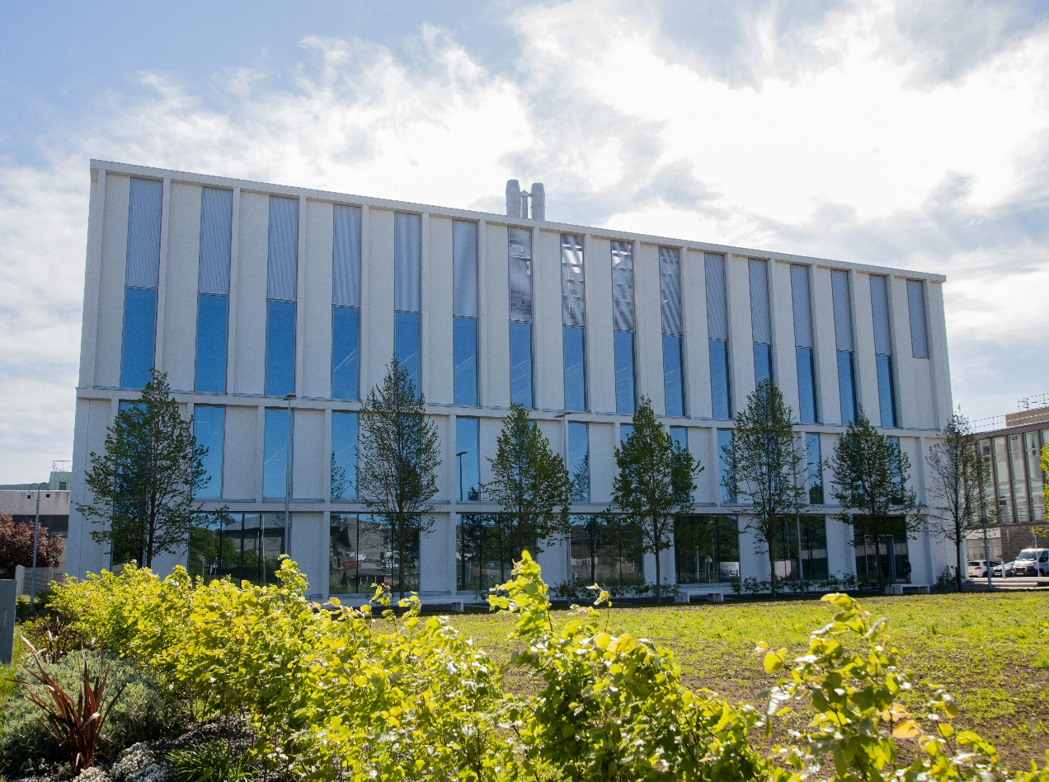
SR2002- The Science of Sports Performance
Course Handbook 2023-2024
Undergraduate Medical Sciences
School of Medicine, Medical Sciences & Nutrition
Contents

- Course Summary (3)
- Course Aims & Learning Outcomes
- Course Teaching Staff
- Assessments & Examinations
- Class Representatives (4)
- Problems with Coursework (5)
- Course Reading List
- Lecture Synopsis (6)
- Practical/Lab/Tutorial Work (7)
- University Policies
- Academic Language & Skills support (8)
- Medical Sciences Common Grading Scale (10)
- Course Timetable SR2002: 2023-2024 (11)
- Campus and Floor Maps

Course Summary
This course is designed to analyse a range of factors which determine athletic performance. From biomechanics and muscle physiology, it develops and focuses on motor control of human movement. It covers the effects of muscle damage on sports performance and elaborates on mechanisms of muscle growth and regeneration after exercise. It also explores performance enhancement in sport as well as regulation and testing.
Course Co-ordinator: Dr Jenny Gregory j.gregory@abdn.ac.uk

Course Aims & Learning Outcomes
The specific objectives of SR2002 are to:
- Understand the range of factors which contribute to sports performance
- Understand forces which contribute towards and limit human performance in selected sports
- Understand the neuromechanical aspects of movement
- Understand the mechanisms of muscle damage and growth after exercise
- Understand performance enhancement and drug use in sport

Course Teaching Staff
Course Co-ordinator(s):
Dr Jenny Gregory (JSG)
Other Staff:
Professor Alison Jenkinson (AJ)
Dr Arimantas Lionikas (AL)
Dr Jenna Gregory (JMG)
Dr Michael Scholz (MS)
Dr Gillian Kerr(GK)
Dr Morgiane Richard (MR)

** Please note – there are two members of staff with very similar names on this course, Jenny Gregory (JSG) and Jenna Gregory (JMG). Please make sure you have the correct one if you are contacting us. Send all course-coordination queries to Jenny Gregory (JSG) j.gregory@abdn.ac.uk

Assessments & Examinations
Examination
The course mark is based on the in-course assessments only. There is no exam.

Assessment Summary
Students are expected to access and study ALL lectures, lab classes and online test materials, and to complete all exercises by the given deadlines. The minimum performance acceptable for the granting of a class certificate is evidence of engagement with, at least, 75% of the lectures and lab classes. Failure to achieve this may result in your class certificate being withheld. The overall performance of the student will be expressed as a grade awarded on the attached Common Grading Scale (CGS).
The final mark will consist of the following:
- Assessment 1 (MCQ test): 20%
- Assessment 2 (MCQ test): 25%
- Assessment 3 (MCQ test): 25%
- Structured Lab Report 15%
- Practical 1 (MCQ test / short answers): 7.5%
- Practical 2 (MCQ test / short answers): 7.5%

Class Representatives

We value students’ opinions in regard to enhancing the quality of teaching and its delivery; therefore, in conjunction with the Students’ Association we support the Class Representative system.

In the School of Medicine, Medical Sciences & Nutrition we operate a system of course representatives, who are elected from within each course. Any student registered within a course that wishes to represent a given group of students can stand for election as a class representative. You will be informed when the elections for class representative will take place.

What will it involve?
It will involve speaking to your fellow students about the course you represent. This can include any comments that they may have. You will attend a Staff-Student Liaison Committee and you should represent the views and concerns of the students within this meeting. As a representative, you will also be able to contribute to the agenda. You will then feedback to the students after this meeting with any actions that are being taken.

Training
Training for class representatives will be run by the Students Association. Training will take place within each half-session. For more information about the Class representative system visit www.ausa.org.uk or email the VP Education & Employability vped@abdn.ac.uk . Class representatives are also eligible to undertake the STAR (Students Taking Active Roles) Award with further information about this co-curricular award being available at: www.abdn.ac.uk/careers.

Problems with Coursework

If students have difficulties with any part of the course that they cannot cope with, alone they should notify the course coordinator immediately. If the problem relates to the subject matter general, advice would be to contact the member of staff who is teaching that part of the course. Students with registered disabilities should contact the medical sciences office, (medsci@abdn.ac.uk) (based in the Polwarth Building, Foresterhill) to ensure that the appropriate facilities have been made available. Otherwise, you are strongly encouraged to contact any of the following as you see appropriate:

- Course student representatives
- Course co-ordinator
- Convenor of the Medical Sciences Staff/Student Liaison Committee (Professor Gordon McEwan)
- Personal Tutor
- Medical Sciences Disabilities Co-ordinator (Dr Derryck Shewan)

All staff are based at Foresterhill and we strongly encourage the use of email or telephone the Medical Sciences Office. You may have a wasted journey travelling to Foresterhill only to find staff unavailable.

If a course has been completed and students are no longer on campus (i.e. work from second half session during the summer vacation), coursework will be kept until the end of Fresher’s Week, during the new academic year. After that point, unclaimed student work will be securely destroyed.

Course Reading List
- Exercise Physiology: energy, nutrition & human performance, WD McArdle, FI Katch, VL Katch, Eighth Edition, 2014. Lippincott Williams & Wilkins.
  - Please note, many different editions are available in the library
- Abernethy, B., Hanrahan, S.J., Kippers, V., Mackinnon, L.T. & Pandy, M.G. (2013) The biophysical foundations of human movement, 3rd Ed. Champaign, IL: Human Kinetics
- Enoka, R. (2015) Neuromechanics of human movement, 5th Ed. Champaign, IL: Human Kinetics
- MacIntosh, B.R., Gardiner, P.F. McComas, A.J. (2006) Skeletal muscle, 2nd Ed. Champaign, IL: Human Kinetics
- Carpenter, R., Reddi, B. (2012) Neurophysiology: A Conceptual Approach, 5th Ed.

Lecture Synopsis
Module 1 (Lecture content for MCQ 1)
Introduction to Biomechanics – Dr Jenny Gregory
- An introduction to the science of Sports Performance.
- Body composition the centre of gravity and motion
- Force and Torque
- Power and work
- Movement analysis
- Writing lab reports

Module 2 (Lecture content for MCQ 2)

Muscle Function and Motor Units – Dr Arimantas Lionikas
- Muscle Mechanics
- Motor unit: Structure and function
- Motor units in movements

Motor Control – Dr Jenna Gregory
- Brain control of movement
Module 3 (Lecture content for MCQ 3)
Drug Use in Sport – Ms Gillian Kerr
*(NB: Recording with invite to clean sport lecture for sports Bursars on the 28th September (7-8pm))
- Drug Use and testing in Sport

Cellular Signalling – Dr Michael Scholz
- Cellular signalling: cell types and adaptations
- Cellular signalling: control of growth, quiescence and death

Muscle Adaptation to Exercise – Dr Michael Scholz
- Cellular signalling in muscle cells
- Exercise as a stimulus for adaptations
- Exercise as a stimulus for muscle growth

Muscle Damage – Professor Alison Jenkinson
- Muscle soreness and damage
- Antioxidants and muscle damage

Performance Enhancement – Professor Alison Jenkinson
- Performance enhancement I
- Performance enhancement II

Practical/Lab/Tutorial Work

There are practical sessions throughout the course and each practical may be run multiple times. Swaps of practical groups are only possible if discussed with the course-coordinators as soon as possible after being assigned a practical group, but ideally should be avoided.
Attendance will be taken at all practical classes. Guidance will be given at each practical class and information about the lab classes will be available on MyAberdeen prior to each class. Please read through the practical guidance using MyAberdeen so that you have some knowledge of what is expected of you in the practical classes, particularly to make sure you bring the appropriate clothes with you (whether sports kit or a lab coat). Please note that it is not possible to borrow or rent lab coats from the teaching staff at the Science Teaching Hub.

University Policies

Students are asked to make themselves familiar with the information on key education policies, available here. These policies are relevant to all students and will be useful to you throughout your studies. They contain important information and address issues such as what to do if you are absent, how to raise an appeal or a complaint and how the University will calculate your degree outcome.
These University wide education policies should be read in conjunction with this programme and/or course handbook, in which School specific policies are detailed. These policies are effective immediately, for the 2023/24 academic year. Further information can be found on the University’s Infohub webpage or by visiting the Infohub.

The information included in the institutional area for 2023-24 includes the following:
- Assessment
- Feedback
- Academic Integrity
- Absence
- Student Monitoring/ Class Certificates
- Late Submission of Work
- Student Discipline
- The co-curriculum
- Student Learning Service (SLS)
- Professional and Academic Development
- Graduate Attributes
- Email Use
- MyAberdeen
- Appeals and Complaints

Where to Find the Following Information:

C6/C7- University of Aberdeen Homepage > Students > Academic Life > Monitoring and Progress > Student Monitoriung (C6 & C7)
https://www.abdn.ac.uk/students/academic-life/student-monitoring.php#panel5179

Absences- To report absences you should use the absence reporting system tool on Student Hub. Once you have successfully completed and sent the absence form you will get an email that your absence request has been accepted. The link below can be used to log onto the Student Hub Website and from there you can record any absences you may have.

Log In - Student Hub (ahttps://www.abdn.ac.uk/studenthub/loginbdn.ac.uk)

Submitting an Appeal- University of Aberdeen Homepage > Students > Academic Life > Appeals and Complaints

https://www.abdn.ac.uk/students/academic-life/appeals-complaints-3380.php#panel2109

Academic Language & Skills support
For students whose first language is not English, the Language Centre offers support with Academic Writing and Communication Skills.

Academic Writing
- Responding to a writing task: Focusing on the question
- Organising your writing: within & between paragraphs
- Using sources to support your writing (including writing in your own words, and
citing & referencing conventions)
- Using academic language
- Critical Thinking
- Proofreading & Editing

Academic Communication Skills
- Developing skills for effective communication in an academic context
- Promoting critical thinking and evaluation
- Giving opportunities to develop confidence in communicating in English
- Developing interactive competence: contributing and responding to seminar discussions
- Useful vocabulary and expressions for taking part in discussions

More information and how to book a place can be found here

Medical Sciences Common Grading Scale

Grade | Grade Point | % Mark | Category | Honours Class | Description
A1 | 22 | 90-100 | Excellent | First | • Outstanding ability and critical thought  • Evidence of extensive reading  • Superior understanding  •The best performance that can be expected from a student at this level
A2 | 21 | 85-89 | Excellent | First
A3 | 20 | 80-84 | Excellent | First
A4 | 19 | 75-79 | Excellent | First
A5 | 18 | 70-74 | Excellent | First
B1 | 17 | 67-69 | Very Good | Upper Second | • Able to argue logically and organise answers well  • Shows a thorough grasp of concepts  • Good use of examples to illustrate points and justify arguments  • Evidence of reading and wide appreciation of subject
B2 | 16 | 64-66 | Very Good | Upper Second
B3 | 15 | 60-63 | Very Good | Upper Second
C1 | 14 | 57-59 | Good | Lower Second | • Repetition of lecture notes without evidence of further appreciation of subject  • Lacking illustrative examples and originality  • Basic level of understanding
C2 | 13 | 54-56 | Good | Lower Second
C3 | 12 | 50-53 | Good | Lower Second
D1 | 11 | 47-49 | Pass | Third | • Limited ability to argue logically and organise answers  • Failure to develop or illustrate points  • The minimum level of performance required for a student to be awarded a pass
D2 | 10 | 44-46 | Pass | Third
D3 | 9 | 40-43 | Pass | Third
E1 | 8 | 37-39 | Fail | Fail | • Weak presentation  • Tendency to irrelevance  • Some attempt at an answer but seriously lacking in content and/or ability to organise thoughts
E2 | 7 | 34-36 | Fail | Fail
E3 | 6 | 30-33 | Fail | Fail
F1 | 5 | 26-29 | Clear Fail | Not used for Honours | • Contains major errors or misconceptions  • Poor presentation
F2 | 4 | 21-25 | Clear Fail | Not used for Honours
F3 | 3 | 16-20 | Clear Fail | Not used for Honours
G1 | 2 | 11-15 | Clear Fail/Abysmal |  | • Token or no submission
G2 | 1 | 1-10 | Clear Fail/Abysmal |  | • Token or no submission
G3 | 0 | 0 | Clear Fail/Abysmal |  | • Token or no submission

SR2002 Course Timetable 2023-2024

Date | Time | Place | Subject | Session | Staff
Week 8
Mon 18 Sep | 10:00-11:00
Tue 19 Sep | 13:00 – 14:00 | MT6  (Meston) | Introduction: The Science of Sport Performance | Lecture | JSG
Wed 20 Sep
Thu 21 Sep | 10:00-11:00 | FN2 (Fraser Noble) | Body composition | Lecture | JSG
Thu 21 Sep | 11:00-12:00 | FN2 | Motion | Lecture | JSG
Fri 22 Sep
Week 9
Mon 25 Sep
Tue 26 Sep | 13:00-14:00 | ZG18 | Force and Torque | Lecture | JSG
Wed 27 Sep
Thu 28 Sep | 10:00-11:00 | FN2 | Power and Work | Lecture | JSG
Thu 28 Sep | 11:00-12:00 | FN2 | Movement Analysis | Lecture | JSG
Thu 28 Sep |  |  | Problem solving / revision recordings released online
Thu 28 Sep | 19:00-20:00 |  | Clean sport (optional)  Invite for SR2002 students to an evening lecture on drugs testing for University of Aberdeen Sports Bursar students.  Recording will be included as lecture material in Module 3 | Optional lecture | GK
Fri 29 Sep | 10:00-11:00 | FN110 | Maths Support 1 - optional | Tutorial | MR
Week 10
Mon 2 Oct |  |  | Wingate data released online
 | 11:00-12:00 | FN110 | Maths Support 2 - optional | Tutorial | MR
Tue 3 Oct | 13:00-14:00 | ZG18 | Writing a lab report / the Wingate test (+ Q & A for assessment 1) | Lecture | JSG
Wed 4 Oct |  |  | END MODULE 1, START MODULE 2
Thu 5 Oct | 10:00-11:00 | FN2 | Muscle Mechanics I | Lecture | AL
Thu 5 Oct | 11:00-12:00 | FN2 | Muscle Mechanics II | Lecture | AL
Fri 6 Oct | 10:00-11:00 | FN110 | Maths Support 3 - optional | Tutorial | MR
Week 11
Mon 9 Oct
Tue 10 Oct |  |  | ASSESSMENT 1 (online)
 | 13:00-14:00 | ZG18 | Motor Unit: Structure and Function | Lecture | AL
Wed 11 Oct
Thu 12 Oct | 10:00-11:00 | FN2 | Motor control I | Lecture | JMG
Thu 12 Oct | 11:00-12:00 | FN2 | Motor control I | Lecture | JMG
Fri 13 Oct
Week 12
Mon 16 Oct |  |  | Drug Use in Sport  Recording released | Recorded Lecture (see 28th Sept) | GK
Tue 17 Oct | 13:00-14:00 | ZG18 | Motor units in movements | Lecture | AL
Wed 18 Oct
Thu 19 Oct | 09:00-12:00 | STH 0.001 (Flat Floor Lab) | PRACTICAL 1 Work and Power (Grp A) | Practical | JSG
Thu 19 Oct | 12:00-15:00 | STH 0.001 | PRACTICAL 1 Work and Power (Grp B) | Practical | JSG
Thu 19 Oct | 15:00-18:00 | STH 0.001 | PRACTICAL 1 Work and Power (Grp C) | Practical | JSG
Fri 20 Oct
Week 13
Mon 23 Oct
Tue 24 Oct | 13:00-14:00 | ZG18 | Muscle fibre types and athletic performance: | Lecture | AL
 |  |  | Wingate lab report due (online)
Wed 25 Oct
Thu 26 Oct | 09:00-12:00 | STH 2.006 | PRACTICAL 1 Fibre typing (GRP 1) | Practical | AL /JSG
Thu 26 Oct | 13:00-16:00 | STH 2.006 | PRACTICAL 1 Fibre typing (GRP 2) | Lecture | AL /JSG
Thu 26 Oct |  |  | Practical 1 submission due (online)
Fri 27 Oct
Week 14
Mon 30 Oct
Tue 31 Oct | 13:00-14:00 | ZG18 | Cellular signalling: cell types and adaptations | Lecture | MS
Wed 2 Nov |  |  | END MODULE 2, START MODULE 3
Thu 3 Nov | 10:00-11:00 | FN3 | ASSESSMENT 2 (online) |  | JSG
Thu 3 Nov | 11:00-12:00 | FN3 | Private study |  | JSG
Fri 4 Nov
Week 15
Mon 6 Nov
Tue 7 Nov | 13:00-14:00 | ZG18 | Cellular signalling: control of growth, quiescence and death | Lecture | MS
Wed 8 Nov
Thu 9 Nov | 10:00-11:00 | FN2 | Exercise as a stimulus for adaptations | Lecture | MS
Thu 9 Nov | 11:00-12:00 | FN2 | Exercise as a stimulus for muscle growth | Lecture | MS
 |  |  | Practical 2 due (online)
Fri 10 Nov
Week 16
Mon 13 Nov
Tue 14 Nov | 13:00-14:00 | ZG18 | Muscle soreness and damage | Lecture | AJ
Wed 15 Nov
Thu 16 Nov | 10:00-11:00 | FN2 | Private Study |  | JG
Thu 16 Nov | 11:00-12:00 | FN2 | Private Study |  | JG
Fri 17 Nov
Week 17
Mon 20 Nov
Tue 21 Nov | 13:00-14:00 | NK10 | Antioxidants and muscle damage | Lecture | AJ
Wed 22 Nov
Thu 23 Nov | 10:00-11:00 | Macrobert LT | Performance Enhancement I |  | AJ
Thu 23 Nov | 11:00-12:00 | Macrobert LT | Performance Enhancement II |  | AJ
Fri 24 Nov |  |  | Assessment 3 (online)
Week 18 – NO TEACHING (CONSOLIDATE INTO 10 WEEKS)

Campus Maps - Foresterhill

Polwarth Floor Plans

