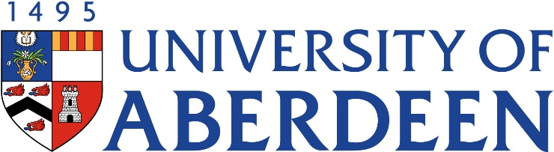

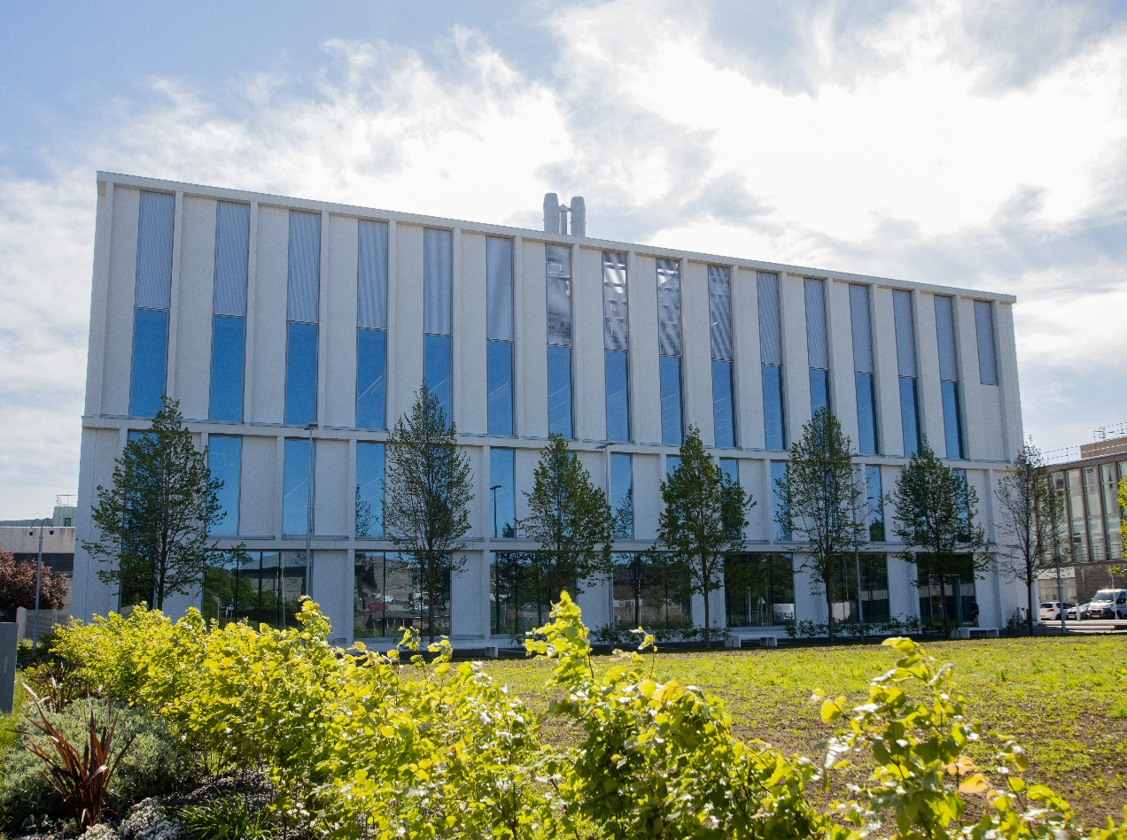
SM1001- Introduction to Medical Sciences
Course Handbook 2023-2024
Undergraduate Medical Sciences
School of Medicine, Medical Sciences & Nutrition
Contents

- Course Summary
- Course Aims & Learning Outcomes
- Course Teaching Staff
- Assessments & Examinations
- Class Representatives
- Problems with Coursework
- Course Reading List
- Lecture Synopsis
- Practical/Lab/Tutorial Work
- Q&A Drop-in Sessions
- University Policies
- Academic Language & Skills support
- Medical Sciences Common Grading Scale
- Course Timetable SM1001: 2023-2024
- Campus and Floor Maps
Course Summary
This course sets out to map many of the key milestones in Medical Science through the ages. It will also highlight the ways technological advances have brought about revolutionary changes to the way we diagnose and treat specific diseases and conditions. Throughout the course, the multidisciplinary nature of this broad subject area will be emphasised with a view to identifying the emergence of the core disciplines associated with the School of Medicine, Medical Sciences & Nutrition. There will also be a strong emphasis on the important contributions made by Aberdeen medical scientists to the advancement of medical knowledge and the treatment of disease.

Course Aims and Learning Outcomes
- To provide a basic understanding of the medical sciences in general.
- To provide an overview of medical advancements throughout history.
- To provide an understanding of fundamental aspects of medical sciences applied to you and the wider population.
- To provide knowledge of basic techniques for assessing medically relevant topics.

Course Teaching Staff
Course Co-ordinator(s):
Prof John Barrow (j.barrow@abdn.ac.uk)
Dr Iain Rowe (iain.rowe@abdn.ac.uk)
Other Staff:
Dr Isabel Crane (i.j.crane@abdn.ac.uk)
Dr Catriona Cunningham (catriona.cunningham@abdn.ac.uk)
Dr Alison Jack (a.jack@abdn.ac.uk)
Dr Pietro Marini (p.marini@abdn.ac.uk)
Dr Silvia Mazzotta (silvia.mazzotta@abdn.ac.uk)
Dr Derryck Shewan (d.shewan@abdn.ac.uk)
Dr Virtu Solano (mariavirtudes.solanocollado@abdn.ac.uk)
Prof Steve Tucker (s.j.tucker@abdn.ac.uk)

Assessment and Examinations
Students are expected to access and study ALL lectures, lab classes and online test materials, and to complete all exercises by the given deadlines. The minimum performance acceptable for the granting of a class certificate is evidence of engagement with, at least, 75% of the lectures and lab classes, and presentation of all set course work. Failure to achieve this may result in your class certificate being withheld.

The course assessment consists of 50% continuous assessment based on your marks from the assessments shown below. 50% of the course grade then comes from an end of term exam assessment run via MyAberdeen as an online test. Resit assessment will be based on a resit examination constituting 50% of the resit grade; the remaining 50% will come from previous continuous assessment. Your overall performance will be expressed as a grade awarded on the Common Grading Scale (CGS).

Continuous assessment weightings:
Medical Challenges Poster 20%
Medical Measurements Lab 10%
Who’s the Strongest Lab 10%
Blood Typing Lab 10%
Total continuous assessment: 50%

Class Representatives
We value students’ opinions in regard to enhancing the quality of teaching and its delivery; therefore, in conjunction with the Students’ Association we support the Class Representative system.

In the School of Medicine, Medical Sciences & Nutrition we operate a system of course representatives, who are elected from within each course. Any student registered within a course that wishes to represent a given group of students can stand for election as a class representative. You will be informed when the elections for class representative will take place.

What will it involve?
It will involve speaking to your fellow students about the course you represent. This can include any comments that they may have. You will attend a Staff-Student Liaison Committee and you should represent the views and concerns of the students within this meeting. As a representative, you will also be able to contribute to the agenda. You will then feedback to the students after this meeting with any actions that are being taken.

Training
Training for class representatives will be run by the Students Association. Training will take place within each half-session. For more information about the Class representative system visit www.ausa.org.uk or email the VP Education & Employability vped@abdn.ac.uk . Class representatives are also eligible to undertake the STAR (Students Taking Active Roles) Award with further information about this co-curricular award being available at: www.abdn.ac.uk/careers.

Problems with Coursework
If students have difficulties and cannot cope with any part of the course then they individually should notify the course coordinator immediately. If the problem relates to the subject matter then our advice would be to contact the member of staff who is teaching that part of the course. Students with registered disabilities should contact the medical sciences office, (medsci@abdn.ac.uk) (based in the Polwarth Building, Foresterhill) to ensure that the appropriate facilities have been made available. Otherwise, you are strongly encouraged to contact any of the following as you see appropriate:

- Course student representatives
- Course co-ordinator
- Convenor of the Medical Sciences Staff/Student Liaison Committee
- Personal Tutor
- Medical Sciences Disabilities Co-ordinator (Dr Derryck Shewan)
All staff are based at Foresterhill and we strongly encourage you to email the Medical Sciences Office to check staff availability. You may have a wasted journey travelling to Foresterhill only to find staff unavailable.

If a course has been completed and students are no longer on campus (i.e. work from second half session during the summer vacation), coursework will be kept until the end of Fresher’s Week, during the new academic year. After that point, unclaimed student work will be securely destroyed.

Course Reading List
Medical Firsts: From Hippocrates to the Human Genome by Robert E. Adler (2004)
John Wiley & Sons
ISBN: 0471401757

Life: The Science of Biology (12th Edition) by David Hillis, et al. (2020)
WH Freeman
ISBN: 1319315788

Lecture Synopsis
A series of lectures introducing medical advancements through time and then focusing on various key themes in the Medical Sciences. Lectures are grouped into themes and were possible these will be in the order shown in e timetable. However, due to staff availability there are some lectures that will be delivered in a slightly different order than the order shown below.

Lectures in grey font are non-examined lectures that provide additional information on careers, information about your degree programmes and other useful guidance.
Course Introduction – John Barrow
Outline of the course and general introduction

Theme 1: Medical Sciences – past, present and future (Iain Rowe)
How did we get here?
A very brief history of the science of life, and some of those who helped us on the road to medical understanding.

What have the Aberdonians ever done for us?
Nobel laureates both local and global, and what we can learn from them.

Body heat
Global climate change and the implications for physiology.

Plastic ain’t fantastic
Challenges and opportunities for sustainable science.

Bias and beyond?
Diversity, data and decolonization of the curriculum.

Choose life!
How our physiology influences our choices.

Medical ethics – John Barrow & Iain Rowe
A real-time voting presentation which will explore your attitudes to challenging ethical issues created by medical science.

Theme 2: It’s what’s inside that counts (John Barrow & Steve Tucker)
Dissecting out the facts – John Barrow
How did we go from a society that had no knowledge of what makes us human to understanding how we are made?

Seeing the impossible – John Barrow
How did we make the leap from diagnosis of internal injuries or disease through touch to using x-rays and other imaging tools?

Imaging living organs – John Barrow
How can clinicians see through your body to understand your deepest thoughts? How can they image your internal organs? What does the future hold for medical imaging?

The history of microscopy – Steve Tucker
A brief history of some of the greatest leaps in the medical sciences that allowed us to see a microscopic world.

Light microscopy and histology – Steve Tucker
A continuation from the previous microscopy lecture, we will discover how medical scientists changed our understanding of how life is constructed through microscopy.

Modern microscopy – Steve Tucker
How do we currently use microscopes? What do they allow us to see? What do they hold for the future of medical research?

Course review/evaluation – John Barrow & Iain Rowe
Mid-term review of the course to date and a chance to share your views and discuss relevant issues with the course staff and your fellow students.

Theme 3: Drug discovery and disease (Steve Tucker & John Barrow)
History of opioid pharmacology – Steve Tucker
What are the opioids? How where they discovered? What are their uses both today and throughout history?

Opioids, pain and Kosterlitz – Steve Tucker
How were the opioids used to treat pain, and who is this Kosterlitz guy?

Cannabis through the ages – Steve Tucker
We all know what cannabis is used for, but how were its properties first discovered and what therapeutic uses does it have?

Discovering insulin – John Barrow
A look at how insulin was first discovered and how Aberdeen had a huge role to play in its discovery.

Drug discovery: the rise of Viagra – Steve Tucker
An example of how a drug developed for treating one condition became particularly useful in an entirely different situation.

Pharmacology of addiction – Steve Tucker
We all have the potential to be addicts. This lecture will discuss the role that the pharmacology plays in us being susceptible to addiction.

Is there life after Medical Sciences? – John Barrow & Iain Rowe
Of course there is! We will discuss some of the career options open to you after you graduate with your shiny new BSc in the medical science disciplines.

Theme 4: Immunology, blood and stem cells (Isabel Crane, Alison Jack and Silvia Mazzotta)

Blood – Alison Jack
Blood is important stuff. This lecture will outline all the amazing properties blood has and describe how the blood transfusion process has evolved over centuries from a haphazard, hit or miss affair into a very safe, commonly practiced medical procedure where strong scientific foundations have almost eradicated the catastrophic consequences of mis-matched transfusions. The immunological basis of blood typing will be described to explain this increase in safety and you will have the opportunity to engage with an interactive MyAb blood transfusion lab.

To proliferate or to differentiate: that is the question! – Silvia Mazzotta
In this lecture, you will hear about the most powerful cells out there; the only cells that you could see featuring in a Shakespearian drama: to proliferate or to differentiate, that is the question! What cells are they? Stem cells, of course! Stem cells come in many “shapes and forms”, but they all have one super-power in common, and that is their ability to choose whether to divide (proliferate) or commit to a specific fate (differentiate)! This gives them unique potential in regenerative medicine and beyond. Together we will discuss different types of stem cells and explore some examples of how stem cells could change medicine as we know it!

The Power of Immunology – Isabel Crane
Why do we need an immune system? What does it do? What happens if it gets out of control?

Harnessing the Power of Immunology – Isabel Crane
Vaccination was the first step to harnessing the power of Immunology and has had a huge impact on human disease. Since then our ability to use the immune system to combat disease has increased remarkably to the point where it is now the first therapy used to treat some cancers.

Theme 5: DNA and the book of life (John Barrow)
What’s all this “genes” stuff about?
What are genes? Why are they so important? What is their purpose?

DNA + life = molecular biology
How does molecular biology affect your everyday life? What milestones have led to molecular biology even existing as a science?

Genomes, Pharming and more...
Do you know what Pharming is? Ever heard of Dolly? This lecture will discuss the science behind some of the recent medical milestones that may affect us all.

Are we all mutants?
This lecture will focus on the mutations that can occur, some good and some bad, in our DNA.

Practical/Lab/Tutorial Work
You are expected to participate in ALL practical sessions to obtain a class certificate.

There are practical sessions throughout the course. You should choose a practical grouping in MyTimetable, which should then correlate with those Groups shown in the timetable at the back of this course guide.

Practical sessions will be based in the Science Teaching Hub on those dates and times shown in the timetable. Attendance will be taken at all practical classes.

If you miss a lab class then you must submit an absence form (via MyAberdeen) and those students with approved absences will be allowed to undertake an equivalent exercise using materials provided online.

We will be using a paperless lab class system called “Lt” for all lab classes. The lab sessions will be made available to you prior to each lab class so please read the lab class material provided in Lt so that you have some knowledge of what is expected of you in the practical classes. Below is a brief synopsis of each practical class.

Medical Challenges – This exercise is designed to provide you with an opportunity to study topical issues in the medical sciences with a chance to carry out some in-depth research as a group. It is also intended as an introduction to carrying out project work on your own, without too much supervision. The aim is to design a scientific poster based on a topic of your choice. The first session will provide you with information and give you the opportunity to ask any questions before your group work starts and you prepare a poster on your chosen topic.

Who’s the Strongest? – In this practical class you will measure grip strength. You will also gain experience of more detailed measurements using electromyography (EMG) equipment to measure electrical activity in muscle during contractions.

Blood Typing Analysis – This practical class will give you experience of blood typing in a “real life” scenario.

University Policies
Students are asked to make themselves familiar with the information on key education policies, available here. These policies are relevant to all students and will be useful to you throughout your studies. They contain important information and address issues such as what to do if you are absent, how to raise an appeal or a complaint and how the University will calculate your degree outcome.
These University wide education policies should be read in conjunction with this programme and/or course handbook, in which School specific policies are detailed. These policies are effective immediately, for the 2023/24 academic year. Further information can be found on the University’s Infohub webpage or by visiting the Infohub.

The information included in the institutional area for 2023-24 includes the following:
- Assessment
- Feedback
- Academic Integrity
- Absence
- Student Monitoring/ Class Certificates
- Late Submission of Work
- Student Discipline
- The co-curriculum
- Student Learning Service (SLS)
- Professional and Academic Development
- Graduate Attributes
- Email Use
- MyAberdeen
- Appeals and Complaints

Where to Find the Following Information:
C6/C7- University of Aberdeen Homepage > Students > Academic Life > Monitoring and Progress > Student Monitoriung (C6 & C7)
https://www.abdn.ac.uk/students/academic-life/student-monitoring.php#panel5179

Absences- To report absences you should use the absence reporting system tool on Student Hub. Once you have successfully completed and sent the absence form you will get an email that your absence request has been accepted. The link below can be used to log onto the Student Hub Website and from there you can record any absences you may have.
Log In - Student Hub (ahttps://www.abdn.ac.uk/studenthub/loginbdn.ac.uk)

Submitting an Appeal- University of Aberdeen Homepage > Students > Academic Life > Appeals and Complaints
https://www.abdn.ac.uk/students/academic-life/appeals-complaints-3380.php#panel2109

Academic Language & Skills support
For students whose first language is not English, the Language Centre offers support with Academic Writing and Communication Skills.

Academic Writing
- Responding to a writing task: Focusing on the question
- Organising your writing: within & between paragraphs
- Using sources to support your writing (including writing in your own words, and
- citing & referencing conventions)
- Using academic language
- Critical Thinking
- Proofreading & Editing

Academic Communication Skills
- Developing skills for effective communication in an academic context
- Promoting critical thinking and evaluation
- Giving opportunities to develop confidence in communicating in English
- Developing interactive competence: contributing and responding to seminar discussions
- Useful vocabulary and expressions for taking part in discussions
More information and how to book a place can be found here

Medical Sciences Common Grading Scale
Grade | Grade Point | % Mark | Category | Honours Class | Description
A1 | 22 | 90-100 | Excellent | First | • Outstanding ability and critical thought  • Evidence of extensive reading  • Superior understanding  •The best performance that can be expected from a student at this level
A2 | 21 | 85-89 | Excellent | First
A3 | 20 | 80-84 | Excellent | First
A4 | 19 | 75-79 | Excellent | First
A5 | 18 | 70-74 | Excellent | First
B1 | 17 | 67-69 | Very Good | Upper Second | • Able to argue logically and organise answers well  • Shows a thorough grasp of concepts  • Good use of examples to illustrate points and justify arguments  • Evidence of reading and wide appreciation of subject
B2 | 16 | 64-66 | Very Good | Upper Second
B3 | 15 | 60-63 | Very Good | Upper Second
C1 | 14 | 57-59 | Good | Lower Second | • Repetition of lecture notes without evidence of further appreciation of subject  • Lacking illustrative examples and originality  • Basic level of understanding
C2 | 13 | 54-56 | Good | Lower Second
C3 | 12 | 50-53 | Good | Lower Second
D1 | 11 | 47-49 | Pass | Third | • Limited ability to argue logically and organise answers  • Failure to develop or illustrate points  • The minimum level of performance required for a student to be awarded a pass
D2 | 10 | 44-46 | Pass | Third
D3 | 9 | 40-43 | Pass | Third
E1 | 8 | 37-39 | Fail | Fail | • Weak presentation  • Tendency to irrelevance  • Some attempt at an answer but seriously lacking in content and/or ability to organise thoughts
E2 | 7 | 34-36 | Fail | Fail
E3 | 6 | 30-33 | Fail | Fail
F1 | 5 | 26-29 | Clear Fail | Fail | • Contains major errors or misconceptions  • Poor presentation
F2 | 4 | 21-25 | Clear Fail | Fail
F3 | 3 | 16-20 | Clear Fail | Fail
G1 | 2 | 11-15 | Clear Fail/Abysmal | Fail | • Token or no submission
G2 | 1 | 1-10 | Clear Fail/Abysmal | Fail | • Token or no submission
G3 | 0 | 0 | Clear Fail/Abysmal | Fail | • Token or no submission

Course Timetable SM1001: 2023-2024
- Times are UK Time and show the timings of live sessions or deadlines for assessment submissions.
- MacRobert LT – MacRobert Building Lecture Theatre, STH 0:004 – Science Teaching Hub Ground Floor Flexible Teaching Lab, STH 1:001/1:007 – Science Teaching Hub First Floor Labs

Timetable Key:

Blue = Live classes delivered in person
Yellow = Assessments
Grey = No scheduled classes for SM1001 on these days

Date | Time | Place | Subject | Session | Staff*
Week 8
Mon 18 Sep | 14:00-15:00 | MacRobert LT | Lecture 1: Introduction | Lecture | JB,IR
Tue 19 Sep
Wed 20 Sep
Thu 21 Sep | 13:00-14:00 | MacRobert LT | Lecture 2: How did we get here? | Lecture | IR
Fri 22 Sep | 09:00-10:00 | MacRobert LT | Lecture 3: What have Aberdonians ever done for us? | Lecture | IR
Week 9
Mon 25 Sep | 14:00-15:00 | MacRobert LT | Lecture 4: Body heat | Lecture | IR
Mon 25 Sep | 15:00-18:00 | STH 1:001  STH 1:007 | Lab 1 – Medical Measurements | Practical | JB,IR,ST,PM,DS,VS,CC,SM
Tue 26 Sep
Wed 27 Sep
Thu 28 Sep | 13:00-14:00 | MacRobert LT | Lecture 5: Plastic ain’t fantastic | Lecture | IR
Fri 29 Sep | 09:00-10:00 | MacRobert LT | Lecture 6: Bias and beyond? | Lecture | IR
Week 10
Mon 2 Oct | 14:00-15:00 | MacRobert LT | Lecture 7: Medical ethics | Lecture | JB,IR
Tue 3 Oct
Wed 4 Oct
Thu 5 Oct | 13:00-14:00 | MacRobert LT | Lecture 8: Dissecting out the facts | Lecture | JB
Fri 6 Oct | 09:00-10:00 | MacRobert LT | Lecture 9: The history of microscopy | Lecture | ST
Week 11
Mon 9 Oct | 14:00-15:00 | MacRobert LT | Lecture 10: Choose life! | Lecture | IR
Mon 9 Oct | 15:00-18:00 | STH 1:001  STH 0:004 | Lab 2 – Medical Challenges 1 – Poster Introduction | Practical | JB,IR,ST,PM,DS,VS,CC,SM
Tue 10 Oct
Wed 11 Oct
Thu 12 Oct | 13:00-14:00 | MacRobert LT | Lecture 11: Light microscopy and histology | Lecture | ST
Fri 13 Oct | 09:00-10:00 | MacRobert LT | Lecture 12: Modern microscopy | Lecture | ST
Week 12
Mon 16 Oct | 14:00-15:00 | MacRobert LT | Lecture 13: Seeing the impossible | Lecture | JB
Tue 17 Oct
Wed 18 Oct
Thu 19 Oct | 13:00-14:00 | MacRobert LT | Lecture 14: History of opioid pharmacology | Lecture | ST
Fri 20 Oct | 09:00-10:00 | MacRobert LT | Lecture 15: Imaging living organs | Lecture | JB
Week 13
Mon 23 Oct | 14:00-15:00 | MacRobert LT | Lecture 16: Course review/evaluation via Ombea | Lecture | JB,IR
Mon 23 Oct | 12:00 | MyAberdeen | Medical Challenges Poster Submission | Assessment
Mon 23 Oct | 15:00-18:00 | STH 1:001  STH 0:004 | Lab 3 – Who’s the Strongest? Lab | Practical | JB,IR,ST,PM,DS,VS,CC,SM
Tue 24 Oct
Wed 25 Oct
Thu 26 Oct | 13:00-14:00 | MacRobert LT | Lecture 17: Opioids, pain and Kosterlitz | Lecture | ST
Fri 27 Oct | 09:00-10:00 | MacRobert LT | Lecture 18: Cannabis through the ages | Lecture | ST
Week 14
Mon 30 Oct | 14:00-15:00 | MacRobert LT | Lecture 19: Discovering insulin | Lecture | JB
Tue 31 Oct
Wed 1 Nov
Thu 2 Nov | 13:00-14:00 | MacRobert LT | Lecture 20: Drug discovery: the rise of Viagra | Lecture | ST
Fri 3 Nov | 09:00-10:00 | MacRobert LT | Lecture 21: Pharmacology of addiction | Lecture | ST
Week 15
Mon 6 Nov | 14:00-15:00 | MacRobert LT | Lecture 22: Is there life after medical sciences? | Lecture | JB,IR
Mon 6 Nov | 15:00-18:00 | STH 1:001  STH 1:007 | Lab 4 – Mid-term Formative Assessment / Medical Challenges 2 – Poster Symposium | Practical | JB,IR,ST,PM,DS,VS,CC,SM
Tue 7 Nov
Wed 8 Nov
Thu 9 Nov | 13:00-14:00 | MacRobert LT | Lecture 23: Blood | Lecture | AJ
Fri 10 Nov | 09:00-10:00 | MacRobert LT | Lecture 24: To proliferate or to differentiate: that is the question! | Lecture | SM
Week 16
Mon 13 Nov | 14:00-15:00 | MacRobert LT | Lecture 25: The power of immunology | Lecture | IC
Tue 14 Nov
Wed 15 Nov
Thu 16 Nov | 13:00-14:00 | MacRobert LT | Lecture 26: Harnessing the power of immunology | Lecture | IC
Fri 17 Nov | 09:00-10:00 | MacRobert LT | Lecture 27: What’s all this “genes” stuff about? | Lecture | JB
Week 17
Mon 20 Nov | 14:00-15:00 | MacRobert LT | Lecture 28: DNA + life = molecular biology | Lecture | JB
Mon 20 Nov | 15:00-18:00 | STH 1:001  STH 1:007 | Lab 5 – Blood Typing Lab | Practical | JB,IR,ST,PM,DS,VS,CC,SM
Tue 21 Nov
Wed 22 Nov
Thu 23 Nov | 13:00-14:00 | MacRobert LT | Lecture 29: Are we all mutants? | Lecture | JB
Fri 24 Nov | 09:00-10:00 | MacRobert LT | Lecture 30: Genomes, Pharming and more... | Lecture | JB
Week 19
TBC | TBC | STH (TBC) | End of Term Exam | Assessment | JB,IR
*Staff
JB – John Barrow (Course Co-ordinator)
IC – Isabel Crane
CC – Catriona Cunningham
AJ – Alison Jack
PM – Pietro Marini
SM – Silvia Mazzotta
IR – Iain Rowe (Course Co-ordinator)
DS – Derryck Shewan
VS – Virtu Solano
ST – Steve Tucker

Campus Maps - Foresterhill

Polwarth Floor Plans

