 | 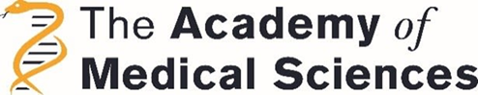 | 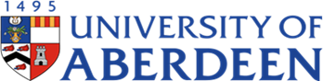

8- WEEK SUMMER SCHOLARSHIPS
UoA INSPIRE PROGRAMME

Dear Students,

With the view of providing world-leading research experience to our medical and dental students, we are very pleased to announce that the Aberdeen Clinical Academic Training Scheme has 4 scholarships available to be held over summer 2023 as part of the INSPIRE scheme of the Academy of Medical Sciences. These scholarships are funded jointly by the Academy of Medical Sciences https://acmedsci.ac.uk/ and the School of Medicine, Medical Sciences and Nutrition, University of Aberdeen.

The successful candidates will be offered a choice of research projects and will spend 6-8 weeks working in a leading Institution within UK.

All offered projects will allow the student to be involved in laboratory, database or clinical research, thus providing a great opportunity to gain specific research skills as well as exposure to working with world leading research teams.

Eligibility

Medical/Dental students who have a free 6-8 weeks period over the summer period and who have clearly demonstrated their interest and capability for a career in clinical academia are encouraged to apply for this scheme.

The scholarship will cover travel, accommodation and subsistence (total scholarship value £2000, of which stipend is £125/week for maximum of 8 weeks).

The application process is simple and involves submitting a CV plus a maximum 200 word personal statement outlining why you think you would be ideal for this opportunity and the value of such a scheme to your future academic career.

Shortlisting and interviews will be conducted within a short time frame.

Please send your application by e-mail to: Scholarship Admin smmsn-ugmed.summerresearch@abdn.ac.uk

Application deadline: 5:00pm 16th December 2022

Interview date for selected candidates: January/February 2023

