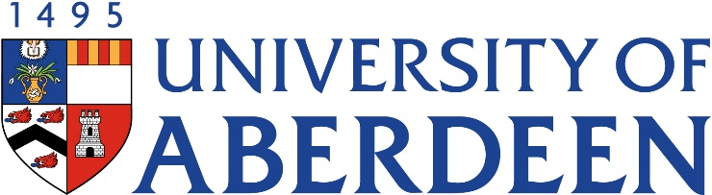


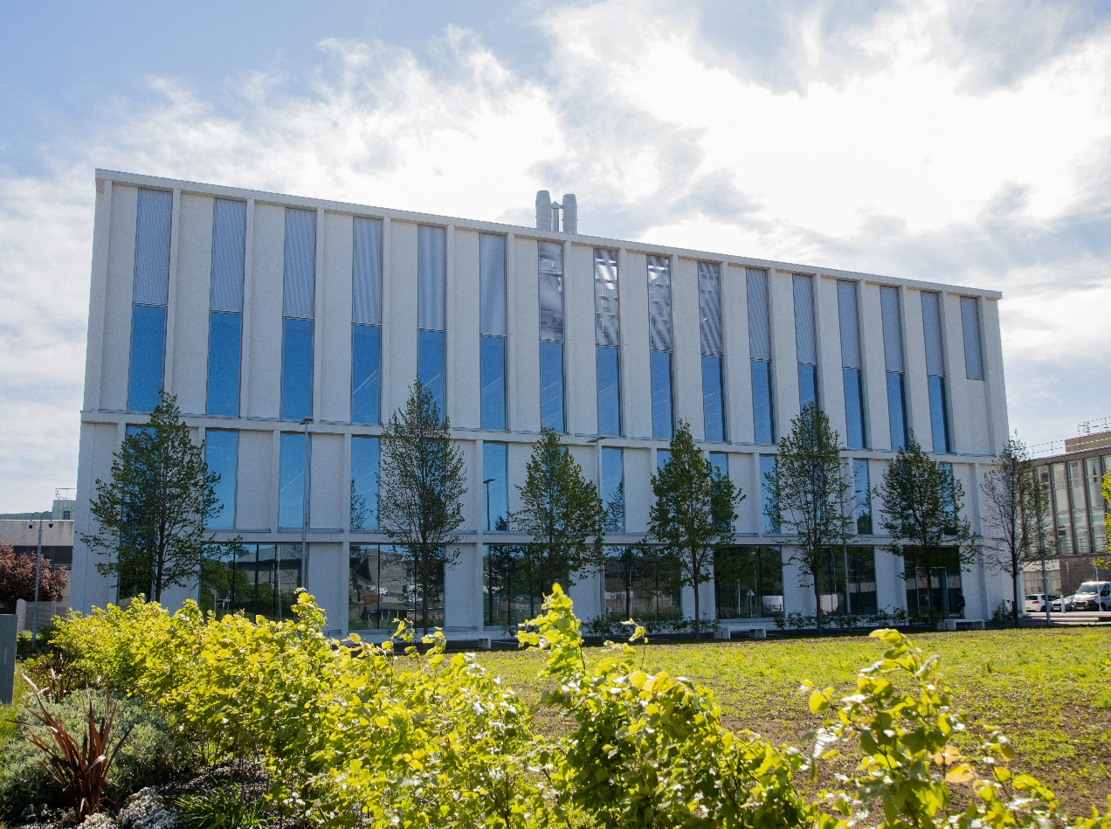
AN4002- Brain Function & Malfunction
Course Handbook 2023-2024
Undergraduate Medical Sciences
School of Medicine, Medical Sciences & Nutrition
Contents

- Course Summary – (3)
- Course Aims & Learning Outcomes
- Course Teaching Staff
- Assessments & Examinations – (4)
- Class Representatives – (4)
- Problems with Coursework – (5)
- Course Reading List
- Lecture Synopsis
- Practical/Lab/Tutorial Work – (8)
- University Policies – (9)
- Academic Language & Skills support – (10)
- Medical Sciences Common Grading Scale – (11)
- Course Timetable AN4002: 2023-2024 – (12)
- Campus and Floor Maps

Course Summary
There is currently much interest in the organisation and function of the mammalian brain. The way in which neuronal pathways interact to produce given behaviours, emotions and desires, and capabilities such as sensation and awareness represents one of the hallmarks of today’s research. In addition, disorders of the central nervous systems (CNS) such as paralysis, schizophrenia and Alzheimer’s disease are of increasing concern to our society. Topics such as these are introduced in lectures, and expanded upon by in-course quizzes and assessments, as well as seminar presentations (delivered by students) and practicals.
Basic knowledge of CNS organisation and function is a pre-requisite but a range of teaching materials is offered during week 1 to refresh your knowledge. The course consists of one introductory and eight topical lectures, 3 practical classes (2 on site, 1 online) and student seminars. AN4002 is examined via continuous assessment based on online assessments and practicals (10%), the seminar presentation (20%) and a 2-hour written exam (70%).

Course Aims & Learning Outcomes
- To provide detailed information on the functional organisation and structure of the human nervous system, and how it compares to other animals.
- To describe function and malfunctions (diseases) of the nervous system.
- To discuss current research relevant to causes, diagnosis and treatment of nervous system disorders.
- To obtain transferrable skills in scientific literature research, as well as preparation and delivery of a scientific presentation.

Course Teaching Staff
Course Co-ordinator: Professor Bettina Platt - b.platt@abdn.ac.uk

Other Staff:
Prof Derek Scott (DS), Medical Sciences (Joint Course Co-ordinator for AN4003)
Professor Simon Parson (SP)
Dr Ann Rajnicek (AMR)
Professor Gernot Riedel (GR)
Dr Derryck Shewan (DAS)
Dr Eunchai Kang (EK)
Dr Daniel Berg (DB)
Dr Fabien Naneix (FN)

Assessments & Examinations
The continuous assessment mark (10%) is comprised of short assessments conducted online during or before the practicals (details below).
The seminar presentation (see later) contributes 20% to the final mark. Marks will be deducted for late hand-ins out of fairness for those students who hand in on time.
The written exam makes up 70% of the mark. The exam consists of a two-hour written examination in the May/June diet.
Satisfactory performance and engagement: Students are expected to attend and engage with all elements of the course and to complete all class exercises. This comprises both online and face-to-face activities and includes assessments and quizzes associated with online teaching material such as lectures. Online engagement is monitored in detail (e.g. date and duration are logged).
The minimum performance acceptable is attendance at 80% of the course.
The completion of all course work, online, written and oral, is an absolute requirement for your degree.

Class Representatives
We value students’ opinions in regard to enhancing the quality of teaching and its delivery; therefore in conjunction with the Students’ Association we support the Class Representative system.
In the School of Medical Sciences we operate a system of course representatives, who are elected from within each course. Any student registered within a course that wishes to represent a given group of students can stand for election as a class representative. You will be informed when the elections for class representative will take place.

What will it involve?
It will involve speaking to your fellow students about the course you represent. This can include any comments that they may have. You will attend a Staff-Student Liaison Committee and you should represent the views and concerns of the students within this meeting. As a representative you will also be able to contribute to the agenda. You will then feedback to the students after this meeting with any actions that are being taken.

Training
Training for class representatives will be run by the Students Association. Training will take place within each half-session. For more information about the Class representative system visit www.ausa.org.uk or email the VP Education & Employability vped@abdn.ac.uk. Class representatives are also eligible to undertake the STAR (Students Taking Active Roles) Award with further information about this co-curricular award being available at: www.abdn.ac.uk/careers.

Problems With Coursework

If students have difficulties with any part of the course that they cannot cope with, alone they should notify the course coordinator immediately. If the problem relates to the subject matter general, advice would be to contact the member of staff who is teaching that part of the course. Students with registered disabilities should contact the medical sciences office, (medsci@abdn.ac.uk) (based in the Polwarth Building, Foresterhill) to ensure that the appropriate facilities have been made available. Otherwise, you are strongly encouraged to contact any of the following as you see appropriate:

- Course student representatives
- Course co-ordinator
- Convenor of the Medical Sciences Staff/Student Liaison Committee (Professor Gordon McEwan)
- Personal Tutor
- Medical Sciences Disabilities Co-ordinator (Dr Derryck Shewan)

All staff are based at Foresterhill and we strongly encourage the use of email or telephone the Medical Sciences Office. You may have a wasted journey travelling to Foresterhill only to find staff unavailable.

If a course has been completed and students are no longer on campus (i.e. work from second half session during the summer vacation), coursework will be kept until the end of Fresher’s Week, during the new academic year. After that point, unclaimed student work will be securely destroyed.

Course Reading List

- D. Richards / T. Clark / C. Clarke. The human brain and its disorders. Oxford University Press 2007.
- E. R. Kandel/ J. H. Schwartz / T. M. Jessel. Principles of neural sciences. Prentice Hall Intl.
- M.F. Bear / B.W. Connors / M.A. Paradiso. Neuroscience: Exploring the Brain. Lippincott Williams & Wilkins.
- K. Afifi / R.A. Bergmann. Functional Neuroanatomy. McGraw-Hill.
- Crossman, A.R. & Neary, D. Neuroanatomy. Churchill Livingstone, 1998.
Note:
It is expected that students use original papers (primary sources) for further reading.

Lecture Synopsis
Introduction: Professor Bettina Platt & Professor Derek Scott
Introduction to the course: Objectives, content, schedule and assessments.
Detailed instructions on anatomy resources (online and reading material) available to all students will be given. These should be used to prepare in good time before the main lectures commence.
A short pre-recorded lecture is available on MyAberdeen on ‘Why is (neuro-)anatomy important? Relation to medical and biomedical research, relevance in the 21st century.’ Brief overview (refresher) of the anatomical background required and the general organisation of the human nervous system.
During the Introduction session, details related to the seminar preparation and presentations will be provided (see also details below).
NOTE: Lectures 1-8 are held jointly with AN4003
Lecture 1: Dysfunction of Neural Stem Cells in the Developing and Adult Brain – Dr Daniel Berg
Neural stem cells (NSCs) give rise to all neurons in the human brain in a process called neurogenesis. Although most active during development, NSCs also exist in adults where they continue to produce new neurons throughout life. Neurogenesis is a tightly regulated process and is controlled at various levels such as proliferation, differentiation, and migration. If any of these steps go wrong, it can lead to several pathological conditions. In these lectures we will discuss cases in which the NSCs don’t behave as they should during development, which can cause neurodevelopmental disorders such as microcephaly, macrocephaly, and autism. We will also discuss the association between malfunctioning NSCs and disrupted neurogenesis in the adult brain and pathological conditions such as epilepsy, Alzheimer’s disease, and depression. Finally, we will also examine how NSCs can be used to cure these pathological conditions
Lecture 2: Mental disorders – Dr. Eunchai Kang
In the first part of this lecture, we will review the symptoms, causes, and treatments of common mental disorders such as schizophrenia and depression. Particularly, we will consider what is their brain basis, how genetic susceptibility and environmental factors interact to cause these diseases, and how control of neurotransmitters is used for treatments.
In the second part of the lecture, we will discuss the current research on schizophrenia and depression to identify the molecular and cellular mechanisms behind the disease using functional imaging, animal models and induced pluripotent stem cell (iPSCs)- derived neuronal and brain organoids culture systems.
Lecture 3: Sensory Systems – Dr Derryck Shewan
Brief overview of the systems that regulate vision, hearing, balance, olfaction, taste, touch, pain and temperature, followed by a more in-depth discussion of the processes underlying the sensation of sight, sound and smell. Particular emphasis on the mechanisms of ‘topographical mapping’ of retinal axons to the brain and the specific projections from odorant receptors in the olfactory epithelium to the olfactory bulb, including a synopsis of leading recent research into these topics. Aspects of malfunction will involve blindness and hearing impairment.
Lecture 4: Forebrain/Dementia & Alzheimer’s Disease - Professor Bettina Platt
This lecture is split into separate parts as follows:
- Online recording: please watch before this lecture: Brief overview of the anatomy of the forebrain, specifically the limbic system and associated forebrain structures. Special considerations of the hippocampal formation, amygdala and septal areas in emotions, learning and memory, and conscious thought.
- Neurodegeneration (in person): 2a: Overview / subtypes / pathologies. 2b: Alzheimer’s disease (AD): Background and research examples. Considerations of recent treatment ‘success’.
Lecture 5: Motor Systems – Professor Gernot Riedel
In this lecture, we will review the ancillary systems supporting and modulating movements generated by the motor cortex. These include the CEREBELLUM, which constitutes a complex neuronal system that integrates information sent from the motor cortex, the muscles and balance related sensors. These three pieces of information are integrated and lead to the correction, fine-tuning and smoothing of voluntary movements. The respective brain regions, their anatomical constituents, input and output pathways as well as neurotransmitters will be discussed.
A second system comprises the BASAL GANGLIA as the central initiator of voluntary movements and instructor of the cortical motor pathways. The lecture includes the anatomical composition of the basal ganglia, their internal connections and their intrinsic physio-pharmacological modules and neuronal units. For both brain centres, there are well known disease states and patient cases will be reviewed. Short assessments will review the principal functions of each brain region.

Lecture 6: Spinal Cord – Dr Ann Rajnicek
The lecture will cover the developmental origins of the spinal cord, the structure and function of the adult intact spinal cord and then consider what happens when it goes wrong. Topics include developmental defects, the physical and functional consequences of traumatic spinal cord injury, prospects for functional recovery, and barriers to recovery of spinal cord function. Current treatments and promising future therapies will also be explored.
Lecture 7: Spinal Muscular Atrophy – Professor Simon Parson
SMA is a relatively (genetically) simple disease resulting from the mutation in a single gene, coding a single protein. The protein has a known function in SnRNP biogenesis, but taken together, this knowledge has not advanced our understanding of the neuromuscular pathology which characterises the disease. Further, more recent work is now showing that widespread systemic defects are also present, and that any future therapies must also target these if effective treatments are to be developed.
Lecture 8: Brain control of food intake – Dr Fabien Naneix
In this lecture, we will review the brain mechanisms controlling food intake from hunger to satiety. We will focus on the hypothalamus and the role of different hypothalamic nuclei in the control of homeostatic feeding. In the second part we will see how these circuits interacts with the reward system controlling hedonic feeding. Finally, we will discuss how the alteration of these circuits is associated with pathological states like obesity.

Practical & Lab Work
1. Computer-based neuroanatomy practical: This practical offers a number of online packages as a refresher on the basics of CNS anatomy. Students are expected to familiarise themselves with general CNS anatomy using a number of online materials provided, before completing a timed online assessment via MyAberdeen.
2. Sheep Brain Dissection (on campus) & Comparative Neuroanatomy (online): This ‘wet’ practical offers the unique opportunity to dissect a sheep’s brain and view additional brain material and models. Brain structures will be identified in situ. We will also discuss ethical issues related to the use of human material for teaching and research, and look into brain anatomy of other animals. Please bring a lab coat. Online material will be used to cover comparative neuroanatomy aspects.
3. EEG practical (on campus): Short introduction into EEG and its role as a diagnostic tool followed by exercises and questionnaires.
Student Seminars
Students can self-enroll for a topic of their choice via MyAberdeen the week before teaching commences, or they will be allocated a topic on the first day of teaching. The seminar has to be prepared as a PowerPoint group presentation as well as an individual written summary (see timetable), both submitted via MyAberdeen. Group presentations are held during the seminar sessions and will be recorded.
Initials should be added to each slide to clarify contributions.
Each student has to present and attend the seminars given by others, and each student has to submit an individual summary of the topic (700 words).
All seminar presentations should include some anatomical aspects as far as possible, with a special focus on the link between nervous system structures and their functions, and possible malfunctions / pathology where appropriate. Importantly, presentations should include recent research examples and data.
Preparation efficiency and literature research skills, presentation style and delivery, slide design and illustrations, organization of the talk, the content and handling of questions will be assessed. The summary is assessed separately, and contributes 30% of the overall seminar mark.
Do not hesitate to contact the lecturer in charge of your topic or the course organiser if in doubt.
You may prepare some notes to help you through the presentation, but please do not read the full text.
Copying or plagiarising another person’s work, either from other students or published material in books or papers and submitted as your own is considered a form of cheating. This is a serious offence and will be penalised according to the extent involved and whether it is decided there was an attempt at deliberate deception, or whether bad practice was involved. If you do use information or ideas obtained from textbooks or other published material you must give a precise reference to the source.

University Policies

Students are asked to make themselves familiar with the information on key education policies, available here. These policies are relevant to all students and will be useful to you throughout your studies. They contain important information and address issues such as what to do if you are absent, how to raise an appeal or a complaint and how the University will calculate your degree outcome.
These University wide education policies should be read in conjunction with this programme and/or course handbook, in which School specific policies are detailed. These policies are effective immediately, for the 2023/24 academic year. Further information can be found on the University’s Infohub webpage or by visiting the Infohub.

The information included in the institutional area for 2023-24 includes the following:
- Assessment
- Feedback
- Academic Integrity
- Absence
- Student Monitoring/ Class Certificates
- Late Submission of Work
- Student Discipline
- The co-curriculum
- Student Learning Service (SLS)
- Professional and Academic Development
- Graduate Attributes
- Email Use
- MyAberdeen
- Appeals and Complaints

Where to Find the Following Information:

C6/C7- University of Aberdeen Homepage > Students > Academic Life > Monitoring and Progress > Student Monitoriung (C6 & C7)

https://www.abdn.ac.uk/students/academic-life/student-monitoring.php#panel5179

Absences- To report absences you should use the absence reporting system tool on Student Hub. Once you have successfully completed and sent the absence form you will get an email that your absence request has been accepted. The link below can be used to log onto the Student Hub Website and from there you can record any absences you may have.

Log In - Student Hub (ahttps://www.abdn.ac.uk/studenthub/loginbdn.ac.uk)

Submitting an Appeal- University of Aberdeen Homepage > Students > Academic Life > Appeals and Complaints

https://www.abdn.ac.uk/students/academic-life/appeals-complaints-3380.php#panel2109

Academic Language & Skills support
For students whose first language is not English, the Language Centre offers support with Academic Writing and Communication Skills.

Academic Writing
- Responding to a writing task: Focusing on the question
- Organising your writing: within & between paragraphs
- Using sources to support your writing (including writing in your own words, and
citing & referencing conventions)
- Using academic language
- Critical Thinking
- Proofreading & Editing

Academic Communication Skills
- Developing skills for effective communication in an academic context
- Promoting critical thinking and evaluation
- Giving opportunities to develop confidence in communicating in English
- Developing interactive competence: contributing and responding to seminar discussions
- Useful vocabulary and expressions for taking part in discussions

More information and how to book a place can be found here

Medical Sciences Common Grading Scale

Grade | Grade Point | % Mark | Category | Honours Class | Description
A1 | 22 | 90-100 | Excellent | First | • Outstanding ability and critical thought  • Evidence of extensive reading  • Superior understanding  •The best performance that can be expected from a student at this level
A2 | 21 | 85-89 | Excellent | First
A3 | 20 | 80-84 | Excellent | First
A4 | 19 | 75-79 | Excellent | First
A5 | 18 | 70-74 | Excellent | First
B1 | 17 | 67-69 | Very Good | Upper Second | • Able to argue logically and organise answers well  • Shows a thorough grasp of concepts  • Good use of examples to illustrate points and justify arguments  • Evidence of reading and wide appreciation of subject
B2 | 16 | 64-66 | Very Good | Upper Second
B3 | 15 | 60-63 | Very Good | Upper Second
C1 | 14 | 57-59 | Good | Lower Second | • Repetition of lecture notes without evidence of further appreciation of subject  • Lacking illustrative examples and originality  • Basic level of understanding
C2 | 13 | 54-56 | Good | Lower Second
C3 | 12 | 50-53 | Good | Lower Second
D1 | 11 | 47-49 | Pass | Third | • Limited ability to argue logically and organise answers  • Failure to develop or illustrate points  • The minimum level of performance required for a student to be awarded a pass
D2 | 10 | 44-46 | Pass | Third
D3 | 9 | 40-43 | Pass | Third
E1 | 8 | 37-39 | Fail | Fail | • Weak presentation  • Tendency to irrelevance  • Some attempt at an answer but seriously lacking in content and/or ability to organise thoughts
E2 | 7 | 34-36 | Fail | Fail
E3 | 6 | 30-33 | Fail | Fail
F1 | 5 | 26-29 | Clear Fail | Not used for Honours | • Contains major errors or misconceptions  • Poor presentation
F2 | 4 | 21-25 | Clear Fail | Not used for Honours
F3 | 3 | 16-20 | Clear Fail | Not used for Honours
G1 | 2 | 11-15 | Clear Fail/Abysmal |  | • Token or no submission
G2 | 1 | 1-10 | Clear Fail/Abysmal |  | • Token or no submission
G3 | 0 | 0 | Clear Fail/Abysmal |  | • Token or no submission

Course Timetable AN4002: 2023-2024

Timetable Key:
Green = Online activities
Blue = Live classes delivered in person or as a live session in MyAberdeen
Yellow = Assessments

Venues:
MyAb – AN4002/3 Course on MyAberdeen (online)
Kuracloud: Online Resource
Med Physics – Medical Physics Building, D2 Workshop, Foresterhill
- Biomedical Physics Lecture Theatre
STH – Science teaching Hub, Old Aberdeen
Polwarth (various rooms)- Polwarth Building, Foresterhill

Date | Time | Place | Subject | Session | Staff
Week 7-8
11-17 Sep |  | MyAb | Sign up for a Seminar Topic via MyAberdeen
Mon  18 Sep | 10:00-12:00 | Med Physics  D2 Workshop | 10-11 General Intro plus Q&A  11-12 Seminar preparations and planning | Tutorial | BP, DS  BP
Wed  20 Sep |  | MyAb & Kuracloud | Neuroanatomy Online Practical: The Human Brain | Pract | BP
Thursday  21 Sep | 12:00-14:00 | Polwarth  2:054 | L1: Stem cell disorders | Lecture | DB
Friday  22 Sept | 17:00 | Kuracloud | Deadline for Neuroanatomy Practical | Online Assess
WEEK 9
Monday  25 Sept | 10:00-12:00 | Med Physics  D2 | L2: Mental disorders | Lecture | EK
Thursday  28 Sept | 12:00-14:00 | Polwarth  2:054 | L3: Sensory Systems | Lecture | DAS
Week 10 |  |  |  |  |  |  |  |  |  | GR
Mon 2 Oct | 10:00-12:00 | Med Physics  D2 | L4: Neurodegeneration and Dementia | Lecture | BP
Thu 5 Oct | 12:00-14:00 | Polwarth  2:054 | L5: Motor system disorders | Lecture | GR
Fri 6 Oct | 9-12 | STH  Flexi Lab 0.004 | SHEEP BRAIN DISSECTION | Practical | DS et al
 |  | MyAb | SHEEP BRAIN Report | Assess
Week 11
Mon 9 Oct | 10:00-12:00 | Med Physics  D2 | L6: Spinal cord development, trauma and repair | Lecture | AMR
Thu 12 Oct | 10-1 | STH  Flexi Lab 0.004 | EEG practical | Practical | DS & BP et al
 |  | MyAb | EEG assessment | Assess
Fri 13 Oct | 10:00-12:00 | Biomed Physics Lecture Theatre | L7: Spinal Muscular Atrophy | Lecture | SP
Fri 13 Oct | 17:00 | MyAb | Deadline for Seminar Submissions (1 group Powerpoint & Individual Summary, online submission via MyAberdeen) | Assess | BP
Week 12
Mon 16 Oct | 11:00-13:00 | Polwarth  2:054 | Groups 1&2 | Seminar & Assess | TBC
Tue 17  Oct | 12:00-14:00 | Med Physics  D2 | Groups 3&4 | Seminar & Assess | TBC
Wed 18 Oct | 10:00-12:00 | Med Physics  D2 | Groups 5&6 | Seminar & Assess | TBC
Thu 19 Oct | 12:00-14:00 | Polwarth  1:032/033 | Groups 7&8 | Seminar & Assess | TBC
Fri 20 Oct | 10:00-12:00 | Biomed Physics Lecture Theatre | Lecture 8: Brain control of food intake | Lecture | FN

*Detailed seminar timetable to follow
Staff

Prof Bettina Platt (BP) (Course Co-ordinator)
Prof Derek Scott (DS)
Prof Gernot Riedel (GR)
Prof Simon Parsons (SP)
Dr Derryck Shewan (DAS)
Dr Ann Rajnicek (AMR)
Dr Eunchai Kang (EK)
Dr Daniel Berg (DB)
Dr Fabien Naneix (FN)

Campus Maps - Foresterhill

Polwarth Floor Plans

