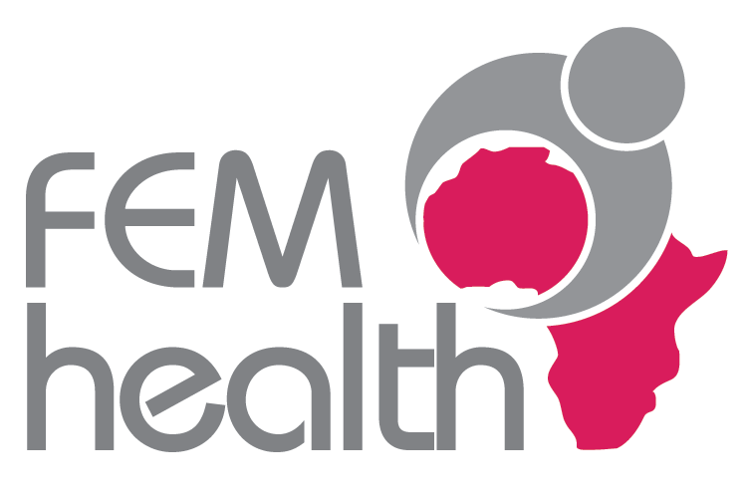 **FEMHealth: assessing the impact of fee exemption on maternal health in West Africa and Morocco: new tools, new knowledge**

**Background to the project**

User fee exemption for normal deliveries, caesarean sections and other obstetric complications has been introduced by many governments, especially in West Africa, in recent years. However, the current evidence base regarding the impact of this policy is not well developed, in part because of evaluation designs that are not able to capture all the necessary information for policy-makers to make informed decisions.

**FEMHealth goal and objectives**

This programme aims to reduce this gap by developing research methodologies and tools that will lead to enhanced research on policy implementation, stronger evidence and improved dissemination.

The objectives of the project are:

(1) to develop new methodological approaches for the evaluation of complex interventions in low-income countries;

(2) to improve the health of mothers and their newborns by performing comprehensive evaluations of the impact, cost and effectiveness of the removal of user fees for obstetric care on maternal and neonatal health outcomes and service quality; and

(3) to facilitate a broad exchange of evidence between policy-makers, researchers and other stakeholders.

**Research methods**

FEMHealth takes a multidisciplinary and innovative approach to complex evaluations (see box 1). The team includes people with backgrounds in health economics, health financing, epidemiology, public health, sociology, anthropology, statistics, obstetrics and midwifery, as well as communication and management.

**Box 1: Main areas of methodological innovation in FEMHealth**

**Innovation** will relate to the following areas:

1. developing a *policy implementation measurement tool* that describes interventions in terms of their adherence to original objectives, their eventual scope and penetration;
2. developing *innovative methodologies for health policy analysis*, focusing on what drives policy change and how policy is transferred, both from international to national level (and back), but also regionally;
3. developing a *comparative case study design, based on realist evaluation* that focuses on adequacy and plausibility of effect of intervention rather than on probability and provides policy relevant information;
4. *testing the use of critical events (maternal, neonatal and health care near miss)* as an entry point for the evaluation of changes to quality of care and health outcomes;
5. piloting a new way of synthesising and disseminating results to policy-makers using a network beyond the four countries - a *‘community of practice’* which encourages cross-learning between policy-makers, international organisations and researchers and between countries in the region.

**Structure of programme**

FEMHealth is funded by the EU under FP7. It runs from January 2011 to December 2013

The research consortium consists of eight partners operating across six countries (see Table 1). The focal countries for the evaluations of national policy will be:

* Benin
* Mali
* Burkina Faso
* Morocco

These countries were selected on the basis of having recently introduced national fee exemption policies for obstetric care and of having expressed an interest, at policy-making levels, in the research goals. Most face serious challenges in improving maternal health indicators. In addition, there is evidence that francophone countries as a group receive less financial and technical support from the international community. The focus of this research is therefore on francophone West Africa and the Maghreb.

|  |  |
| --- | --- |
| **Table 1. Participant organisations** | **Area of focus** |
| University of Aberdeen, UK | Coordination of programme (WP 1);  Health policy and finance (WP2) |
| Institute of Tropical Medicine, Antwerp | Local health systems (WP3) |
| London School of Hygiene and Tropical Medicine | Quality of care and health outcomes (WP4) and health policy |
| Agence de Formation, de Recherche et d’Expertise en Santé pour l’Afrique (AFRICSanté) | Leading Burkina Faso programme (WP6) |
| Centre de Recherche en Reproduction Humaine et en Démographie (CERRHUD) | Leading Benin programme (WP7) |
| Centre d'Appui à la Recherche et à la Formation (CAREF) | Leading Mali programme (WP8) |
| Institut National d’Administration Sanitaire (INAS) | Leading Morocco programme (WP9) |
| Institut de Recherche en Sciences de la Santé (IRSS), Burkina Faso | Leading community of practice component (WP5) |

**Programme outputs**

We expect to generate the following outputs:

1. A comprehensive multi-disciplinary understanding of the positive or negative impact of the policies on health outcomes for mothers and babies, quality of care, and access to emergency care in each of the countries
2. Cross-country learning and recommendations generated on how to improve policies to remove user fees
3. Methodological advancements in relation to health policy and financing tools, tools for mapping the effects of policies on the local health system, and the use of realist case studies and near miss events
4. A vibrant regional community of practice is in place and growing, involving major stakeholders

The project will impact on several main actors:

* women and their families in Africa and other resource-poor settings
* national stakeholders at policy and health service levels
* the global health and safe motherhood community
* the scientific community working on complex health care evaluations

Dissemination will be carried out through well-maintained relationships and networks at local, national, regional and international levels.

*For further information, see* [*www.abdn.ac.uk/femhealth*](http://www.abdn.ac.uk/femhealth)