Weekly Divinity UG Newsletter: Being Divine

Welcome!
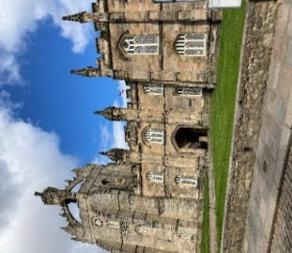
Here’s wishing you a wonderful academic year! Here’s looking forward to an exciting semester too, with lots of events and opportunities on offer in addition to our main subject studies. I am looking forward to meeting you too!
This week’s newsletter with exciting events and news!
(King’s College: photograph by Amy Bender)

What’s on this week:

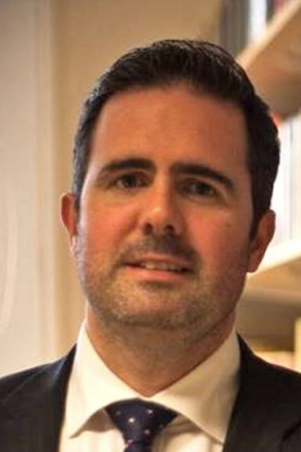
Welcome to Divinity Undergraduates by the Head of Department, Professor Tom Greggs

Professor Tom Greggs will offer a welcome lecture which will take place on Friday 9th October 2020 @ 10am-11am in the Divinity library, King’s College (quad).

If you would like to attend you will need to register your place via Eventbrite: https://www.eventbrite.co.uk/e/divinity-outreach-group-fridays-10am-11am-tickets-122122352243

Other events this week:
- Thursday 8th October 2020: Hot Topic Debate - ONLINE - Sam Newington will host a debate on Theology, Ecology and Climate
To access the online events:
i. Log into myaberdeen
Ii. Click on ‘Organisations’
Iii. Click onto ‘Divinity, History and Philosophy Student Information Undergraduates’
Iv. Click on Divinity folder - here you will find the access link to Events and further information

Theology and Religion Flexible Learning Programme (distance):

Dr Rev. Dr Ken Jeffrey is the coordinator of the TRFLP and is available each week during an online office hour, by appointment (email ksjeffrey@abdn.ac.uk) , from 7 October to 9 December, except 18 November and 2 December 2020.

Getting Involved:

Class Representatives:
For those taking Divinity courses this year, from Undergraduate level 1 to level 4, why not consider becoming a class rep!?
Class Representatives provide a vital role in collating and providing course and Programme feedback. The role involves liaising with course and Programme co-ordinators.
If you are interested in becoming a class representative, please send an email to your course co-ordinator by Friday 9th October 2020.
Further details are available here: https://www.ausa.org.uk/representation/academicreps/

Faculty and UG Workshops and Events:

Every Thursday (Online) and Friday (Campus), there will be a series of events on offer including careers advice, an introduction to ancient languages and culture, academic skills and student-led topic debates.
The topics for the Thursday (@5.00pm Online) and Friday (10am-11am Divinity Library) sessions are as follows:
Week 2 (w/c: 5th October):
- Thursday: Hot Topic Debate - Sam Newington will host a debate on Theology, Ecology and Climate
- Friday: Divine Dialogue - Professor Tom Greggs will offer a welcome to the academic year.
Week 3 (w/c: 12th October):
- Thursday / Friday: Drop In Session - Academic Skills - Sam Newington will lead a session on preparing for assessments and reflective learning approach.
Week 4 (w/c: 19th October):
- Thursday / Friday: Magic, Mysteries and Superstition in the Ancient World - This session will look at magic and spells in Ancient Greece.
Week 5 (w/c: 26th October):
- Thursday / Friday: Drop In session - Careers - This session will offer careers guidance, and insights into volunteering and CV development.
Week 6 (w/c: 2nd November):
- Wednesday: Divine Dialogue Online Series: Women, Academia and the Church hosted by Dr Katie Cross
- Thursday / Friday: Magic, Mysteries and Superstition in the Ancient World - This session will explore ancient mystery religions and mystical experience.
Week 7 (w/c: 9th November):
- Wednesday: Online Informal Coffee Morning @ 10am - Catch up and queries
- Thursday / Friday: Hot Topics Debate - Religion, Sin and Salvation
Week 8 (w/c: 16th November):
- Wednesday@ 10am: Online Informal Coffee Morning - Catch up and queries
- Thursday / Friday: Drop In Session - Academic skills – Academic development and reflective learning approaches.
Week 9 (w/c: 23rd November):
- Wednesday: Online Informal Coffee Morning @10am Catch up and queries
- Thursday / Friday: Drop In Session - Student Voice
Week 10 (w/c: 30th November):
Thursday / Friday: Magic, Mysteries and Superstition in the Ancient World - Magic and Christianity
Week 11 (w/c: 7th December):
- Wednesday: Divine Dialogue Online Series: Science, Faith and (dis)Belief hosted by TBC
- Thursday / Friday: Drop In Session - Employability Enhancement - looking at ways to enhance career development and funding opportunities.

Being Divine Online Series:
In addition, on the first Wednesday of each month (except in October 2020) there will be a Divine Dialogue Online Series; which will introduce top topic debates discussed by academics, undergraduates and postgraduate researchers.

To access the online events:
i. Log into myaberdeen
Ii. Click on ‘Organisations’
Iii. Click onto ‘Divinity, History and Philosophy Student Information Undergraduates’
Iv. Click on Divinity folder - here you will find the access link to Events and further information
To attend campus events:
To attend the campus events, you will need to send an attendance request to Dr Sam Newington (s.newington@abdn.ac.uk) and enrol via the following link: https://www.eventbrite.co.uk/e/divinity-outreach-group-fridays-10am-11am-tickets-122122352243 .

Careers and Employability:

Here are some wonderful resources from the Careers Service which you will find very useful at each level of study:
- Level 1: https://rise.articulate.com/share/kmenKUf4zsJpxOaezD-GsoqWxEhxwmlw
- Level 2: https://rise.articulate.com/share/YRRqnVUvJ3aD06eCs_a6ornG2GK7do5_
- Level 3: https://rise.articulate.com/share/wz8y8Q3G1kjnq45VaaTd2qaRRliSwTMs
- Level 4: https://rise.articulate.com/share/DwFt-kbFV2n8y06oPR5qrmkYWuMVsltR
- PGT: https://rise.articulate.com/share/rer2s0YBHYgux5B4qT2H-6-nPvmBHAXg

TRSS – Message from the Society:

TRSS News and updates:
This term, ALL TRSS events will be online. Undergraduates, postgraduates, staff members and mature students are all more than welcome to come along and join in the fun!
AUSA is currently sorting TRSS’s access to Microsoft Teams. So, check out TRSS’s Facebook group for further event information and stay posted for the links to the events, which will be made available on the Facebook group. https://www.facebook.com/groups/2272399396416039

Forthcoming Events:
Week 3: Thursday 8th October (7-8pm)- TRSS Pizza Night
Whether you choose to treat yourself to a Domino's, make your own or get a frozen ASDA special- we won't judge. Bring your own pizza and join us for a natter.

Week 4: Thursday 15th October (7:30-8:30pm)- TRSS Pub Quiz
All rounds will have a religion-based twist! Each team should consist of 2-3 people. Please email TRSS with the names of your teammates and your team name by Wednesday the 14th at 6pm. If you are new to DRS or struggling to find teammates, do not worry! Send us an email letting us know you would like to attend, and we will be able to team you up with others on the night!

If you are interested in becoming a member or finding out more about TRSS and the events we organise, here is the link to our Facebook group: https://www.facebook.com/groups/2272399396416039/

If you do not have Facebook and are interested in joining TRSS, you can email us at: TRSSABDN@outlook.com

Support:

There is a range of support on offer here at the Department of Divinity and University of Aberdeen:

Divinity Support and queries: Dr Sam Newington (s.newington@abdn.ac.uk)
Chaplaincy: https://www.abdn.ac.uk/chaplaincy/
Student Support: https://www.abdn.ac.uk/students/
Coronavirus FAQ: https://www.abdn.ac.uk/staffnet/working-here/coronavirus/faqs-9773.php

AUSA: https://www.abdn.ac.uk/students/support/

Semester News:

Throughout the semester, I will post here your interesting news and updates! If you would like to contribute towards the newsletter, please do not hesitate to contact me. It’d be great to hear from you!

Here’s to a wonderful semester and all very best wishes,

Sam (Dr Newington)

