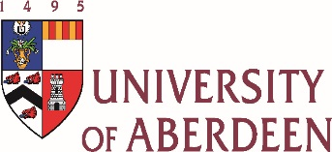
CENTRE FOR MINISTRY STUDIES
Luther for the Church – 500 years on
Saturday 20th May 2017
Sir Duncan Rice Library, Aberdeen University

Contributors Biographies

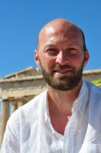
Dr Brian Brock is Lecturer in Moral and Practical Theology at the University of Aberdeen. He has degrees in medical ethics (Loma Linda University) Christian Ethics (King’s College, London) and Theology (Oxford University). He earned his D.Phil. in Christian Ethics from King’s College, London, for a theological study of technological development. He was also a visiting scholar at Friedrich Alexander University, Erlangen, Germany, and Duke University, USA.
He is well known for his work on theology and disability, in which the notions of humanity and inhumanity as well as practices in which the “human” is established and denied are critically addressed. But he has written extensively on a diverse range of topics (technology, economy, sports, scripture, theology in the university) always from the perspective that theology is most interesting when it is done in relation to the concrete questions of daily life.

Rev Dr Ken Jeffrey was born in Northern Ireland. He went to Stirling University in 1988 where he studied History with Professor David Bebbington. After graduating, Ken went to Malawi where he taught English and Bible Knowledge for two years at Livingstonia Secondary School. In 1994, he returned to Aberdeen University where he gained a first class honours BD in 1997. He was awarded his PhD in 2000. Between 2000 and 2002, he served as a Probationary Minister at Rubislaw Parish Church in Aberdeen, before he was ordained and inducted as minister of The Parish Church of Cupar Old and St Michael of Tarvit in Fife. Latterly, he also undertook further study at Aberdeen University and Pittsburgh Seminary. In January 2014 he was appointed as the coordinator of the new Centre for Ministry Studies at Aberdeen University.
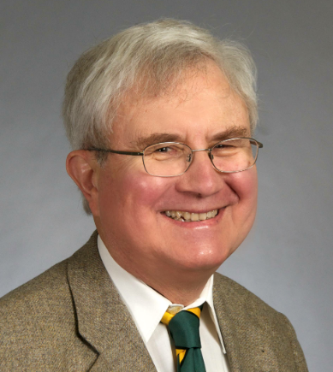
Professor Robert Kolb was born and raised in Fort Dodge,
Iowa. He attended Concordia Seminary, St. Louis, Mo. (1963-1968, M.Div., S.T.M.). After completing his doctorate in history at the University of Wisconsin, Madison (1973), he served as director of the Center for Reformation Research in St. Louis (1973-1977). Concordia College, St. Paul, called him in 1977 to teaching positions in the departments of religion and history; he also served as acting president (1989-1990). In 1993 Concordia Seminary, St. Louis, called him to be Missions Professor of systematic theology and director of the Institute for Mission Studies. From 1994 through 2010 he taught abroad, chiefly in post-Soviet Europe, for three months of the year.
Kolb served as associate editor (1973-1994) and co-editor (1995-1997) of The Sixteenth Century Journal and is still co-editor, with A.R. Victor Raj, of Missio Apostolica (since 1996). He was a member of the Commission on Theology and Church Relations of The Lutheran Church—Missouri Synod (1984-1992) and its chair (1990-1992).
He served as president of the Sixteenth Century Studies Conference (1981-1982) and the Society for Reformation Research (1994-1996). Since 1993 he has been a member of the Continuation Committee of the International Congress for Luther Research. Kolb has lectured at more than 40 educational institutions on five continents and at many ecclesiastical gatherings. Since 1996 he has been Gastdozent at the Lutherische Theologische Hochschule in Oberursel, Germany.
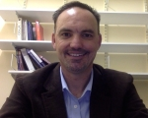
Dr Mike Laffin joined the staff at Aberdeen University in 2016 as a lecturer in Ethics. His interests in ethics, politics, and theology go back to his undergraduate days, when he was a political science major. He earned a Master’s degree in politics (Claremont Graduate University) and a Master’s degree in theology (Talbot School of Theology), before combining the two interests in a PhD thesis on political theology. He has recently published The Promise of Martin Luther's Political Theology: Freeing Luther from the Modern Political Narrative. T&T Clark Enquiries in Theological Ethics.
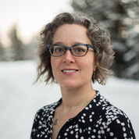
Mrs Caireen Likely is currently working on a part time PhD in Theological Ethics at Aberdeen University looking at theological anthropology through the lens of ageing and dementia.
‘My hope is to come to a description of subjectivity that allows us to affirm the enduring of our humanity in old age, and both reveals and challenges the presupposition of justification by works that underlies emphases on cognitively driven, deliberative action in many models of the subject. It is also my hope to provide the church with the language to describe passive receiving as genuine action, and thus better our ability to describe ourselves as disciples whose lives include ageing and decline.’
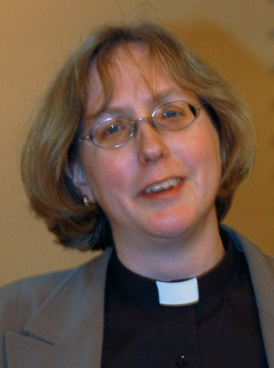
The Rev Canon Dr Charlotte Methuen is Senior Lecturer in Church History at the University of Glasgow. She has taught previously at the Universities of Oxford, Bochum and Hamburg. Her main area of research is the intellectual history of Reformation, in particularly structures of authority and interactions between theology, philosophy and astronomy. She is the author of Kepler’s Tübingen: Stimulus to a theological mathematics, Science and Theology in the Reformation: Studies in Theological Interpretation and Astronomical Observation in Sixteenth-Century Germany. She also works on twentieth-century ecumenical relations and has published on the history of women and authority in the Church.
An Anglican priest with a strong interest in ecumenism, Charlotte Methuen serves or has served on the Faith and Order Commission of the Church of England, the Inter-Church Relations Committee of the Scottish Episcopal Church, the Meissen Commission, the Anglican Lutheran International Commission, and the and the inter-Anglican standing Committee for Unity, Faith and Order.
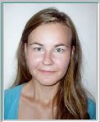
Miss Ivana Sopuchova is currently in Germany, working in the protestant Parish in Alzey, while being a guest student at the University of Heidelberg, where she follows classes on Martin Luther and the Reformation. She graduated in History and Divinity at the University of Aberdeen in 2015 and then completed her Masters with a dissertation focussing on the impact of the Reformation period on family lives in the 16th century. She is now considering pursuing a PhD in the field of the Reformation history in the following academic year.

