[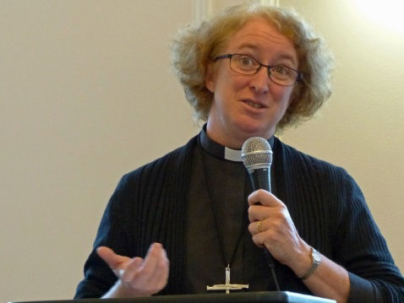](https://www.google.co.uk/url?sa=i&rct=j&q=&esrc=s&source=images&cd=&cad=rja&uact=8&ved=0ahUKEwiJzsKi4oXUAhWDtxQKHeeKDsIQjRwIBw&url=https://dresdenremembered.com/launch/coventry-canon-sarah-hills/&psig=AFQjCNF_760xcDmwmPriTK2dliNud1t28Q&ust=1495620355468016)**Rev Dr Canon Sarah Hills** is the Canon for Reconciliation Ministry at Coventry Cathedral.Following it’s destruction in 1940 by enemy bombing, a commitment was made for forgiveness and reconciliation with those responsible. Using a national radio broadcast from the Cathedral ruins on Christmas Day 1940, the Provost declared that when the war was over he would work with those who had been enemies “to build a kind er, more Christ-child-like world.” It was this moral and prophetic vision which led to Coventry Cathedral’s development as a world Centre for Reconciliation, which over the years has provided inspiration and support to many Christians addressing ongoing conflict in contemporary society.

The Cathedral’s work for reconciliation has involved it in some of the world’s most difficult and long-standing areas of conflict. It is a Centre for excellence to resource the church in the practical outworking of reconciliation as an integral part of Christian worship, witness and discipleship. Canon Sarah, was born in South Africa, brought up in Northern Ireland, and has lived in Sheffield since the mid 1980’s. She qualified in medicine and worked as a psychiatrist, specialising in psychotherapy. She was ordained in 2007, and has most recently held the post of the Bishop of Sheffield’s Adviser in Pastoral Care and Reconciliation. She has recently submitted her doctoral thesis in the theology of reconciliation at the University of Durham, and is a Visiting Fellow of St John’s College, Durham.’

<http://www.coventrycathedral.org.uk/wpsite/our-reconciliation-ministry>

**Rev Dr Ken Jeffrey** was born in Northern Ireland. He went to Stirling University in 1988 where he studied History with Professor David Bebbington. After graduating, Ken went to Malawi where he taught English and Bible Knowledge for two years at Livingstonia Secondary School. In 1994, he returned to Aberdeen University where he gained a first class honours BD in 1997. He was awarded his PhD in 2000. Between 2000 and 2002, he served as a Probationary Minister at Rubislaw Parish Church in Aberdeen, before he was ordained and inducted as minister of The Parish Church of Cupar Old and St Michael of Tarvit in Fife. Latterly, he also undertook further study at Aberdeen University and Pittsburgh Seminary. In January 2014 he was appointed as the coordinator of the new Centre for Ministry Studies at Aberdeen University.

**Rev Ruth Harvey** is the Director of Place for Hope. Place for Hope accompanies and equips people and faith communities so that all might reach their potential to be peacemakers who navigate conflict well. The Place for Hope vision is for a world where people embrace the transformational potential of conflict and nurture the art of peace-building.

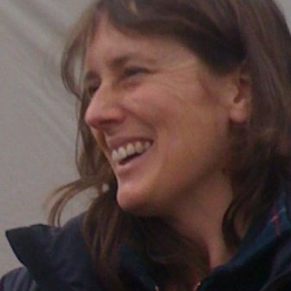Ruth is passionate about peace building and adult spiritual formation, she has worked in this area alongside churches, faith groups and small charities in Scotland, England and Europe for the past 30 years, and has edited books and written on these themes. She is a Church of Scotland minister, a Quaker, and a member of the Iona Community. In her spare time Ruth enjoys writing poetry and prayers, camping, camp-fires, and being in Argyll – on, in or near the sea.

[](https://www.facebook.com/photo.php?fbid=389715181197137&set=a.103837059784952.9048.100004759747865&type=1&source=11)

Rev Dr Jim Gordon is an Honorary Lecturer at Aberdeen University with a special interest in the work of the Centre for Ministry Studies and comes to the University and the Centre with a wealth of experience in ministry training and education.

He has been a Baptist minister for nearly 40 years serving churches in Partick, Glasgow, and in Paisley, and Aberdeen. In 2002 he was appointed as Principal of the Scottish Baptist College and spent the next 12 years involved in ministry formation and theological education in the context of the University of the West of Scotland. While in College he quite intentionally continued to serve churches in preaching, pastoral care and leadership especially where experienced support was needed to help churches move forward in faith and vision.

He is now part time minister at Montrose, and enjoys the balance of pastoral practice and ministry formation. He is interested by the ‘challenges that face all those engaged in Christian ministry in a world like ours; a world that is broken, beautiful, sometimes scary and just as often astonishing, and always God-loved. ‘

**Rev Professor John Swinton** holds the chair in Practical Theology and Pastoral Care at the University of Aberdeen. He is also an honorary Professor at Aberdeen’s Centre for Advanced Studies in Nursing. Professor Swinton worked as a registered nurse specialising in psychiatry and learning disabilities and was a hospital chaplain, then a community mental health chaplain. ‘It was whilst working in these fields that I began to gain a passion for developing modes of care that are genuinely person centred and which take seriously the significance of theology, spirituality and religion within the processes of healing and community building.’   
He is an ordained minister in the Church of Scotland, and is the founder of the University’s Centre for Spirituality, Health and Disability and the Centre for Ministry Studies. He became Master of Christ’s College in 2012. Professor Swinton is currently working on a project called Friendship House which is looking to establish a L’arche type community house within at the University of Aberdeen. He has worked extensively with Jean Vanier and was successful in his nomination of Jean Vanier for the Templeton prize.

**Also taking part:**

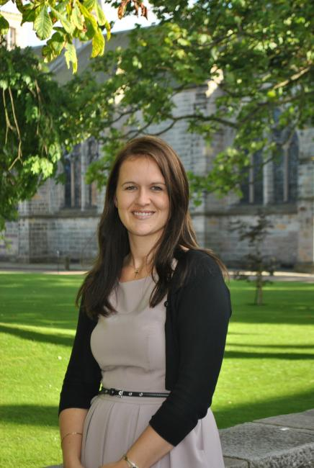

**Rev Marylee Anderson**

### Chaplain to the University

[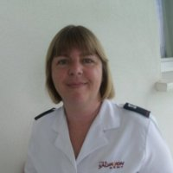](https://www.linkedin.com/start/view-full-profile?_ed=0_LiQcNmtVgM6JejtdYSN6Vvqu5lvsBFEdsMlSA8iXTgzmHYGYrqvgdH4CpnEM7r1b&trk=public_profile_tc-view)

**Lieutenant Helen Froud**

Commanding Officer of Salvation Army in Aberdeen