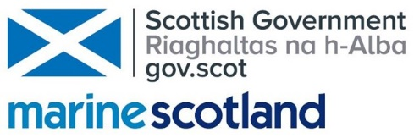

Ocean multi-use at floating offshore windfarms:
Exploring commercial fishing opportunities
at Equinor’s ‘Hywind Scotland’ farm

Project steering group

Equinor: Hannah Mary Goodlad and Dr. Monica Fundingsland
Marine Scotland Science – Dr. Andronikos Kafas and Dr. Marion Harrald
Marine Scotland Planning and Policy – Bruce Buchanan
Marine Scotland Fisheries Policy Branch – TBC
University of Aberdeen – Prof. Beth Scott
SAMS – Dr. Sally Rouse

Background on ocean multi-use

As maritime uses of our seas and oceans soar in abundance and intensity, space is becoming ever more contested. One means of reducing potential conflict of space is to utilise it more effectively. Rather than exclusive resource rights being given to one activity, the concept of ‘multi-use of ocean space’ represents a radical shift in which the sea or ocean may be shared for multiple purposes. When the term ‘multi-use’ was first coined, examples of coexisting activities were limited to industry, such as offshore wind coexisting with wave energy devices or aquaculture. The EU project MUSES (Multi-Use in European Seas) has been widening the concept further to include combinations of multi-use which include management objectives, such as offshore wind farms coexisting with marine conservation measures, local fisheries or even tourism.

Introduction

Floating offshore windfarms (floating wind) are a rapidly developing, emerging technology sector, which enables the offshore wind industry to exploit areas of deeper water than traditional windfarms can operate in. However, the ecological impacts of floating wind and its interactions with other marine users are poorly understood. Commercial fishermen are arguably the stakeholder group most likely to be directly impacted by floating wind energy developments. A traditional offshore windfarm has fixed foundations and buried cables, which enables multi-use of the site with mobile fishing gear. At a floating wind site, the cables are surface-laid and there is a system of mooring lines. As such, trawling or dredging around the vicinity of the site could be unsafe and is therefore likely to result in the impediment of mobile fisheries. However, other forms of fishing, e.g. static gear, may be able to operate within floating wind sites. Additionally, the exclusion of mobile fishing gear has the potential to create areas of refugia for commercial exploited species, leading to localised increases in fish biomass. ‘Spillover’ of this biomass into adjacent waters has the potential to mitigate for the loss of seabed access experience by fisheries.

In order to understand the extent to which multi-use offers a way to mediate conflicts, balance access to an area by multiple users and move towards more sustainable decision-making, it is necessary to evaluate the potential for static fishing within floating wind farms and the extent to which fisheries can be enhanced.

The WIND⁺ project and the Hywind Scotland opportunity

Equinor’s “New Energy Solutions” Innovation Lab recently investigated the concept of “multi-use” within an offshore windfarm and explored ways in which the space occupied by an operational windfarm could have an additional use (the WIND⁺ project; Figure 1).

The WIND+ project presents an opportunity for Equinor to realise ambitions to become industry leaders in coexistence with offshore wind. Government and academic partners will benefit from partnering with an industrial partner and develop a meaningful research project that will contribute to understanding better the ecological impacts of floating wind and its interactions with other marine users.

Equinor recently (Feb 2019) completed an internal exercise that scoped WIND⁺ focus on a fishing and floating offshore wind (FOW) multiuse pilot at Hywind Scotland (Phase 1). Equinor is now looking to progress with Phase 2 that will refine WIND⁺ that will focus on scoping further and refining project activities. Ultimately, project activities are likely to be implemented in summer 2020 the earliest (Phase 3).

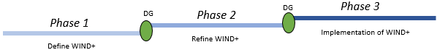
Figure 1: Outline of WIND+ timeline and associated decision gates.

Phase 2 presents a unique opportunity to study the value of ocean multi-use at a deep water offshore windfarm through a collaboration between Equinor, MSS, SAMS and the University of Aberdeen.

The demonstration of pilot project (like WIND⁺) would help provide the necessary empirical evidence that prove meaningful coexistence between floating wind farms and commercial fishers, as well as reduce many of the stakeholder conflicts that are experienced throughout a project development phase.

Equinor has built, 'Hywind Scotland Pilot Park' (Hywind) in the Buchan Deep, 25 km off the coast of Peterhead, in the northeast of Scotland. The site is close to the shore and in relatively deep water (approximately 100 m). Equinor proposed that the Hywind site could act as a pilot for quantifying the ecological impacts of floating wind together with its potential for multi-use of ocean space.
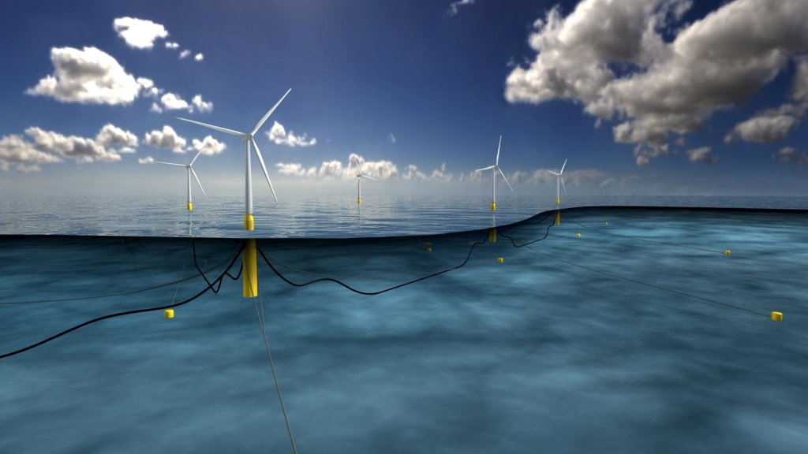
Hywind Scotland Pilot Park
(Hywind Scotland. Illustration from Equinor)

Design of the Hywind floating wind farm.
(Hywind Scotland. Illustration / Equinor)

The 30 MW Hywind site in approximately 100 m of water. It uses a ballasted catenary layout with three mooring cables with 60 tonne weights hanging from the midpoint of each anchor cable to provide additional tension. This ballast (88 m draught, 14.4 m diameter) will extend part way through the water column. There will be a system of free-hanging cables connecting the turbines which will lie on the seabed. The fisheries exclusion zone is 15 km².
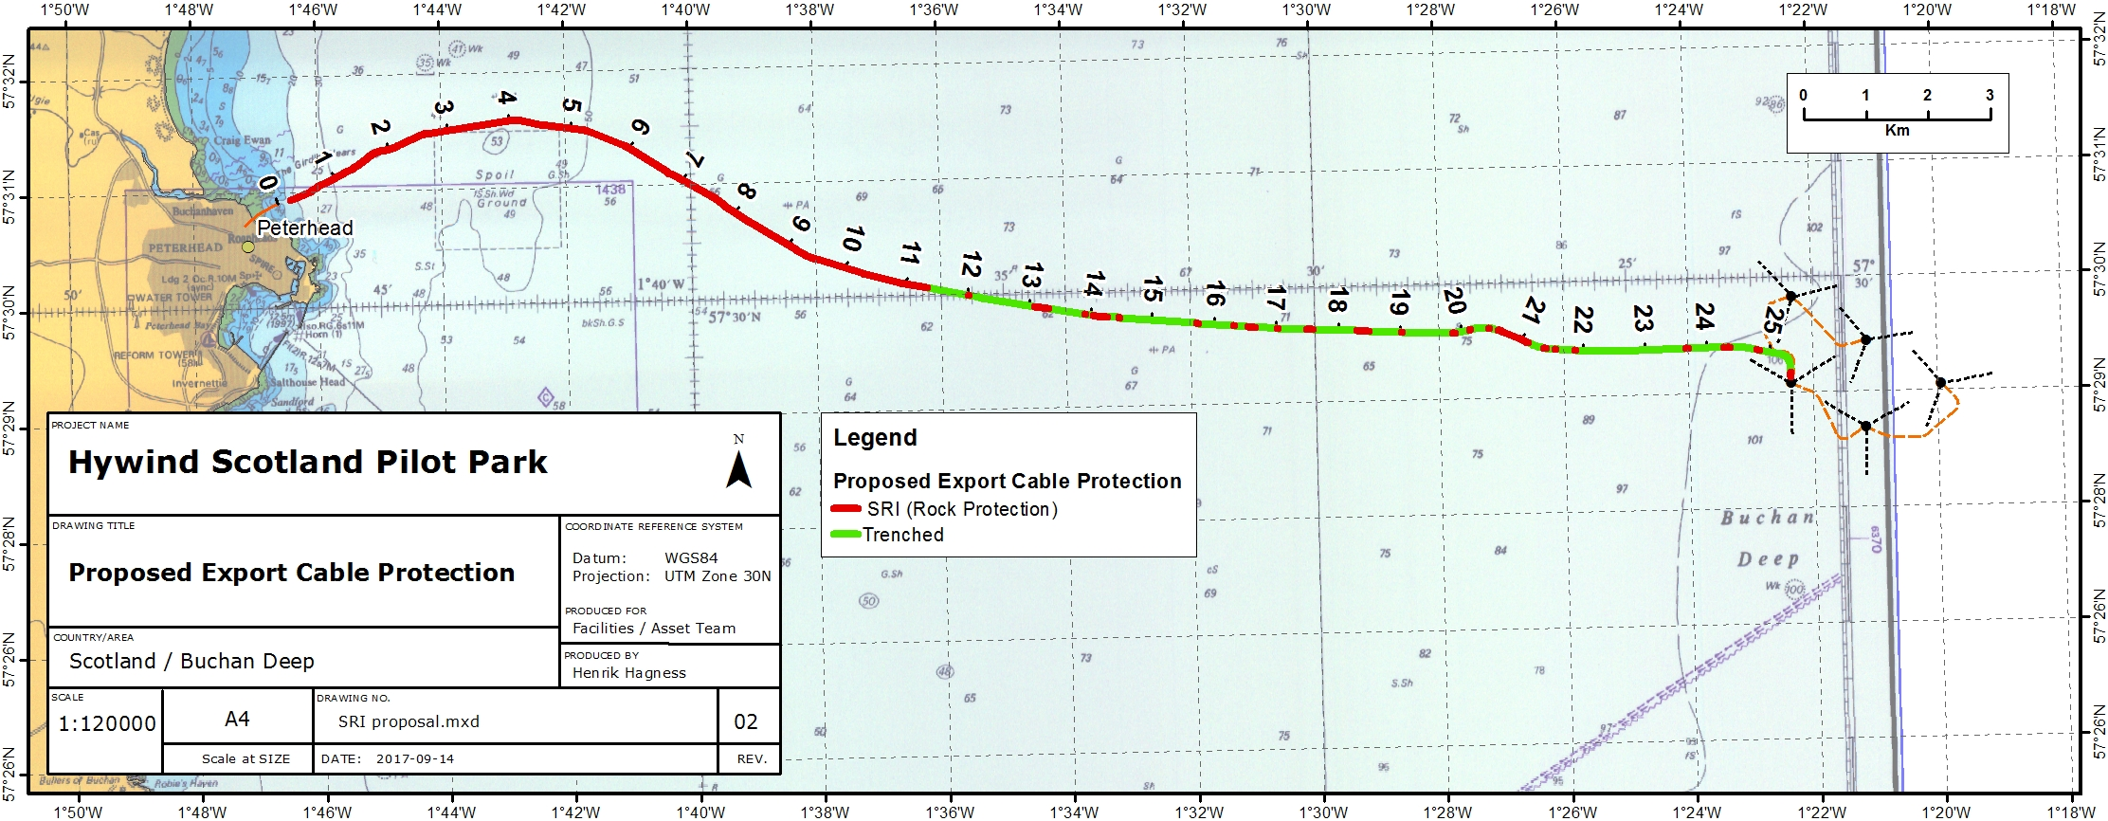
Location of Hywind Scotland Pilot Park
(Hywind Scotland. Illustration / Equinor)

Scope of project

We are seeking for a postgraduate student to propose and explore potential for combinations of multi-use at the Hywind site. Three possible ideas that could be explored further are described below, but there is flexibility to accommodate further suggestions:

a) Offshore wind and static fishing: The presence of free-hanging cables provides an entanglement hazard and safety risk to fishing with mobile gears. However, it may still be possible to operate static fishing gear for either commercial or research purposes, such as baited traps and baited underwater cameras. The majority of static gear in Scottish waters is deployed within 3 nautical miles from the shore, however, some sectors of the fleet deploy their static gear much further from shore, therefore site location and distance from shore will influence applicability of such a proposal. This study would test the safe deployment of fishing gear within the Hywind site. Is it possible to establish a fishery potentially on a new target species with gear that is safe to work with around the Hywind site?

b) Offshore wind and marine conservation: Where mobile fisheries are excluded it may allow for a localised recovery of the benthos and localised mobile animals with associated spill-over effects from enhanced local production into adjacent areas. Is it possible to quantify the change in benthic and fish communities as a result of exclusion of mobile gear? Do such changes in community structure have a measureable change on ecosystem structure and function? Is there evidence for a new ecosystem service providing marine conservation benefits and how does this impact decision making? What kind of equipment would be best to use to study those changes e.g. radar, video, thermal imaging, passive acoustics etc.)?

c) Offshore wind and artificial reefs effects: Hard substratum introduced into the marine environment can function as an artificial reef by providing habitat and shelter for marine species. The installation of artificial reefs has been used worldwide as a mechanism to enhance local fisheries. However, the use of artificial reefs as a fisheries enhancement tool must be considered alongside other potential changes associated with the introduction of artificial structures including transition from a soft-sediment to hard substrate environment. Coupled with the exclusion of mobile fishing gear, the artificial reef effects associated with the ballast of floating wind turbines have the potential to locally enhance commercial-exploited fish species, with subsequent spillover to adjacent waters. The efficacy of these steel poles as an artificial reef could be enhanced by adding cryptic spaces and complexity to the surface. It may also be possible, subject to licencing and local acceptance, to erect an artificial reef within the Hywind site. The fisheries enhancement provided by artificial reefs at this site could be quantified and evaluated in terms of risks to native fauna vs. attracting new species. The value of an artificial reef vs. the ethical constraints could be explored.

Internship opportunity

MS is looking for a postgraduate/postdoctoral student to undertake an internship. The intern will propose a project to investigate the multi-use of deep water offshore wind farms, using Hywind as a case study. The proposal should outline the key research aims of the proposed internship, length, and preferred start date, the tasks involved in the project, preliminary schedule, and key outputs. Projects are expected to be mostly desk-based, but there may be scope for lab and/or field work for small pilots, if the proposal can demonstrate that agreement for access to necessary lab equipment, fieldwork tools, and/or databases has been made with the relevant owners. Any available data from the Hywind project will also be included and can be utilised as part of the project. We expect project ideas to only include either small research pilots (as proof of concept) or make use of the internship to develop a full funding proposal in collaboration with MSS for a later competitive funding application. The wider impact of the project should also be explained.

The student will be jointly supervised by MS, SAMS, the University of Aberdeen and Equinor. This is an exciting opportunity for a student to get exposed to working with industrial partners and familiarise with commercial sensitivities.

Marine Scotland offers a stipend of £1,250.75 per month. The placement duration is expected to be between 3 and 6 months, however proposals for a longer period will be considered, if justified. The working pattern for these placements is full-time (i.e. a single block of time with continuous engagement). However, alternative working patterns will be considered, if justified. Students are expected to be based in MSS offices in Aberdeen, but there is scope for students to work from their institution or third-party host organisation, subject to interim face-to-face meeting with MS staff.

Next steps

The administrator of this opportunity (University of Aberdeen) has announced the call for application on the 22nd of July. Candidates for the project idea with Equinor should submit a CV to Kirsty Wright from Marine Scotland (kirsty.wright@gov.scot) by 17:00 Monday 19th August. Support from Marine Scotland will then be given to the successful candidate for completing the application form for the call. Applications to the ScotMER competitive call for internship funding are due then on Tuesday 29 August. Detailed instructions can be found at:
https://www.abdn.ac.uk/sbs/research/scotmer-internship-programme-2019-616.php

We would like to identify a high-calibre postgraduate student and invite them to join the project consortium. Then, we will support the student to develop a high quality application and hopefully succeed in securing the competitive funding.

We expect a physical kick-off meeting to take place in Aberdeen in autumn 2019 and the student to complete their work before February 2020. Monthly progress meetings will take place during the period of the internship. An overview of all key dates is provided below:

22 July 2019 – Call opens, and applications are invited.
19 Aug 2019 - Candidates for the project idea with Equinor deadline for submission of CV to Marine Scotland – Kirsty Wright
29 Aug 2019 – ScotMER call closes - deadline for applications.
Sept 2019 – Sifting and scoring of applications. Announcement of successful projects.
Sept 2019 – Earliest start date for projects.
Feb 2020 – Latest end date for projects.
Feb 2020 – Likely uptake of the findings by Hywind project board.
Mar 2020 – Dissemination of findings at a ScotMER Symposium.
Spring 2020 – Consider steps with Phase III

