Make a speedy bird cake (taken from www.rspb.co.uk)
Make this quick and easy cake to keep the birds happy.

Stuff you need
Good quality bird seed; raisins; peanuts; grated cheese; suet or lard; yoghurt pots; string; mixing bowl; scissors
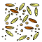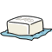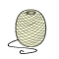

Important notes
Not suitable for children with nut allergies. Note that bird seed, including peanuts bought for birds, is not suitable for human consumption.

Steps
- Carefully make a small hole in the bottom of a yoghurt pot. Thread string through the hole and tie a knot on the inside. Leave enough string so that you can tie the pot to a tree or your bird table.
- Allow the lard to warm up to room temperature, but don’t melt it. Then cut it up into small pieces and put it in the mixing bowl.
- Add the other ingredients to the bowl and mix them together with your finger tips. Keep adding the seed/raisin/cheese mixture and squidging it until the fat holds it all together.

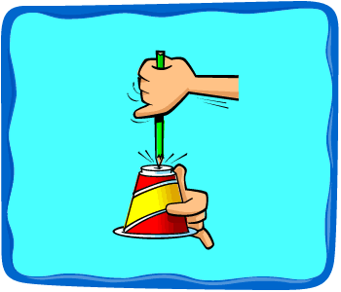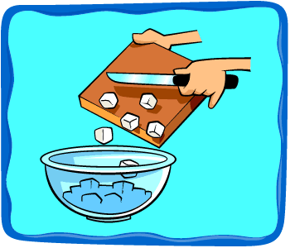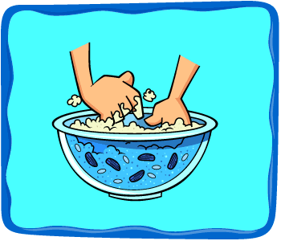

- Fill your yoghurt pots with bird cake mixture and put them in the fridge to set for an hour or so.
- Hang your speedy bird cakes from trees or your bird table. Watch for greenfinches, tits and possibly even great spotted woodpeckers.

