Impact of increasing temperature
So, the experiments we have done so far have shown us that burning fossil fuels over the past couple of centuries has released millions of tonnes of carbon dioxide into the atmosphere and that this has resulted in the climate warming. We’re now going to look at some experiments that can show us what impact this can have on the planet.

Experiment 1. Plant and chocolate inside car vs outside.
We need the energy from the sun to survive, but too much of a good thing can be bad. A car parked in the sun on a hot day is a great model of the greenhouse effect. In this experiment, we are going to wilt a plant and melt some chocolate in a parked car.

What you need:
- Two plants of the same size
- A car
- A sunny day
- 2 thermometers
- 2 chocolates, each inside its own plastic bag
- A record sheet

Method:
- On a sunny day, place one chocolate (inside a plastic bag) and one of your plants inside a car. Roll up all the windows.
- Place one of the thermometers inside the car in such a way that you can see the readings.
- Close the car door.
- Place the second plant, chocolate (inside a plastic bag), and the second thermometer outside the car.
- Check back every 10-15 minutes and write down the readings on your observation sheet.
- Warning for adults: Keep an eye on the temperature reading! It can get pretty hot inside the car. Take the thermometer out before the mercury reaches the top to prevent it from bursting!
- After recording a few readings, you can take the thermometers inside the house and leave the plants and the chocolate inside the car for a few hours.
What happened to the plant and the chocolate?

Talking points:
The temperature inside a parked car on a sunny day can be 80°C degrees higher than outside the car! Sunshine (solar energy) goes through the car windows and heats up the interior. Most of the heat is unable to escape again, and so the car gets hotter and hotter. This represents the increased amount of carbon dioxide in the atmosphere trapping more of the suns heat near the earth. The heat from the sun is still coming in all the time, but less of it can escape, so the planet gets warmer and warmer.
Plants and animals on earth are adapted to the range of temperatures that we have experienced on earth for the last few thousand years. Changing these temperatures too quickly will not allow living things enough time to adapt to the changing conditions. Some things might change the range of where they live, moving away from the warmer parts of the globe to closer to the polar regions or higher up mountains where the temperatures are cooler, but other things will not be able to do this. Organisms that are adapted to live in the coldest places on Earth will have nowhere else to go.
Plants and animals may suffer due to drought (such as the plant in the car), or other changing weather patterns. The melting chocolate in the car represents what is happening to our polar ice caps and mountain glaciers. As the climate warms up, these areas of the earth are melting faster and more extensively every year.

Experiment 2. Melting ice caps and sea level rise.
One concern with climate change is that as the average temperature increases, this will cause ice to melt, which could make the sea level rise. Many people around the world enjoy living near coasts, but even a small rise in sea levels will cause flooding of areas that are at a low elevation and close to the sea. In 2007, a study found that about 634 million people (about 1 in 10 people in the world) live in locations that are less than 9 meters (30 feet) above sea level and are, consequently, at risk from rising seas, as shown in figure 2 below.
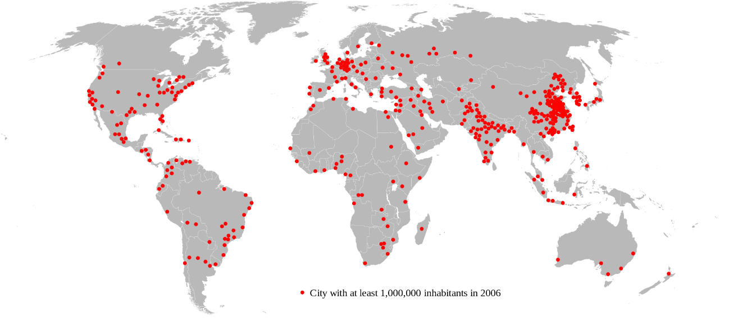
Figure 2. Each red dot on this map of Earth is a city with over 1 million people. You can see that many of these big cities are close to coasts and at risk of flooding from rising seas. (Wikimedia Commons, 2007.)

In this experiment, you will see if ice melting near the North or South Poles will make sea levels rise. The ice in the north is in the form of a floating polar ice cap, while the ice in the south is mainly in the form of an ice sheet on top of the continent of Antarctica. If the floating ice near the North Pole were to melt, would that make the sea levels rise? What about the ice sheet on top of Antarctica at the South Pole? For this experiment you will make a model of the ice at each pole to find out!

You will need:
- Play-Doh® or modelling clay,
- Clear plastic containers, approximately 540 ml,
  - Smaller or larger containers can be used, but you will need to scale up or down the amount of dough you add to the containers.
  - Note: The containers will be marked with permanent marker.
- Cold tap water
- Ice cubes (12 are needed, but you should have extra on-hand in case some get dropped and break.)
- Permanent marker
- Ruler, metric
- Optional: Camera
- Lab notebook
- Optional: Graph paper

Method:

Preparing Your North Pole Ice Models
- Fill three containers about one-third to half full of cold tap water.
  - The water represents the ocean.
  - Three containers are being used because you are going to make three trials of your experiment. Running trials helps to make sure your results are accurate and repeatable.
- Add two ice cubes to each container.
- The ice cubes represent the floating northern polar ice cap.
- Immediately mark the water level on the side of the container with a permanent marker. Try not to get the tip of the marker wet.
- Label each of these three containers "North Pole Ice Model" with the permanent marker and set the containers aside.

Preparing Your South Pole Ice Models
- Mould playdoh into a mound with a flat and level top.
  - This mound of dough will represent the continent of Antarctica (the South Pole).
  - Leave some space between the sides of the dough and the wall of the container all around, so that you can add water.
- Add water around the sides of the dough, so that the water level comes up about one-third to half of the way up the dough.
  - The water represents the ocean.
- Place two ice cubes on top of the dough.
- Press the ice cubes down lightly into the dough.
  - The ice cubes represent the southern polar ice sheet.
- Immediately mark the water level on the side of the container with a permanent marker. Again, try not to get the tip in the water.
- Label the container "South Pole Ice Model" with the permanent marker and set the container aside.
- Repeat steps 1–6 for two more empty plastic containers. Try and have them all contain approximately the same amount of water.
  - You are making three models of the South Pole so that you have three trials of your experiment. Doing more than one trial helps to ensure your results are accurate and repeatable.
- You should now have six containers containing ice models—three for the North Pole and three for the South Pole, as shown in the examples in Figure 3, below:
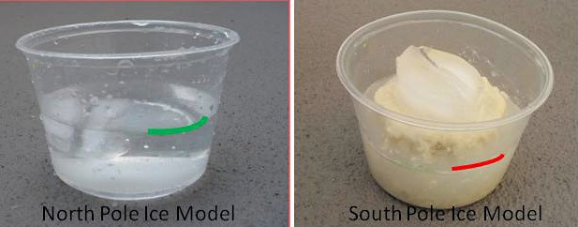
Figure 3. These photos show examples of the completed ice models. The starting level is marked on each container. You can take photos of your models with a camera for your display board if you wish.

Testing Your Ice Model
- Allow the ice in your models to melt in a place where they will not be disturbed.
- Keep an eye on the ice cubes in the South Pole model to make sure they stay balanced on the clay, and that the water from these melted ice cubes is able to run off the clay.
- Once the ice has completely melted, get down at eye level with the water and see if the water level has risen in any of the containers. If the water level has risen, measure and record the amount of rise with a ruler, in millimetres (mm), and record it in a data table, like Tables 1 and 2 below, in your lab notebook.
Amount of Water Rise in the North Pole Ice Models (mm)
Trial 1
Trial 2
Trial 3
Table 1. If you see a rise in the water level of the North Pole ice models (once the ice has completely melted), make a data table like this one in your lab notebook and record your measurements in it.

Amount of Water Rise in the South Pole Ice Models (mm)
Trial 1
Trial 2
Trial 3
Table 2. If you see a rise in the water level of the South Pole ice models (once the ice has completely melted), make a data table like this one in your lab notebook and record your measurements in it.

Talking points
Looking at your data table, did you see the water level rise when the ice melted in the North Pole model? What about when the ice melted in the South Pole model? Based on your results, which pole melting do you think is more of a concern for people who live near coasts?
The North Pole ice sheets are largely floating in water already. Ice is less dense than water, and so takes up more room than water. When ice floating in water melts, it doesn’t make the level rise, because the ice itself was already contributing to the level of the water. The ice sheets at the South Pole are mostly resting on land. If they melt and run into the sea, that will make sea levels rise as it is new water going into the ocean. The same is true for glaciers in Greenland and other islands in the arctic region. If all this ice melts and runs in the ocean, ocean levels will rise by several meters.

Experiment 3. Melting glacial ice.
Climate change causes variations in both temperature and snowfall. Warming temperatures cause glaciers to melt faster than they can accumulate new ice. Warming temperatures also mean some areas will get rain, rather than snow, further lessening ice accumulation. When glaciers lose more ice in the warmer months than they gain in the colder months, they retreat or recede.
As a glacier melts, a river or lake may form at its end. In this experiment we will investigate whether this has an impact on how fast the glacier melts.

Why ice melts
Changes of state always involve a transfer of energy. Ice melts when heat energy causes the frozen water molecules to move faster. When ice comes into contact with warmer air or water, it absorbs the surrounding energy (heat). The air and water molecules bump against the ice molecules and transfer some of their energy. The increased energy causes the ice molecules to break away, and the water changes state from a solid to a liquid.

You will need:
- Two identical plastic containers or one divided container
- Ice cubes
- Water (room temperature)
- Food colouring (optional)
- Timer or stopwatch

Method:
- Place an equal number of ice cubes in each container. You can use either regular ice cubes or ice cubes made with coloured water. (Colouring makes no difference to melting. It simply makes it easier to see the ice as it melts. If you use coloured ice, explain why to the students.)
- Add a small amount of water to one of the containers.
- Set the timer or stopwatch. Visit the containers every few minutes to see what is happening.
- While the ice is melting, view videos of glacier melting or collapses (for example Part of Perito Moreno glacier collapses or Franz Josef timelapse retreat).
- Record the time it takes for the ice in each container to melt.

Talking points:
Ice melts faster in water than in air because water is denser – has a greater concentration of molecules – than air. When ice is in water, more molecules bump against it and transfer more heat energy. Even when cold water is used, it is warmer than the ice, and the heat energy from the water molecules can quickly be transferred to the molecules in the ice, causing it to warm up and melt.
When glaciers have a river or a lake at their end, they will melt more quickly. The same is true when pools or lakes of ice water melt on top of ice sheets in polar regions. This water causes the ice around it to melt more quickly, and so increases the amount of ice melting.
The footage and photographs of retreating glaciers can be visually compelling evidence of the changing climate over the past few decades. Some examples are given below.
Photo Evidence: Glacier National Park Is Melting Away | National Geographic - YouTube
https://www.youtube.com/watch?v=Pem4fpMwkSQ

