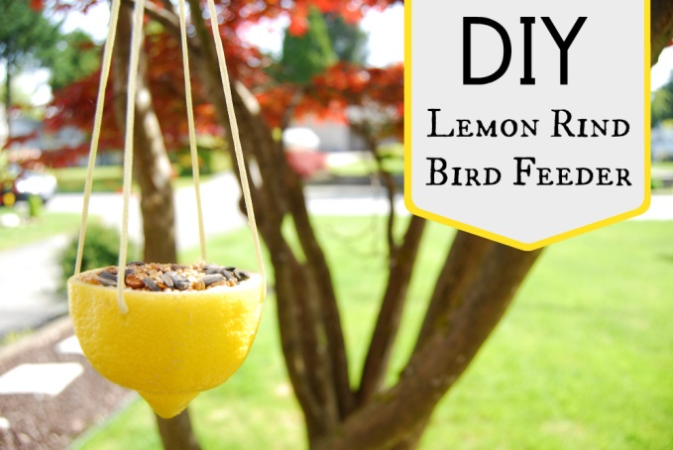
What you will need….
- Lemon rinds
- Thread
- Embroidery needle
- Bird feed
- Peanut butter

Make your own lemon rind bird feeder!

Instructions
- Thread the needle and tie a knot at the end of the string, then push the needle through one side of the citrus cup straight through to the other
- Pull up the centre of the loop to create a long loop for hanging
- Do a quarter turn with the needle and feed the needle straight through the rind this again, this time at right angles to the first set of holes
- Pull the second centre string to meet the first and tie a knot on the outside of the citrus cup to secure everything
- To make the bird feed, take some bird seed and mix in a tablespoon of peanut butter for every half cup of seed to give it some ‘stick’. The peanut butter provides a very nutritious treat for the birds as it is high in calories and fat content.
- Carefully fill the cups with the stick seed mixture one scoop at a time
- Find a spot to hang your new bird feeder! They can either be placed in the back garden or at a window sill.
