Recipe Analysis for Nutritional Labelling

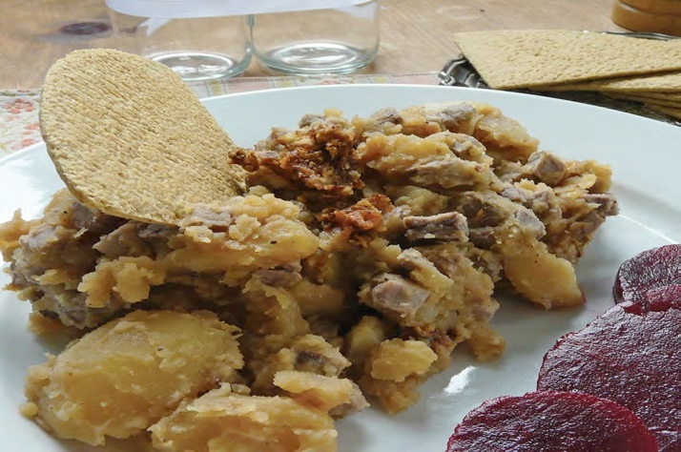

The Rowett Institute has a team of research dietitians and nutritionists with expertise and experience in nutritional analysis and access to an extensive database of nutritional information for specific ingredients. They can calculate the nutritional composition of your products, analyse the energy and nutrient content of your menus and provide advice on reference intakes, portion size labelling, nutrition claims and can help guide you through nutrition labelling legislation.
This case study is an example of how recipe analysis is used to create food labels. Recipe analysis can also be the first step when reformulating a food product to make it healthier.

Recipe Analysis
To analyse a recipe and make suggestions for reformulations, we need to know:
- The full list of the standard recipe ingredients, including fluid
- All weights in grams with the edible portion weight e.g. drained weight for canned foods, fruit and vegetables after peeling
- Clearly defined ingredients in the recipe e.g. beef - is it cooked or raw? What cut?
- The batch size and portion yield should be established by testing the recipe
- Calculate cooking losses or gains, by test weighing the finished product before and after cooking
- Product specification sheet for ingredients
This information allows the dietitian or nutritionist to analyse the recipe and prepare back of pack (BOP) nutrition labels, front of pack (FOP) nutrition labels, calculate the percent reference intakes (RIs) information and highlight any nutrition claims that can be made.
The traditional Stovies recipe is an example of a recipe inputted into a nutritional analysis programme. Changes were then made to this recipe to reduce the fat, saturated fat and salt which can be seen in the Reformulated Stovies recipe.
Traditional Stovies Recipe | Reformulated Stovies Recipe
900g potatoes, uncooked | 900g potatoes, uncooked
225g beef fore-rib/rib-roast roasted | 225g beef fore-rib/rib-roast roasted
150g Onion raw | 150g Onion raw
25g butter | 50g vegetable spread 45% fat
25g beef dripping
300g water | 300g water
7g beef stock cube | 3g beef stock cube
1g salt | 1g salt
Weight loss on cooking: 19% | Weight loss on cooking: 25%

Not all foods are included in the accepted McCance and Widdowson food composition database which is used in nutritional analysis software. This is one of the limitations in using nutritional analysis software to analyse a recipe. In this instance the manufacturer would be asked to provide the product specification of the ingredient. If this information was not available, inputting the figures from published data, where the food is sufficiently similar, would have to be agreed.

Labelling

Back of Pack (BOP)
In December 2016 back of pack nutrition labelling was made compulsory for most pre-packaged foods. Exemptions from BOP labelling legislation do apply, mainly to minimally processed foods or those with little nutritional value.

Should be expressed in a table format, unless space does not allow.

Include values for energy (kJ and kcal), fat (including saturates), carbohydrates (including sugars), protein and salt per 100g or 100ml of the product. Per portion information is often also provided, this information is not however mandatory.

Mandatory BOP nutrition information may also be supplemented with values for monounsaturates, polyunsaturates, polyols, starch, fibre and listed vitamins/minerals present in significant amounts. A significant amount of a vitamin and minerals is defined as 15% of nutrient reference values per 100g or 100ml or 7.5% for beverages.

Front of Pack (FOP)
Although not mandatory, FOP nutrition labelling is highly recommended by the UK and Scottish Government. If provided, FOP labelling must be in addition to BOP nutrition information.

Provides at-a-glance information for nutrients that are of importance to public health to support healthier food choices.

FOP labels can include energy alone or energy plus fat, saturates, sugars and salt.

Energy must be expressed per portion and per 100g or 100 ml. Fat, saturates, salt and sugar may expressed per portion only.

Portion size and/or consumption unit information is required.
In line with guidance from UK Government and Devolved Administrations, FOP labels will also typically contain:
- Reference intake information (%) based on the amount of energy, fat, saturates, sugar and salt in a portion. RI are based on an average-sized woman, doing an average level of physical activity.
- Red, amber and green colour coding of the nutrient content (not including energy)
The UK Government and Devolved Administrations launched a consultation in 2020 to gather evidence on the current FOP labelling scheme. This consultation is looking into how the FOP label may be improved and how it compares to schemes other countries have adopted. The results are expected later this year

Traditional Stovies BOP Label

Typical Values | Per 100g | Per serving (340g)
Energy | 550kJ  131kcal | 1760 kJ  419kcal
Fat | 5.5g | 17.6g
of which: Saturates | 2.8g | 8.9
Carbohydrate | 14.3g | 45.8g
of which: Sugars | 1.3g | 4.2g
Protein | 7.2g | 23.0g
Salt | 0.33g | 1.06g

Traditional Stovies FOP Label
Per Portion (340g)
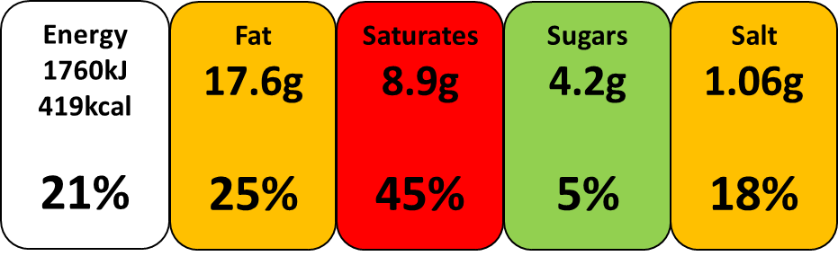of an adult’s reference intake
Typical values per 100g: Energy 550kJ/131kcal

Reformulated Stovies BOP Label

Typical Values | Per 100g | Per serving (340g)
Energy | 547kJ  130kcal | 1750kJ  416kcal
Fat | 4.6g | 14.7g
of which: Saturates | 1.5g | 4.8g
Carbohydrate | 15.4g | 49.3g
of which: Sugars | 1.4g | 4.5g
Protein | 7.7g | 24.6g
Salt | 0.26g | 0.84g

Reformulated Stovies FOP Label

Per portion (340g)
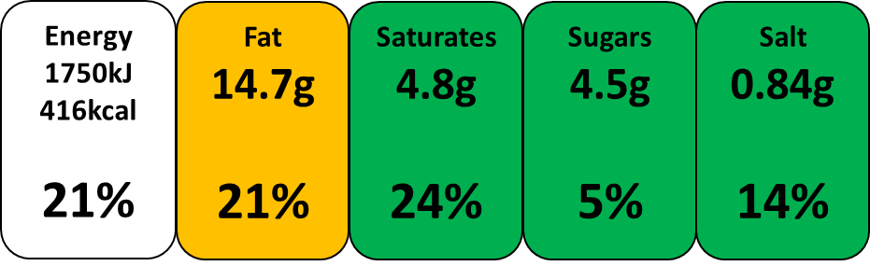of an adult’s reference intake
Typical values per 100g: Energy 547kJ/130kcal

From the food labels it can be seen the reformulated Stovies recipe contains less fat, saturated fat and salt compared to the traditional Stovies recipe, due to small changes made to the traditional recipe. The FOP label makes it very quick and easy to make comparisons between these products, which can support consumers to see which is healthier and make more informed choices.

Nutrition Claims
Making nutrition and health claims is closely controlled by EU legislation, Regulation 1924/2006. This regulation defines a ‘claim’, ‘nutrition claim’ and ‘health claim’.
A ‘claim’ defines any message or other representation such as pictorial, graphic or symbol in any form which expresses, suggests, or implies that a food has particular characteristics.
A ‘nutrition claim’ makes a statement about the level of a nutrient in a food in a way that suggests it is beneficial. A ‘health claim’ implies a relationship with a food or it’s constituents to health.
The following nutrition claims can be made on the Reformulated Stovies recipe:

Low Saturated Fat
A claim that a food is low in saturated fat, and any claim likely to have the same meaning for the consumer, may only be made if the sum of saturated fatty acids and trans-fatty acids in the product does not exceed 1.5g per 100g for solids and the sum of saturated fatty acids and trans-fatty acid must not provide more than 10% of energy. In this product the saturated fat content is 1.5g per 100g and provides 10% of energy.

Low salt
A claim that a food is low in sodium/salt, and any claim likely to have the same meaning for the consumer, may only be made where the product contains no more than 0.12g of sodium or the equivalent value for salt, per 100g or per 100 ml. In this product the salt content is 0.26g, which equates to 0.10g sodium per 100g.

High Protein
A claim that a food is high in protein, and any claim likely to have the same meaning for the consumer, may only be made where at least 20% of the energy value of the food is provided by protein. In this product 24% of the energy value is provided by protein.

