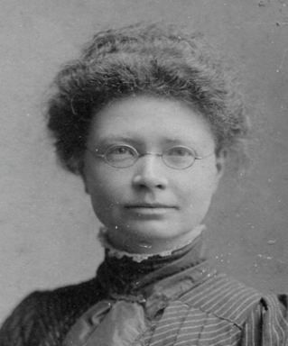
2026 PRIZES in memoriam Dr Jeannie MacLeod (1874-1902)

JOIN US TO LISTEN TO THE SHORTLISTED
MEDICAL HUMANITIES STUDENT PRESENTATIONS
THURSDAY 26th FEB 2-5pm
SUTTIE CENTRE ROOM 402 or
Join the meeting now
Meeting ID: 357 133 264 243 08 Passcode: 76Gd397S
Panel will award three prizes of £300, one for each category. Members of the shortlisting and awarding panel include; Dr Andrea Woolner, Dr Helen Vosper, Dr Sam Skinner, Dr Okezi Ononeme, Dr Laura Muirhead, Ashley Meldrum, Dr Wendy Lowe, Dr Susan Logan, Dr Aisling Halliday, Dr Ching-Wa Chung, and Dr Leeanne Bodkin

2pm Women in Medicine
The prize will be awarded for the best submission or submissions on the subject of, the changing roles and experiences of women in healthcare and medicine.
MAHNOOR IMRAN
The Body as a Canvas: Making endometriosis visible through art ~(ME33A2 Alternative Project)
KATHERINE MALONE
‘I’m worried we might be gambling with society’s diversity’: From Margaret Sanger to Sally Phillips, an exploration into the relationships between feminism, eugenics and reproductive rights. (ME33E2 - Essay Project on the History of Medicine)
SAJIYAH ZAHRA
The Hunger Haunting Gaza’a Wombs Long Term impacts of Maternal Starvation – a Case Study of Gaza (ME33GH Global Health and humanities)

2.45pm Diversity in Medicine
The prize will be awarded for the best submission or submissions on the subject of, valuing diversity and inclusivity in medicine and healthcare.
KATHERINE CORNFIELD
Understanding Widening Access Criteria Factors Held by UK Universities Across Medicine Courses: An Online Content Analysis (ME33A2 Alternative Project)
FLEUR DIJKMAN
Seeing Without Knowing: To What Extent do Characters with Prosopagnosia in Genre Fiction Follow Established Stereotypes of People with Disabilities? (ME33A2 Alternative Project)
JOSHUA JEAL
A proposal to survey MBChB students at The University of Aberdeen to understand attitudes, awareness and confidence toward providing trans*-inclusive healthcare(ME33A2 Alternative Project)
SUNNA HAIDER
How representative are the medical datasets used for AI models? Recognising bias and blind spots (ME33A2 Alternative Project)

3.45pm
Mental Health, Resilience and Wellbeing
The prize will be awarded for the best submission or submissions on the subject of mental health, resilience in healthcare practitioners, and initiatives to promote health and wellbeing.
DUAA EL-ZAROUK
Threads of Me A Collection of Short Stories (ME33CW Creative Writing)
AYAA MADJID
Where Peace Once Sat, A Mother’s Final Hold, A Childhood Interrupted (ME33AM Fine Art and Medicine)
RYAN SANDISON
Aberdeen Royal Infirmary Soundscape (ME33A2 Alternative Project)

4.30 pm Award of prizes by Dr Wendy Watson MBChB Programme lead.

