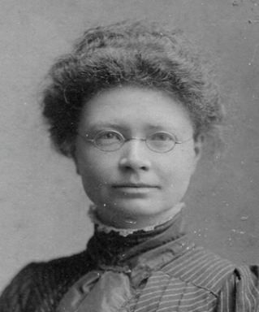
2025 PRIZES in memoriam Dr Jeannie MacLeod (1874-1902)
PROGRAMME Student Presentations
Three Prizes of £300 awarded one for each category to be awarded by the benefactor Dr Bob Clarke

- 1pm Diversity in Medicine
The prize will be awarded for the best submission or submissions on the subject of valuing diversity and inclusivity in medicine and healthcare.
RHEURE LOPES
Adapting Brazil’s Community Health Worker Model for the NHS to Enhance Primary Care (ME33A2)
JACK INGLIS
Levelling the donating field (ME33A2)
HANAH ABDEL-FATTAH
Interdisciplinary Lesson (IDL) on Waterborne Disease (ME33HS)

- 2pm Women in Medicine
The prize will be awarded for the best submission or submissions on the subject of the changing roles and experiences of women in healthcare and medicine.
KATHRYN GILLESPIE
‘Under the hood’: a design-forward medical education website exploring female sexual function. (ME33A2)
ALICE RIDLEY
Representing the doctor-patient relationship in modern literature: a critical evaluation (EL45HQ BMedSc Medical Humanities)
MAX MACDONALD
Hysteria – artwork (ME33AM)

- 3pm Mental Health, Resilience and Wellbeing
The prize will be awarded for the best submission or submissions on the subject of mental health, resilience in healthcare practitioners, and initiatives to promote health and wellbeing.
ADEELA RANA
Creative writing portfolio (ME33CW)
ERIN SANDIFORD
How did the perception of mental illness change in Europe in the Modern Period? (ME33BM)
JANE WU
The journey of people experiencing anxiety and depression – artwork (ME33AM)

