Making Biodiversity and Ecosystem Functioning Visible: Field Notes and Science Communication from Ethiopia’s Midlands, Highlands and Lowlands
CROSSROADS-SSA (Cataloguing and Rating of Side‑lined Species for the Restoration of Agriculturally Degraded Soils in Sub‑Saharan Africa) is a Global Centre on Biodiversity for Climate (GCBC)‑funded collaboration led by the University of Aberdeen alongside the International Water Management Institute (IWMI), Hawassa University, and Central Ethiopia Agricultural Research Institute. The programme is active in Ethiopia from November 2024 to October 2027 and integrates a range of reviewed literature, community knowledge, field and laboratory measurements, and co‑designed tools to evaluate how under‑utilised native plants can help to restore soils and strengthen climate resilience.
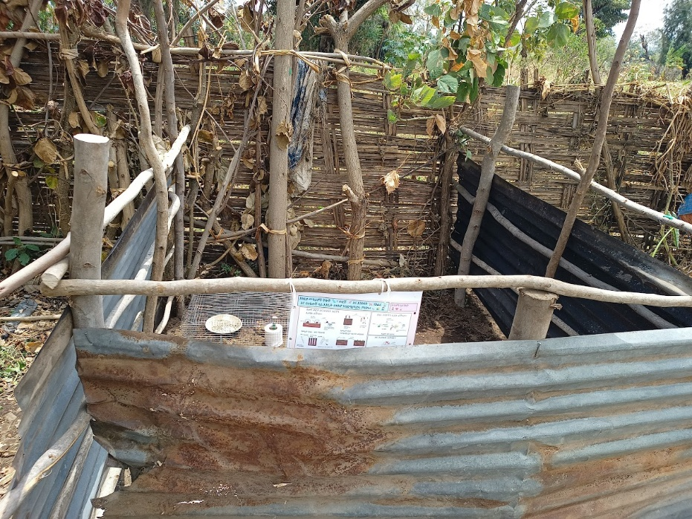
Example of a BEF site underneath Cordia Africana in the Midlands. The fencing in this area is protected using corrugated iron sheets.
Across sites, a common suite of biodiversity–ecosystem functioning (BEF) tests were applied ranging from: seed predation as a proxy for natural pest control; tea bags and toilet rolls to quantify decomposition and nutrient cycling; bait‑lamina strips to indicate soil‑fauna feeding activity; plasticine caterpillars to index predation pressure; and simple measures of dung removal and bioturbation to reflect soil mixing by invertebrates. Protocols for these tests drew on widely used, standardised approaches and are being compiled into future practical toolkits for farmers and local communities.
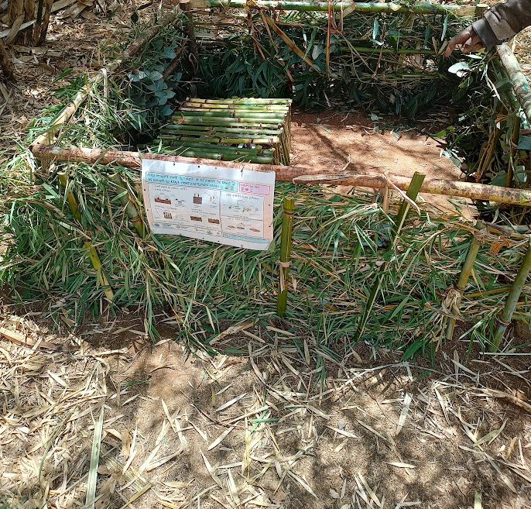
Example of a BEF site underneath Bamboo in the Highlands. The fencing in this area is protected using natural bamboo sticks and leaves
Fieldwork spanned Ethiopia’s Midlands near Halaba (Misraq Bedewach), where homestead Erythrina brucei (Korch) and Cordia africana (Wanza) are common features; the Highlands at Alicho Woriro (near Butajira), where Erythrina brucei (Korch) and Yushania alpina (Bamboo) were examined; and the Lowlands in Loka Abaya (Aleta Sodo kebele), focusing on Albizia schimperiana (Maticho) and Faidherbia albida (Tadacha). These canopy species are widely associated with improved soil conditions and crop‑relevant nutrient environments in Ethiopian farming systems.
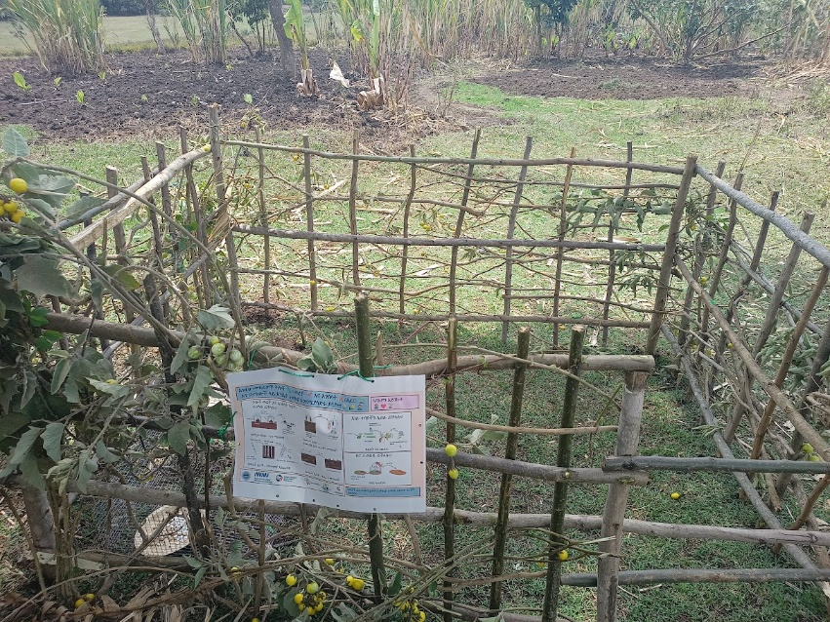
Example of a BEF site underneath Albizia Schimperiana in the Highlands. The fencing in this area is protected using branches of neighbouring trees and rope to prevent cattle disturbance
Under‑utilised native plants frequently fix nitrogen, mobilise phosphorus, contribute organic litter, and stabilise soils, supporting the functions measured in these BEF tests, aligning with CROSSROADS’ objectives. Evidence from Ethiopia indicates that Faidherbia albida improves soil properties and can provide nutrient benefits to grain beneath its canopy, aided by its dry‑season leafing. Cordia africana has been linked to providing higher soil organic matter, as well as an improved nutrient status and increased maize yields at optimal distances from the trunk. Albizia schimperiana also contributes nitrogen fixation, shade and soil conservation, reinforcing its value in agroforestry systems. Combined, these species illustrate how biodiversity buffers function, if one decomposer or predator declines, nutrient cycling and pest regulation can still be maintained.
Good science only travels as far as people can use it. To maximise uptake, the project produced a bilingual (Amharic/English) poster that explains BEF tests with minimal text and accessible graphics.
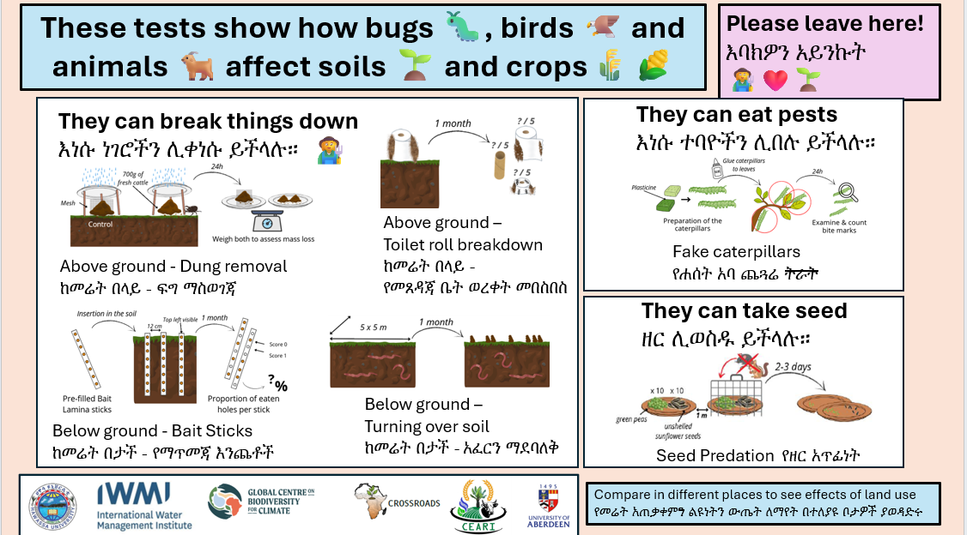
Example BEF poster used at each of the sites across the Lowlands, Midlands and Highlands. The poster has been created both in English and Amharic to improve accessibility, literacy and awareness
This approach helped to improve:
Access: Visuals helped to improve language and literacy barriers, so school pupils, extension agents and elders could understand what was going on.
Agency: Posters were left attached at field sites so that communities could see what was going and (perhaps for the future) be inspired to repeat tests on their own and compare results.
Awareness: Simple visuals were used to help highlight the visibility of soil and biodiversity processes, sparking curiosity and discussion amongst communities.

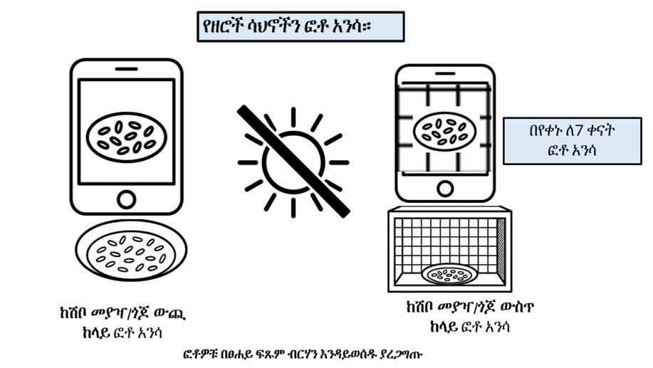
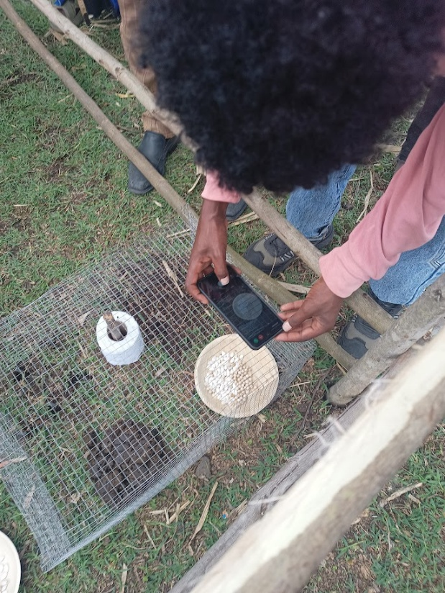
Photo showing one of the Development Agents (DAs) examining seed predation activity at one of the sites (left) and instructions for the DAs to take appropriate photographs of the tests in Amharic.
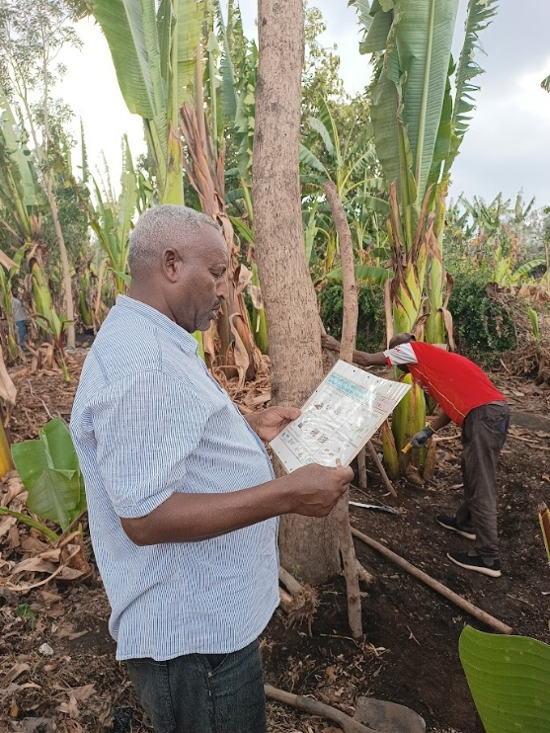
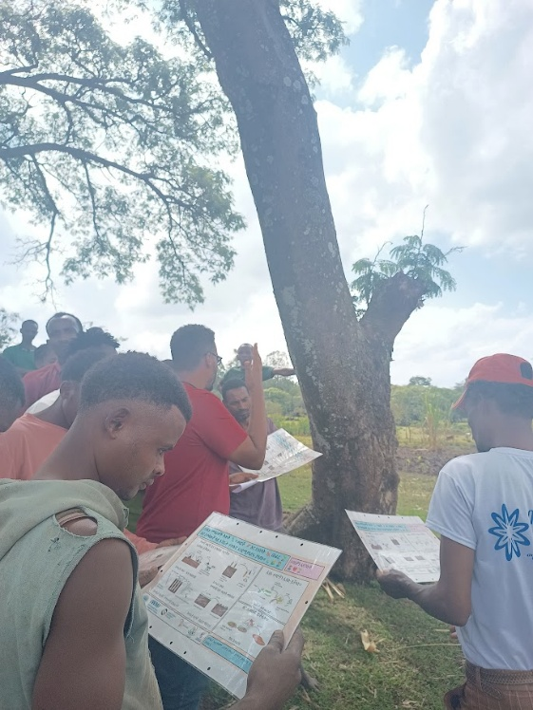
Community groups and local farmers across the Lowlands (left) and Midlands (right) interacting with the BEF posters.
Future work will see CROSSROADS partners consolidate findings into co‑designed toolkits and resources to support demonstrations on farms and field plots, enabling communities to trial species and simple BEF tests as well as informing policy on scalable, low‑cost nature‑based options for soil restoration.

