How low-cost and labour-efficient innovations can be used to recycle household organic wastes for crop production and soil improvement
**Suggested text for a technical note for policy makers – to be translated. Country-specific photos should be substituted in to make it more locally applicable **
Based on: Smith et al., 2026. Environ. Res. Commun. 8, 042002 https://doi.org/10.1088/2515-7620/ae59f6

Rising prices and limitations in supply of fertilisers are placing increasing pressures on smallholder farmers and threatening their ability to sustain productive and resilient cropping systems.
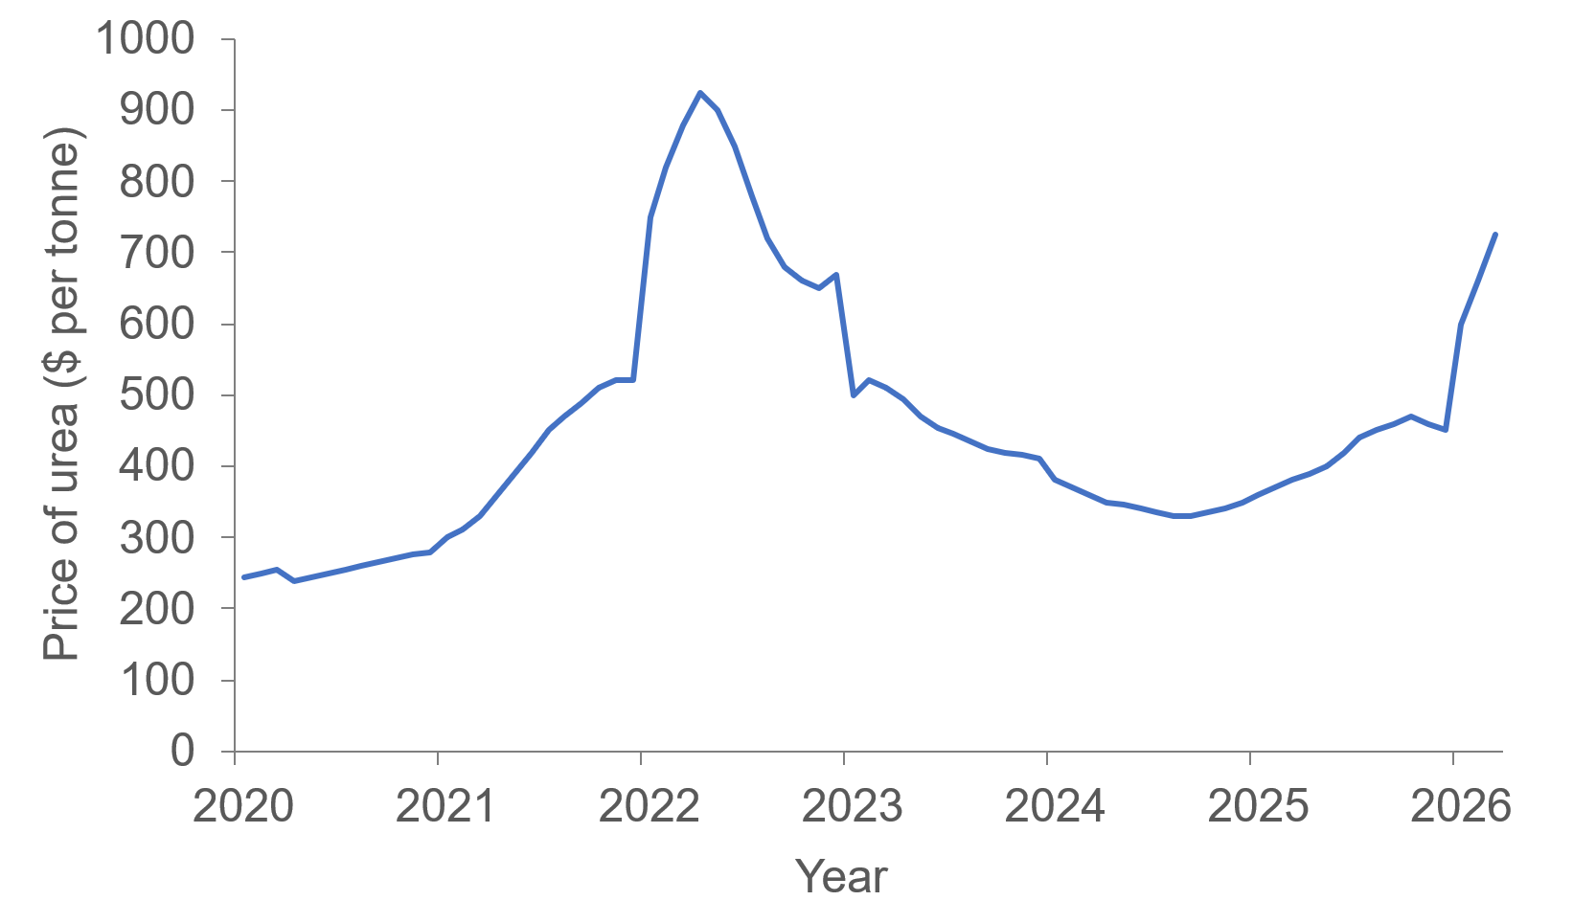
Source: World Bank Pink Sheets (extracted by Co-Pilot

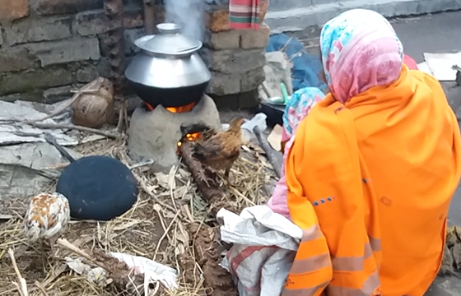
Recycling organic wastes offers a cost-effective alternative source of nutrients, with potential to reduce dependency on imported synthetic fertilisers. However, labour availability can sometimes compel farmers to burn crop residues in the fields. Higher fuel costs can also drive greater use of crop residues and animal manures for household energy. These practices remove essential nutrients from agricultural soils and degrade air quality, posing serious risks to human health.

Therefore, low-cost and labour-efficient innovations are needed to improve recycling of organic wastes, while also meeting energy demands and reducing labour. These should stabilise residues so that soil organic matter can be managed with less inputs and enhance the nutrient content of residues to produce more effective organic fertilisers.
Composting, anaerobic digestion and pyrolysis are key methods that can be used to achieve this. The best option depends on type of organic waste and other resources available at the household level.
Key messages
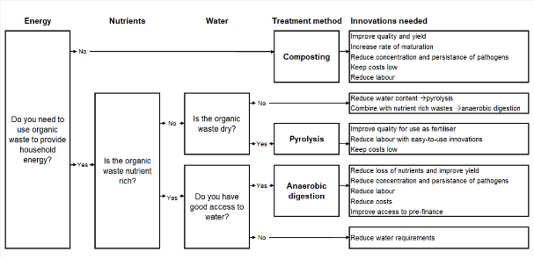
The most suitable way for a household to use organic wastes depends on household energy needs, the nutrient and water content of the waste, mechanization and the availability of labour, finance and water.
- If organic wastes are used to provide household energy, anaerobic digestion or pyrolysis are the better options; if energy is not needed, composting is a good choice as it requires less equipment and labour than the other methods.
- If the organic waste is high in nutrients, anaerobic digestion will provide biogas for cooking, while also allowing nutrients to be retained in bioslurry and applied to crops. However, dry materials will need to be mixed with wetter feedstocks or water, and digesters have relatively high startup costs.
- If the organic waste is dry and low in nutrients, a top lit updraft cookstove can be used for cooking, leaving behind pyrolysed carbon (biochar) that can be used to improve soil. Stoves are relatively cheap, and if biochar is used to soak up nutrients in animal urine, it becomes a convenient fertiliser that can be applied to crops.
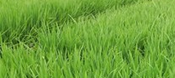
With appropriate choice of technology and management, households can efficiently recycle nutrients to fertilise crops while also meeting energy needs.

Composting
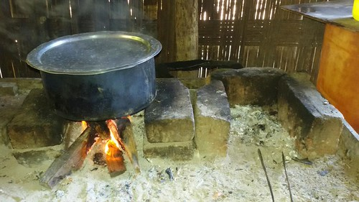
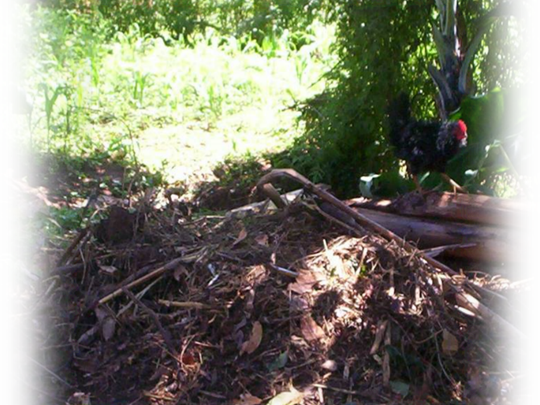
If the household does not need to use organic waste for energy, composting is a good option. It is low-cost, improves the supply of nutrients and stabilizes the organic matter. However, if the organic waste available is low in nutrients or dry, innovations are needed to improve the nutrient content and increase the rate of composting, while also avoiding increased financial costs, water use or labour.

Nitrogen
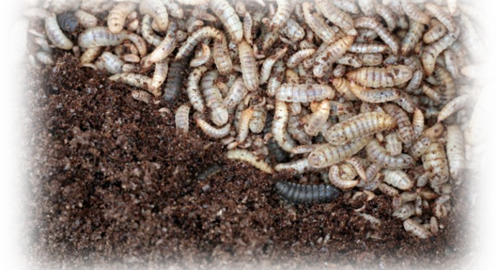
The optimal carbon (C) to nitrogen (N) ratio in the compost heap is 25–35. Below 25, ammonia is released; above 35, compost fails to heat or supply N. Low C:N ratio can be corrected with rice straw, biochar, soil, coir dust or ammonia‑oxidising inoculants; high C:N with poultry manure or N‑fixing inoculants.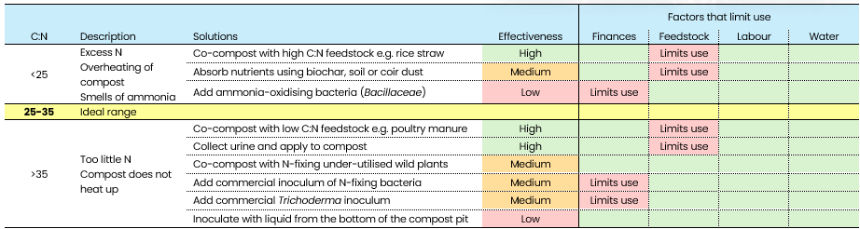
Phosphorus
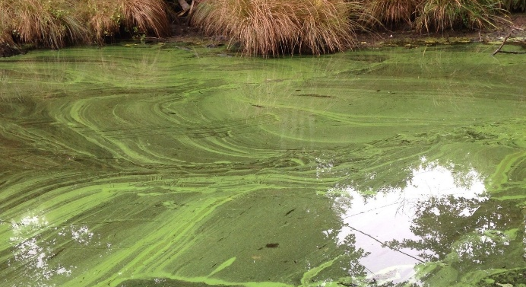
The optimal C to phosphorus (P) ratio is around 50. Below this, nutrient runoff can trigger algal blooms, and plants may show yellowing leaves with weak roots. Above 50, compost fails to heat properly, and plants exhibit poor flowering and purple leaves. Low C:P ratio can be corrected by co‑composting with rice straw or adding biochar, soil or coir dust; high C:P by co‑composting with poultry manure, adding rock phosphate or using P‑mobilising inoculants.

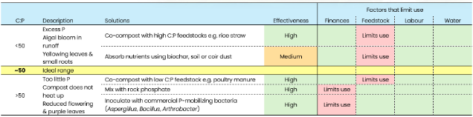
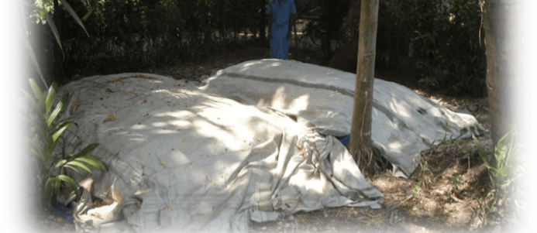

Acidity
Composting works best at pH between 5.5 and 8.5. Outside this range, the heap will not heat-up properly. When pH is too low (acidic), compost smells sour and fungi may grow on the compost. The pH can be raised by adding lime, wood ash or alkaline materials, such as cattle manure or the washings from cattle sheds; covering the heap can also help. When the pH is too high (alkaline), balance can be restored by adding acidic or low C:N materials, such as poultry manure, food waste, pine needles or citrus peel.

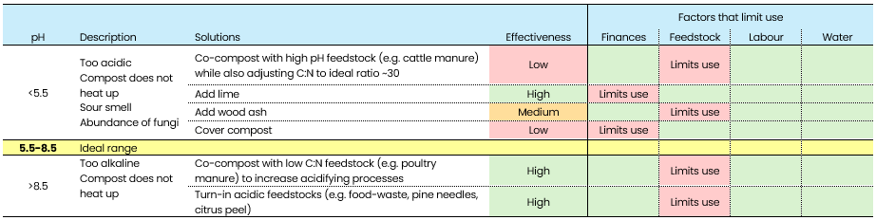
Moisture and aeration
The moisture content of the compost heap should be 50% - 60%. If it is too wet or too dry, the heap will not heat up; very wet compost may smell of rotten eggs. Excess moisture can be corrected by adding dry materials, turning the heap more often, or improving aeration using pipes or the action of worms or insect larvae. Dry compost can be improved by adding wet materials, urine or water, by covering the heap with plastic, soil or leaves, or using a shallow pit.

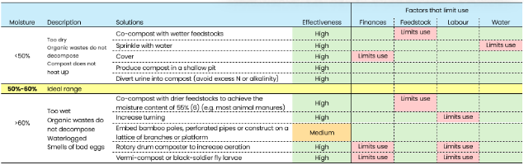
Temperature
The ideal composting temperature is 15–35 °C. Below 15 °C, heat can be conserved by increasing heap size, insulating the pile, or composting in a pit. Above 35 °C, there is a risk of overheating, so the heap should be turned, spread out, or lightly watered to release excess heat.

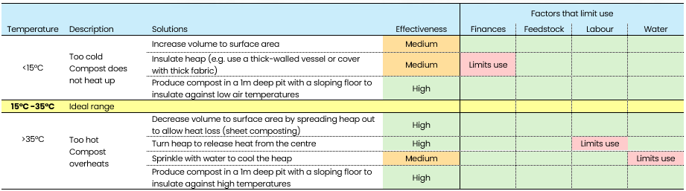
Anaerobic digestion
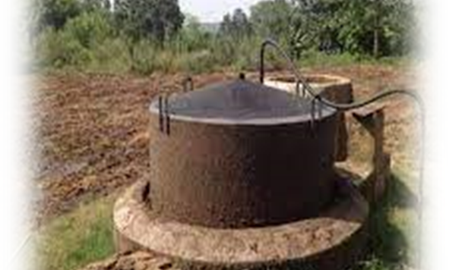
If the household needs the organic waste for energy, nutrient rich wastes can be fed into an anaerobic digester to produce biogas, an alternative clean energy source. However, innovations are needed to reduce or meet water requirements, especially for dry feedstocks, and to reduce financial costs, labour and nutrient losses from the bioslurry.

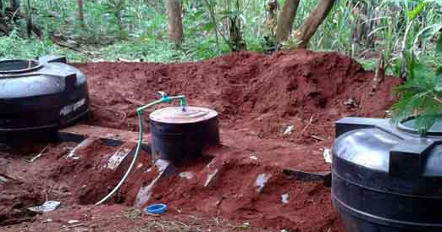
Nitrogen
The optimal C to N ratio in the digester is 20–35. Below 20, when N is too high, the bioslurry smells of ammonia; above 35, biogas production drops. Low C:N ratio can be corrected by adding rice straw, biochar, soil or coir dust; high C:N with poultry manure, collected urine or N‑fixing wild plants.
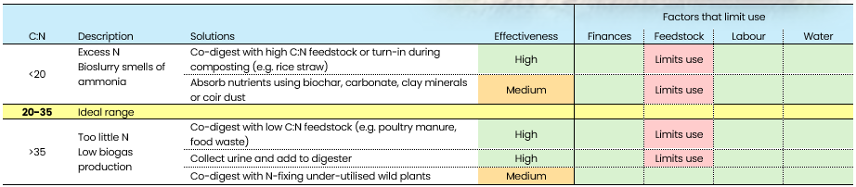
Bulk density
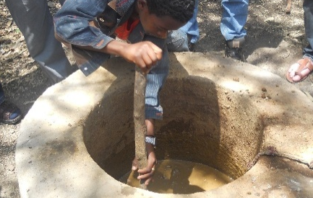
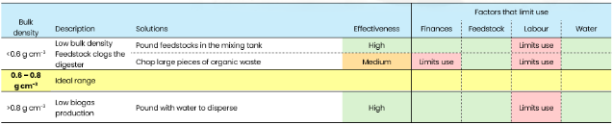
Feedstock bulk density should ideally be 0.6–0.8 g cm⁻³. Below this range, large or bulky materials can clog the digester; above it, overly dense feedstocks may not decompose well, reducing biogas production. Bulk density can be adjusted by chopping or pounding the waste. However. this adds labour or requires additional equipment.
Lignin

Woody materials and stiff crop residues have high lignin levels. When lignin exceeds about 7.5%, biogas production falls. Yields can be improved by pre‑treating feedstock with cattle urine, manure, rumen fluid, or white‑rot fungi from decaying wood. These methods are low‑cost but require extra labour.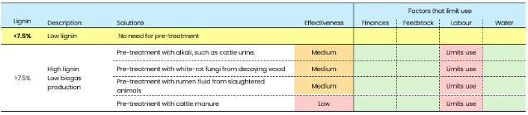
Acidity
Anaerobic digestion occurs by different processes; those that breakdown the feedstock into smaller molecules and those that convert the small molecules into methane (biogas). Methane producers work best at a pH of 6.8–7.4, while the first breakdown stage can handle more acidic conditions. Outside this pH range, biogas production slows. If pH drops below 6.8, the slurry smells sour. It can be raised by adding alkaline materials such as cattle manure, lime, wood ash or biochar. If pH goes above 7.4, acidic materials, such as food waste, pine needles or citrus peel can be added. Another option is a two‑vessel system; the first vessel allows low‑pH breakdown, and the second keeps a higher pH for efficient methane production.

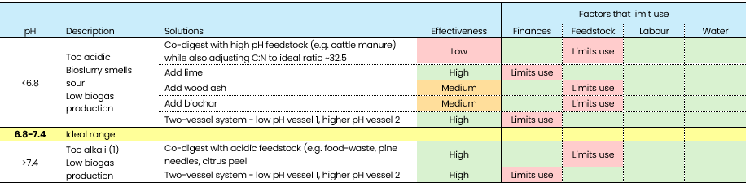
Water
Anaerobic digestion works best with a water content of 85–95%. Below 85%, it is too dry and biogas production drops. This can be fixed by adding wetter feedstocks, water (rainwater or reused household water), recycled bioslurry or small amounts of urine without adding too much nitrogen. Above 95%, biogas production also falls because the slurry moves through the digester too quickly. This can be corrected by adding drier materials.
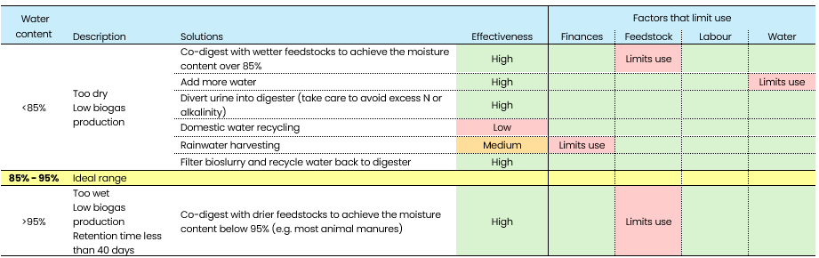
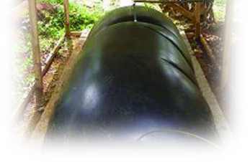
Temperature
The best temperature for anaerobic digestion is 35–45 °C. Fixed‑dome digesters are built underground to buffer against temperature extremes, but this increases construction costs. Cheaper designs, such as floating‑drum or simple fixed‑dome digesters, can use insulation or solar heating to raise temperatures, and shading to reduce overheating.
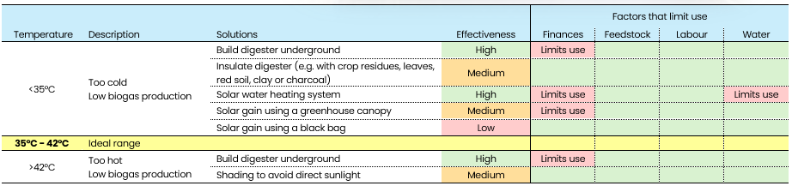
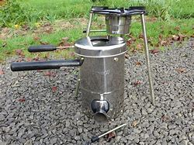
Pyrolysis
Nutrient poor and dry wastes are better used to provide energy by pyrolysis; innovations are needed to enrich and so improve the quality of the biochar as an organic fertiliser, and to reduce labour and financial costs. For nutrient poor wastes that are wet, innovations are needed, either to dry the waste before pyrolysis, or to increase the nutrient content so that it is suitable for anaerobic digestion.
Nitrogen
Organic wastes with a C:N ratio below 40 are unsuitable for pyrolysis because much of the N is lost to the atmosphere, reducing air quality. However, biochar produced with a low N content can be enriched by using the biochar to capture N from elsewhere on the farm, such as from animal housing (urine), compost or bioslurry. This produces an effective organic fertiliser while also reducing N pollution to the wider environment.
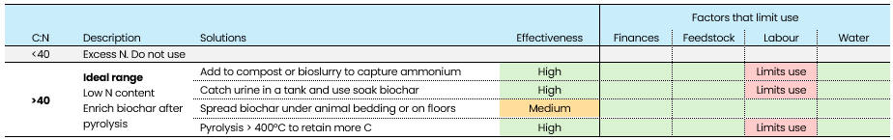
Water content
Biochar can only be effectively produced from dry organic wastes, with a water content less than 20%.
If the feedstock is wetter than this, it can be sub-dried before use. However, drying the feedstock requires more labour which might limit use. 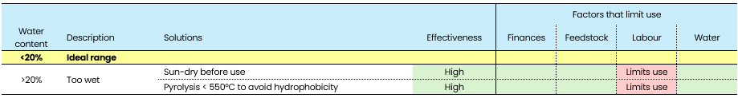
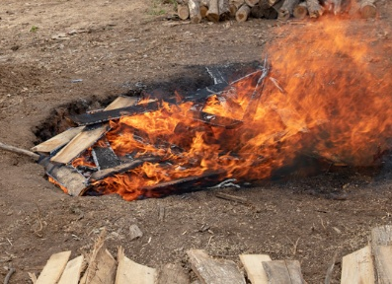
Energy
If the household needs energy from pyrolysis, a top‑lit updraft cookstove can be used to produce biochar while cooking. If the energy is not required, alternative methods can be used. In‑field techniques reduce labour but generally produce lower‑quality biochar than purpose‑built kilns. These kilns, however, require upfront investment, which may limit adoption by some farmers. 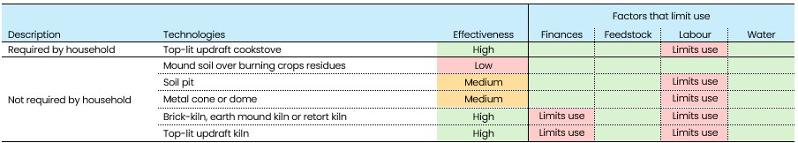

Acknowledgements

This work was funded by the Academy of Medical Sciences Networking Grant Scheme A20921. We are also grateful for the funding provided for underpinning research by the Global Challenges Research Fund (GCRF) “BREAD” project (NE P004830), the GCRF South Asian Nitrogen Hub (NE/S009019/1) and the UK Department of Environment, Food and Rural Affairs (Defra) Global Centre on Biodiversity for Climate (GCBC) “CROSSROADS” project (RG2-009244). GCBC is a UK Official Development Assistance (ODA) programme that aims to support developing countries to better value, protect, restore, and sustainably manage biodiversity in ways that tackle climate change and poverty alleviation. The views expressed do not necessarily reflect the UK government’s official policies.
Authors
Jo Smith ª, Umme Aminun Naher ^{b}, Khem Raj Dahal ^{c}, Md. Mahmodol Hasan ^{d}, Md. Mizanur Rahman ^{e}, Pete Smith ª, Mukunda Bhusal ^{f}, Jennifer Wardle ª, Dominik Bittner ª, Vince Chukwu ª, Tapan Adhya ^{g}, Raj Kumar Adhikari ^{h}, Masuda Akter ^{b}, Grant Campbell ª, Yam Kant Gaihre ^{i}, Sakhawat Hossain ^{b}, Md. Nurul Islam ^{j}, Mehedi Hasan Khan ^{b}, Salu Maharjan ^{k}, Wolde Mekuria ^{l}, Ripon Mia ^{b}, Awdenegest Moges ^{m}, Rujuta Nalavade ª, Timothy Namaswa ^{a,n}, Qurban Ali Panhwar º, Vianney Tumwesige ^{p}, Shree Prasad Vista ^{q}, Getahun Yakob ^{r}, Ali Tan Kee Zuan ^{s}

ª School of Biological Science, University of Aberdeen, Cruickshank Building, Aberdeen, UK. Emails in order: jo.smith@abdn.ac.uk; pete.smith@abdn.ac.uk; jennifer.wardle3@abdn.ac.uk; d.bittner.24@abdn.ac.uk; grant.campbell@abdn.ac.uk; vince.chukwu2@abdn.ac.uk; r.nalavade.20@abdn.ac.uk; t.namaswa.22@abdn.ac.uk
^{b} Soil Science Division, Bangladesh Rice Research Institute, Gazipur-1701, Bangladesh. Emails in order: naher39@gmail.com; masudabrri@gmail.com; sakhawatbrri@gmail.com; khanmehedi16@gmail.com; rafathonmoy1995@gmail.com.

^{c} Institute of Agriculture and Animal Science (IAAS), Tribhuvan University, Nepal. Email: d.khemraj@ymail.com.


^{d} Department of Agronomy and Agricultural Extension, University of Rajshahi, Rajshahi-6205, Bangladesh. Email: mmhasan@ru.ac.bd.

^{e} Institute of Climate Change and Environment, Gazipur Agricultural University, Gazipur 1706, Bangladesh. Email: mizan@gau.edu.bd.


^{f} Ministry of Agriculture and Livestock Development, the Government of Nepal. Email: omukunda@gmail.com.


^{g} Kalinga Institute of Industrial Technology Bhubaneswar - 751024, Odisha, India. Email: adhyas@yahoo.com.


^{h} Heifer International Nepal, Kathmandu, Nepal. Email: raj.adhikari@heifer.org.


^{i} International Fertilizer Development Center (IFDC), United States. Email: ygaihre@ifdc.org.


^{j} Soil Resource Development Institute, Bangladesh. Email: nurulsrdi78@gmail.com

^{k} Department of Agriculture, Nepal. Email: salumaharjan24@gmail.com


^{l} International Water Management Institute, Addis Ababa, Ethiopia. Email: W.Bori@cgiar.org.


^{m} Hawassa University, Hawassa, Ethiopia. Email: awde_moges@yahoo.co.uk.


^{n} Kenya Forestry Research Institute, P.O. Box 20412-00200, Nairobi, Kenya tnamaswa@kefri.org.

º Nuclear Institute of Agriculture, Pakistan. Email: pawhar107@yahoo.com.

^{p} Equator Solar Systems, Renewables & Environment, Kampala, Uganda. Email: trustvianney@gmail.com.

^{q} Nepal Agricultural Research Council, Khumaltar, Nepal. Email: spvista002@gmail.com.

^{r} Central Ethiopia Agricultural Research Institute, Hawassa, Ethiopia. Email: getahunyakob@gmail.com.


^{s} UDRP – Regenerative Agriculture for Sustainable Crop Productivity, D/A Department of Land Management, Faculty of Agriculture, Universiti Putra Malaysia, 43400 UPM Serdang, Selangor, Malaysia. Email: tkz@upm.edu.my.

