

University of Aberdeen

School of Education

ONLINE PGDE PRIMARY

INDUCTION BOOKLET

Cohort 26

PGDE (Professional Graduate Diploma in Education) Primary
Induction Booklet

Contents
Welcome 3
Initial contacts 4
Programme timeline - Year 1 5
Timetable 6
Library/ICT 7
IT services 7
Quick links 7
Student email 8
IT Help 8
Student advice and support 9
MyAberdeen/Getting yourself ready for day 1 10
Optional pre-course reading 11
Recommended course reading 12

Welcome

Dear Students,

On behalf of the School of Education, welcome to the University of Aberdeen!

We are delighted to welcome you to the PGDE Online Primary Programme as you begin your studies with us. As a Tutor Team, we wish you an exciting, challenging and fulfilling year, as you journey towards attaining your teaching qualification and provisional registration with the General Teaching Council for Scotland.

The following information contained within this Induction Booklet is set to provide you with some key information and points of contact to support you within your studies on the programme. All information contained within this Induction Booklet was correct at the time of publication, January 2026.

If you have any questions or would like to discuss any information further, please do not hesitate to get in touch. We very much look forward to sharing the next 18 months with you.

Yours sincerely,


Alyson Young
Programme Director
alyson.young@abdn.ac.uk

Ryan Ghaffray
Programme Administrator
pgde@abdn.ac.uk

Initial contacts

The following are your first points of contact throughout the course. By addressing any questions and passing on any information to the correct person, this will help us to best support your needs.

Further contact information is contained in the Programme Handbook, found on MyAberdeen.

Curriculum | Curricular tutors as detailed in MyAberdeen
Professional Studies | Your LinC Tutor:  Lorna Stewart (lorna.stewart@abdn.ac.uk) or  Eleanor Connon (eleanor.connon@abdn.ac.uk)
School Placements or Disclosure | Partnership Unit: partnershipunit@abdn.ac.uk
School Experience support  (once you are in school) | School Experience Tutors (in the first instance)  School Experience lead: Alyson Young  (alyson.young@abdn.ac.uk)  You will be allocated a school experience tutor who will support/visit you during placement.
Programme admin issues  e.g. absence, enquiries about courses, timetables, MyAberdeen, etc. | Programme administrator: pgde@abdn.ac.uk
Programme issues  (out with those above): | Programme director: alyson.young@abdn.ac.uk
General advice or guidance for personal issues | Your LinC Tutor (see above)
University Disability support contact | student.disability@abdn.ac.uk  www.abdn.ac.uk/disabilities
Disability Officer | TBC – see Programme Director
Student Learning Services | The Student Learning Service can help you with a range of requirements for your course: e.g. writing essays and assignments, managing your time, thinking critically, etc.  Visit www.abdn.ac.uk/sls/ for further information.
Aberdeen University Students’  Association (AUSA) | Visit www.ausa.org.uk to find out about the range of services provided by the Students’ Association.
Library Services | Claire Molloy: c.a.l.molloy@abdn.ac.uk
ICT problems with e-reg | PGDE Admin pgde@abdn.ac.uk then  Service desk - servicedesk@abdn.ac.uk
Registry and Finance | educationregistryofficer@abdn.ac.uk
Student Info Hub | www.abdn.ac.uk/infohub

NB: If you consider yourself to have a disability or any learning difference, please contact Student Support as soon as you have a confirmed place on the programme, especially if you are entitled to Disability Support Allowance, as you can begin the assessment process during the summer break.

Programme timeline - Year 1
Year 1
Uni Wk | Wk Beg | ED451H | ED451J | Other information
Uni Wk | Wk Beg | Education in Context  (15 credits) | Exploring the Curriculum  (15 credits) | Other information
23 | 29/12/25 | Online Registration
24 | 5/1/26
25 | 12/1/26 | LinC/Curriculum – week 1
26 | 19/1/26 | LinC/Curriculum – week 2
27 | 26/1/26 | LinC/Curriculum – week 3
28 | 2/2/26 | LinC/Curriculum – week 4
29 | 9/2/26 | LinC/Curriculum – week 5
30 | 16/2/26 | LinC/Curriculum – week 6
31 | 23/2/26 | LinC/Curriculum – week 7
32 | 2/3/26 | LinC/Curriculum – week 8
33 | 9/3/26 | LinC/Curriculum – week 9
34 | 16/3/26 | LinC/Curriculum – week 10 |  | In-person day 1: Sat 21st March
35 | 23/3/26 | LinC/Curriculum – week 11
36 | 30/3/26 | University holidays |  | Assessment 1A Submission
37 | 6/4/26 |  |  | Monday 6th April at 23.59
38 | 13/4/26 | Independent Learning Week
39 | 20/4/26 | SE1  9 weeks | SE week 1
40 | 27/4/26 | SE1  9 weeks | SE week 2
41 | 4/5/26 | SE1  9 weeks | SE week 3
42 | 11/5/26 | SE1  9 weeks | SE week 4 | Virtual recordings
43 | 18/5/26 | SE1  9 weeks | SE week 5
44 | 25/5/26 | SE1  9 weeks | SE week 6 | SE Assessments
45 | 1/6/26 | SE1  9 weeks | SE week 7 | SE Assessments
46 | 8/6/26 | SE1  9 weeks | SE week 8
47 | 15/6/26 | SE1  9 weeks | SE week 9 | Return visits as required

Assessment 1B - Monday 13th July at 23.59

All together joining event in January

NB: There will be an altogether online session on Monday 12th January 2026 at 6pm for both groups of students i.e. the Mon/Thurs group AND the Friday group. If at all possible, please put this date in your calendar now. This session will be recorded should someone from the Friday cohort not be able to attend but you must email in advance to let us know.

Further details about how/where you meet online for this one off altogether session will be emailed directly to you. We look forward to seeing you all then.

Timetable

Below is the draft timetable for year 1 of the course.

This will be confirmed week beginning 5th January 2026 ahead of classes beginning the following week.

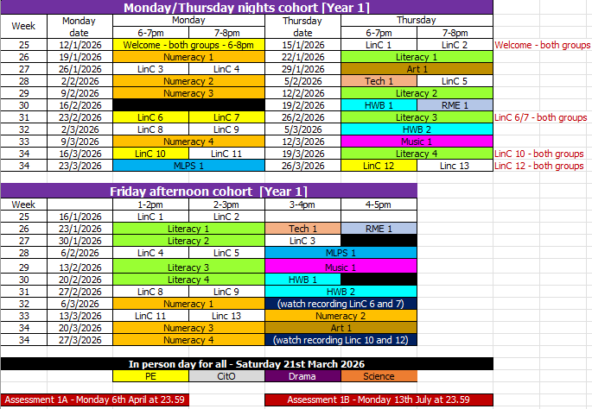

On Saturday 21st March there will be an in-person day for both cohorts to cover the sessions that are hard to do online. Please put this date in your calendar now.

Library/ICT

A wide range of online information can be accessed to support you with any ICT issues and essential Library skills. All information is available on MyAberdeen.

IT services

Having gone through the process of E-registration and MyCurriculum, you can then access:

  - Computing facilities and MyAberdeen

Log in using Computer Username
e.g. t01ap25

  - Student Email

Log in using your email address
e.g. a.person.25@abdn.ac.uk

Use the same password for both, which you chose as part of e-registration.

Quick links

On the university website: www.abdn.ac.uk Go to Quick Links.

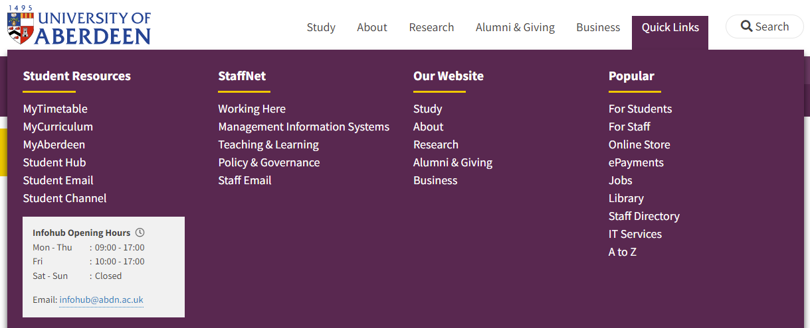

Here you will find shortcuts to:
  - MyAberdeen
  - Student Email
  - IT Services

Student email

You must use and check your University email account regularly as all communication from tutors, course, MyAberdeen and the University is sent to that account.

- Login to this from the same Quick Links section.
- Use the email address you chose during the e-registration process and your password.

The email address will be of a form similar to a.person.25@abdn.ac.uk. If you do not know your email address, you will find a note of it in your Student Portal.

The first time you log into student email from the website, you will be required to enter authentication details that can be used should you need to re-set your password at any time.

IT Help

When you need help, visit the Service Desk. This is your first point of contact for IT support.

  - Login to MyIT Portal at https://myit.abdn.ac.uk/
  - Email: servicedesk@abdn.ac.uk

IT Services for Students - www.abdn.ac.uk/it/student

Toolkit - www.abdn.ac.uk/toolkit/

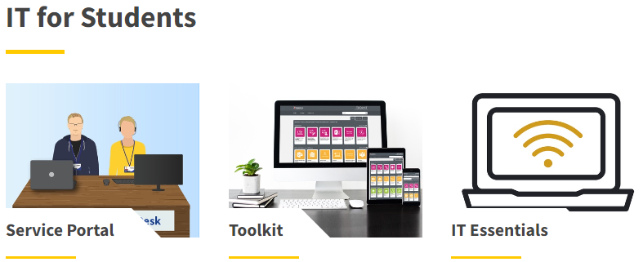

Student advice and support

The Student Advice and Support team offer a wide range of impartial and confidential advice and support to students on any issue or matter of concern which they might face throughout their time at University, including those of a personal, emotional or financial nature.

The Student Support Advisers also administer the University’s discretionary funds, including the childcare fund.

The team can provide specific information and support for students with disabilities, students with mental health issues, and students who require advice on visas and immigration.

Telephone: 01224 273935
Email: Student Support: student.support@abdn.ac.uk
Disability Team: student.disability@abdn.ac.uk
International Student Support: student.international@abdn.ac.uk

The website has lots of great information which is updated regularly with support service updates, and resources for students to access online: www.abdn.ac.uk/students/support.

Launched in December 2021, the Student Helpline is available 24/7 and specifical designed for periods normal support services are not. This is open to ALL students regardless of their location.

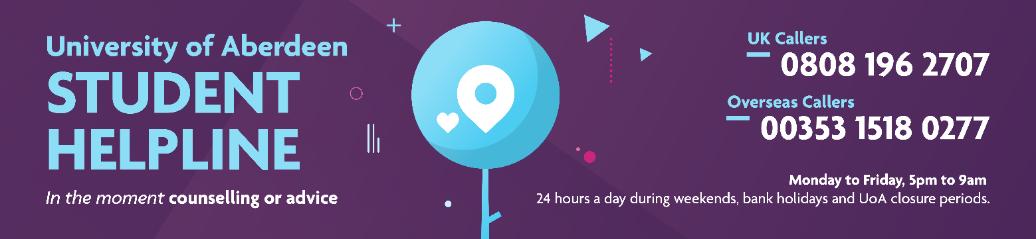

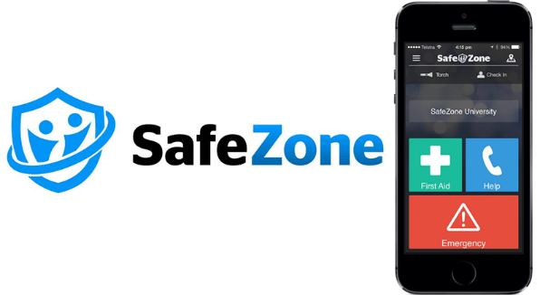
The University also uses an app, SafeZone, which connects you to the University campus security team in an emergency.

The University can send you important campus information.

You can download the app on Android or iOS and register with your University email.

MyAberdeen/Getting yourself ready for day 1

MyAberdeen is the Virtual Learning Environment used by the University of Aberdeen. This is where you will find all your course information, materials, resources, messages, announcements and assessment. Once you have access, you will find the Programme Handbook here.

For MyAberdeen/Teams to work Chrome is the preferred browser to use. You will also need a set of headphones with a microphone (so you don’t get feedback) and if your computer doesn’t have a built-in camera, then an external webcam is required.

- From Quick links, select MyAberdeen or type https://abdn.blackboard.com/.

- At the login page, use your University computer username which you were allocated during e-registration. This is of the form t01ap25 where the ap are your initials.

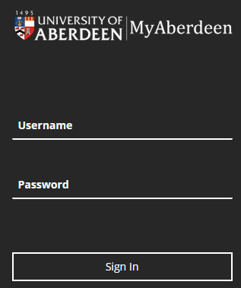

Use the password that you set up during e-registration.

- By default it always goes first to ‘activity stream’, so you need to click the LHS panel ‘courses’ and look for:
ED451H (2024-25): Education in Context [Cohort 26] (for your LinC materials)
OR
ED451J (2024-25): Exploring the Curriculum [Cohort 26] (for your Curriculum materials)

To learn more about MyAberdeen, click on this link for Toolkit to watch the video/read the guides.

Optional pre-course reading

If you would like to engage with some pre-programme reading, you can choose from some of the links below or take a look at some of the books on the recommended reading list. Remember to read broadly and think critically – you don’t have to understand everything or agree with everything!

GTCS Professional Standards for Teachers 2021
https://www.gtcs.org.uk/professional-standards/professional-standards-for-teachers/

The Curriculum for Excellence, especially the Principles and Practice Sections
https://education.gov.scot/Documents/All-experiencesoutcomes18.pdf

Realising the Ambition
https://education.gov.scot/media/3bjpr3wa/realisingtheambition.pdf

Learning for Sustainability
https://education.gov.scot/resource-themes/learning-for-sustainability/

Recommended course reading

Below is a list of books you will find useful during this year of study and beyond. Some of these books will be referred to by your tutors during the course. Your tutors will also provide links to additional sources, which they will ask you to access to support your thinking.

The books have been organised by theme to support you in identifying the readings you might find most useful at different points in the course. Please note that there is no expectation for you to have read each of them in their entirety before joining the course. Initially, choose the ones that interest you the most.

*Available on-line [for free] via the library, once you have your University login
Learning, Teaching and Pedagogy
BATES, B., (2023). Learning theories simplified. 3rd edition. London: SAGE Publications.

*CREMIN, T. & BURNETT, C., (2018). Learning to teach in the primary school. London: Routledge.
http://www.vlebooks.com/vleweb/product/openreader?id=Aberdeen&isbn=9780203854624

GAUNT, A. & STOTT, A., (2019). Transform teaching and learning through talk. London: Rowman & Littlefield.

*HATTIE, J., (2012). Visible learning for teachers: maximizing impact on learning. Abingdon: Routledge.
https://www.taylorfrancis.com/books/mono/10.4324/9780203181522/visible-learning-teachers-john-hattie

WATERS-DAVIES, J., (2022). Introduction to Play. London: Sage.

Social Justice, Inclusion and Diversity
*ARSHAD, R., WRIGLEY, T. & PRATT, L., (2020). Social Justice Re-Examined: Dilemmas and Solutions for the Classroom Teacher. London: Institute of Education Press.
https://ebookcentral.proquest.com/lib/abdn/detail.action?docID=6403353.

*BLACK-HAWKINS, K., FLORIAN, L. & ROUSE, M., (2015). Achievement and inclusion in schools. 2nd edition. London: Routledge.
https://www.vlebooks.com/Vleweb/Product/Index/864408?page=0

*HART, S. et al., (2004). Learning without Limits. Maidenhead: Open University Press.
https://ebookcentral.proquest.com/lib/abdn/reader.action?docID=290385

THOM, J., (2020). A quiet education challenging the extrovert ideal in our schools. United Kingdom: John Catt Educational Limited.

Assessment
*CLARKE, S., (2014). Outstanding Formative Assessment: Culture and Practice. London: Hodder Education.
https://www.vlebooks.com/Product/Index/416781?page=0&startBookmarkId=-1

Professional Enquiry
*POULTNEY, V. & FOX, A., (2020). Professional Learning Communities and Teacher Enquiry. St Albans: Critical Publishing.
https://ebookcentral.proquest.com/lib/abdn/reader.action?docID=6146802

Learning for Sustainability
*BEAMES, S., HIGGINS, P. & NICOL, R., (2012). Learning Outside the Classroom. Abingdon: Routledge.
https://ebookcentral.proquest.com/lib/abdn/detail.action?docID=957269

*MURRAY, P., (2011). The Sustainable Self: A Personal Approach to Sustainability Education. London: Earthscan.
https://ebookcentral.proquest.com/lib/abdn/detail.action?docID=981647&pq-origsite=primo

Classroom Climate/Ethos
*DIX, P., (2017). When the adults change everything changes: Seismic shifts in school behaviour. Carmarthen: Crown House Publishing Limited.
https://ebookcentral.proquest.com/lib/abdn/detail.action?pq-origsite=primo&docID=4871033

Academic Support
REDMAN, P., (2017). Good Essay Writing: A Social Sciences Guide. 5th edition. London: SAGE.

School Experience
*MEDWELL, J. & SIMPSON, F., (2008). Successful teaching placement in Scotland: Primary and Early Years. Exeter: Learning Matters.
https://ebookcentral.proquest.com/lib/abdn/reader.action?docID=820164

Book bundle purchasing option


PGDE Primary staff have worked with the Blackwell’s campus bookshop to share this year’s reading list and create a book bundle of 3 key titles for the Primary PGDE course, highlighted in yellow in the reading list.



This exclusive bundle is specially made just for this course and is discounted to be cheaper than buying the books individually anywhere else online.

To take advantage of this offer, please contact the store directly. They can be contacted by either email - aberdeen@blackwell.co.uk or via telephone - 01224 486102. Alternatively, if you are based in Aberdeen, you can call into the shop which is located at 99 High Street, Old Aberdeen, Aberdeen, AB24 3EN.

If you have any questions at all, please contact the shop by email or phone.

Email - aberdeen@blackwell.co.uk
Telephone - 01224 486102

