REF 2029: Guidance and information
Contribution to Knowledge and Understanding: Completing Reviews

Before you start
Reviewers should receive an email notification from Pure when they have been assigned to an output and asked to review it. If you are using the web form the email notification can be used as a reminder of the title of the review(s) that you have been asked to complete

Review an output via the web form
When you access the web form your university credentials will be used to identify you and to present a list of outputs for you to review. Please note that once you start the review you will be required to complete all the mandatory questions, the web form does not offer a ‘save for later’ option.
Available outputs for review are drawn from Pure. Allocated reviews are downloaded from Pure each working day and uploaded to the web form. If the review you are attempting to complete is not on the list, please email researchreporting@abdn.ac.uk.

To find an output to review begin typing the name of the output in the box for Output title and click on the title to select the output.
The reviewer’s name will be automatically populated.



If the output meets the REF definition of research tick ‘Meets Research Definition’ and add any comments as appropriate.

If the output Meets the remit of the REF panel, tick ‘Meets Panel Remit’ and add any comments as appropriate.

Select the Unit(s) of assessment that the output could be submitted to. you can select more than one unit of assessment.
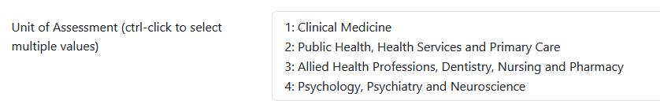

If the output should be cross referred to another panel, tick ‘Cross referred’ and add any comments as appropriate.

If the output meets author contribution requirements, tick ‘Meets author contribution requirements’ and add any comments as appropriate.

If the output is interdisciplinary, tick ‘Interdisciplinary’ and add any comments as appropriate.


If the output should be double weighted, tick ‘Double Weighting’ and add any comments as appropriate.


Grades and comments should be provided for Originality, Significance, and Rigour, select a grade from each of the drop-down lists and provide comments to justify the grade selected.
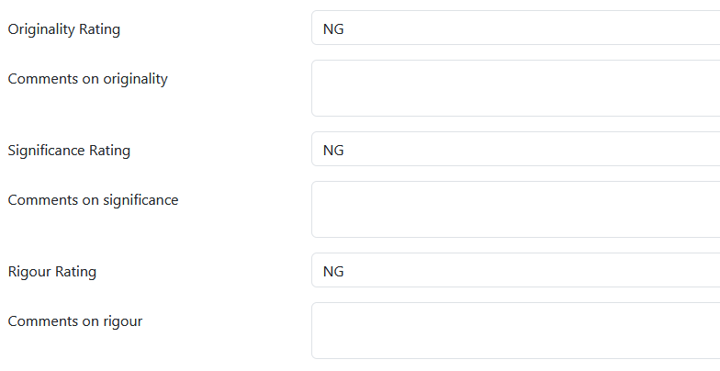

If the reviewed item is a draft output or a pre-print, it can be helpful to provide suggestions for improvement in the comments box. This section is optional.

For the overall rating of an output, consider the grades and comments selected under Originality, significance and rigour, then select an overall grade from the drop-down list.
Information added under additional comments, should be considered as feedback to the author, and may be shared with the author as part of the final grade summary.
When completing the review, you will be asked to indicate how confident you are in the scores that you have given. Select a response from the confidence scale. There are no additional comments for this question.
Then press submit

The web form is not directly linked to Pure so your review response will not appear in Pure immediately. At the end of each working day a file will be downloaded, and the completed reviews will be uploaded to Pure.
As the process is not fully automated, nominations via the web form may take one working day to appear in Pure.

Once the completed reviews are uploaded to Pure, review administrators and REF leads will be notified and the process of finalising the reviewed outputs will begin.

For the purposes of REF, research is defined as a process of investigation leading to new insights, effectively shared. It includes work of direct relevance to the needs of commerce, industry, culture, society, and to the public and voluntary sectors; scholarship, the invention and generation of ideas, images, performances, artefacts including design, where these lead to new or substantially improved insights; and the use of existing knowledge in experimental development to produce new or substantially improved materials, devices, products and processes, including design and construction. It excludes routine testing and routine analysis of materials, components and processes such as for the maintenance of national standards, as distinct from the development of new analytical techniques. It also excludes the development of teaching materials that do not embody original research. It includes research that is published, disseminated or made publicly available in the form of assessable research outputs, and confidential reports. Scholarship for REF is defined as the creation, development and maintenance of the intellectual infrastructure of subjects and disciplines, in forms such as dictionaries, scholarly editions, catalogues and contributions to major research databases. Where an output does not meet the REF definition of research, it should be flagged and marked unclassified.
Author contributions must be substantial and verifiable, including significant contributions to conception, design, execution, analysis, or interpretation of the work, as well as drafting or critically revising the manuscript. Substantial contributions must also be acknowledged in the acknowledgements or a separate contribution statement.
For the purposes of the REF, interdisciplinary research (IDR) is understood to achieve outcomes (including new approaches) that could not be achieved within the framework of a single discipline. Interdisciplinary research features significant interaction between two or more disciplines and/or moves beyond established disciplinary foundations in applying or integrating research approaches from other disciplines
Institutions may request that outputs of extended scale and scope be double-weighted (count as two outputs) in the assessment, the decision of whether to double weight an output is entirely separate from the quality assessment. For outputs in Panel A, the panel anticipates that it will double weight outputs only where they derive from substantial academic endeavour by the member of staff against whom the output is listed in the submission. Such endeavour might be understood in terms of (but is not limited to) the ambition of the project. The expectation is that requests for double weighting will occur only exceptionally. The panel does not expect that journal articles and conference proceedings will normally embody work of this nature.

