REF 2029: Guidance and information

Contribution to Knowledge and Understanding: Completing Reviews

Before you start
Reviewers should receive an email notification from Pure when they have been assigned to an output and asked to review it, the email does offer a direct link to the review in Pure, however we recommend accessing Pure via the login link in this guide as this offers more flexibility with the review screen.

Review an output in Pure

Log into Pure to find your assigned reviews in Pure.

From your personal overview screen click on ‘My output reviews’, highlighted in the image below.
This will take you to a list of outputs where you are a named reviewer.
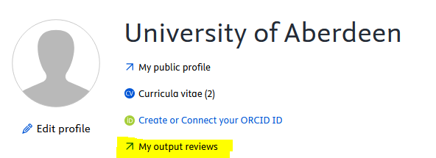

In the reviews area look for reviews at the status ‘sent to reviewers’ these reviews will require completion by you
Items at the step ‘replies received’ may require your attention, items will be marked ‘replies received’ when at least one reviewer has responded.
Items with a status of completed do not require any further action.

Click on the Title of the review to open it.
Clicking on related content on the right-hand side will take you to the publication record rather than the review record.

When the review opens, click to accept the review.
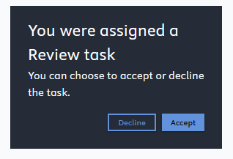

You will then need to work through the list of 13 questions and provide responses and comments.

Questions in Pure may have large description boxes, this is to aid in decision making and to explain concepts or guidance related to REF

All questions are mandatory apart from ‘Suggestions for improvement’.

Comments against each of the questions are not mandatory but you are encouraged to add comments against grades for Originality, Significance and Rigour and for the review grade, as this can aid in the final grade decision for the paper.

Comments given against question 12 ‘overall score for the output’ should be considered as feedback to the author, these comments may be used by the REF lead as final summary content and may be shared with the author when the review is finalised.

- Does the output meet the REF definition of research
  - Meets definition of research
  - Definition of research not met
  - Comments box

- Does this output meet the remit of the panel
  - Meets remit of the panel
  - remit of the panel not met
  - Comments box

- Please indicate which unit(s) of assessment you feel this output would be most suited to - you can indicate more than one option.
  - Text box

- Should this output be Cross-referred to a different unit of assessment?
  - item should be Cross-referred
  - Cross-referral not required
  - Comments box

- Does the contribution of the Aberdeen author(s) meet the requirements of significant contribution?
  - significant contribution
  - contribution not clear
  - author has not made a significant contribution
  - Comments box

- Is this output Interdisciplinary?
  - Interdisciplinary
  - Not interdisciplinary
  - Comments box

- Should this output be considered for Double weighting?
  - Double weighted
  - Not Double weighted
  - Comments box

- Please indicate how you rate the Originality of the Research
  - Select a grade from the options available
  - Comments box, please provide comments here to support or justify the grade that you have selected

- Please indicate how you rate the Significance of the output
  - Select a grade from the options available
  - Comments box, please provide comments here to support or justify the grade that you have selected

- Please indicate how you rate the Rigour of the output
  - Select a grade from the options available
  - Comments box, please provide comments here to support or justify the grade that you have selected

- Suggestions for improvement (optional)
  - Text box, please provide any suggestions on the output. This is an optional section and is mostly used where a draft item is being reviewed

- Please provide an overall score for the output
  - Select a grade from the options available
  - Comments box, please provide comments here to support or justify the grade that you have selected. Please consider the comment you add here to be feedback to the author. Content added here may be shared with the author as part of the final summary.

- Confidence scale
  - Very Confident
  - Confident
  - Not Confident

Once all the questions have been answered click on ‘Submit review’,
The submit button will remain greyed out if any of the mandatory questions have been missed.
If there are any areas that you are unsure about you can use the save for later button and come back to the review later.
Once the completed reviews are uploaded to Pure review administrators and REF leads will be notified and the process of finalising the reviewed outputs will begin.

