REF 2029: Guidance and information

Contribution to Knowledge and Understanding

Nomination of outputs for review

Before you start
Make sure your Pure record is up to date, tell us about any newly accepted or published publications.

Send an email to paperaccepted@abdn.ac.uk along with the confirmation e-mail or letter from your journal or publisher and the final accepted version of the output.
You can also tell paperaccepted@abdn.ac.uk about any publications that you think might be missing from your Pure profile.

What to Nominate
Nominate an output that is eligible and one which you think will achieve a good score in the REF exercise. Before nominating, check that the output.
- meets the REF definition of research
- contains original research, where you have made a distinct and substantial contribution to the output
- i published, including early online publication, after 1 January 2021
- is openly accessible. If the item is a journal article or a conference proceeding with an ISSN, the publication needs to meet the REF open access requirements.

Reviewers will assess the originality, significance and rigour of your work, these factors should be the main drivers when choosing your output for review, other indicators, such as citations, may feature in your decision but should not be your primary reason for proposing an output.

Nominate an output via the web form

Access the web form to nominate your outputs

Your university credentials a used to identify you and to present a list of outputs for you to nominate for review.
Available outputs come from Pure. Outputs are prefiltered for available types and items not already nominated for review.

We regularly download new outputs from Pure and upload them to the web form. If the output you are attempting to propose/nominate is not on the list, please email researchreporting@abdn.ac.uk.

To find an output begin typing the name of the output in the box for Output title and click on the title to select the output.

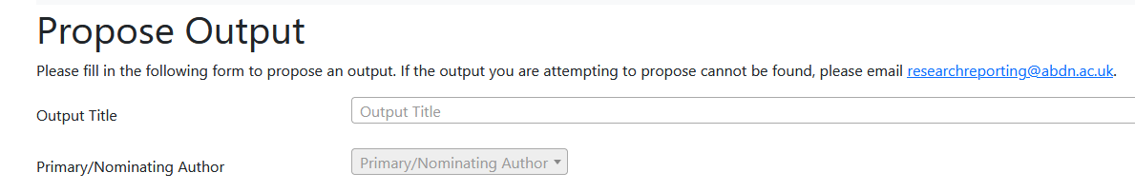

Once you select the output, your name is added to the Primary/Nominating author section
Select the unit of assessment that you think aligns to the work that you are proposing, if the output could fit in more than one unit of you can select multiple options.

If you think the output should be considered for double weighting, check the box.

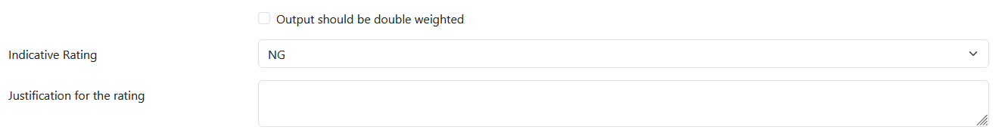

Finaly provide an indicative grade and a short justification for the selected grade.

Provide a brief description of your contribution to the output.

Then press submit.


The web form is not linked to Pure so your review request will not appear immediately.
At the end of each working day a file is downloaded, and the requested reviews uploaded to Pure. As the process is not fully automated, nominations via the web form will take one working day to appear in Pure.

Once the central team uploads the nominations to Pure review, administrators will be notified and the process of sending your output to reviewers will begin.

For the purposes of the Research Excellence Framework (REF), research is defined as a process of investigation leading to new insights, effectively shared. It includes work of direct relevance to the needs of commerce, industry, and to the public and voluntary sectors; scholarship; the invention and generation of ideas, images, performances, and artefacts including design, where these lead to new or substantially improved insights; and the use of existing knowledge in experimental development to produce new or substantially improved materials, devices, products and processes, including design and construction. It excludes routine testing and routine analysis of materials, components, and processes such as for the maintenance of national standards, as distinct from the development of new analytical techniques. It also excludes the development of teaching materials that do not embody original research.

