REF: Contribution to knowledge and understanding
Output reviews: guidance for unit of assessment leads and administrators.
Monitoring reviews and finalising grades.

Monitoring Reviews
Reviews in various states will be visible in the review workspace in Pure. This area of Pure is only accessible to staff with administrative or editorial permissions.
Statuses
- If a review is waiting to be assigned to reviewers, the status will show as ‘Requested’.
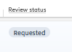
- While reviews are being completed the status of the review will show as ‘sent to reviewers’.
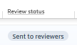
- Once at least one review has been received on a publication the status of the review will show as replies received.
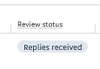
Accessing Reviews
From the Reviews area click on the Title of the requested review to open the record.

Where reviews have been completed by the reviewers, the Responses and reviewer feedback can be viewed in the Responses area, the third tab on the screen.

Under the summary section you will see the summary of each review and the responses to the questions from the REF review template.
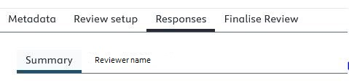
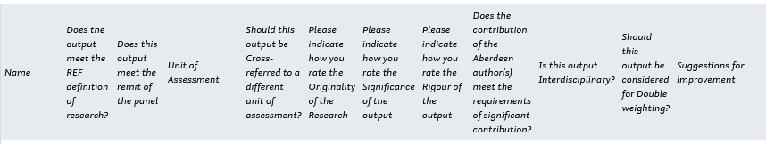

You can also click on the name of each reviewer to see the full review details.
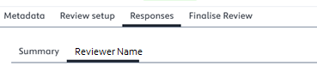

Finalising the review
Once the minimum of two reviews have been received the review can be finalised.
Click on Finalise Review, the fourth tab on the screen.
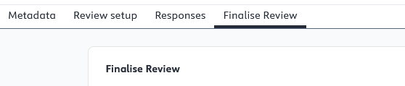
Add a summary of the review to the summary text box, this is the text that you want to share with the author in relation to the outcome of the review, it may include suggestions for improvement if applicable.
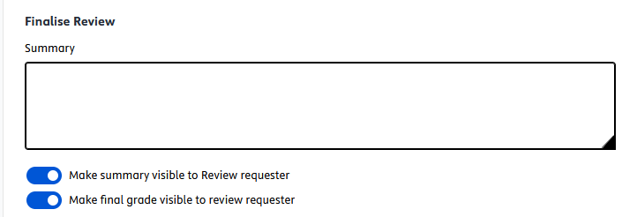
Summary text and final grades will default to visible, toggle these to off (greyed out) to indicate if the summary text and/or final grade should not be available to the author who proposed the outputs.

Select the Final status as ‘Done’ from the dropdown list, then select the final grade based on the feedback from the reviewers.
The final grade is usually the average of the review scores provided but can be independently selected if needed.
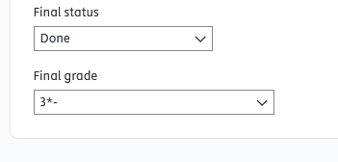

Click on Finalise Review.

Confirm the finalisation of the review.



The agreed provisional grade for the publication will then be visible on the review summary screen.

