University of ABERDEEN

Climate Friendly Procurement

GUIDANCE for laboratorY STAFF

This guidance aims to assist purchasers in laboratories to consider environmental sustainability during their day-to-day procurement activities i.e., up to a value of £50,000.

As part of the University’s statutory duty to contribute to national climate objectives, and in support of the sustainability commitments we made in Aberdeen 2040, all staff are encouraged to be mindful of the environmental impacts of purchases made as part of their roles at the University.

This is particularly important in our laboratory spaces. Laboratory related purchases are one of the biggest categories of procurement at the University, while procurement in general is responsible for up to 50% of our annual tracked emissions. These emissions are associated with the procurement of goods and services and are a result of the manufacture and supply of the things we buy.

To enable the transition to a more sustainable future for our laboratories, and in response to requirements from a selection of grant funders, the University has joined the Laboratory Efficiency Assessment Framework (LEAF). In order to achieve accreditation to any of the LEAF standards, lab users must be able to demonstrate that they are considering procurement impacts as part of the standard operating procedures of their lab. The criteria encourage lab staff to demonstrate that they have thought about the life cycle impact of the products they buy (e.g. energy performance), the principles of the circular economy (e.g. return schemes for certain categories of waste), and the waste hierarchy (e.g. working with suppliers to minimise packaging waste).

In making purchasing decisions we encourage all staff to make use of the ‘Expanded Waste Hierarchy’ (represented below) to help inform mindful procurement choices. The hierarchy spells out some of the procurement considerations that can be used to encourage positive choices.

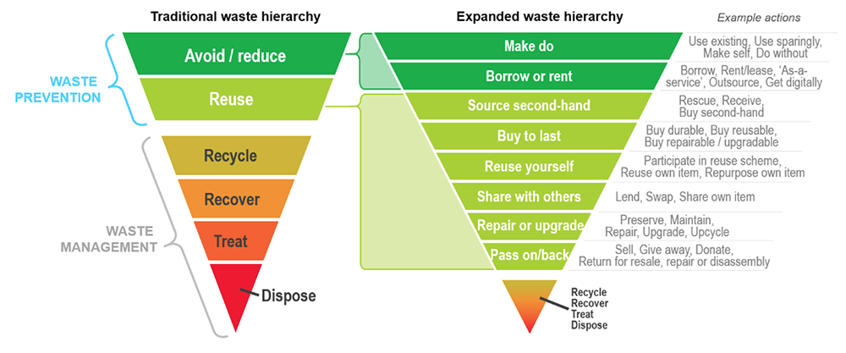
Sourced from: https://lgnsw.org.au/Public/Public/Policy/Waste/Waste-and-the-Circular-Economy.aspx

To assist in this, we have developed a ‘Climate Friendly Purchasing Checklist’ (attached) that aligns with the expanded waste hierarchy. It poses several questions that buyers can ask themselves as part of the pre-procurement process. It encourages buyers to give due consideration to sustainability issues.

In considering more sustainable options, you will of course need to consider whether there is a significant price differential which might prevent the purchase of a more sustainable version. In some instances, an additional business case may need to be made e.g. where lifetime energy usage will reduce the lifetime cost of operating a piece of equipment. Where possible, we would encourage that consideration be given to choosing sustainable versions wherever practicable and affordable.

Please note that if a purchase is over £50,000 and requires a tendering exercise, environmental sustainability and net zero focused questions are available for inclusion. Please contact the Sustainability or Procurement teams for more information. However, please note that even for these procurement exercises the same principles should be applied.

Context

As part of the Climate Change (Scotland) Act 2009, the Scottish Government has set out the following expectation for public bodies:

“How goods, works and services are procured should promote inclusive economic growth, create fair opportunities for all, and accelerate the just transition to a net zero economy. “

It requires us to be aware of the impact of our procurement activities and to ensure that environmental sustainability is considered as part of standard procurement practices.

Emissions resulting from procurement at the University are our largest single category of emissions (c.50%). These indirect emissions are associated with the procurement of goods and services and are a result of the manufacture and supply of the things we buy.

As part of the University’s commitment to achieving Net Zero before 2040, a procurement focused decarbonisation pathway has been developed as part of our Net Zero Strategy. It encourages all staff to be mindful of the sustainability impacts of purchasing as part of their role. The expanded waste hierarchy highlights example actions that can be taken to limit the climate impacts of procurement.

One major contributor to ‘procurement’ emissions is the purchasing associated with our research and teaching laboratories. By their nature, laboratories are energy and resource intensive and have a significant impact on our emissions profile through materials consumed, waste generated, and equipment used.

Useful Links and Contacts

Below are a number of useful links and contacts for further information:
- University of Aberdeen: Net Zero Strategy
- University of Aberdeen: Procurement Policy
- University of Aberdeen: Sustainability E-Learning Module for UoA staff
- Laboratory Efficiency Assessment Framework (UCL page)
- Contact the sustainability team via sustainability@abdn.ac.uk

Climate Friendly Purchasing Checklist
When undertaking any procurement activity, the following sustainability focussed questions should be considered:
Question | Justification (illustrative examples)
Is a new product needed? | e.g. Yes. Neither we nor another department have the item we require.
Might another department / team / lab have something that you can borrows e.g. a piece of equipment. | e.g. Yes. We can borrow the piece of equipment we need from another School.
Can you reuse, repurpose or repair something you already have, or can you buy a second-hand or pre-used version? | e.g. Yes. We have an older version of the equipment that requires an inexpensive repair.
Can this product be shared with other departments / teams / labs? | e.g. Yes. We would intend to make this item available to other labs / Schools to utilise.
Is the product you would normally use a sustainable version of that product? If not, are more sustainable versions available? e.g. uses FSC certified wood or recycled plastics. | e.g. Yes. A version using FSC certified wood is available but at a cost. Business case to be made based on lifespan.
Does the product you want have an extended lifespan e.g. can it be repaired or upgraded at its end-of-life? | e.g. Yes. The supplier offers a repair and upgrade option at the end of the product’s usable life.
Are there versions of the product that have lower energy demand and higher energy efficiency ratings? | e.g. Yes. More energy efficient versions are available but at a premium e.g. c. 20%. Strong lifecycle business case to be made.
Can your purchase be consolidated into a larger order (perhaps with another School) e.g. to minimise transportation impacts? | e.g. Yes. Although we have not previously done this, we will explore options to consolidate purchasing.
Does your supplier offer product exchanges for old equipment e.g. part-exchange deals or discounted replacement / takeback schemes? | e.g. Yes. The offers a takeback and discount scheme should we replace the product at the end of its useful life.
Does your supplier remove and recycle packaging? | e.g. Yes. The supplier removes packaging as part of the purchase price.
Does your supplier use recycled packaging? | e.g. Yes. All deliveries are made using recyclable or biodegradable materials.
Is a local supplier of the product available? | e.g. No. Unfortunately, there is only a single (overseas) supplier of this type of equipment.

