Estates & Facilities – Service Desk Guide V 1.01



Document Title | Estate & Facilities – Service Desk Guide
Version | 1.01
Owner | Estate & Facilities Systems
Status | Published
Version Date | 18/02/2026
Next Full Review Date | 6 Months from the published date or with the next Software version update
Document Location | E&F Systems SharePoint (Private)

Version | Date | Author | Comments | Approval
0.1 - Draft version | 19/03/25 | Mahilal Peiris | Draft doc created and initial load of information | n/a
0.12 - Draft version | 22/04/25 | Kaye Lee | Proposed Pre-Go Live version | n/a
1.0 - Final Version | 11/02/2026 | Mahilal Peiris | Published reviewed comments
1.01 | 19/02/2026 | Mahilal Peiris | Reviewed the document for accessibility + Figures

1. Introduction 3
1.1 Overview 4
1.2 Background 4
1.3 Terminology 4
1.4 Tables & Figures 4
2. Report an Incident and Submit a Service Requests 5
2.1 User Credentials and Login 6
2.2 Log a Service Request/Incident 7
2.3 View a job 10
2.4 Edit a job 11
2.5 Email Notifications 12
3. Support and Troubleshooting 13
3.1 URL not found 13
3.2 Login issues 14
3.3 Email Notifications Not Received 14
3.4 Location Not Found 14
3.6 Cancel Request 15
3.7 Customer Portal Unresponsive or Slow Loading Time 16
4. Feedback and Continuous Improvement 16
Appendices 17
Appendix A – Glossary 17
Appendix B – Related Processes 18
Flow Diagrams 19
Appendix C – Sub Category list 23
Appendix D – Response Time 26

1. Introduction

1.1 Overview
The Estates & Facilities Customer Portal is designed to streamline incident reporting and service requests, ensuring an efficient and consistent user experience. The portal forms part of the MICAD Facilities Management System and enables transparent tracking of requests from submission through to completion.

1.2 Background
The Customer Portal allows authorized users to log incidents, submit service requests, upload supporting documentation, and monitor progress in real time. All requests are stored within a centralized system to support efficient allocation, response management, and reporting.


It is accessible from various devices, including mobile phones and tablets via University Network. Users can track the status of their requests and incidents in real-time, providing transparency and keeping everyone informed about progress. All data related to incidents and service requests are stored in a centralised system, making it easier for the Estate and Facilities team to manage and respond to issues.

1.3 Terminology
Definitions of key terms used within this document can be found in Appendix A – Glossary.

1.4 Tables & Figures

Figure 2.11 | Table of Login types
Figure 2.12 | Login page
Figure 2.21 | Portal Welcome Page
Figure 2.22 | Details screen
Figure 2.23 | Priority details screen
Figure 2.24 | Confirmation Window
Figure 2.25 | Request Confirmation Message
Figure 2.31 | My Jobs search
Figure 2.32 | Job Number Search
Figure 2.41 | Job Number Search 2
Figure 2.42 | Add Notes
Figure 2.43 | Add Notes 2
Figure 2.44 | Add Notes 3
Figure 2.45 | Add Notes 4
Figure 3.21 | Reset Password for Non-SSO Users
Figure 3.41 | Location Not Found
Figure 3.61 | Email Confirmation
Figure 3.62 | Job Number Search 3
Figure 3.71 | BCP for Service Desk Portal
Figure 5.1 | General Staff Service Deks Flow Diagram
Figure 5.2 | Housing Dept Customer Flow Diagram
Figure 5.3 | Student Support Flow Diagram
Figure 5.4 | Emergency Requests Flow Diagram
Figure 5.5 | Staff Single Sign On Workflow Diagram

2. Report an Incident and Submit a Service Requests

2.1 User Credentials and Login
The Service Desk Portal is available to:
- University of Aberdeen Staff
- Honorary Staff Members
Access is provided via Microsoft Single Sign-On (SSO).
Qualified User Groups for identified as Customers within the Customer Portal are as follows.
User Group | Allowed (Yes/No) | Access Method, else comments
University of Aberdeen Staff + Honorary Groups | Yes | Microsoft Login (SSO)
University of Aberdeen Students | No | Students should reach out to the respective Student Support Teams/Resident Staff
NHS staff (@nhs.scot) | No | Reach out to the respective UOA TO/Teams
UOA Affiliate | No | Nil, contact UOA staff or email to efrequest@abdn.ac.uk
University of Aberdeen Residential Tenant's | No | Email to Housing Office via housing@abdn.ac.uk
University of Aberdeen External Contractors, ASV staff | Yes | Estate Provided and Approved Credentials
Figure 2.11
- The URL for the customer portal is: Estates & Facilities - Service Desk
- As the default method for the Staff user, choose to sign in using external services by clicking Sign in with Microsoft
- If you have been instructed to use a Username/Password combination only, enter your username/password and system identification key, ‘abdn’ as the system identification key.
- Important: Please ignore the “Google Sign in” button as this is not working for the current version and will be taken out in future versions.
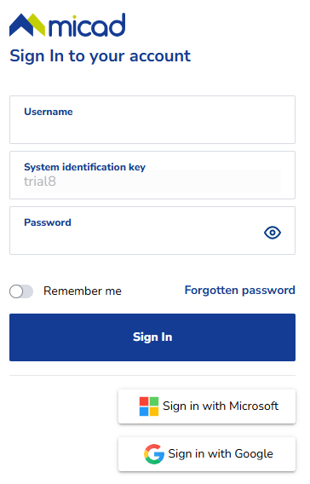 | à
 | à
Figure 2.12

2.2 Log a Service Request/Incident
- To log a new job, choose ‘Log a new job’ in the left sidebar
- Certain details in the forms, such as the name, are retrieved from the user profile
- Email address should match your login (or sxxxx@abdn.ac.uk)
- Typing the location keyword or asset number in the search bar will automatically look it up. Alternatively, specific details can be selected from the available options.
- Click the button Raise new request to proceed to next stage.
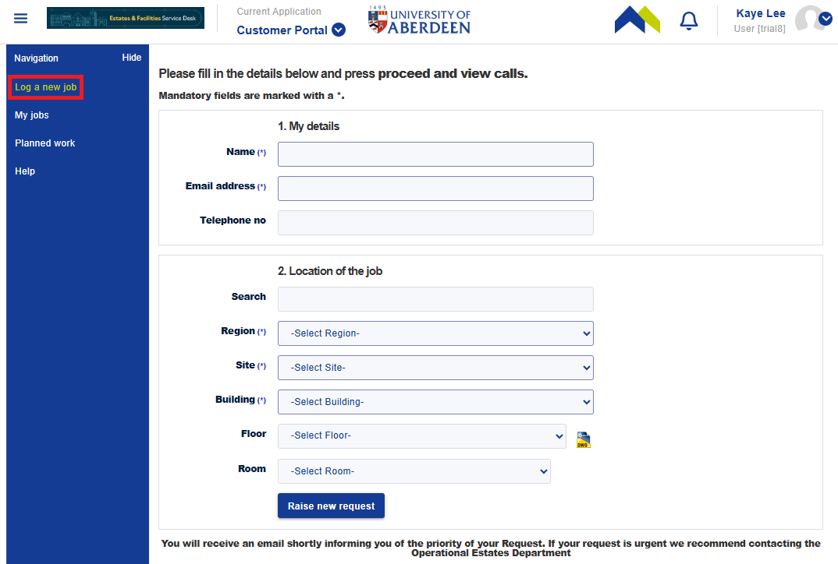Figure 2.21
- Enter a Short description of the services/incidents
- Select the most appropriate Sub Category
- Select the most appropriate or most relevant Work Type
- Input the Details of services/incidents
- Provide Access information if applicable
- Choose file to upload up to 10 files. Supported file formats include: xls, xlsx, pdf, docx, doc, jpg, jpeg, gif, png, tif, bmp, csv, ppt, pptx, and zip. Video and email file formats are not supported.

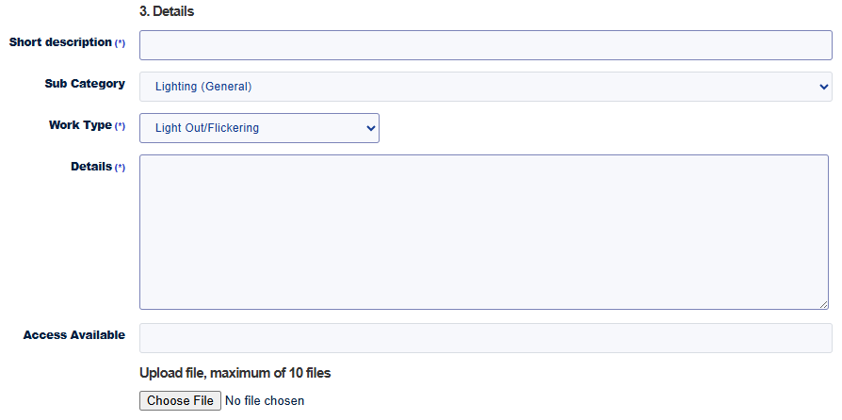Figure 2.22
- Priority explanation is filled by default.
- Default priority is automatically set based on the selected Work Type
- To add any details on the priority, use the Priority Description field.
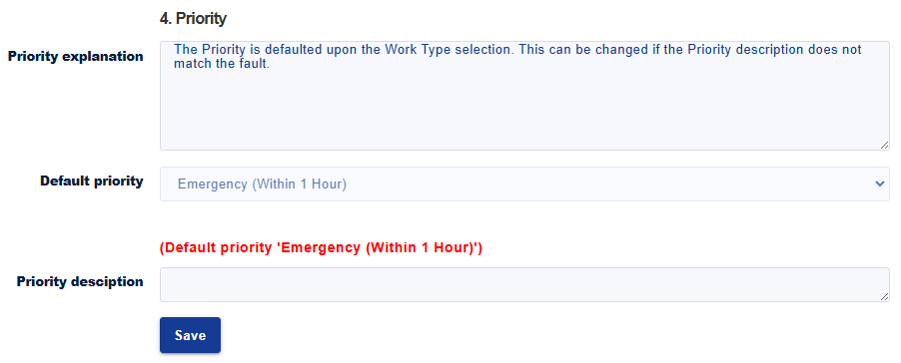Figure 2.23
- Click Save button, a summary of your case details will pop up.
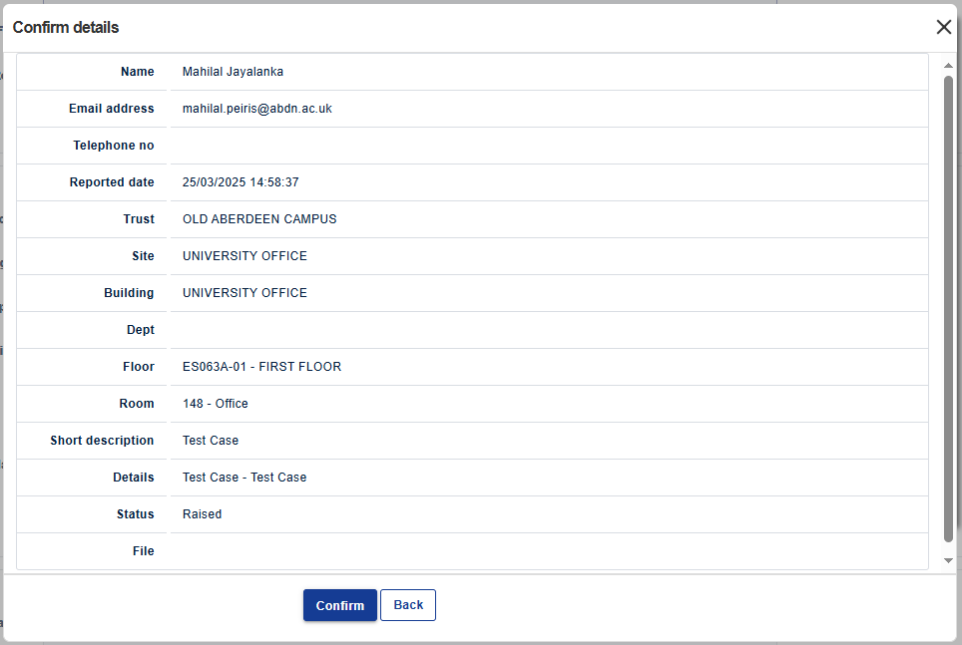Figure 2.24
- To change any information, click the Back button to return to the previous forms and make your changes
- If all details are correct, click the Confirm button
- The Portal will generate and display your Call ID details as shown below
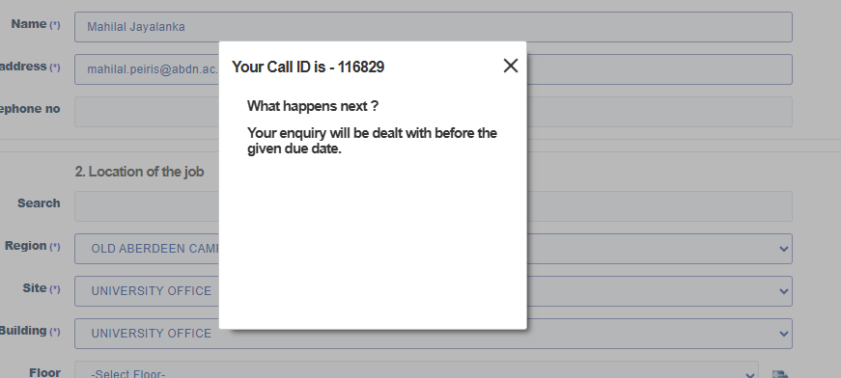Figure 2.25

2.3 View a job
- Choose ‘My jobs’ in the left sidebar, your job order will be displayed
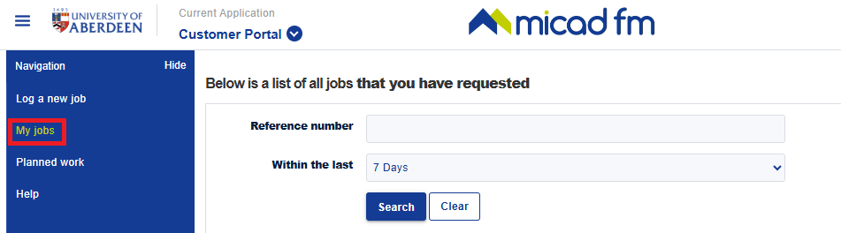
Figure 2.31
- To search for a specific job, enter the job number in the reference field and click 'Search
- Jobs can be searched within the last 7 days to 2 years
- Click next to column name to sort the jobs in ascending or descending order
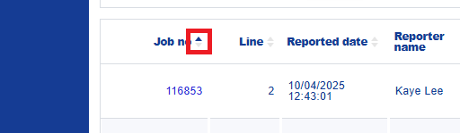
Figure 2.32

2.4 Edit a job
- Click the job no to edit, job details will be pop up.
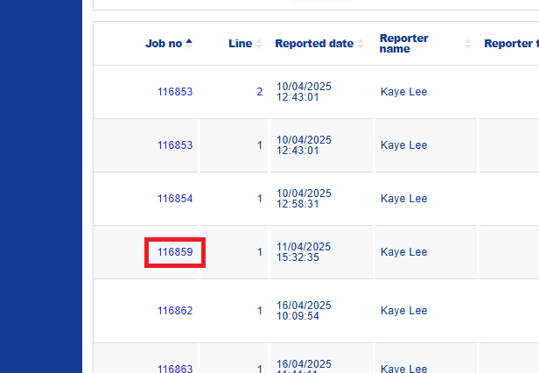 | à | 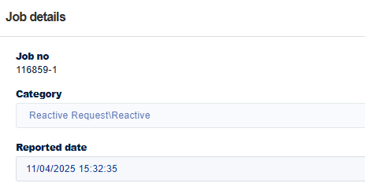
Figure 2.41
- Scroll down to the most bottom
- Type your message, then click Update notes
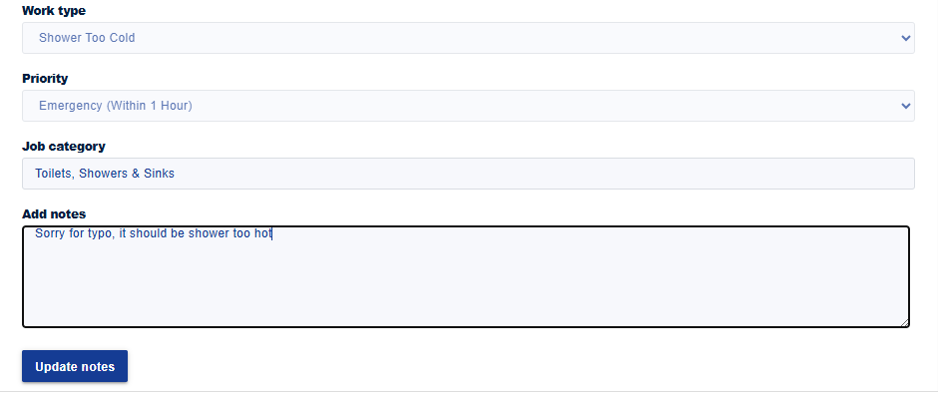Figure 2.42
- The Portal will notify that the notes have been updated
- The added notes will display it accordingly in ‘Notes’
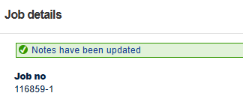 | à | 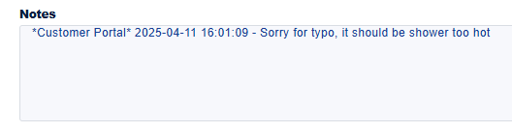
Figure 2.43
- When the helpdesk adds notes (replies) to the job, they will be displayed in the customer portal and treated as communication between the customer and the maintenance team.
- To stay informed, customers can view helpdesk replies by clicking into the job where all communication is recorded.
Helpdesk view | 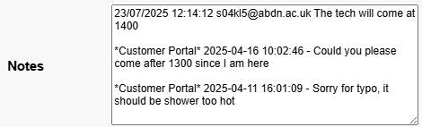  Figure 2.44
Customer Portal view | 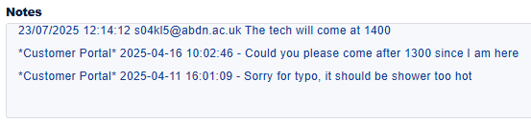  Figure 2.45

2.5 Email Notifications
- Automated notifications are issued for case creation, assignment, priority updates, resolution, cancellation, and password resets.
- Notifications are sent from no-reply@micadpro.net or no-reply@micadnotifications.co.uk. These mailboxes are not monitored.

3. Support and Troubleshooting
Contact the Estates & Facilities Systems Team for (Summary):
- Login issues
- Missing email notifications
- Location not found
- Portal performance issues
- Subcategory or work type queries
- Email: estates.systems@abdn.ac.uk
For urgent operational matters during working hours, contact efrequest@abdn.ac.uk.

3.1 URL not found
- The URL for the customer portal is: https://abdn-cp.micadpro.net/
- The latest URL will always be updated in the most recent version of this document.
- To stay updated on the Customer Portal, visit – https://abdn.ac.uk/staffnet/estates-service-desk

3.2 Login issues
- If signing with Microsoft does not work, please write to <estates.systems@abdn.ac.uk>

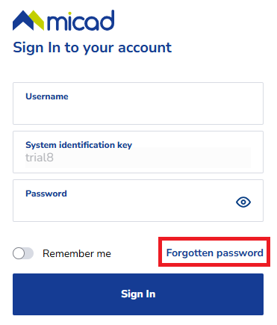 | à | 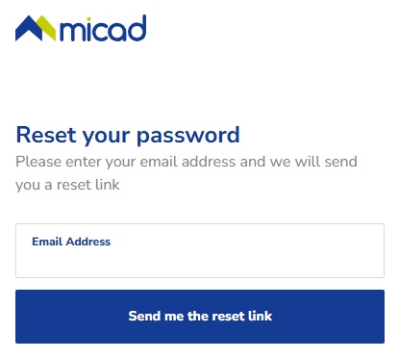
Figure 3.21

3.3 Email Notifications Not Received
- An email may not have been received due to it being directed to the Junk Email
- Before moving emails from Spam folder make sure the sender email is <no-reply@micadpro.net> or <no-reply@micadnotifications.co.uk>
- If the problem still exists, or input the alternate email, contact at <estates.systems@abdn.ac.uk>

3.4 Location Not Found
- If the location cannot be found in the system, try searching from the region to the site to the building, it might have alternative name.
- If it still does not appear, please contact at <estates.systems@abdn.ac.uk>.
- To address immediate issues, further describe the location in the 'Details' field.
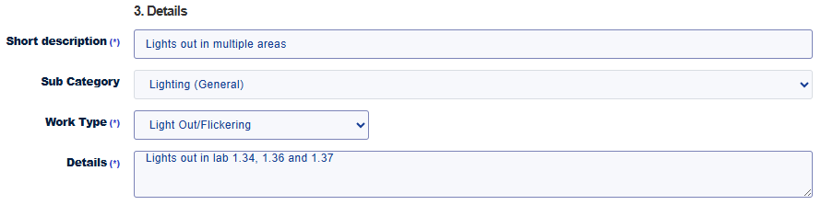 Figure 3.41
3.5 Sub category or Work Type Issues
- Describing the incident or request can be challenging. To better understand the situation, photos may be uploaded. However, videos are not allowed at this stage.
- If the available sub categories or work types do not match your query, contact <estates.systems@abdn.ac.uk>, the system team will be happy to assist further

3.6 Cancel Request
- To cancel a job request, write to <estates.systems@abdn.ac.uk> and quote the ‘Call ID’, which is the ‘Job no’
- Refer to the email notification and forward it to request job cancellation.
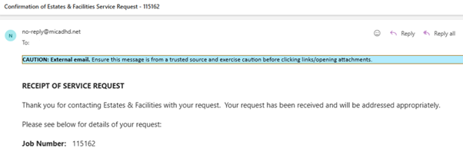Figure 3.61
- If the email is lost or deleted, find the job number in the Customer Portal by selecting My Jobs from the left sidebar. All jobs will be displayed on the right side, with the Job Number usually listed in the first column

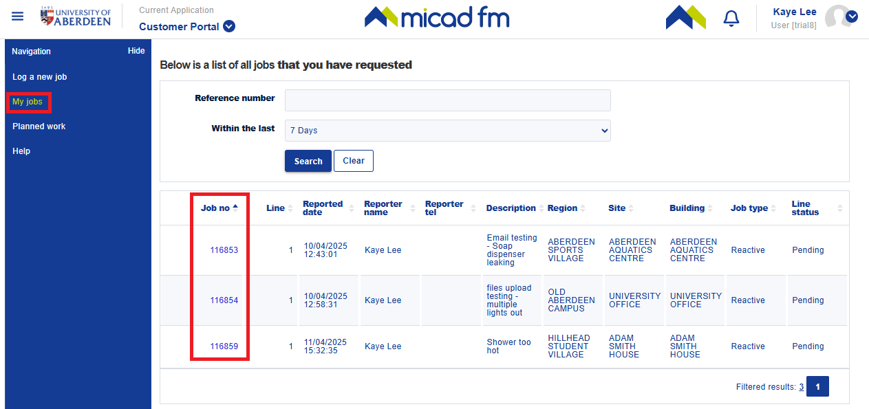Figure 3.62

3.7 Customer Portal Unresponsive or Slow Loading Time
- Ensure the device is connected to a stable internet connection. If issues persist, contact the IT helpdesk for assistance.
- Sometimes, the page may take a few moments to load. Allow some time before attempting to reload the page.
- If the job needs urgent resolution while there’s a technical issue with the portal, contact the Estates and Facilities helpdesk during operating hours via <efrequest@abdn.ac.uk>
- For more details, visit <https://www.abdn.ac.uk/staffnet/forms/js-cookiecheck/>
(The picture below is just for information, copied from the E&F Service Desk web page.)
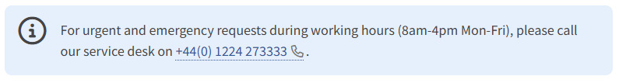Figure 3.71

4. Feedback and Continuous Improvement
Feedback is welcomed to support continuous improvement of the Service Desk and customer experience.
Please send suggestions to estates.systems@abdn.ac.uk.

Appendices

Appendix A – Glossary
Term | Description
Call ID | A reference number assigned to a logged case for customer, used interchangeably with ‘Job no’.
Customer | Anyone who contacts Estates & Facilities to resolve an issue or utilise any of the services provided by Estates & Facilities is considered a customer. This includes individuals associated with the University, whether they are staff, students, or formal/potential contractors.
Job no | A job number assigned to a specific job or task within a service request, used interchangeably with ‘Call ID’.
Service request | A formal request made via the Customer Portal and/or E&F helpdesk for maintenance, repairs, or other support services. It typically imitates a workflow for resolving an issue or fulfilling a need within the estates and facilities of UoA. (Service Request represents what has been reported to Estates & Facilities by a customer who wishes to report a fault(s) or use an Estates & Facilities Service) <-- from other sources
SSO | Single Sign-On, a user authentication process that allows a user to access multiple applications with one set of login credentials.
Sub category | A classification within the facility management system used to define specific areas or types of jobs. Each sub category is associated with an allocation type, which specifies the team responsible for performing the jobs within that category.
Upload file | The process of transferring a file from a local device to the facility management system. Accepted file formats include xls, xlsx, pdf, docx, doc, jpg, jpeg, gif, png, tif, bmp, csv, ppt, pptx, zip.
User profile | It refers to the stored data related to an individual user in MICAD.
Work type | A classification within the facility management system used to define job response times. Each work type is associated with a default priority. (See Appendix D)

Appendix B – Related Processes

Flow Diagrams
Notice: Images attached above are for illustrative purposes only. or more informative viewing, click the attached diagram file. (E&F - Service Desk V2

General User Diagram
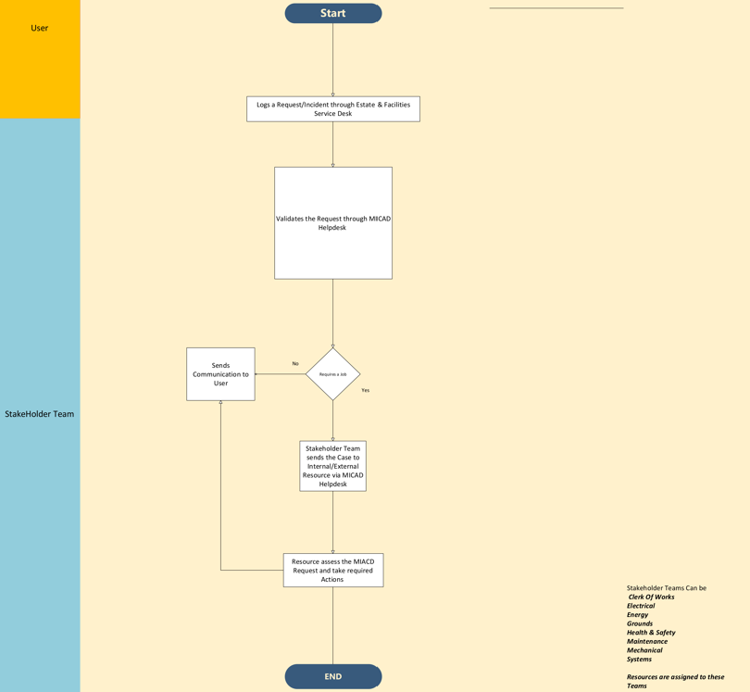

Figure 5.1

Housing Department Customers Diagram
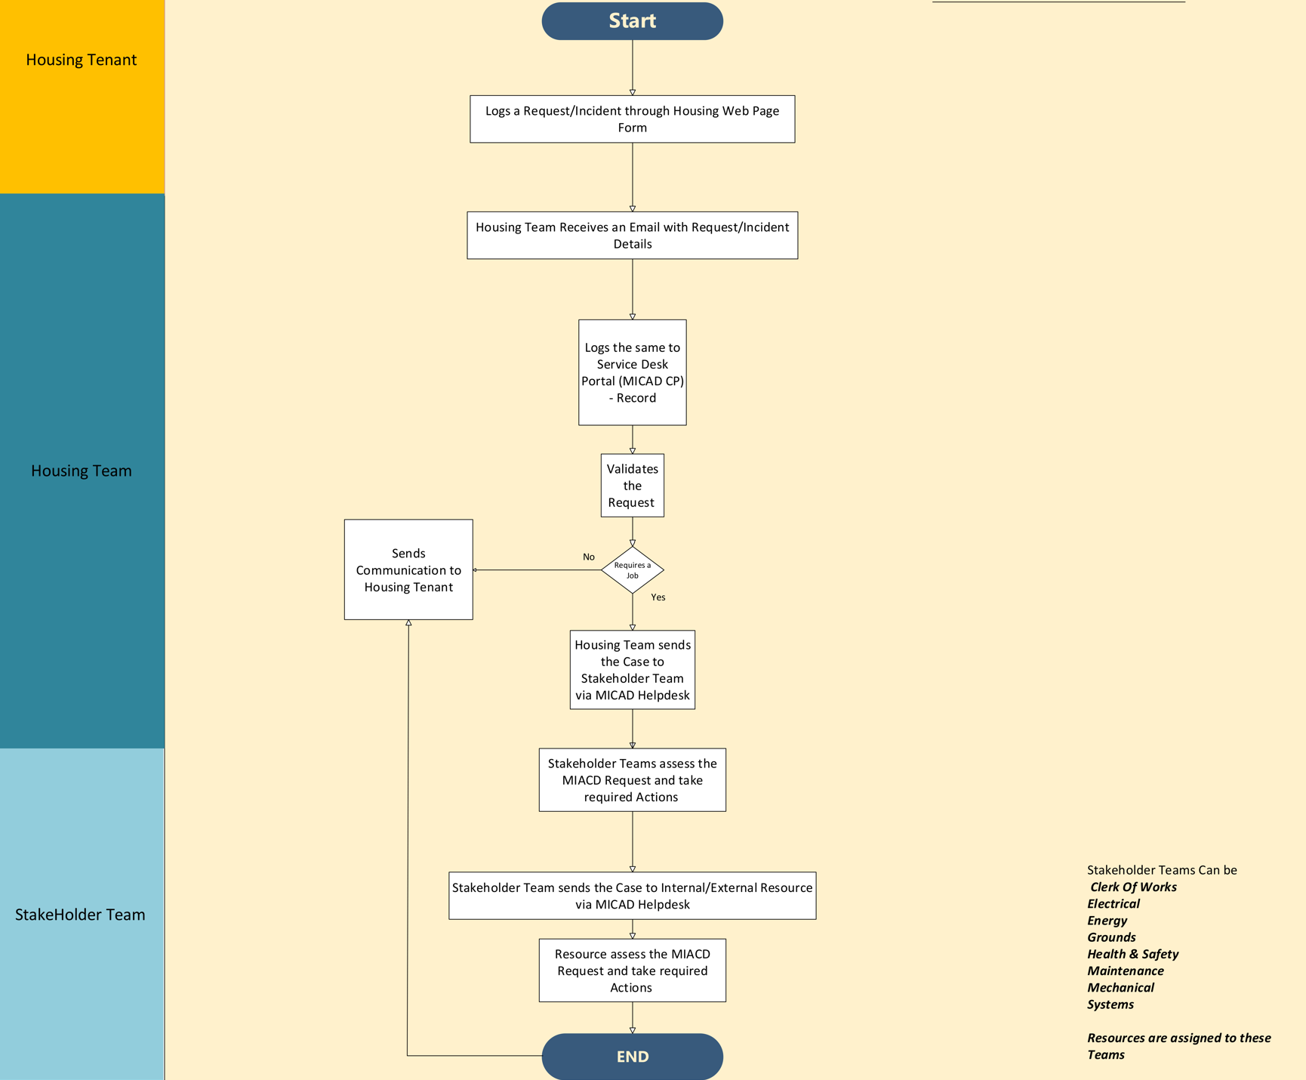

Figure 5.2

Student Flow
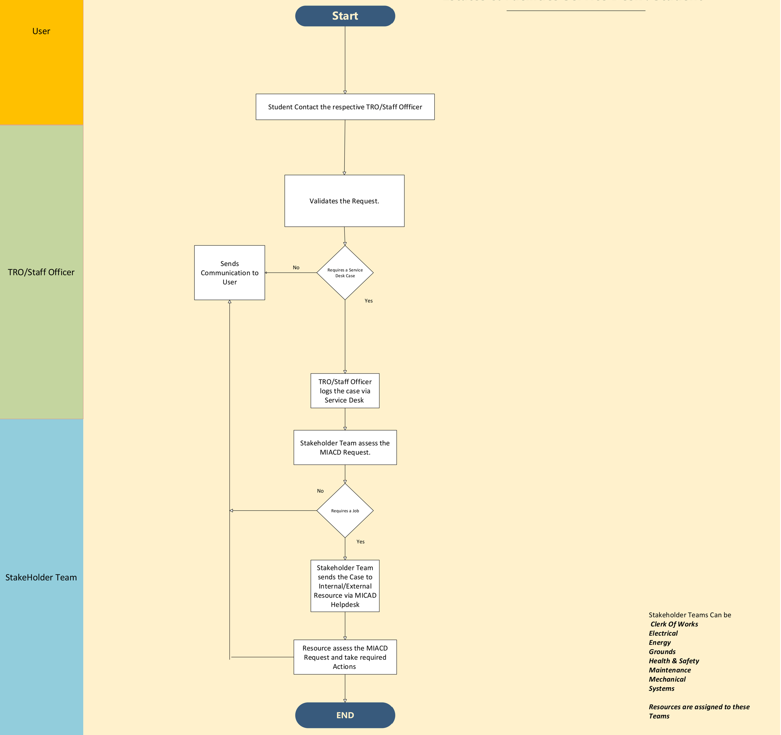

Figure 5.3

Emergency Call Flow
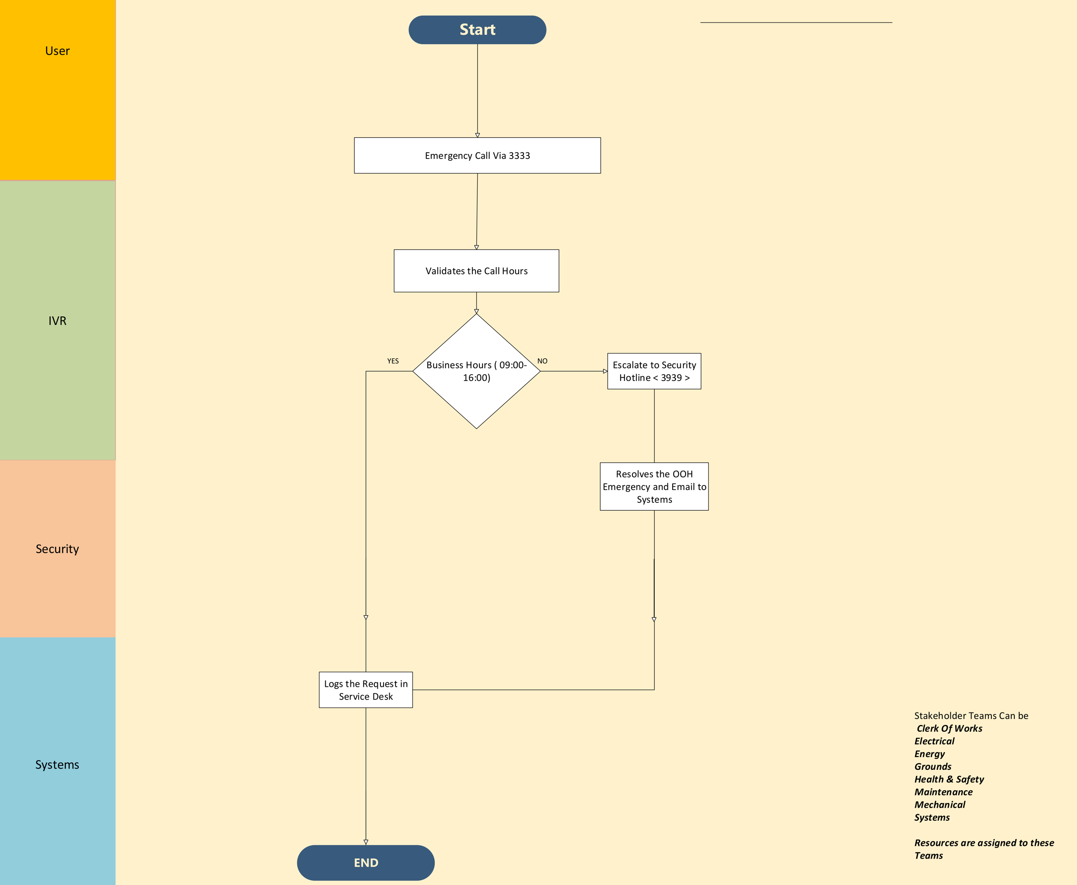

Figure 5.4

Single Sign On (Microsoft) – High Level Flow
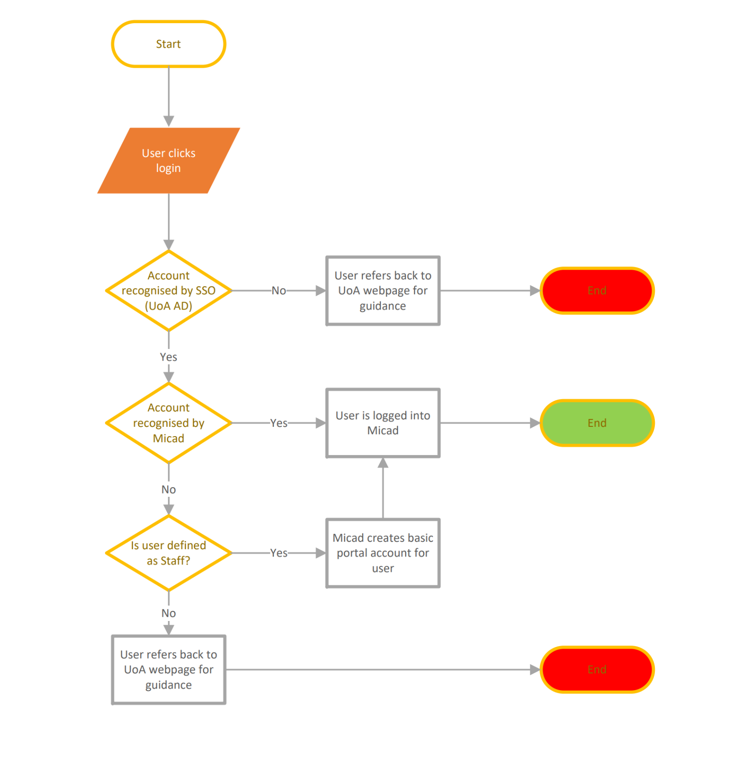

Figure 5.5

Appendix C – Sub Category list

Sub Category | Default Allocation
Access Control | Systems
Alarm – Fire Alarms | Electrical
Alarm - Freezer Alarms | Electrical
Alarm - Intruder Alarms | Electrical
Alarm - Panic Alarms | Electrical
Alarm - Refuge Alarms | Electrical
Alarm - Toilet Alarms | Electrical
Alarm - Water Leak Alarms | Mechanical
Appliance (Laundry) | Electrical
Appliance (Kitchen) | Electrical
Asbestos | Health & Safety
Barriers, Bollards & Gates (Powered/Motorised) | Electrical
Barriers, Bollards, Gates & Fences (Non-Powered) | Clerk of Works
BMS | Mechanical
Building fabric | Clerk of Works
Building Maintenance Unit (BMU, Gantries, Cradles & Hoists) | Clerk of Works
Cameras/CCTV | Systems
Ceiling | Clerk of Works
Chillers | Mechanical
Cleaning - Housing | Housing
Compressed Air | Mechanical
Door Bells & Intercoms | Electrical
Doors - Automatic Doors | Electrical
Doors - Hold Open Device | Electrical
Doors - Manually Operated | Clerk of Works
Drainage | Clerk of Works
Electrical/Power Supply | Electrical
Evacuation Chair | Electrical
Extractor Fans (Wall/Window) | Electrical
Fire Fighting Equipment | Clerk of Works
Fixtures | Clerk of Works
Flooring | Clerk of Works
Fridges, Freezers & Cold Stores | Mechanical
Fuel Tank | Mechanical
Fume Cupboards, LEVs & Extractors | Mechanical
Furniture | Clerk of Works
Gas (Lab Gas) | Mechanical
Gas (Natural Gas) | Mechanical
Generators | Electrical
Grounds Equipment | Grounds
Grounds Maintenance | Grounds
Heating | Mechanical
Housekeeping - Electrical | Electrical
Housekeeping - Mechanical | Mechanical
Housing - Residential | Housing
Leak | Clerk of Works
Lifts | Electrical
Lighting (Emergency Lights) | Electrical
Lighting (General) | Electrical
Lightning Protection | Electrical
Locks & Keys | Clerk of Works
Monitoring systems | Systems
Movable Partitions | Clerk of Works
Network (Data & Computers) | Electrical
Outdoor benches and seating | Clerk of Works
Outdoor Shelters | Clerk of Works
PA System | Electrical
Painting & Decoration | Clerk of Works
Pest Control | Clerk of Works
Pipework (Water) | Clerk of Works
Plant room | Mechanical
Plumbing (General) | Clerk of Works
Plumbing (Hot Water) | Clerk of Works
Portable Appliance Testing (PAT) | Electrical
RAAC | Clerk of Works
Radio Communication | Electrical
Railings, handrails & banisters | Clerk of Works
Roads, Paths & Walkways | Clerk of Works
Roller Shutter | Electrical
Roof edge protection | Clerk of Works
Roofs | Clerk of Works
Sewage Pumps (Electrical) | Electrical
Sewage Pumps (Mechanical) | Mechanical
Signage | Clerk of Works
Solar PV Panels | Electrical
Sport Fields | Grounds
Sprinkler System | Mechanical
Stairwells | Clerk of Works
Steam | Mechanical
Temperature | Mechanical
Toilets, Showers & Sinks | Clerk of Works
TV | Housing
UPS | Electrical
Utilities - Electrical | Electrical
Utilities - Housing | Housing
Utilities - Mechanical | Mechanical
Vandalism & Graffiti | Clerk of Works
Vehicle Maintenance | Grounds
Ventilation | Mechanical
Walls | Clerk of Works
Waste Bins External | Grounds
Waste Skip | Grounds
Water Cooler/Fountain | Electrical
Water Risk Assessment | Mechanical
Water Tank | Mechanical
Windows & Blinds | Clerk of Works

Appendix D – Response Time

Each work type is automatically assigned a response time by the system.
Our 5 standard response times are:
- Emergency – Within 1 hour
- Urgent – Within 2 Days
- Non-Urgent – Within 7 Days
- Routine or other – Within 10 days
- Ongoing – Timescale Specified (usually within 14 weeks)
In cases where the default priority needs to be adjusted, simple descriptions can be added in the Priority Description field.
Response time targets for the job typically refer to internal processes but do not account for the time spent dealing with external contractors.

