Equality, Diversity and Inclusion Digest (August 2024)
Welcome to the Equality, Diversity and Inclusion (EDI) Digest where you will find a rundown of EDI activities over the last quarter including discussions at our latest University EDI Committee (in July 2024).
The information presented in this digest is organised with reference to the University of Aberdeen's Equality Outcomes and Aberdeen 2040's Inclusive commitments.
Please note: This EDI digest is in a new format. We have endeavoured to ensure accessibility, if you experience any accessibility challenges, please do let us know via edi@abdn.ac.uk. The digest is also available in Word on our EDI committee web page.

Equality Diversity and Inclusion Governance
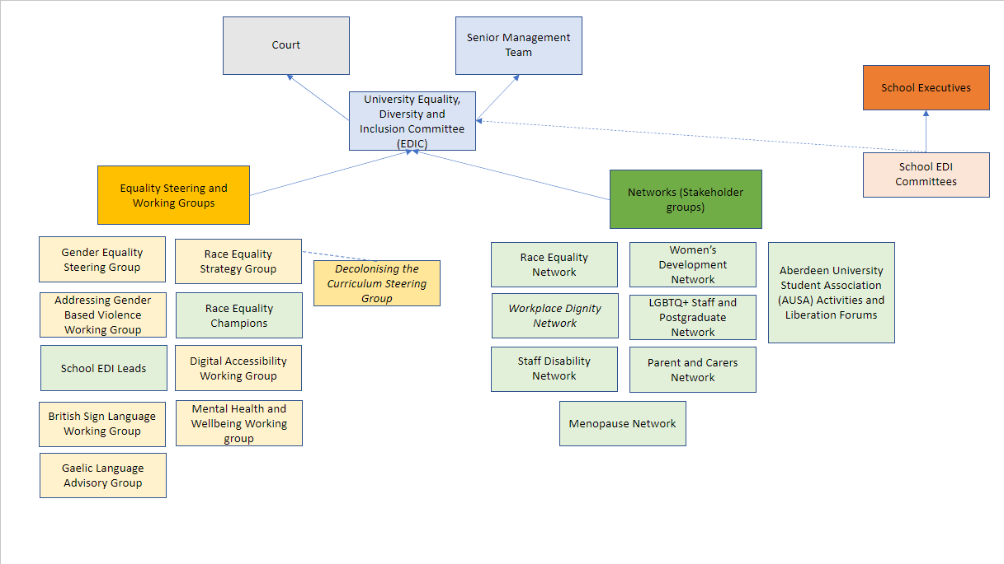
1 - Visual of the University's EDI Governance structure
The University's EDI Committee (EDIC) normally meets four times a year and is responsible for the strategic direction of Equality, Diversity and Inclusion activities as set out within the Inclusive strand of Aberdeen 2040 and the University's Equality Outcomes for the period up to 2025.
EDIC reports to Senior Management Team and University Court. The University's Equality Steering Groups and Working Groups, staff networks and student liberation forums report to EDIC. Equality Groups include the Gender Equality Steering Group, the Race Equality Strategy Group, Addressing Gender Based Violence Working Group, Digital Accessibility Working Group, British Sign Language Working Group, Mental Health and Wellbeing working group and Gaelic Language Advisory Group. School EDI committees report to School Executives and feed into the University EDIC.

Equality Outcome Spotlight
At EDIC all our Equality Outcomes are considered, on a rotational basis. At the recent EDIC (held in July 2024), focus was on the following Equality Outcomes:
Outcome 4: Create an antiracist university by developing and implementing the antiracism strategy action plan.
Outcome 6: Create a culture where gender-based violence is eradicated within the University community and staff or students who do experience this can seek effective support
Outcome 7: Create and maintain an inclusive culture which everyone (staff and students) feels a part of, which is safe, respectful, and supportive.

Create an antiracist university by developing and implementing the antiracism strategy action plan (Outcome 4)
The University was awarded its first Race Equality Charter (REC) bronze award in May 2024 in recognition of its commitment to advancing race equality. The University is the third Scottish Institution to hold a REC award.
The Charter provides a rigorous and robust framework through which institutions work to critically reflect and act on institutional and cultural barriers standing in the way of the progression and success of racially minoritised staff and students. The work was led by the Race Equality Strategy Group (RESG) and resulted in the development of an Antiracism Action Plan. The next step will be implementation of the action plan with responsibility for implementation across Schools and Directorates.
Presentations have been delivered on anti-racism, the strategy and action plan to several Schools to date. Race Equality Champions, who have been engaged throughout the process, will co-deliver further planned presentations.
Read more about terminology and find other resources on Race Equality Resources web page.

Legacies of Slavery Report

2 - George Keith, 10th Earl Marischal (National Portrait Gallery)
The recently published Legacies of Slavery Report, produced by Dr Richard Anderson (Lecturer in the History of Slavery and member of RESG), highlights the significant financial benefits brought to the University from proceeds of the slave trade.
There is still time to contribute your reflections on the report by filling this form.
Decolonising the curriculum
As part of our Aberdeen 2040 Strategy and our ‘Inclusive’ Strategic Theme, Schools are taking forward a Decolonising the Curriculum initiative. The University Decolonising the Curriculum Steering Group recently released a set of resources and guidance for staff to support the work of Schools on this area.
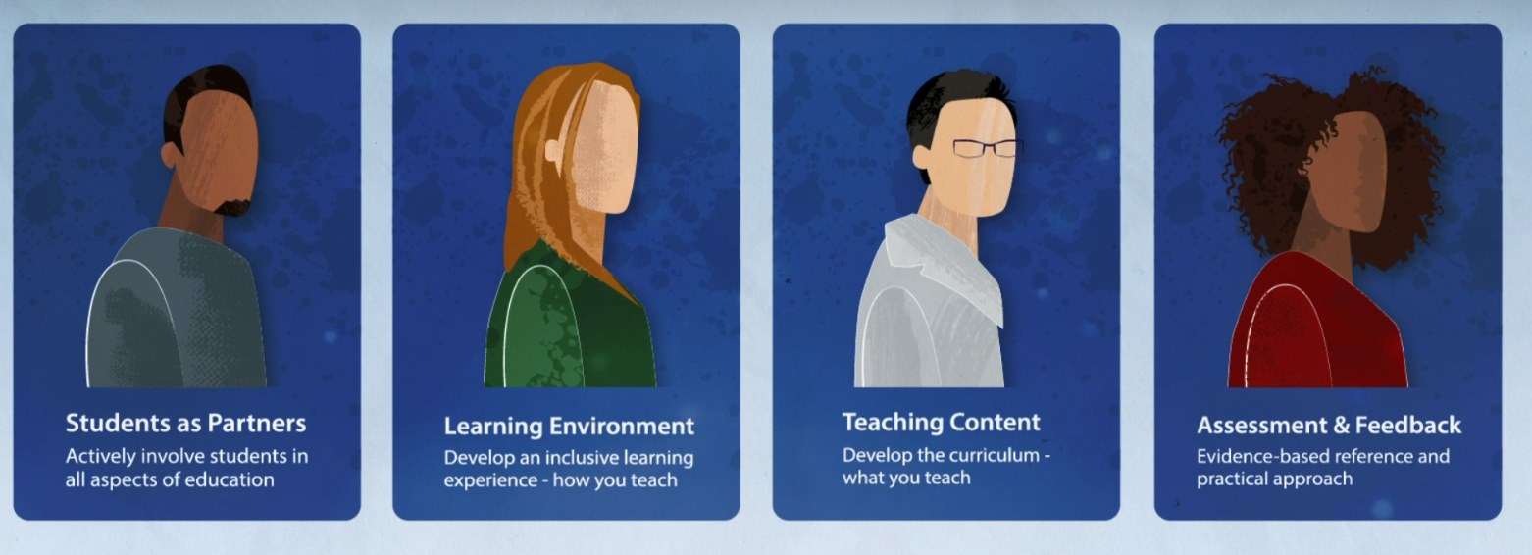
3 - Decolonising the Curriculum toolkit
How to deal with the disclosure of a racist incident
The University recently developed guidance for School EDI Leads, Race Equality Champions and all staff on How to deal with a disclosure of a race incident. If you have any feedback, please email the central EDI team on edi@abdn.ac.uk

Create a culture where gender-based violence is eradicated within the University community and staff or students who do experience this can seek effective support (Outcome 6)
An updated Addressing Gender-Based Violence and Sexual Harassment Policy was presented at the last EDI Committee in July for approval along with the associated Equality Impact Assessment. The Policy has been streamlined and updated in line with the University's work on the Emily Test Charter and the evolving language around gender-based violence.
Information on sources of support is available on the Addressing Gender-Based Violence web page. Further information is available from Nick Edwards, Deputy Director of People, Student Advice & Support
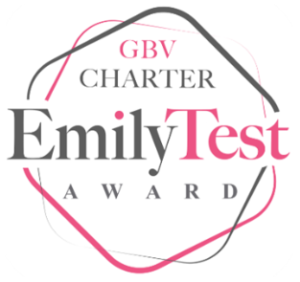
4 - Emily Test Logo

Create and maintain an inclusive culture which everyone (staff and students) feels a part of, which is safe, respectful, and supportive (Outcome 7)
At the last EDI Committee, an update was provided on the Dignity at Work and Study (DAWS) Toolkit. The Toolkit has recently been approved. Planning for implementation is now underway, including uploading of the Toolkit online and planning for University-wide communications with involvement from EDI related champion roles. Watch out for further updates!!

5 - Confidential online reporting tool banner image
The University does not tolerate any form of discrimination or harassment, bullying, violence and sexual misconduct. Read more on how to access support or to make a Report to the University through our Online Reporting Tool.

Consultation for University of Aberdeen Gaelic Language Plan 2025 – 2030 / Co-chomhairleachadh air Plana Gàidhlig Oilthigh Obar Dheathain 2025 – 2030
The University of Aberdeen's current Gaelic Language Plan comes to an end in 2024. The recent consultation for the University's new Gaelic Language Plan for 2025-2030 received a good response. Final amendments to the Plan are now underway.
If you have any questions, please contact the University’s Gaelic Development Officer: carola.maccallum@abdn.ac.uk.

Staff Equality Networks / Student Liberation Forums
We have a range of Staff and PGR Student Equality Networks at the University, including the LGBTQ+ Staff and Postgraduate Network, Women's Development Network, Parents & Carers Network, Menopause Network, Race Equality Network and Disability Network. There are also student Liberation Forums.
The Experience and Engagement team have a full schedule coming up for Orientation and Welcome Week:
16th September - Welcome week
10th September - World Suicide Prevention Day
7th to 11th Oct- BeWell and Inclusion Week
Full details of staff events can be found on the Staff Events & Activities web page.
Madge Jackson, Senior Lecturer in the School of Psychology, and Lucy Drysdale, Information Assistant in Library Services, are excited to have launched the University of Aberdeen’s new Neurodiversity Network!
The network aims to build a strong community and dispel myths and misconceptions around neurodiversity, to hold campus-wide events, and to collate and collaborate with others on resources, advice and support. The Network welcomes everyone: neurodivergent and neurotypical, staff and students.
If you have any requests for specific events or event topics please feel free to get in touch with the Neurodiversity Network co-chairs, Lucy Drysdale (lucy.drysadale@abdn.ac.uk) or Madge Jackson (m.jackson@abdn.ac.uk).
The Women's Development, Menopause, and Neurodiversity Networks are pleased to announce an upcoming joint event:
Navigating Neurodivergence: Experiences of Neurodivergent Women in academia 26th September, 10 am – 11.30, Microsoft Teams
We are pleased to welcome Dr Rachel Moseley (Principal Academic, Bournemouth University), Ms Karen Mitchell (Academic Skills Adviser, University of Aberdeen) and Dr Helen Knight (Senior Lecturer, University of Aberdeen), who will share their own experiences, explore what neurodivergence is, offer insights into supporting neurodivergent students and share research behind the impact of hormones on neurodiversity.
For more information and booking please email womensnetwork@abdn.ac.uk

6 - Share your ideas for Black History Month (BHM) 2024
Staff are invited to join the Black History Month 2024 Planning Group. As the group commences preparations for Black History Month 2024, it is looking for committed individuals to assist in discussing and planning events. If you are interested please email racenetwork@abdn.ac.uk
To make Black History Month at the University a memorable experience that celebrates, educates, and supports the contributions and experiences of our Black community, the Planning Group are seeking ideas and suggestions for both school-level and University-wide initiatives.

Resources!
Thank you to Dr Aideen M. O'Leary and Barbara Barreiro, Race Equality Champions, School of Language, Literature, Music and Visual Culture for sharing their Equality Playlist! We have shared a few resources from their playlist.
You can view Museums and Special Collections web page for Black History Month which includes stories of Aberdeen's earliest Black Students and an online exhibition ‘Legacies of Slavery’ on Scotland, Africa and Slavery in the Caribbean
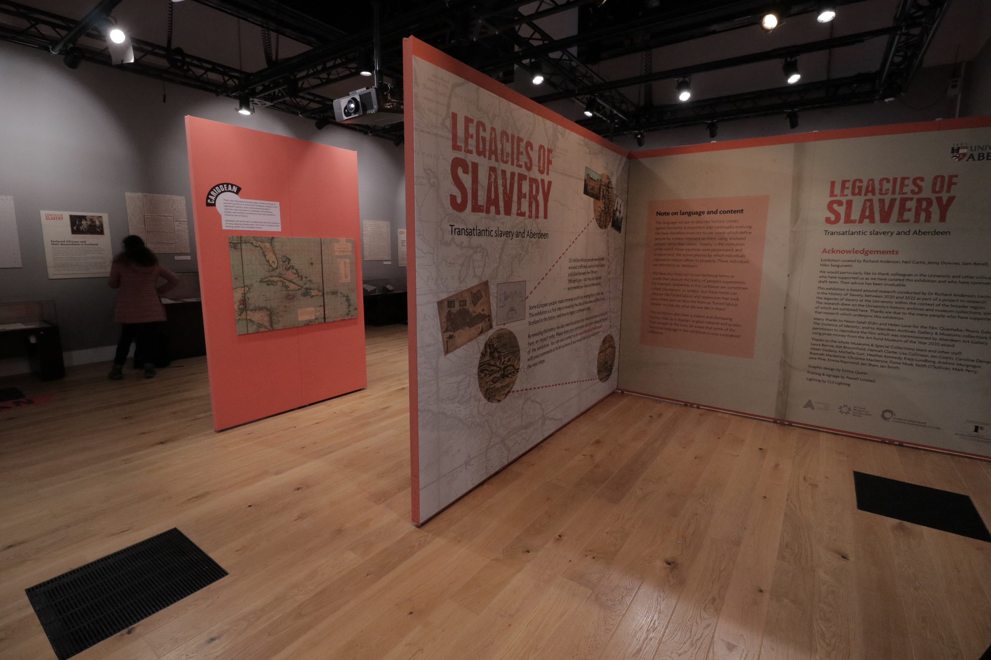 7 - Legacies of Slavery Exhibition
 8 - 525 Years in the Pursuit of Truth
The University of Aberdeen 525 Years in the Pursuit of Truth: A New History of The University of Aberdeen podcast.
The Black British Academics blog provides further consideration on the importance of language and terminology.
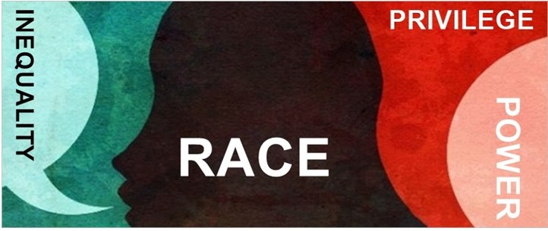
9 - Racial categorisation and terminology
Alan Bissett reads from his book ‘Lads - A Guide to Respect and Consent’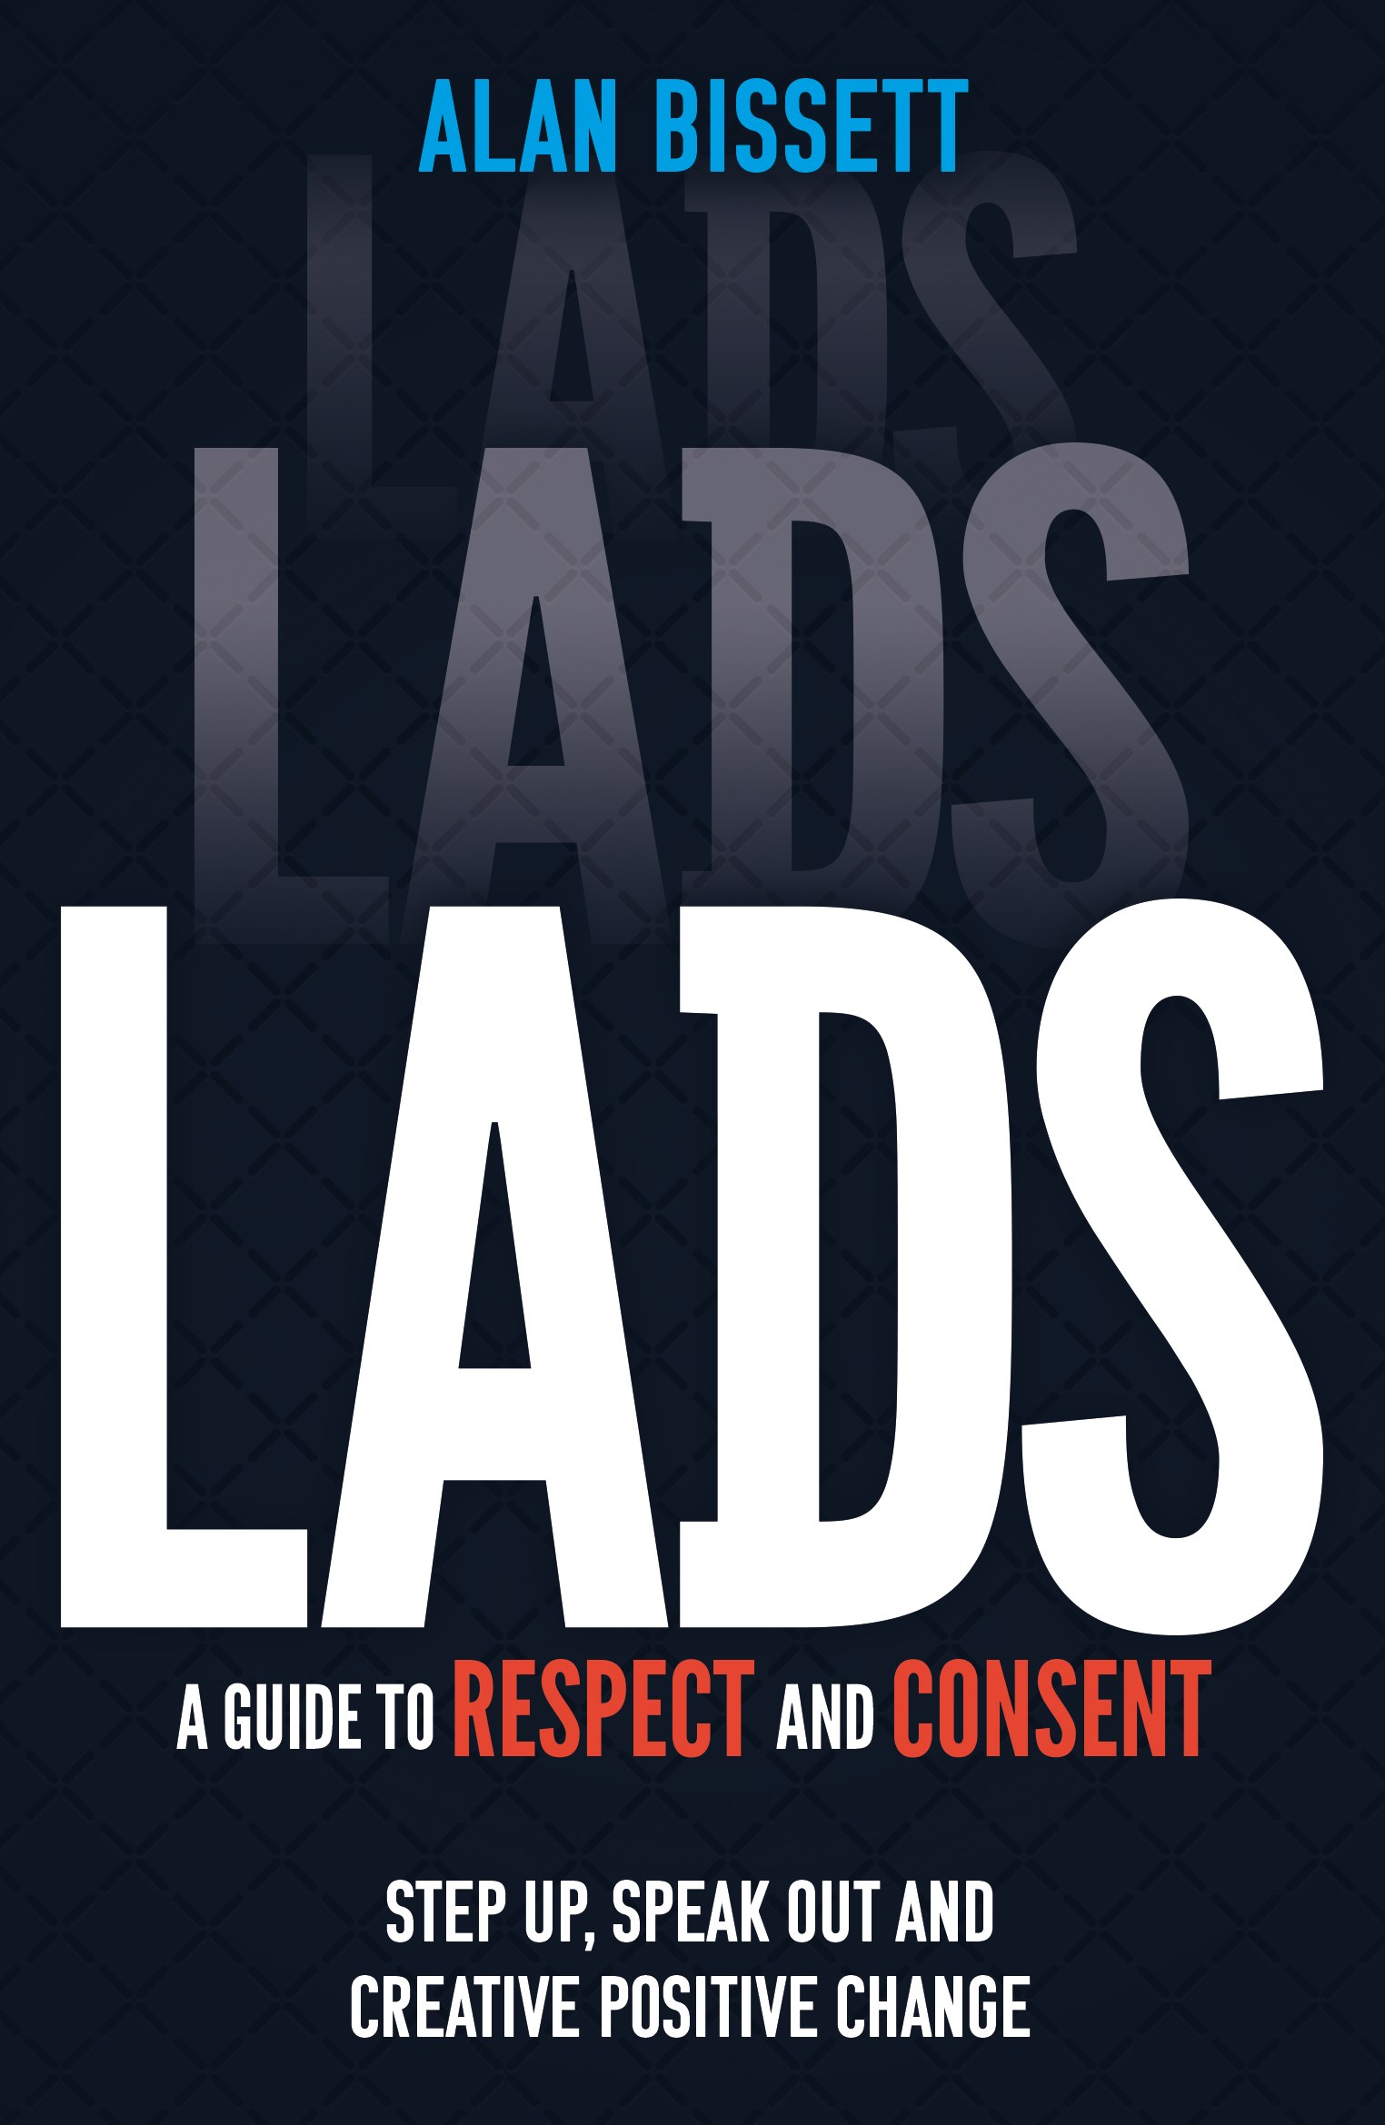10 - Lads - A Guide to Respect and Consent
Contact us!
If you have any feedback or suggestions for the EDI digest, please let us know at edi@abdn.ac.uk

