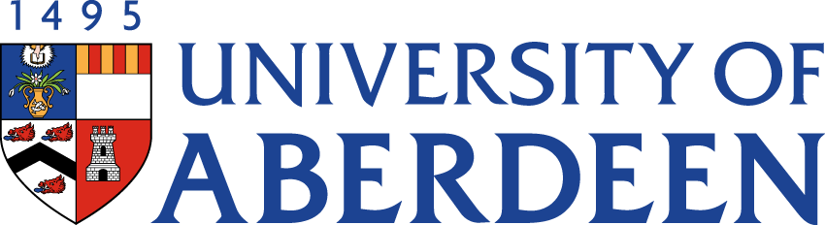

There will be a meeting of the SUSTAINABLE DEVELOPMENT COMMITTEE on WEDNESDAY 24 AUGUST 2022 at 10.35pm – 12.25pm via Microsoft Teams.
Heather Crabb
Senior Vice-Principal’s Office
Tel: 01224 272404
Email: h.crabb@abdn.ac.uk
BUSINESS
DECLARATION OF INTEREST:
Any member or individual in attendance (including officers) who has a clear interest in a matter on the agenda must declare that interest at the meeting. Items for information will not normally be considered.

FOR DISCUSSION

- MINUTES
Minutes of the Sustainable Development Committee meeting held on 25 May 2022
(enclosed)
- MATTERS ARISING
2.1 Table of Actions SDC22:46
2.2 Update on Sustainability Structures Oral Report

- ANNUAL REVIEW OF TERMS OF REFERENCE SDC22:47

- SUSTAINABILITY RISK REGISTER SDC22:48

- SUSTAINABLE DEVELOPMENT GOALS UPDATE
  - THE Impact Rankings Strategy Oral Report

- CLIMATE CHANGE
6.1 Public Bodies Climate Change Duty Reporting 2022/23 SDC22:49
6.2 Climate Assembly Update Oral Report

- NET ZERO
7.1 Queen’s Jubilee Sustainability Challenge SDC22:50
To Note: Appendix (Draft EAUC Carbon Emissions Standardised Framework) is not for wider circulation
7.2 Net Zero Update Oral Report

- ABERDEEN 2040 ACTION PLAN UPDATE
  - Sustainability Commitments 16, 17 and 19 SDC22:51

- UPDATE FROM AUSA SDC22:52

- UPDATE FROM INTERDISICPLINARY CENTRES
10.1 Update on Centres’ Activities Oral Report
10.2 Report on Grant Income SDC22:53

FOR INFORMATION

- CAMPUS ENERGY/HEATING UPDATE
  - Update from Sustainable Heating Programme Board SDC22:54

- DATE OF NEXT MEETING
The next meeting of the Sustainable Development Committee will be held on Tuesday 15 November 2022 at 10.35am via Microsoft Teams.

