Toolkit 01
Social Media (YouTube & Vimeo)
Film

Starting to Film
- Hold the camera horizontal (landscape)
Microphone

- Think about VAL (Video, Audio, Lighting)’s frame or image. Check if your settings are still on UHD (3840 x 2160) for the highest video resolution.
- Think before filming where you will stand and what shots you will have to take.
- The microphone for the audio is located at the bottom of your phone (for Samsung Galaxy A53), and so make sure not to cover it when filming if you only use the internal microphone.
- Shut down all background noise if possible: close the radio, television, and even boiler or kitchen fan when possible.
- Think about the light and backlight, situate yourself in such a position that you do not face the sun (or other very bright light) and neither that you cast a shadow on the frame.
If all this is set, it is time to begin filmmaking for Social Media & Film platforms.
NOTES

General Tips
- 10 Seconds - When filming an action, start filming 10 seconds before the action and leave the camera rolling 10 seconds after filming the action.
- Longer clips – Film a lot between anywhere from 1 minute to 30 minutes or more. When editing film, you can always cut. Remember that the first few seconds are crucial to draw in the audience.
- Microphone Position - When using an external microphone, make sure that the microphone faces the person speaking or whatever sound you want to record.
- Clean lens - Before filming, always make sure that your lens is clean from any dust or water drops. It is good practice to test your film footage before filming to see if it is not blurry or has any dirt that might ruin your film
- Tripods - For making establishing shots or long (wide) shots (the shots that are filmed from a distance to establish a scene), it is best to use a tripod to keep a steady frame. It also good to use one when filming selfies. If you do not have a tripod at hand, you could use any stable surface (like a table or a skidoo).
- No Zoom – Try to zoom in and out as little as possible wherever you can. Rather, move with the camera to film close-up or medium. Zooming in and out can create bad quality frames because the image loses quality or is shaky if the zoom is too big. As one teacher said, don’t let the camera do all the work.
- Audio – Before filming, always check your audio (sound) by making a quick practice round. Film 10 seconds with either yourself or someone else saying something (this could just be a simple “test”, “test”, “test”). Play the video back and see whether it recorded sound and if there is any background noise you need to get rid off. (A pair of earphones would be ideal)
- Panning, Tilting and Moving Camera – to create dynamic frames, you will move the camera at times. Make sure that you do not make quick movements if you are panning (moving the camera from left to right or right to left) or tilting (moving the camera from up to down or down to up). To repeat, try to avoid zooming in or out but rather move slowly with the camera when possible.
- Use variety of shots, depending on the story – you might want to use different close-up and medium shots to tell one video story.
- Background audience – when filming be sure there are no children or other people around for which you have not obtained consent agreements.
- Rule of Thirds – you might want to think about using grid lines to make it easier to divide your frame in thirds. The cross-sections of the field are important to frame your image.

NOTES

Types of Shots
There are a number of different shots with close-up shot, medium shot, and long shot or wide shot being the most common. Here are some shot examples from other (influential) Inuk filmmakers
Extreme close-up
Frames zoomed in to show the most up close details. These shots are helpful to show the audience the texture of meat or the expression in the eyes.
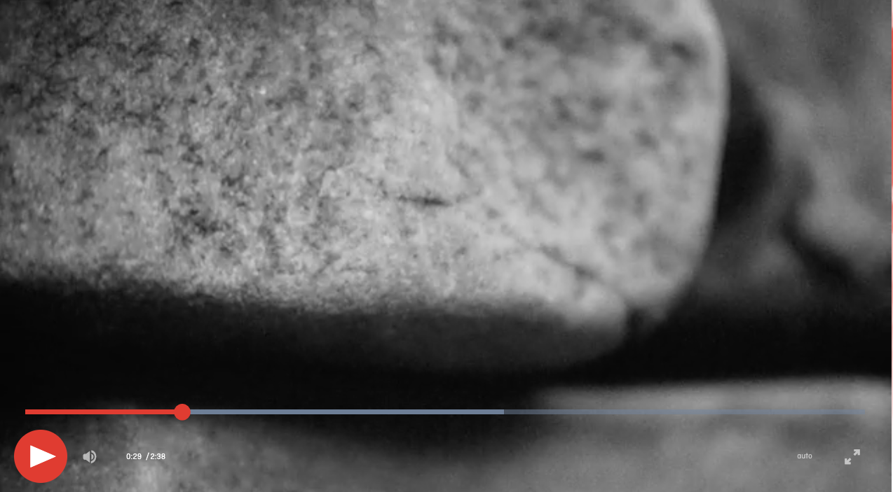
Scene from Jabie Weetaluktuk’s Vistas: InukShop
Close-up
Most of the close-up shots, however, show hands, face, tools etc. up close. This allows the audience to see more details while still understanding what the action is, like the hands holding an ulu cutting muktuk.

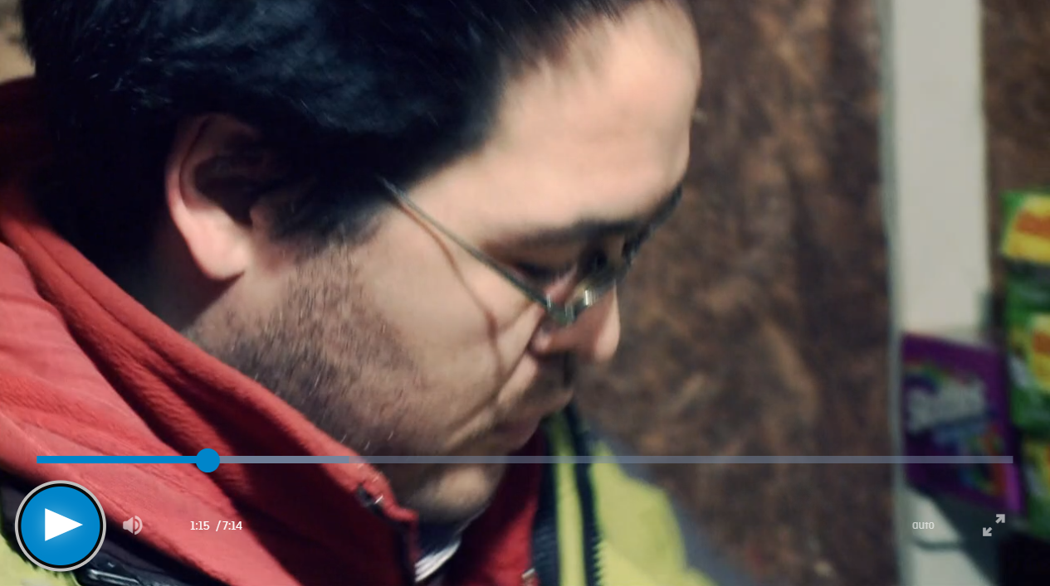
Scene from Jessica Katierk’s The Vending Machine

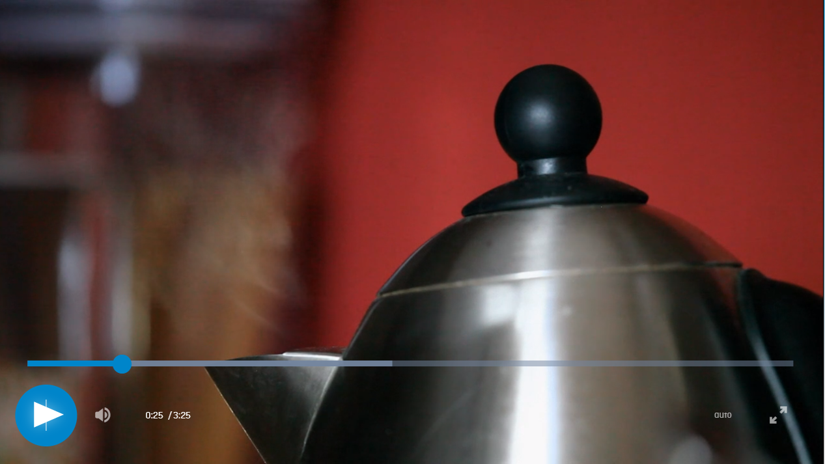

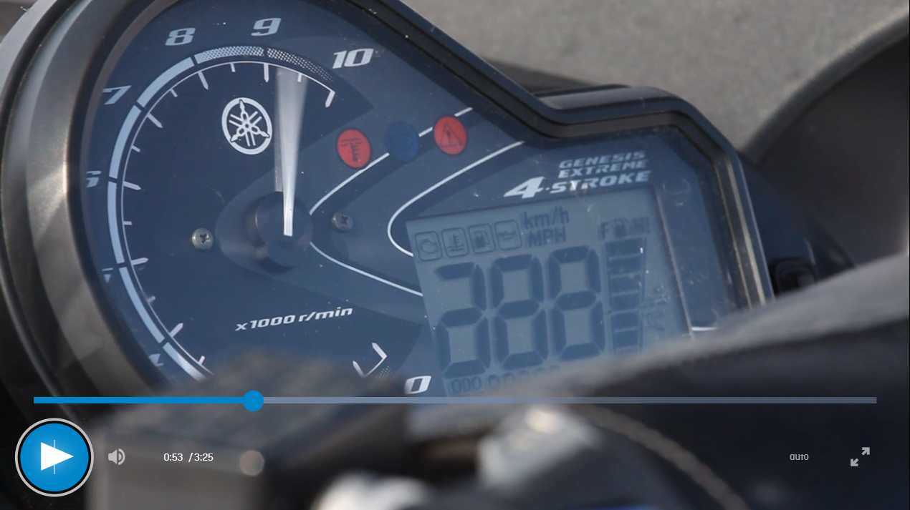
Scenes from Qajaaq Ellsworth’s Nippaq
NOTES

Medium Close-up
Many videos in TikTok use medium close-ups when showing someone is eating or talking. The shots are from the chest upwards for a person or show almost an entire plate or pan/pot. It can also show a part of the arms.
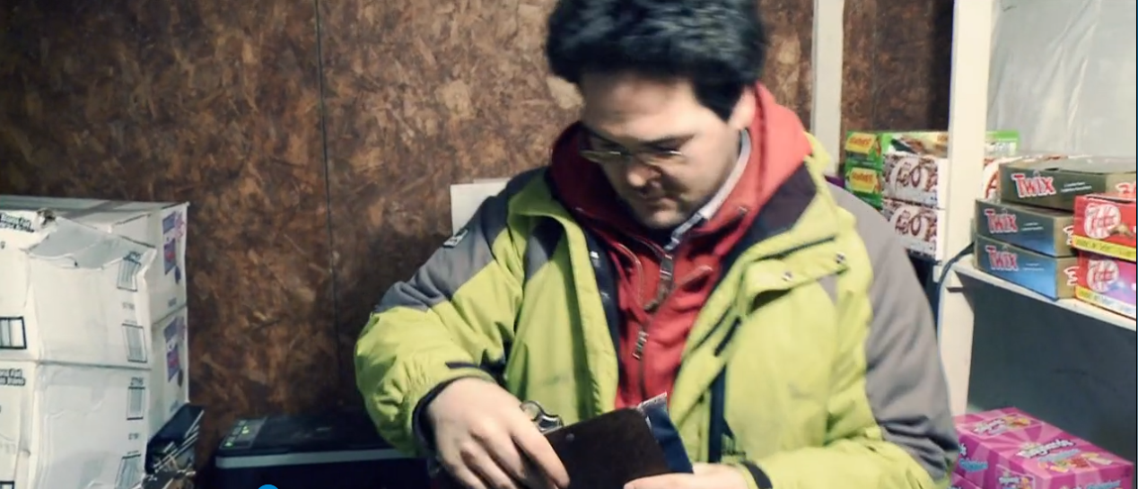

Scenes from Jessica Katierk’s The Vending Machine

Medium Shot
Another type of shot very common in films is the medium shot. Medium shots are great to give context and to allow the audience to know the “character” or “object” on the screen. With a medium shot, you see a part of the body from the waist up.
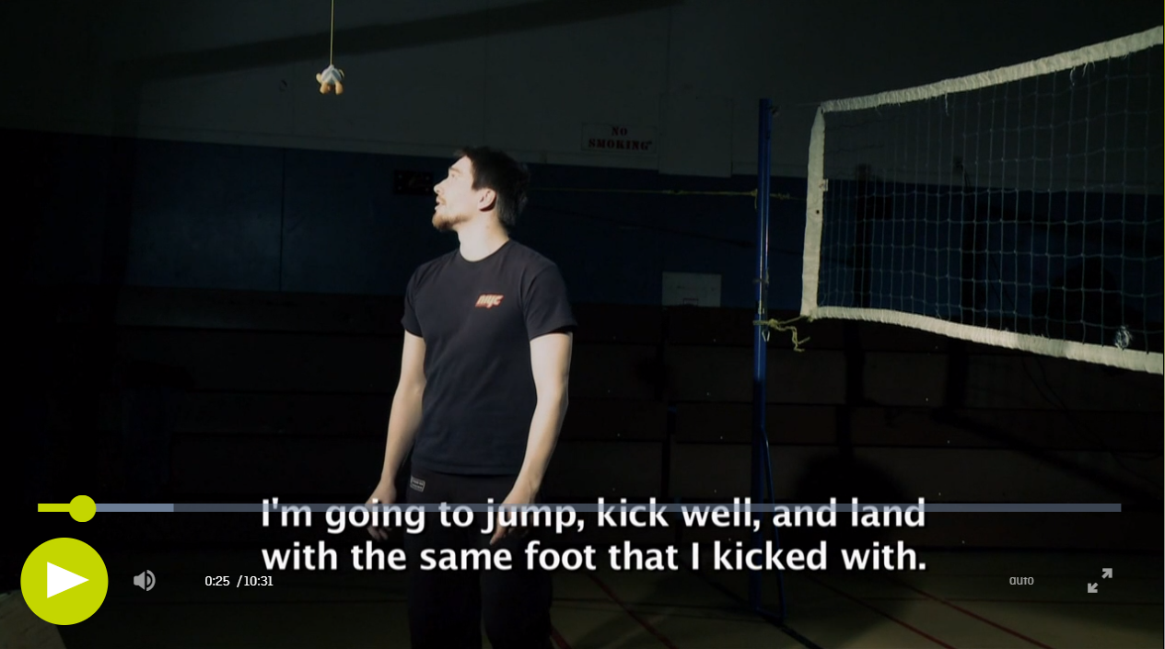
Scene from Allen Auksaq’s Strength, Flexibility, and Endurance
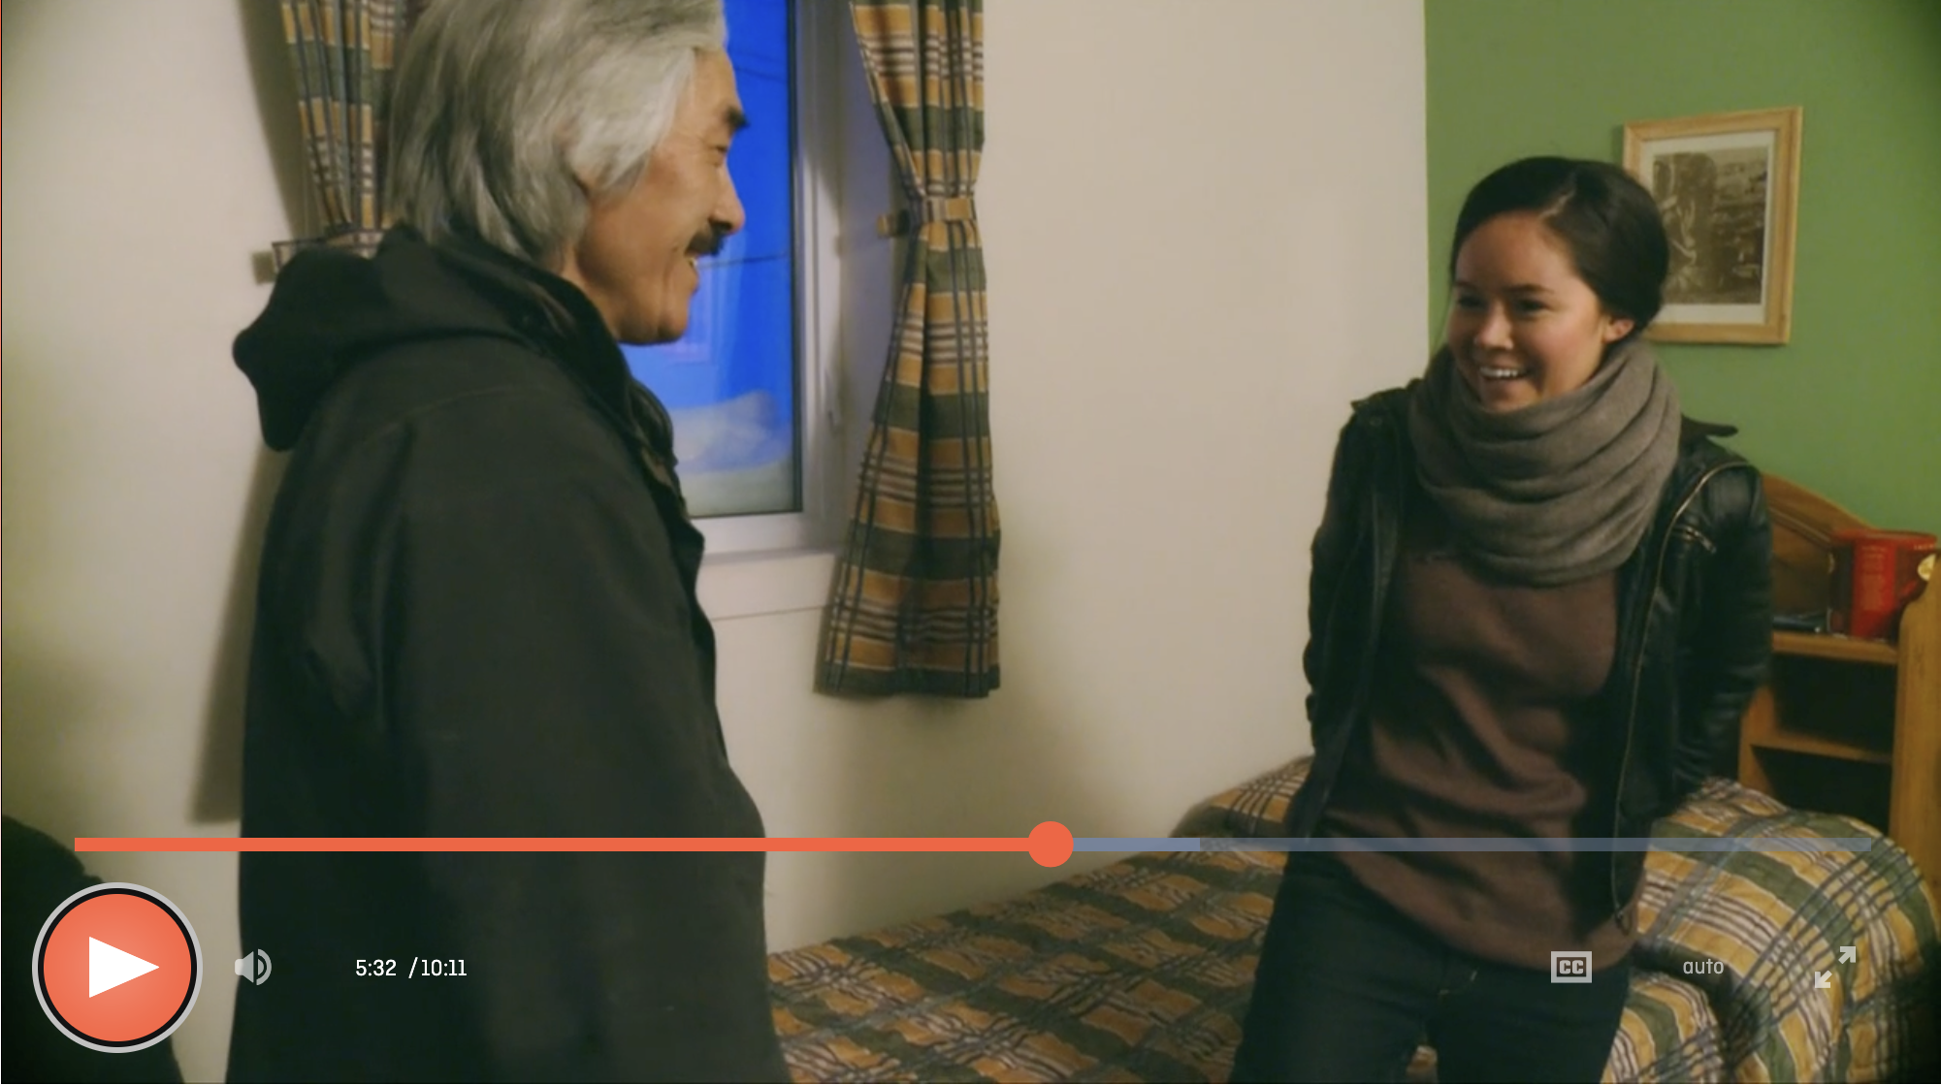
Scene from Nyla Innuksuk’s Finding Home
Establishing or Long (wide) shot
As the word says, these shots are filmed to establish a scene or location. The shots film the entire body of a person (either sitting or standing), or it shows a landscape or a house or community from distance, or it shows an activity (like fishing or hunting or cooking) from a distance. Establishing shots or long shots are important for the audience to understand a location, an action, or a person
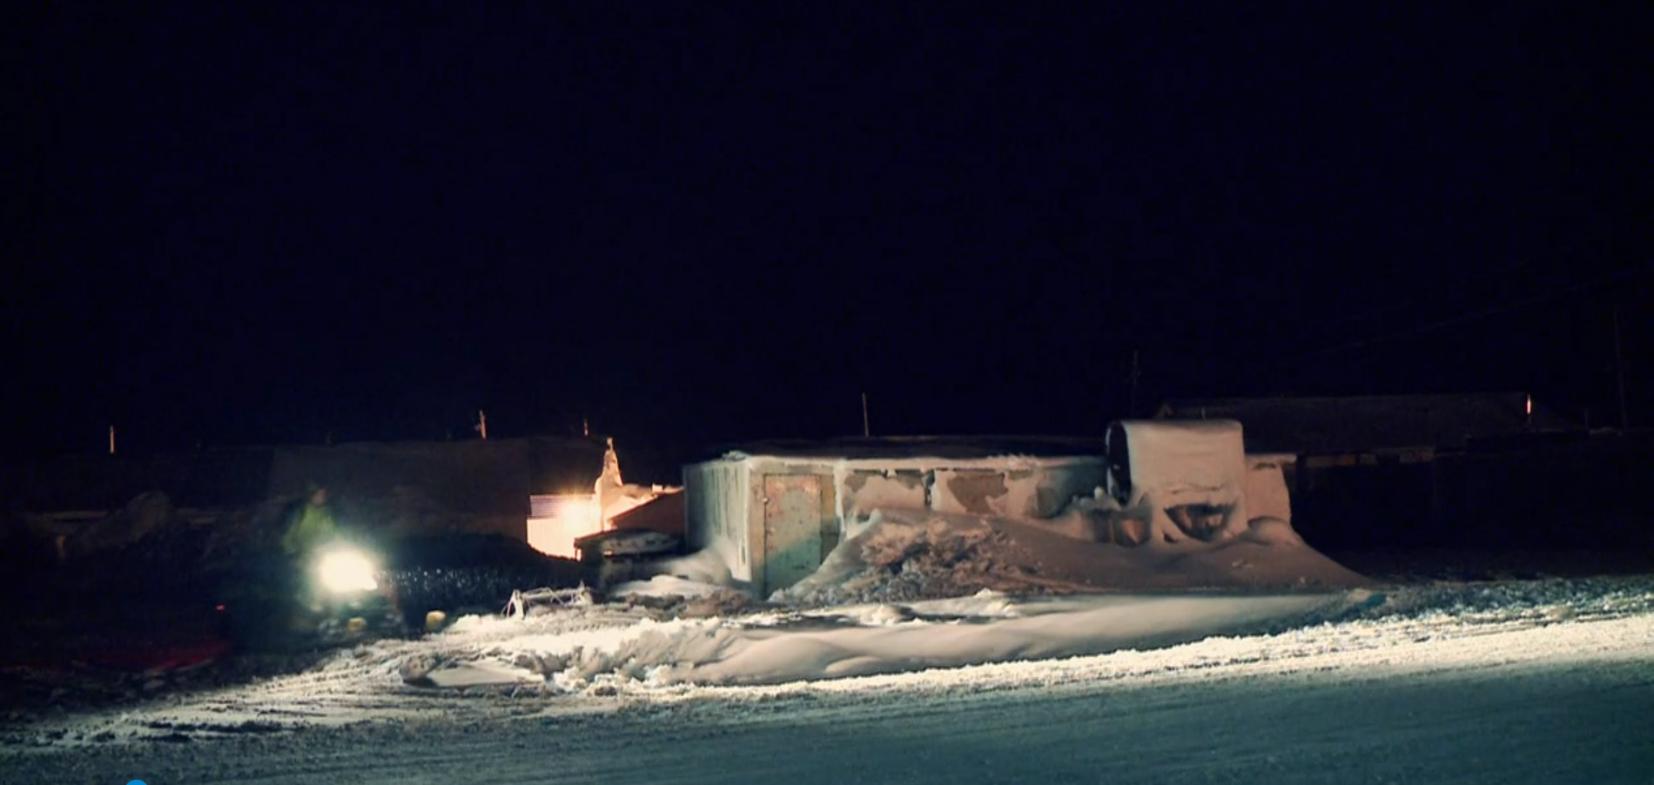
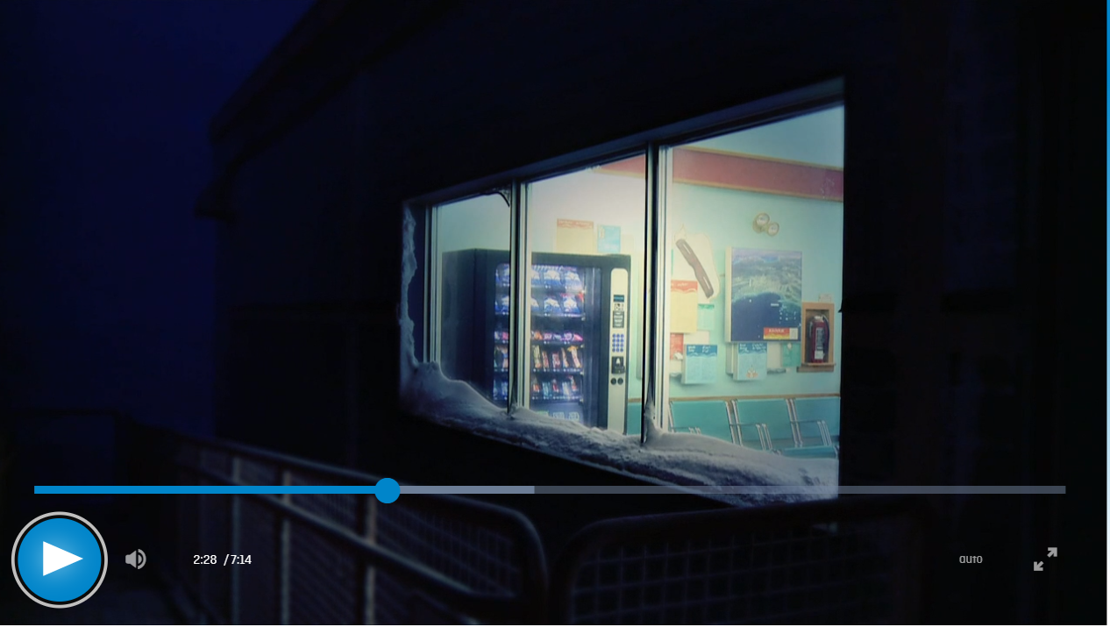
Scenes from Jessica Katierk’s The Vending Machine
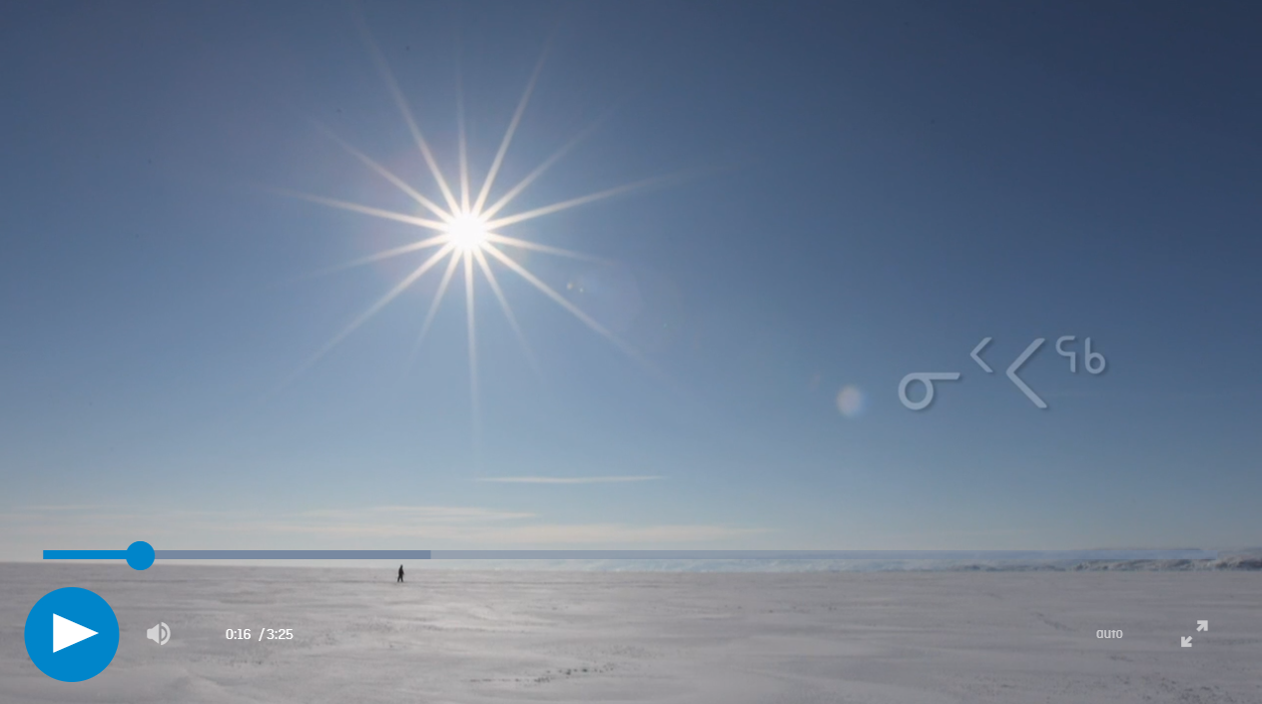
Scene from Qajaaq Ellsworth’s Nippaq

NOTES
Saving onto OneDrive
The following instructions are for Samsung Galaxy A53 G5 Enterprise. You can do this automatically or manually
- Automatically
- Go to the Gallery 
- Go to Menu 
- Go to Settings 
- Click on Sync with OneDrive (first tab)
- Create Account
- Put in the details
- Put in your OneDrive email [for example, University]
- Your photos and videos should now be synched with OneDrive automatically.

- Manually
- Go to the OneDrive App 
- Sign up on your OneDrive (like York University account)
- Go to the Gallery
- Click on the image(s)/photo(s)/video(s) you want to put onto OneDrive. You can select more than one.
- Go to Share 
- Scroll to the left of the bottom line with the Apps (skip step 5 if you can already see the OneDrive icon)
- Go to More 
- Go to OneDrive
- Click on the Menu in left corner 
- Click on relative OneDrive account (like York University)
- Click on Files
- Click on the folder where you want to save the photo(s)/image(s)/video(s).
- Alternatively, clicking New Folder icon 
- When in the right folder, click the  on the top screen.
- Your photo(s)/image(s)/video(s) are now saved onto OneDrive.
- If your phone storage is getting full (or earlier), you need to delete the photos once they are placed on the OneDrive.

NOTES

