

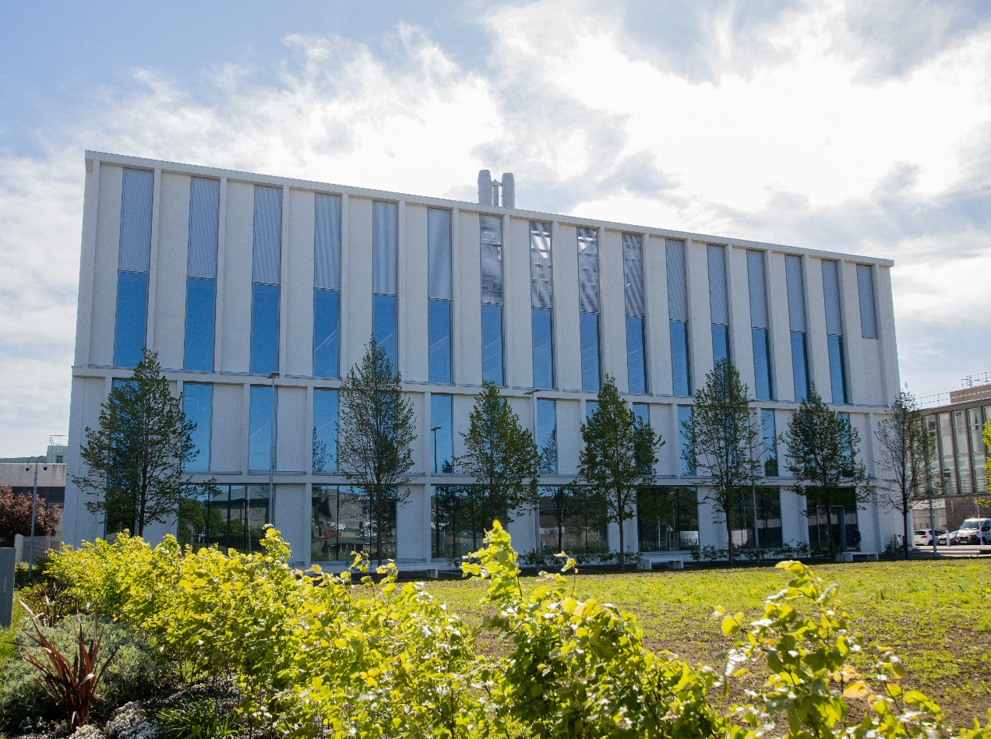
SR3508 – Clinical Exercise Physiology
Course Handbook 2023-2024
Undergraduate Medical Sciences
School of Medicine, Medical Sciences & Nutrition
Contents

- Course Summary (3)
- Course Aims & Learning Outcomes
- Course Teaching Staff
- Assessments & Examinations (4)
- Summary of In-course Assessments
- Class Representatives
- Problems with Coursework (5)
- Course Reading List
- Lecture Synopsis
- Practical/Lab/Tutorial Work (6)
- University Policies
- Academic Language & Skills support (9)
- Medical Sciences Common Grading Scale (11)
- Course Timetable SR3508: 2023-2024 (12)
- Campus and Floor Maps
Course Summary

Clinical exercise physiology is a subfield of exercise physiology. It covers the effects of chronic disease and drugs on exercise capacity and the use of exercise for the prevention and treatment of disease. This course is focused on using exercise for the treatment of disease. To complement the theory, you will participate in exercise-based practical sessions (see section on Practical classes).

Course Aims & Learning Outcomes
If you successfully complete this course you will be able to:
- Describe the anatomy of the musculoskeletal system and relate the anatomical features to injury propensity and disease.
- Describe the lung anatomy, muscles of respiration and explain breathing process.
- Describe the spinal cord anatomy, spinal nerve formation and explain function of the somatic nervous system.
- List different forms of musculoskeletal injuries and explain the types of treatment.
- Define sarcopenia and other forms of skeletal muscle atrophy, explain the underlying mechanisms and the link with falls.
- Describe the development of myocardial infarction and heart failure.
- Explain the development of asthma.
- For all diseases above explain their effect on exercise capacity and describe how exercise and other treatments can be used to treat or ameliorate these diseases.

Course Teaching Staff
Course Coordinator:
Dr Ari Lionikas (a.lionikas@abdn.ac.uk)

Other Staff:
- DB- Derek Ball derek.ball@abdn.ac.uk
- SP - Simon Parson simon.parson@abdn.ac.uk
- DC - David Chorn d.j.chorn@abdn.ac.uk
- BS – Bahgat Sami bahgat.sami@abdn.ac.uk
- SS – Shahida Shahana s.shahana@abdn.ac.uk
- FG – Flora Groening f.groening@abdn.ac.uk
- DS – Derek Scott d.scott@abdn.ac.uk
- MS – Michael Scholz m.e.scholz@abdn.ac.uk
- CR – Christine Roberts christine.roberts@abdn.ac.uk
- GK – Gillian Kerr g.kerr@abdn.ac.uk
- JG – Jenny Gregory j.gregory@abdn.ac.uk

Assessments & Examinations

Students are expected to attend all lectures, laboratory classes, and tutorials, and to complete all class exercises by stated deadlines. The minimum performance acceptable for the granting of a class certificate is attendance at 75% of the practical classes, and presentation of all set course work, written and oral. Attendance records will be taken throughout the course.
Continuous assessment (CA): consists of two components of equal weighting, the anatomy in-course assessment (15%) and a case study (15%). Written Examination: 70% of the total assessment is based on one written paper. The student must attempt to answer two questions (of equal weighting) selected from a choice of four questions.
The degree examination is held in April/May, with the re-sit examination in June/July.

Class Representatives

We value students’ opinions in regard to enhancing the quality of teaching and its delivery; therefore, in conjunction with the Students’ Association we support the Class Representative system.

In the School of Medicine, Medical Sciences & Nutrition we operate a system of course representatives, who are elected from within each course. Any student registered within a course that wishes to represent a given group of students can stand for election as a class representative. You will be informed when the elections for class representative will take place.

What will it involve?
It will involve speaking to your fellow students about the course you represent. This can include any comments that they may have. You will attend a Staff-Student Liaison Committee and you should represent the views and concerns of the students within this meeting. As a representative, you will also be able to contribute to the agenda. You will then feedback to the students after this meeting with any actions that are being taken.

Training
Training for class representatives will be run by the Students Association. Training will take place within each half-session. For more information about the Class representative system visit www.ausa.org.uk or email the VP Education & Employability vped@abdn.ac.uk . Class representatives are also eligible to undertake the STAR (Students Taking Active Roles) Award with further information about this co-curricular award being available at: www.abdn.ac.uk/careers.

Problems with Coursework

If students have difficulties with any part of the course that they cannot cope with, alone they should notify the course coordinator immediately. If the problem relates to the subject matter general, advice would be to contact the member of staff who is teaching that part of the course. Students with registered disabilities should contact the medical sciences office, (medsci@abdn.ac.uk) (based in the Polwarth Building, Foresterhill) to ensure that the appropriate facilities have been made available. Otherwise, you are strongly encouraged to contact any of the following as you see appropriate:

- Course student representatives
- Course co-ordinator
- Convenor of the Medical Sciences Staff/Student Liaison Committee (Professor Gordon McEwan)
- Personal Tutor
- Medical Sciences Disabilities Co-ordinator (Dr Derryck Shewan)

All staff are based at Foresterhill and we strongly encourage the use of email or telephone the Medical Sciences Office. You may have a wasted journey travelling to Foresterhill only to find staff unavailable.

If a course has been completed and students are no longer on campus (i.e. work from second half session during the summer vacation), coursework will be kept until the end of Fresher’s Week, during the new academic year. After that point, unclaimed student work will be securely destroyed.

Course Reading List

Ehrman JK, Gordon PM, Visich PS and Keteyian SJ. (2003). Clinical Exercise Physiology. Human Kinetics, Champaign IL.
Saltin, B, Secher N, Boushel R, Mitchell J (1999) Exercise and Circulation in Health and Disease. Human Kinetics, Champaign IL.
Agur, AMR, Dalley, AF (2019) Moore’s Essential Clinical Anatomy, 6th edition. Wolters Kluwer, Alphen aan den Rijn, The Netherlands

Lecture Synopsis
- Anatomy & sports injuries: A basic overview of skeletal and muscular anatomy together with joint structure and mobility with special relevance to sports injuries. Supported by laboratory work with human cadaveric material.
- Muscle injury: Muscle injury, repair and interventions to aid repair.
- Sarcopenia: The mechanisms underlying ageing related muscle atrophy and treatment strategies will be discussed.
- Cancer: The role of physical activity and exercise in cancer risk and their therapeutic applications will be covered.
- Cardiac rehabilitation: Heart anatomy, arteriosclerosis, myocardial infarction, exercise therapy.
- Osteoporosis: The development, progression and treatment of osteoporosis (with a particular mention to falls and fractures prevention amongst the elderly) will be investigated in detail.
- Asthma: Exercise for individuals with asthma and the impact of asthma treatment on performance will be discussed.

Practical/Lab/Tutorial Work

Practical Work (University Sport and Exercise Team)
You will take part in 3 exercise based practical sessions within your class. These must be attended to permit you to participate in a variety of client-based exercise classes:
-Evergreens Exercise – for active older adults
-Cardiac Rehabilitation
-Stable & Able – strength and balance exercise for falls prevention
Full details of your expectations and requirements for these sessions will be given.

Course Work

(Continuous assessment); Coursework contributes 30% of the overall mark. Continuous assessment is based upon equally (50/50) weighted assessment of the anatomy element of the course and the clinical exercise physiology element. In week 30 the anatomy assessment worth 15% of the final mark will be conducted. In week 31, you will be given an exercise prescription case study task worth 15% of the final mark. Students must attempt ALL elements of the continuous assessment program.

In week 35 you will receive a second case study to prepare you for your exam. The task will be discussed in week 39 but not formally assessed.

University Policies

Students are asked to make themselves familiar with the information on key education policies, available here. These policies are relevant to all students and will be useful to you throughout your studies. They contain important information and address issues such as what to do if you are absent, how to raise an appeal or a complaint and how the University will calculate your degree outcome.
These University wide education policies should be read in conjunction with this programme and/or course handbook, in which School specific policies are detailed. These policies are effective immediately, for the 2023/24 academic year. Further information can be found on the University’s Infohub webpage or by visiting the Infohub.

The information included in the institutional area for 2023-24 includes the following:
- Assessment
- Feedback
- Academic Integrity
- Absence
- Student Monitoring/ Class Certificates
- Late Submission of Work
- Student Discipline
- The co-curriculum
- Student Learning Service (SLS)
- Professional and Academic Development
- Graduate Attributes
- Email Use
- MyAberdeen
- Appeals and Complaints

Where to Find the Following Information:
C6/C7- University of Aberdeen Homepage > Students > Academic Life > Monitoring and Progress > Student Monitoriung (C6 & C7)
https://www.abdn.ac.uk/students/academic-life/student-monitoring.php#panel5179

Absences- To report absences you should use the absence reporting system tool on Student Hub. Once you have successfully completed and sent the absence form you will get an email that your absence request has been accepted. The link below can be used to log onto the Student Hub Website and from there you can record any absences you may have.

Log In - Student Hub (ahttps://www.abdn.ac.uk/studenthub/loginbdn.ac.uk)

Submitting an Appeal- University of Aberdeen Homepage > Students > Academic Life > Appeals and Complaints

https://www.abdn.ac.uk/students/academic-life/appeals-complaints-3380.php#panel2109

Academic Language & Skills support

For students whose first language is not English, the Language Centre offers support with Academic Writing and Communication Skills.

Academic Writing
- Responding to a writing task: Focusing on the question
- Organising your writing: within & between paragraphs
- Using sources to support your writing (including writing in your own words, and
citing & referencing conventions)
- Using academic language
- Critical Thinking
- Proofreading & Editing

Academic Communication Skills
- Developing skills for effective communication in an academic context
- Promoting critical thinking and evaluation
- Giving opportunities to develop confidence in communicating in English
- Developing interactive competence: contributing and responding to seminar discussions
- Useful vocabulary and expressions for taking part in discussions

More information and how to book a place can be found here

Medical Sciences Common Grading Scale

Grade | Grade Point | % Mark | Category | Honours Class | Description
A1 | 22 | 90-100 | Excellent | First | • Outstanding ability and critical thought  • Evidence of extensive reading  • Superior understanding  •The best performance that can be expected from a student at this level
A2 | 21 | 85-89 | Excellent | First
A3 | 20 | 80-84 | Excellent | First
A4 | 19 | 75-79 | Excellent | First
A5 | 18 | 70-74 | Excellent | First
B1 | 17 | 67-69 | Very Good | Upper Second | • Able to argue logically and organise answers well  • Shows a thorough grasp of concepts  • Good use of examples to illustrate points and justify arguments  • Evidence of reading and wide appreciation of subject
B2 | 16 | 64-66 | Very Good | Upper Second
B3 | 15 | 60-63 | Very Good | Upper Second
C1 | 14 | 57-59 | Good | Lower Second | • Repetition of lecture notes without evidence of further appreciation of subject  • Lacking illustrative examples and originality  • Basic level of understanding
C2 | 13 | 54-56 | Good | Lower Second
C3 | 12 | 50-53 | Good | Lower Second
D1 | 11 | 47-49 | Pass | Third | • Limited ability to argue logically and organise answers  • Failure to develop or illustrate points  • The minimum level of performance required for a student to be awarded a pass
D2 | 10 | 44-46 | Pass | Third
D3 | 9 | 40-43 | Pass | Third
E1 | 8 | 37-39 | Fail | Fail | • Weak presentation  • Tendency to irrelevance  • Some attempt at an answer but seriously lacking in content and/or ability to organise thoughts
E2 | 7 | 34-36 | Fail | Fail
E3 | 6 | 30-33 | Fail | Fail
F1 | 5 | 26-29 | Clear Fail | Not used for Honours | • Contains major errors or misconceptions  • Poor presentation
F2 | 4 | 21-25 | Clear Fail | Not used for Honours
F3 | 3 | 16-20 | Clear Fail | Not used for Honours
G1 | 2 | 11-15 | Clear Fail/Abysmal |  | • Token or no submission
G2 | 1 | 1-10 | Clear Fail/Abysmal |  | • Token or no submission
G3 | 0 | 0 | Clear Fail/Abysmal |  | • Token or no submission

SR3508 Course Timetable: 2023-2024

Date | Time | Room | Subject | Session | Lecturer
Week 26
Mon 22 Jan | 15:00-16:00 | 1:039/040 | Introduction | Lecture | AL
Tue 23 Jan | 09:00-09:30 | Anat 304 | Anatomy Act | Lecture | SP
Tue 23 Jan | 09:30-10:00 | Anat 304 | Bones | Lecture | DC
Tue 23 Jan | 10:00-12:00 | Anat 304 | Practical: Bones | Practical | DC
Tue 23 Jan | 15:00-17:00 | Suttie 012 LT | What will you do after your degree? | Lecture | DS
Week 27
Mon 29 Jan | 10:00-11:00 | 1:039/040 | Exercise Referral classes | Lecture | CR
Tue 30 Jan | 09:00-10:30 | Anat 304 | Joints | Lecture | DC
Tue 30 Jan | 10:30-12:00 | Anat 304 | Joints | Practical | DC
Wed 31 Jan | 11:00-12:00 | MR252 | Falls and prevention | Lecture | CR
Week 28
Mon 5 Feb | 10:00-11:00 | 1:039/40 | Lung anatomy | Lecture | SS
Mon 5 Feb | 14:00-15:00 | 1:039/40 | The back | Lecture | BS
Mon 5 Feb | 15:00-16:00 | 1:039/40 | Muscle groups | Lecture | BS
Tue 6 Feb
Tue 6 Feb | 10:00-12:00 | Anat 304 | Practical: Muscles | Practical | BS
Tue 6 Feb | 12:00-13:00 | Anat 315 | Practical: Lung | Practical | SS
Wed 7 Feb | 14:30-16:30 | ASV | Stable & Able | Practical | CR/GK
Fri 9 Feb | 15:00-16:00 | Anat 315 | Formative Assessment –Bones, Joints, Back, Muscles and lung | Practical | DC/BS/SS
Week 29
Mon 12 Feb | 10:00-10:30 | Anat 304 | Spinal cord | Lecture | SS
Mon 12 Feb | 10:30-12:00 | Anat 304 | Spinal cord | Practical | SS
Tue 13 Feb | 09:00-10:00 | 1:039/40 (40) | Introduction to Clinical Exercise Physiology | Lecture | AL
Fri 16 Feb | 15:00-16:00 | D2 WORKSHOP (70) | Type 2 diabetes I | Lecture | AL
Week 30
Mon 19 Feb | 14:00-15:00 | 2_054 | Type 2 diabetes II | Lecture | AL
Tue 20 Feb | 09:00-11:00 | Anat 304 | Anatomy In-course Assessment - Bones, Joints, Back, Muscles and Lung | Practical | SS/DC/BS
Tue 20 Feb | 11:00-13:00 | Anat 304 | Spare slot | Practical
Tue 20 Feb | 14:00-15:00 | 1:039/040 | Sarcopenia and atrophy I | Lecture | AL
Wed 21 Feb | 09:00-10:00 | 2_054 | Sarcopenia and atrophy II | Lecture | AL
Fri 23 Feb | 14:00-15:00 | 1:032/033 | Cancer I | Lecture | MS
Fri 23 Feb | 15:00-16:00 | D2 WORKSHOP | Cancer II | Lecture | MS
Week 31 - Students receive case study (deadline 31st March)
Mon 26 Feb | 10:00-11:00 | ASV | Cardiac Rehab class (Group A; wear sports clothes) | Practical | CR
Mon 26 Feb | 14:00-15:00 | 1:039/40 | Osteoporosis I | Lecture | JG
Tue 27 Feb | 14:00-15:00 | 1:039/040 | Osteoporosis II | Lecture | JG
Wed 28 Feb | 14:30-16:30 | ASV | Spare slot for Stable & Able | Practical | CR/GK
Fri 1 Mar | 15:00-16:00 | D2 WORKSHOP | Formative Assessment – Spinal cord | Practical | SS
Week 32
Mon 4 Mar | 10:00-11:00 | ASV | Cardiac Rehab class (Group B; wear sports clothes) | Practical | CR/GK
Mon 4 Mar | 14:00-15:00 | 1:039/40 | Students receive patient cases and have to present a plan for exercise interventions | Lecture | DS
Tue 5 Mar | 14:00-15:00 | 1:039/040 | Spare slot | Lecture
Fri 8 Mar | 15:00-16:00 | D2 WORKSHOP | Heart disease I | Lecture | DB
Week 33
Mon 11 Mar | 10:00-11:00 | ASV - Sky Studio | Cardiac Rehab class (Group C; wear sports clothes) | Practical | CR/GK
Tue 12 Mar | 12:00-13:00 | 1:039/040 | Heart disease II | Lecture | DB
Wed 13 Mar | 10:00-11:00 | ASV | Evergreens (Group A) | Practical | JS
Fri 15 Mar | 14:00-16:00 | ASV | Health and wellbeing | Practical | DB
Week 34
Mon 18 Mar | 14:00-15:00 | 1:039/40 | Hypertension | Lecture | AL
Tue 19 Mar | 14:00-15:00 | 1:039/040 | Asthma I | Lecture | AL
Wed 20 Mar | 10:00-11:00 | ASV | Evergreens (Group B) | Practical | JS
Fri 22 Mar | 15:00-16:00 | D2 WORKSHOP | Stroke | Lecture | DB
Week 35 - Students receive case study B (preparation for Honours exams, AL)
Mon 25 Mar | 10:00-12:00 | ASV – Sky Studio | Spare slot for Cardiac rehab | Practical | CR/GK
Tue 26 Mar | 09:00-10:00 | 1:039/040 | Anatomy of the heart | Lecture | FG
Tue 26 Mar | 10:00-12:00 | Anat 304 | Practical: Heart | Practical | FG
Tue 26 Mar | 12:00-13:00 | 1:039/040 | Anatomical basis of common sports injuries | Lecture | SS
Wed 27 Mar | 10:00-11:00 | ASV | Evergreens (Group C) | Practical | JS
Fri 29 Mar | 15:00-16:00 | D2 WORKSHOP | Asthma II | Lecture | AL
Fri 29 Mar | Deadline for case study task submission
Week 39 - No Teaching - Revision Week
Tue 30 April | 12:00-13:00 | 1:039/40 | Discussion of case study b (preparation for Honours exam) | Revision Session | AL

Venues

Polwarth building | Suttie centre | Macrobert building | Medical Physics building | Aberdeen Sports Village
1:039/040  2_054 | 012 Lecture Theatre  Anat 304, Anat 315 are the Anatomy Labs, 3rd Floor | MR252 | D2 Workshop | ASV – Sky Studio  ASV – Sports Hall

Staff
- AL – Arimantas Lionikas (Course Co-ordinator) a.lionikas@abdn.ac.uk
- DB- Derek Ball derek.ball@abdn.ac.uk
- SP - Simon Parson simon.parson@abdn.ac.uk
- DC - David Chorn d.j.chorn@abdn.ac.uk
- SB - Sami Bahgat bahgat.sami@abdn.ac.uk
- SS – Shahida Shahana s.shahana@abdn.ac.uk
- FG – Flora Groening f.groening@abdn.ac.uk
- DS – Derek Scott d.scott@abdn.ac.uk
- MS – Michael Scholz m.e.scholz@abdn.ac.uk
- CR – Christine Roberts christine.roberts@abdn.ac.uk
- GK – Gillian Kerr g.kerr@abdn.ac.uk
- JG – Jenny Gregory j.gregory@abdn.ac.uk

Campus Maps - Foresterhill

Polwarth Floor Plans

